1. Declare a single-dimensional array of 5 integers inside the main method. Traverse the array to print the default values. Then accept records from the user and print the updated values of the array.

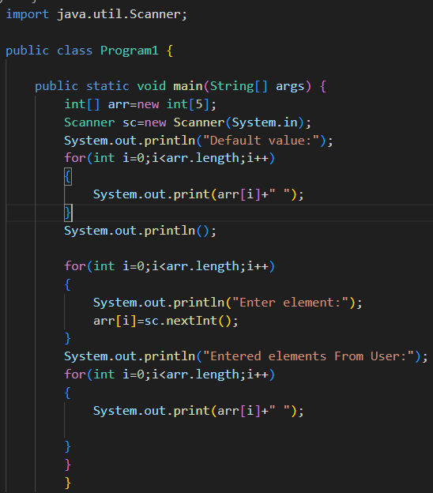

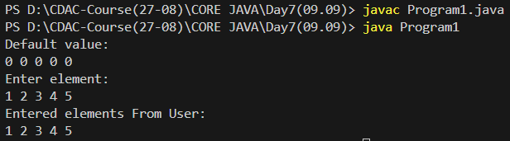

1. Declare a single-dimensional array of 5 integers inside the main method. Define a method named acceptRecord to get input from the terminal into the array and another method named printRecord to print the state of the array to the terminal.

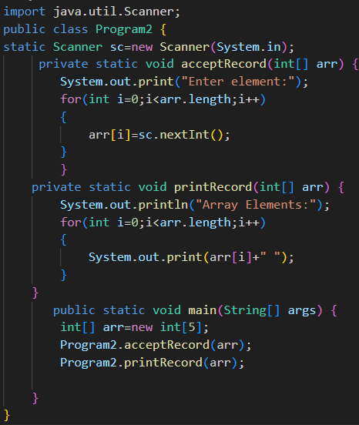

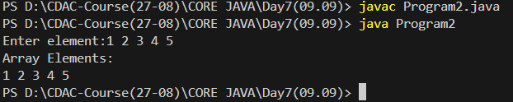

1. Write a program to find the maximum and minimum values in a single-dimensional array of integers.

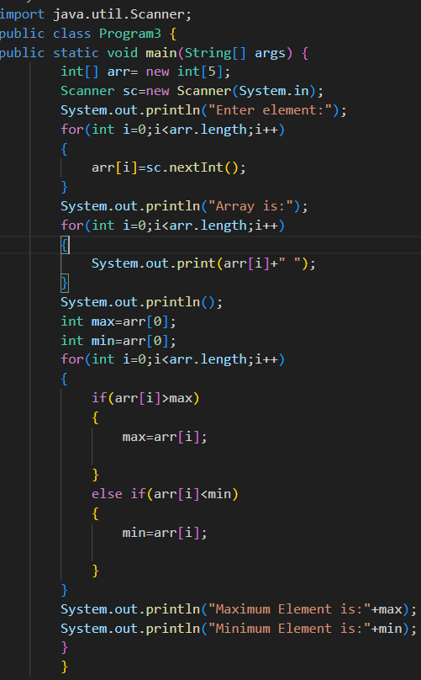

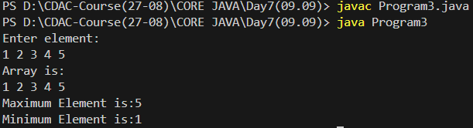

1. Write a program to remove duplicate elements from a single-dimensional array of integers.

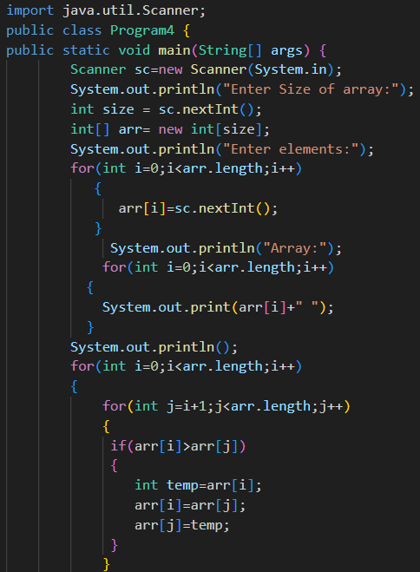

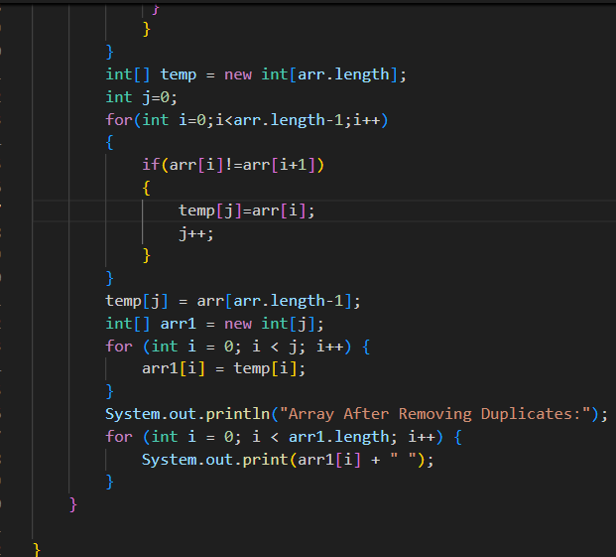

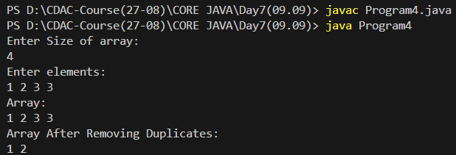

1. Write a program to find the intersection of two single-dimensional arrays.

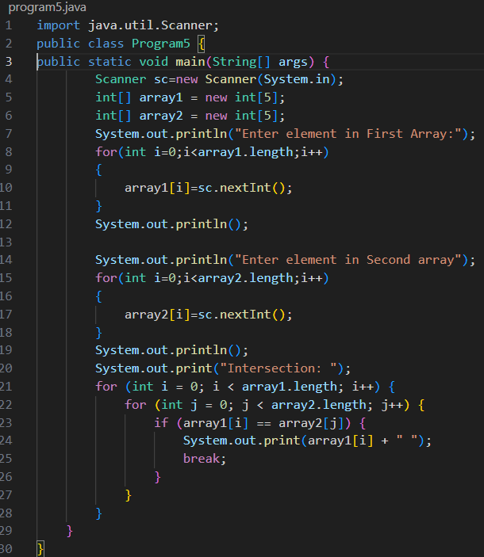

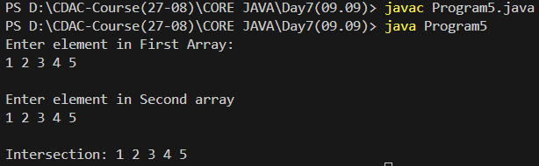

1. Write a program to find the missing number in an array of integers ranging from 1 to N.

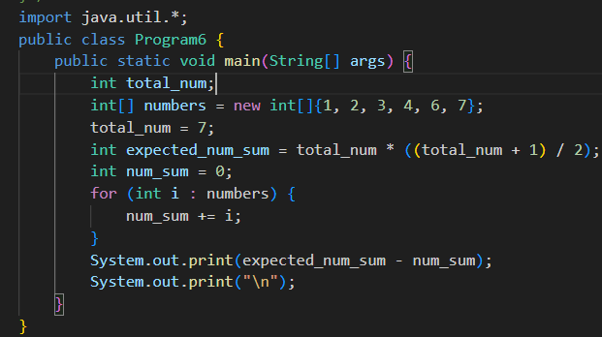



1. Declare a single-dimensional array as a field inside a class and instantiate it inside the class constructor. Define methods named acceptRecord and printRecord within the class and test their functionality.

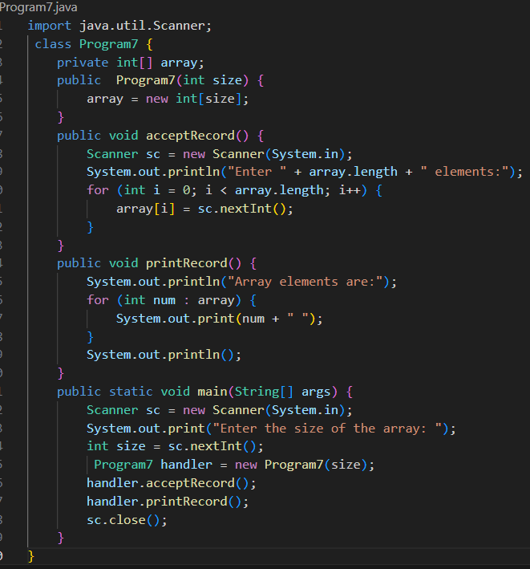

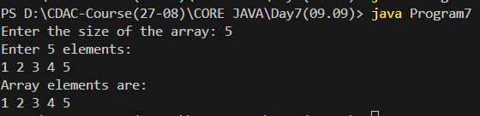

1. Modify the previous assignment to use getter and setter methods instead of acceptRecord and printRecord.
2. You need to implement a system to manage airplane seat assignments. The airplane has seats arranged in rows and columns. Implement functionalities to:

* Initialize the seating arrangement with a given number of rows and columns.
* Book a seat to mark it as occupied.
* Cancel a booking to mark a seat as available.
* Check seat availability to determine if a specific seat is available.
* Display the current seating chart.