**Trupti Thakur**

**CMSC-204**

**09/09/2020**

**Montgomery College**

**CMSC 204**

**Assignment 1 Design**

Test table

|  |  |  |  |  |  |
| --- | --- | --- | --- | --- | --- |
| **Test Case #** | **Input** | **Actual Input** | **Expected Output** | **Actual Output** | **Did the test pass?** |
| 1 | Neha | Neha | Not a valid password. Less than 6 character | The password must be at least 6 character long | pass |
| 2 | myPassword | myPassword | Not a valid password. Special symbols are not included | The password must contain atleast one digit | pass |
| 3 | a1AAA#b1Bc1Cd1D | a1AAA#b1Bc1Cd1D | InValid password | The password can not contain more than two letters in sequence | Pass |
| 4 | Im2cool4U# | Im2cool4U# | Valid password | Password is valid. | pass |

Screenshots:

Length less than 6 character long 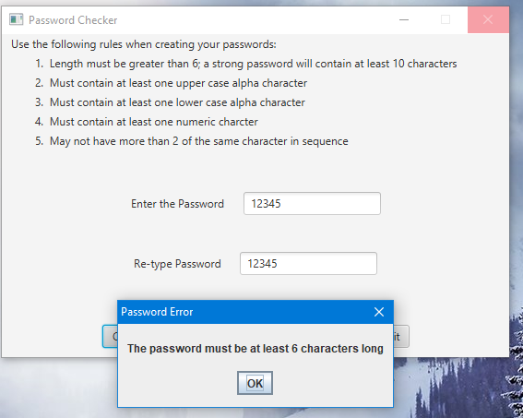

1. No Lowercase :
2. 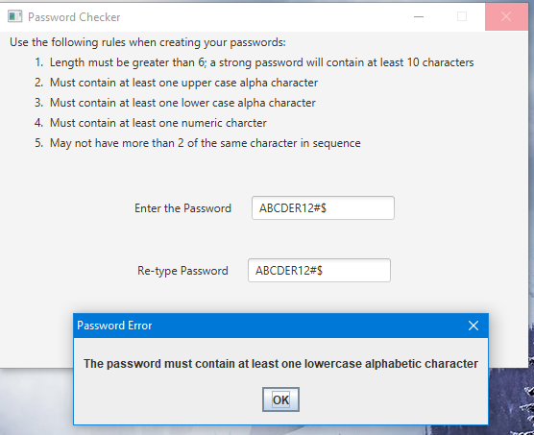
3. No UpperCase :

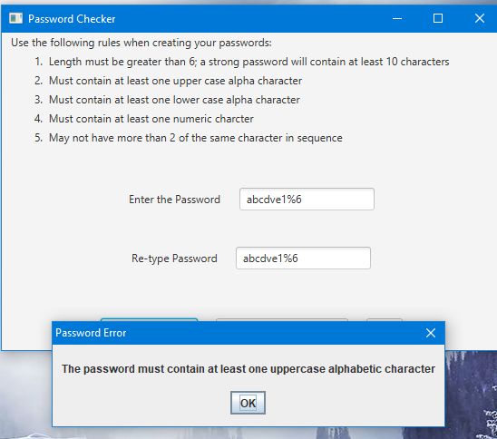

2) No digit :

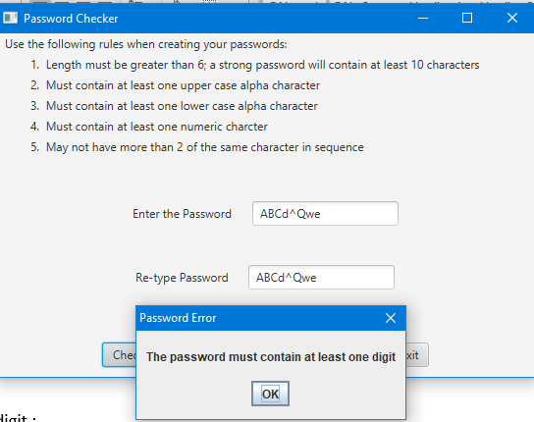

3) If the password is OK, but between 6 and 10 characters, you will see:

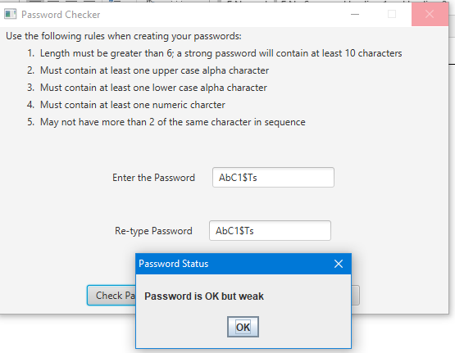

4) If password has more than two of the same characters in a row :

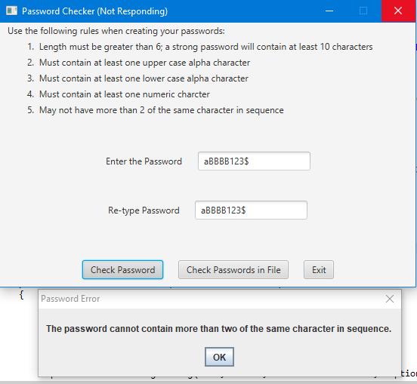

5) if password is valid :

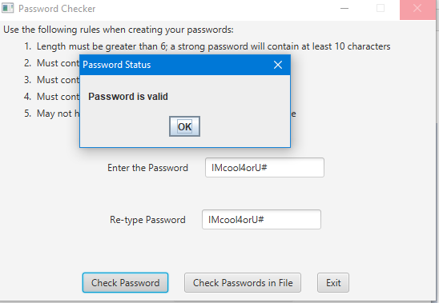

6) when password do not match

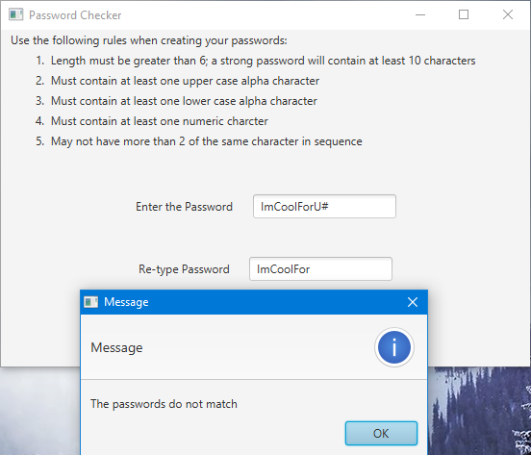

7)when the user selects “Check Passwords in File”: Displays errors to user when selecting Check Passwords in File. Note that valid passwords (including weak but otherwise valid passwords) are NOT displayed.

