Checklist

1. Installed JDk /JRE. Set environment variables
2. Installed Eclipse. ( Version….)
3. Installed Maven : <https://maven.apache.org/download.cgi>

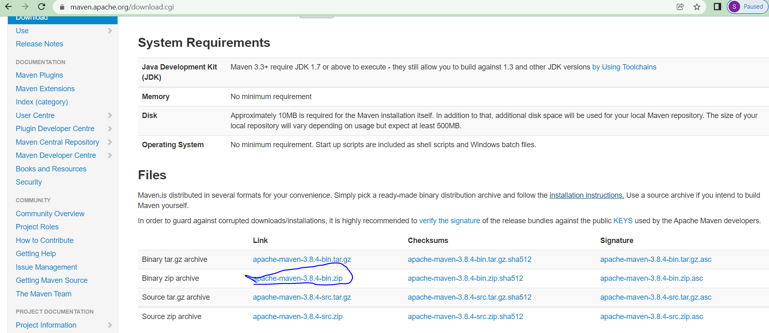

<https://youtu.be/RfCWg5ay5B0>

1. Set environment variables for Maven
2. Verify maven is installed on your pc : 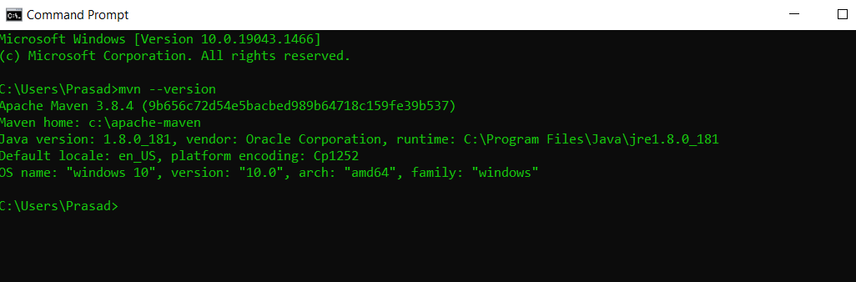
3. Download Git repository: <https://github.com/Trupti-GitRepository/book_library_project.git>

Save it on your pc.

Import as a Maven project in Eclipse. 🡺 File 🡺 New project

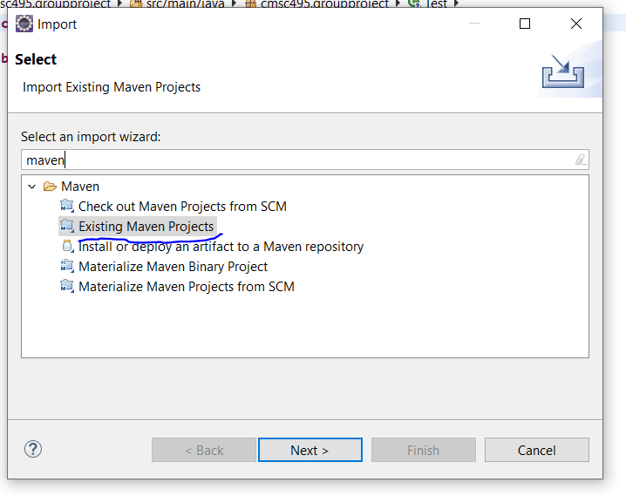

Should look like this once imported

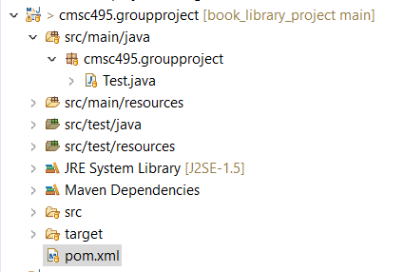

1. Installed git client on your pc

<https://git-scm.com/downloads> :

