A

Project Report

On

**ADAPTIVE QUIZ**

Developed by

**TRUPTI GANDHI (CE-34) (17CEUON042)**

**HETVI JOSHI (CE-51) (17CEUON034)**

**SAMYAK MEHTA (CE-67) (17CEUON035)**

**B.Tech CE Semester-VI**

**Guided By**

**Prof. Pandav K. Patel**

**Assistant Professor**



**Faculty of Technology**

**Department of Computer Engineering**

**Dharmsinh Desai University**



**Faculty of Technology**

**Department of Computer Engineering**

**Dharmsinh Desai University**

## CERTIFICATE

### This is to certify that the project entitled “Adaptive quiz” in the subject of “System Design Practice” is a bonafied report of the work carried out by

**TRUPTI GANDHI (CE-34) (17CEUON042)**

**HETVI JOSHI (CE-51) (17CEUON034)**

**SAMYAK MEHTA (CE-67) (17CEUON035)**

of Department of Computer Engineering semester **VI** in the branch of **Computer Engineering** during the academic year **2019-2020.**

Prof. Pandav K. Patel Dr. C. K. Bhensdadia,

Assistant Professor, Head,

Department of Computer Engineering, Department of Computer Engg.,

Faculty of Technology, Faculty of Technology,

Dharmsinh Desai University, Nadiad Dharmsinh Desai University, Nadiad

**ACKNOWLEDGEMENT**

The success and final outcome of this project required a lot of guidance and assistance from many people and we are extremely privileged to have got this all along the completion of our project. All that we have done is only due to such supervision and assistance and we would not forget to thank them.

We respect and thank to the faculties for providing us an opportunity to do the project and giving us all support and guidance which made us complete the project duty. We are extremely thankful to them for providing such a nice support, guidance by taking keen interest in our project.

We would also like to express our special thanks of gratitude to our HOD Prof. CKB sir who gave us the golden opportunity to do this wonderful project on the topic: Adaptive quiz System. We would also like to thank him for including such things in curriculum making it more interesting and useful practically.

Finally we would like to thank each and every person who was there around us helping more or less in our project and keeping us motivated to work hard and complete the project. We would also thank them for inspiring us and sharing their ideas and views to make this project a success.

Yours sincerely,

Trupti Gandhi(CE-34)

Hetvi Joshi (CE-51)

Samyak Mehta (CE-67)

**Table of Contents**

1.Abstract...…………………………..…………………..……………………………………..5

2 Introduction……………………………………………………………………….…..............6

2.1 Brief Introduction …………………..........................................................................6

2.2 Technology and Tools Used.......................................................................................7

3 Software Requirement Specifications ………………………...……………………………... 8

4 Design……………….……….……………………….……………………………..……….12

4.1 Use Case Diagram ……….…………..…….……………………………..………...12

4.2 Class Diagram………………….………………...….……………………..……….14

4.3 Sequence Diagram……..……………………………………………………………15

4.4 Activity Diagram……..……………………………………………...………..…….17

4.5 State Diagram…………………………………………………………...………..…18

4.6 E-R Diagram ….………………………………………………..……...………..…..19

4.7 Data Dictionary………………………………………………………..………...…..20

5 Implementation Details ……………………………….……………………………….…...…22

5.1 Modules …………………………..………………………………...………….…...22

6 Testing ………………………………………………………………………………………...24

6.1 Testing Method….……………………….…………………………….........……….24

6.2 Test Cases ……………………………………………………………………......….24

7 Screen‐shots of the System ………………………………………………......……..…….…...25

8 Conclusion ………………………………………………………………….…......….……….28

9 Limitations and Future Extensions of System ………………………………………………...29

10 Bibliography …………………………………………………….……………………..……29

1]. ABSTRACT

Adaptive Quiz improves motivation by only giving student items at the right difficulty for them. These tests are much harder to cheat and/or steal. These tests produce scores with greater precision than conventional tests. These comes from decades of research and academic publications. Examinees have equivalently precise scores – a more fair than ensuring the same set of items.

It is good source of interactivities among students and between the teacher and students. It is done in order to improve student‘s comprehension levels and learning motivation.  As one of their tools, online test tools are quite effective.

2] INTRODUCTION

* The ADAPTIVE QUIZ is a web application for to take online test in an efficient manner and no time wasting for checking the paper.
* For students they give papers according to their convenience and time and there is no need of using extra thing like paper, pen etc. This can be used in educational institutions as well as in corporate world. Can be used anywhere any time as it is a web based application(user location doesn’t matter). No restriction that examiner has to be present when the candidate takes the test.
* This Web Application provides facility to conduct online examination world wide.  It saves time as it allows number of students to give the exam at a time and displays the results   as the test gets over, so no need to wait for the result.
* It is automatically generated by the server.
* Administrator has a privilege to create, modify and delete the test papers and its particular questions.
* User can register, login and give the test with his specific id, and  can see the results as well.
* Almost all of the contemporary testing systems are applied as paper-based. There have been numerous studies to apply exams online and carry out the measurement and evaluation processes through computers since technological means such as computer and internet have been widely used in educational activities.
* In these exams, students take tests either on a printed document and place their answers on a sheet; or they answer them on a computer screen. Besides, in these sorts of exams, all students are required to answer the same questions.

2.1]Technology/Platform/Tools used

**Technology**

* HTML
* CSS3
* BOOTSTRAP4
* DJANGO FRAMEWORK(2.2.7)
* DBSQLITE(BACKEND)
* PYTHON

**TOOLS**

* SUBLIME TEXT

**PLATFORMS**

* <http://127.0.0.1:8000/>

3]**Software Requirement Specification**

**Types of Users:**

**1] Students**

**2]Admin**

**R.1 User**

R.1.1 Manage Sign up

Description: If you are a new user, register yourself by adding valid credentials.

Input: Username, email, password.

Output: Successfully registered message.

R.1.2 Manage Login

Description: If you have already an account, login here.

Input: Username, password.

Output: Successfully logged in.

Processing: User will enter username and password to login, if already registered.

R.1.3 Select Quiz

Description: User can select any quiz from the category user want.

Input: User selection.

Output: Quiz selected successfully.

R.1.4 Take Quiz

Description: User will attempt the selected quiz.

If quiz are of single attempt access

Then user will be allowed only once.

Input: User selection.

Output: Quiz attempted successfully.

R.1.5 View Personal Scoreboard

Description: User can view the personal scoreboard.

R1.5.1 View Category wise Scoring

Input: User Selection.

Output: List of category wise scores.

R.1.5.2 View Previous test results

Input: User selection.

Output: List of previous test results.

R.1.6 View Exam Results

Description: User can view the exam results after quiz completion.

R.1.6.1 View Answers

Description: User can view the correct answers.

Input: User selection.

Output: Correct Answer displayed.

R.1.6.2 View result status

Description: User can view the status of result.

Input: User selection.

Output: Text displayed.

R.1.7 Logout

Description: User logout from the application.

Input: User selection.

Output: Successfully logged out.

R.1.8 Select Text to Speech Option

Input: Select Play , Pause or Stop button.

Output: Voice of Question and its options will be heard.

**R.2 Admin**

R.2.1 Manage Login

Description: Admin will login from admin panel.

Input: Username, password.

Output: Successfully logged in.

R.2.2 Manage User

Description: Admin can manage the user details.

R.2.2.1 Add User

Input: User details.

Output: User added successfully.

R.2.2.2 Delete User

Input: User details.

Output: User deleted successfully.

R.2.2.3 Update User

Input: User details.

Output: User updated successfully.

R.2.3 Manage Category

Description: Admin can manage the category.

R.2.3.1 Add Category

Input: Category name.

Output: Category added successfully.

R.2.3.2 Delete Category

Input: User Selection.

Output: Category deleted successfully.

R.2.3.3 Update Category

Input: User selection.

Output: Category updated successfully.

R.2.4 Manage Quiz

Description: Admin can manage the quiz.

R.2.4.1 Add Quiz

Description: Admin will have to enter details

whether it will be allowed for

Single attempt and whether it will be for random order and other details after which quiz will be created

Input: Quiz name, Description ,friendly URL ,pass text ,fail text , pass percentage.

Output: Quiz added successfully.

R.2.4.1 Delete Quiz

Input: User selection.

Output: Quiz deleted successfully.

R.2.4.2 Update Quiz

Input: Quiz details.

Output: Quiz updated successfully.

R.2.5 Manage Question

Description: Admin can manage the multiple choice questions.

R.2.5.1 Add Question

Description: Admin will add question and question-type

based on which randomly questions will be generated and also add options and tick the correct answer.

Input: Add the Question, Question-Type, Options.

Output: Question added successfully.

R.2.5.2 Delete Question

Input: User selection.

Output: Question deleted successfully.

R.2.5.3 Update Question

Input: Question details.

Output: Question updated successfully.

R.2.6 Logout

Input: Command select.

Output: Successfully logged out.

**4]DESIGN**

**4.1 Use Case Diagram of Admin and User**

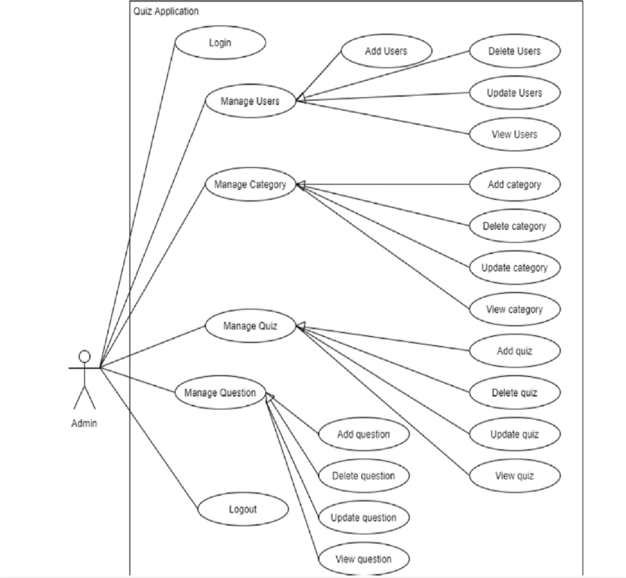

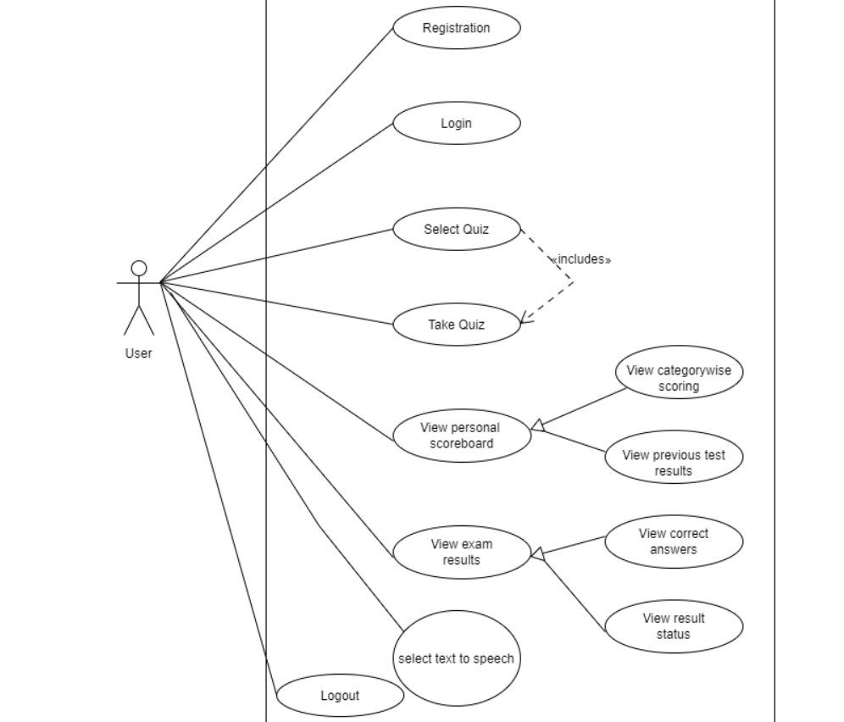

**4.2 Class Diagram**

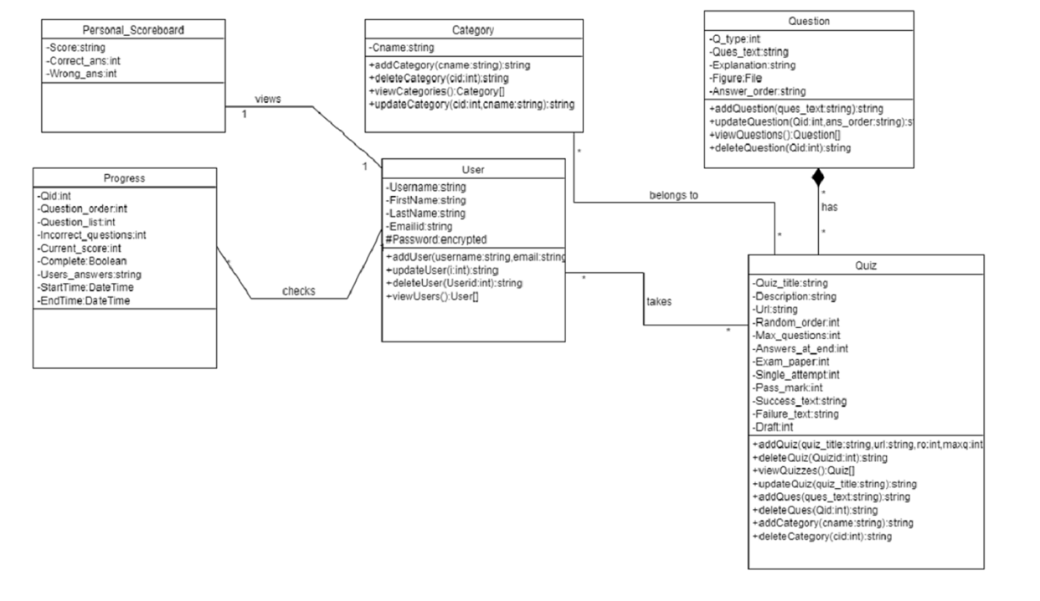

**4.3 Sequence Diagram**

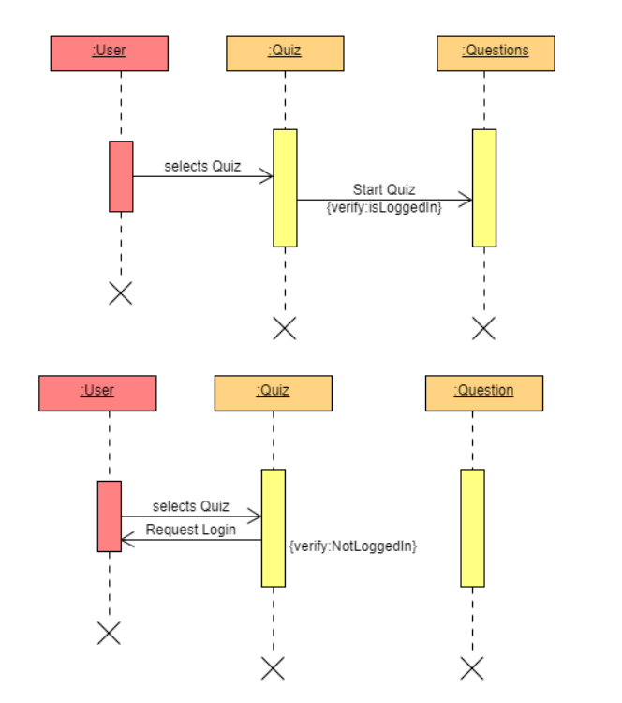

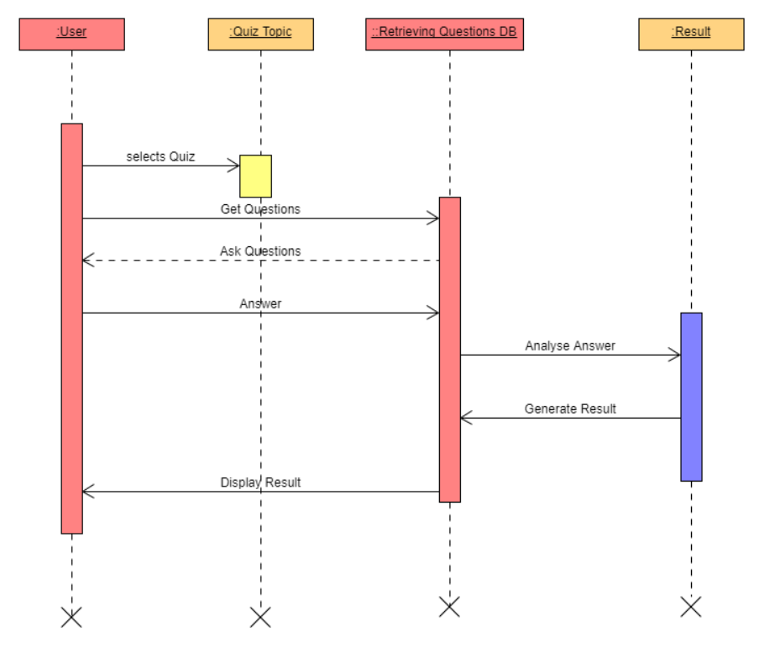

**4.4 Activity Diagram**

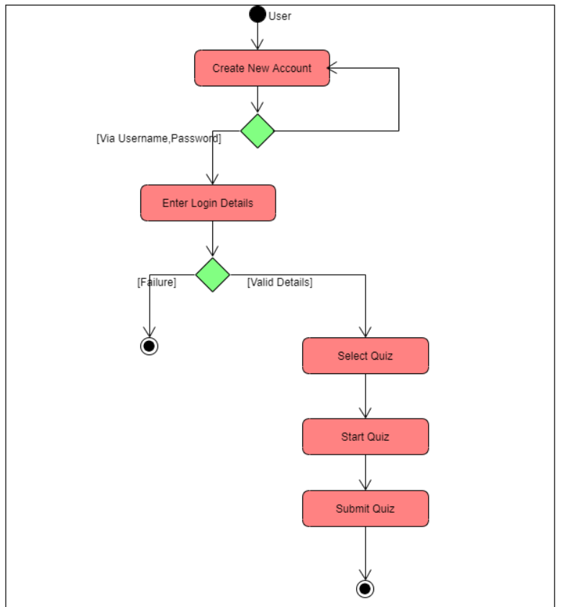

**4.5 State Diagram**

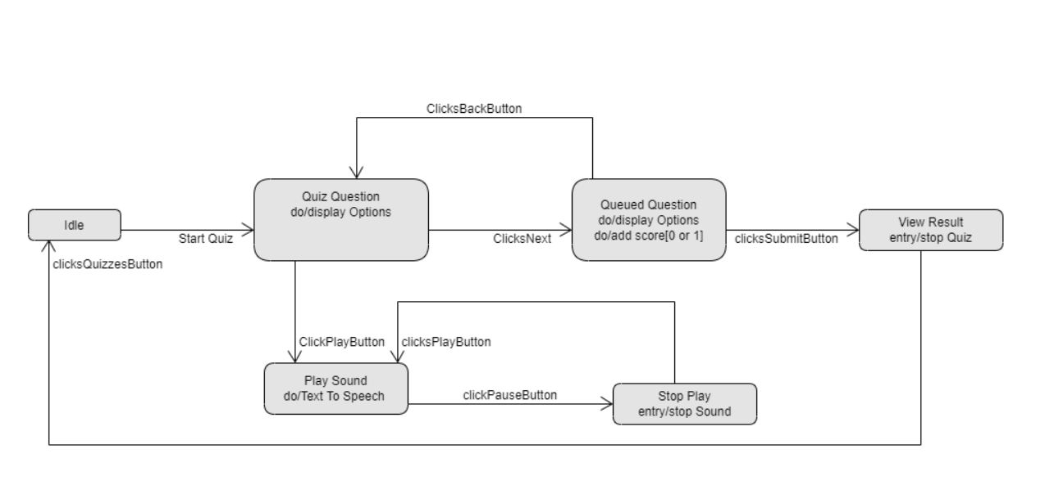

**4.6 ER-Diagram**

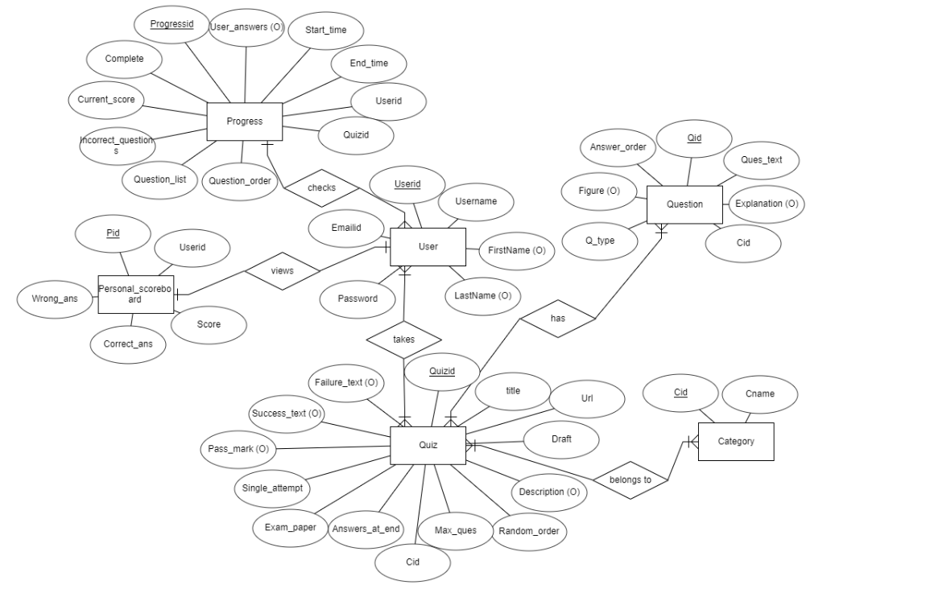

**4.7 DATA DICTIONERY:**

|  |  |  |  |  |  |  |  |
| --- | --- | --- | --- | --- | --- | --- | --- |
| **User** | | | | | | | |
| Sr. No. | Field Name | Data  Type | Width | Required | Unique | PK/FK | Referenced Table |
| 1 | UserId | Number | 20 | Yes | Yes | PK |  |
| 2 | Username | Varchar2 | 30 | Yes | Yes |  |  |
| 3 | FirstName | Varchar2 | 30 | No | No |  |  |
| 4 | LastName | Varchar2 | 30 | No | No |  |  |
| 5 | Password | Varchar2 | 15 | Yes | Yes |  |  |

|  |  |  |  |  |  |  |  |
| --- | --- | --- | --- | --- | --- | --- | --- |
| **Category** | | | | | | | |
| Sr. No. | Field Name | Data  Type | Width | Required | Unique | PK/FK | Referenced Table |
| 1 | Cid | Number | 20 | Yes | Yes | PK |  |
| 2 | Cname | Varchar2 | 30 | Yes | Yes |  |  |

|  |  |  |  |  |  |  |  |
| --- | --- | --- | --- | --- | --- | --- | --- |
| **Question** | | | | | | | |
| Sr. No. | Field Name | Data  Type | Width | Required | Unique | PK/FK | Referenced Table |
| 1 | Qid | Number | 20 | Yes | Yes | PK |  |
| 2 | Answer_order | Varchar2 | 10 | Yes | No |  |  |
| 3 | Explanation | Varchar2 | 100 | No | No |  |  |
| 4 | Cid | Number | 20 | Yes | No | FK | Category |
| 5 | Q_type | Number | 1 | Yes | No |  |  |
| 6 | Q_time | Number | 3 | No | No |  |  |
| 7 | Figure | File | - | No | No |  |  |

|  |  |  |  |  |  |  |  |
| --- | --- | --- | --- | --- | --- | --- | --- |
| **Personal scoreboard** | | | | | | | |
| Sr. No. | Field Name | Data  Type | Width | Required | Unique | PK/FK | Referenced Table |
| 1 | Pid | Number | 20 | Yes | Yes | PK |  |
| 2 | Userid | Number | 20 | Yes | Yes | FK | User |
| 3 | Score | Varchar2 | 100 | Yes | No |  |  |
| 4 | Correct_ans | Number | 100 | Yes | No |  |  |
| 5 | Wrong_ans | Number | 100 | Yes | No |  |  |

|  |  |  |  |  |  |  |  |
| --- | --- | --- | --- | --- | --- | --- | --- |
| **Quiz** | | | | | | | |
| Sr. No. | Field Name | Data  Type | Width | Required | Unique | PK/FK | Referenced Table |
| 1 | Qid | Number | 20 | Yes | Yes | PK |  |
| 2 | Cid | Number | 20 | Yes | Yes | FK | Category |
| 3 | Quiz_Title | Varchar2 | 15 | Yes | No |  |  |
| 4 | Description | Varchar2 | 100 | No | No |  |  |
| 5 | Url | Varchar2 | 15 | Yes | No |  |  |
| 6 | Random_Order | Number | 2 | Yes | No |  |  |
| 7 | Max_Questions | Number | 2 | No | No |  |  |
| 8 | Single_attempt | Number | 2 | Yes | No |  |  |
| 9 | Pass_mark | Number | 99 | No | No |  |  |
| 10 | Success_text | Varchar2 | 100 | No | No |  |  |
| 11 | Failure_text | Varchar2 | 100 | No | No |  |  |

|  |  |  |  |  |  |  |  |
| --- | --- | --- | --- | --- | --- | --- | --- |
| **Progress** | | | | | | | |
| Sr. No. | Field Name | Data  Type | Width | Required | Unique | PK/FK | Referenced Table |
| 1 | Progressid | Number | 20 | Yes | Yes | PK |  |
| 2 | Userid | Number | 20 | Yes | Yes | FK | User |
| 3 | Qid | Number | 20 | Yes | Yes | FK |  |
| 4 | Question_order | Number | 1024 | Yes | No |  |  |
| 5 | Question_list | Number | 1024 | Yes | No |  |  |
| 6 | Incorrect_questions | Number | 1024 | Yes | No |  |  |
| 7 | Current_score | Number | 1 | Yes | No |  |  |
| 8 | Complete | Boolean | 1 | Yes | No |  |  |
| 9 | User_answers | Varchar2 | 100 | No | No |  |  |
| 10 | Start | DateTime | - | Yes | No |  |  |
| 11 | End | DateTime | - | Yes | No |  |  |

**5. IMPLEMENTATION DETAILS**

**5.1 Modules Description**

**Registration module**

This module is used to store user's data to the database and enables

the user to login to the system. All the fields in system module contains required validations. User can also navigate to login page if he/she has already registered

**Login module**

This module takes user credentials and then verifies it with

registered users, if user is not registered the invalid credentials is

shown else if they match with database then login user.

**Quizzes module**

The user is given list of quizzes available and then user selects a quiz and random set of a quiz is generated and random questions of that set is shown to the user. As a set is completed randomly next set is taken and so on. The start time and end time of the quiz is also stored. Similarly Remarks are provided on each question on the basis of time taken and minimum time provided by the admin for that specific question.

**Text to Speech module**

As the questions are generated, Users are given option to Play, Pause and Stop to convert text to speech. In this way, Question as well as options are spoken using GTTS protocol.

**Admin module**

This module is accessed only by Admin. It provides Admin to view

User details with all the details and update, delete and add the users. It also provides Admin to Create a Category , Create a Quiz and Add Questions and options and correct answer associated with it.

Also the Admin should define Question type which indicates hardness of the question as well as question time allotted to each question for indicating the remarks.

Input: User Selection

Output: Corresponding response

**6]Testing**

We have performed black box testing for this system.

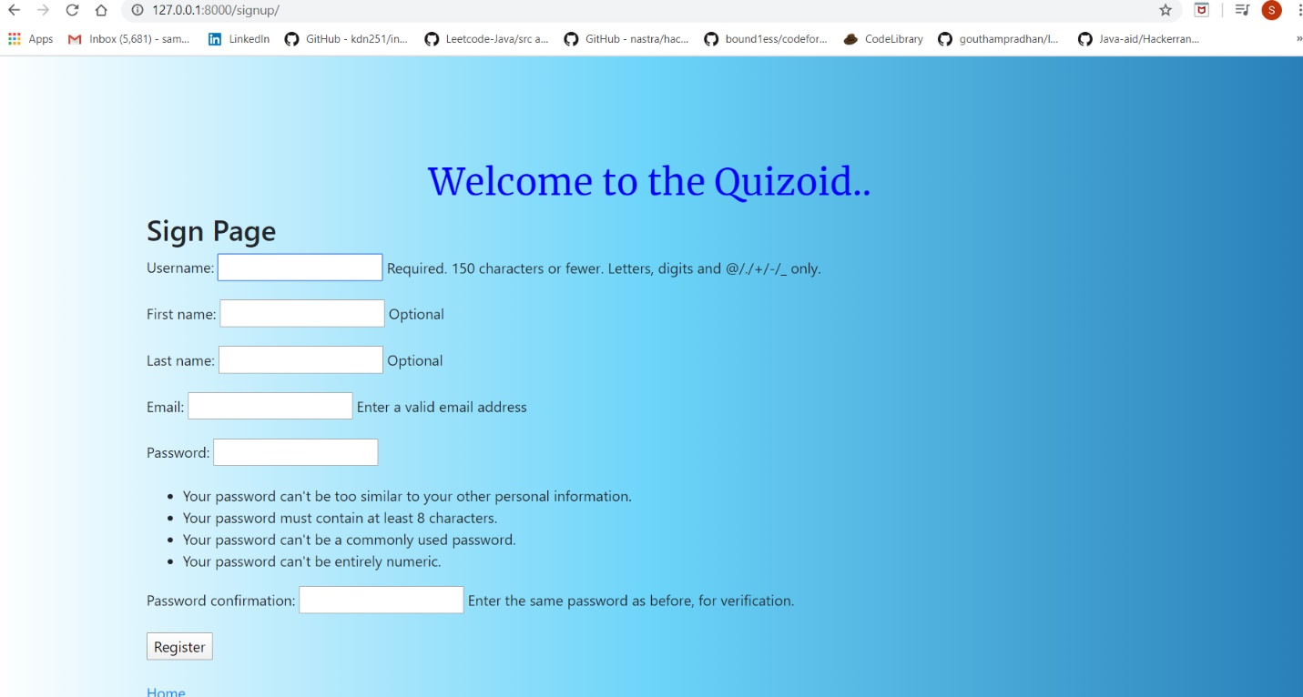

The user should provide proper credentials otherwise he/she will not be able to register in the system.

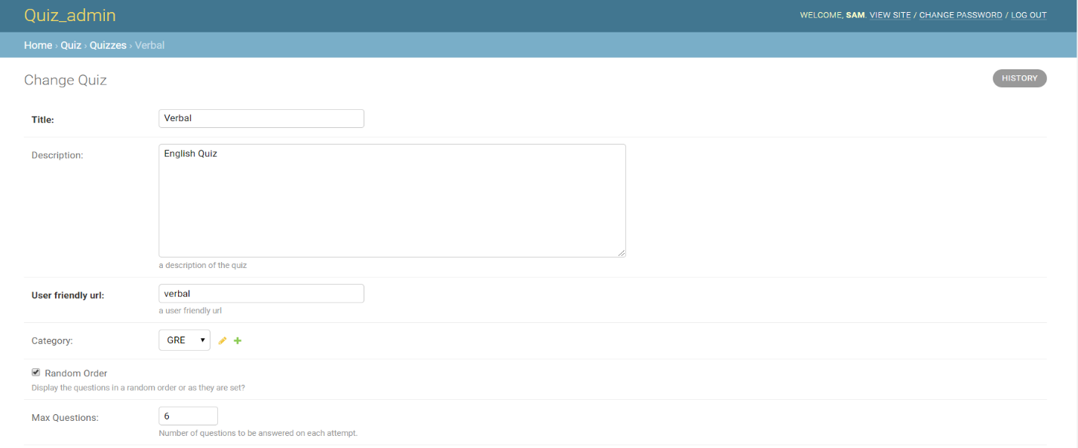

Max questions provided by admin will only be seen and not all the questions linked by admin while creating questions.

**7] Screenshots**

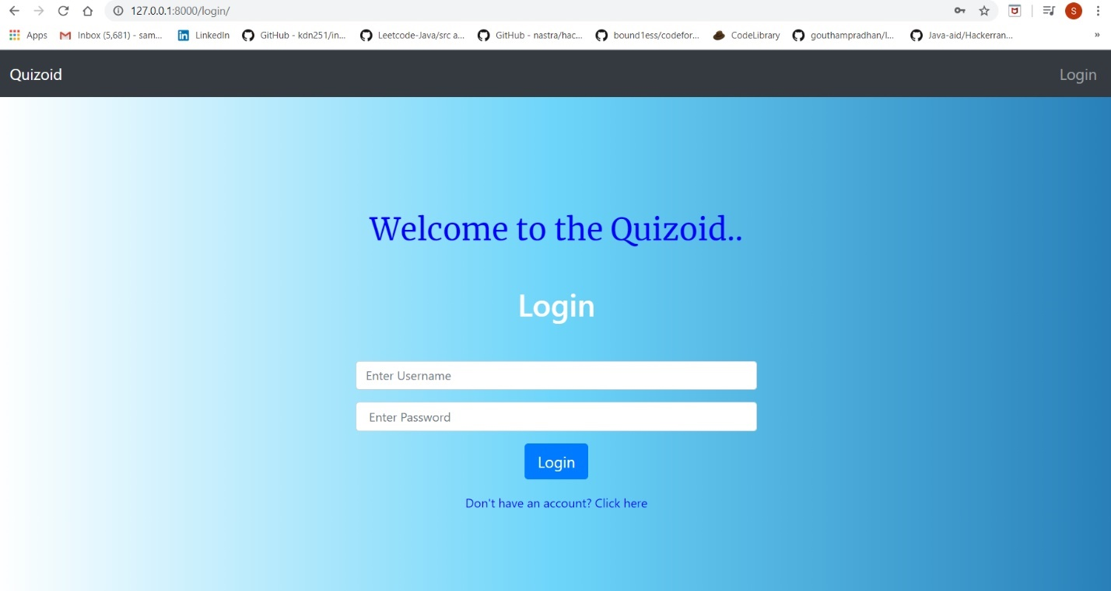

[The Home page which shows Login and gives option to register if not.]

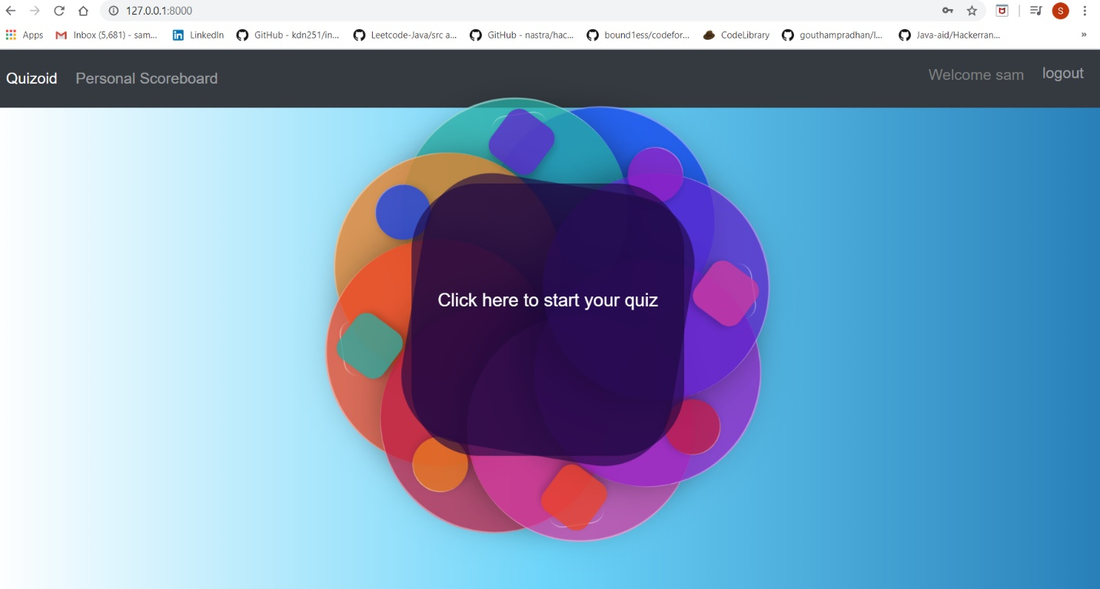

[Account page of the User after log in.]

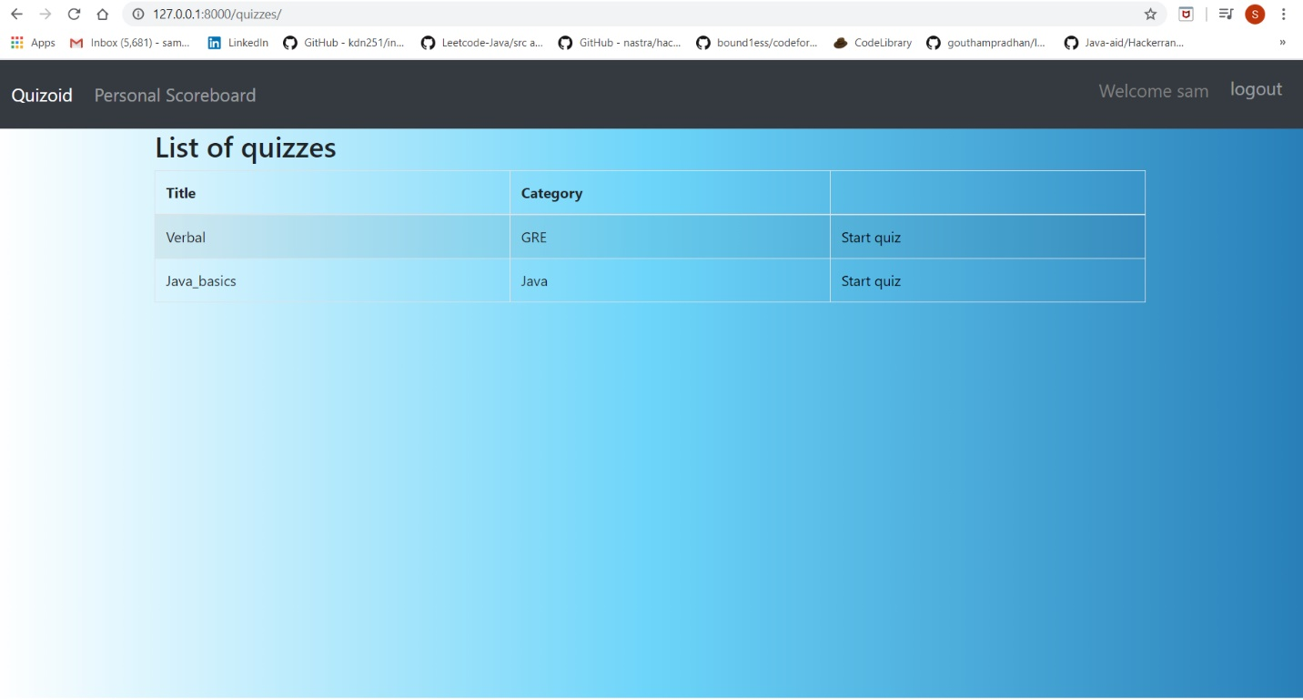

[List of Quizzes Available.]

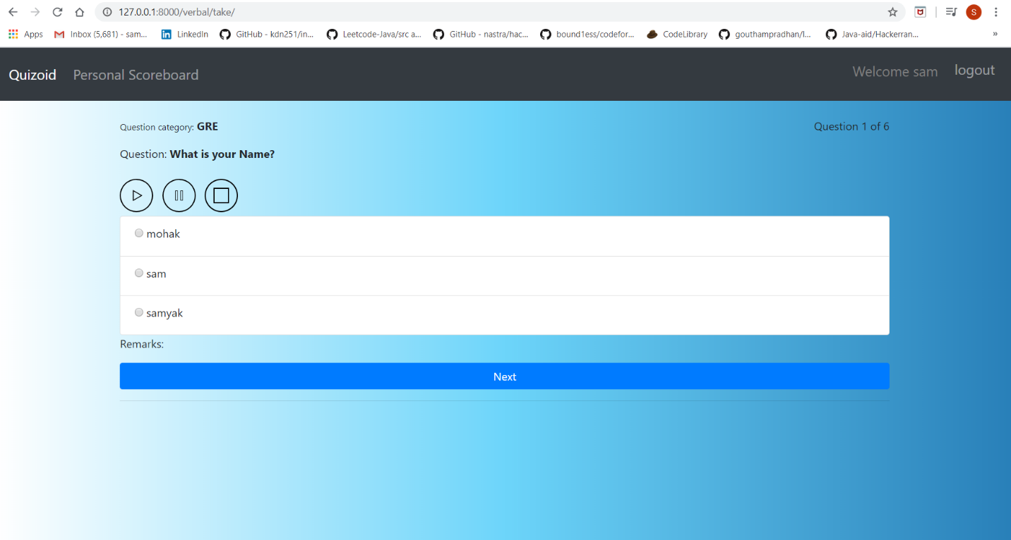

[Start of the quiz. Questions are generated.]

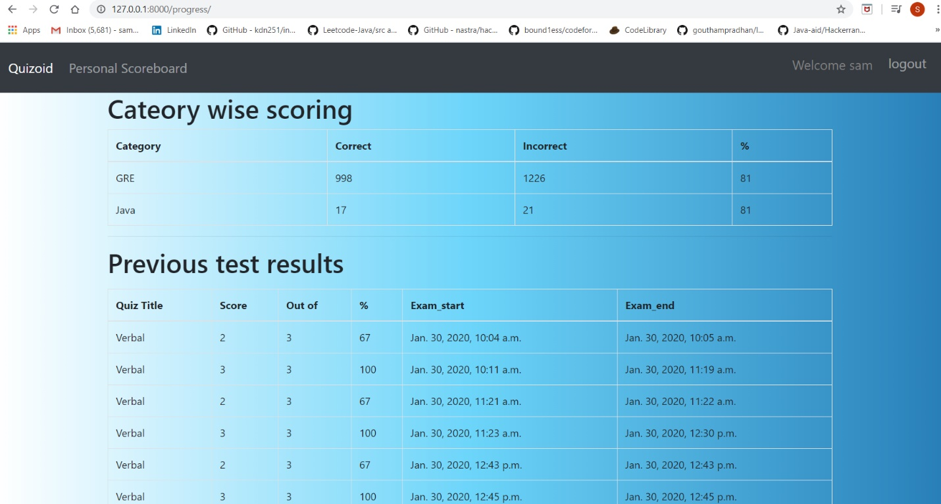

[Personal Scorecard of quizzes is also shown]

**8]Conclusion**

* User Registration containing all the necessary validations on fields.
* Login
* User Authentication
* Session Management
* Quiz_List
* Quiz_take
* Progress report after every quiz
* Personal History
* Text to speech
* Remarks based on time taken for each question

• Admin Add, update, Delete user

• Admin Add Category, Quiz and Questions.

After Implementation the whole application was tested with different validations and then have tried the best to remove the loopholes and tried to complete most of the functionalities.

9] **Limitations**

* The website doesn’t allow to skip questions and user can leave the site and when it returns it shows from where user previously left.
* The user is not shown to navigate to different questions because questions are randomly set-wise generated.

**Functionalities not Implemented**

* Adaptive in a way is not implemented as quiz randomly selects the questions and all of it are stored in the database as soon as the quiz starts.
* Secure login using face recognition to check that same person is giving the test.

**Future Extension**

* Making the quiz dynamic based on user’ answers.
* Multiple language support for speech.
* Countdown timer.
* Live camera facility for detecting that user don’t cheat.

**10] Bibliography**

1. <https://docs.djangoproject.com/en/3.0/> for Django 3.0

2. <https://github.com/tomwalker> for basics of quiz application.