**Step1 :** Initial load

; 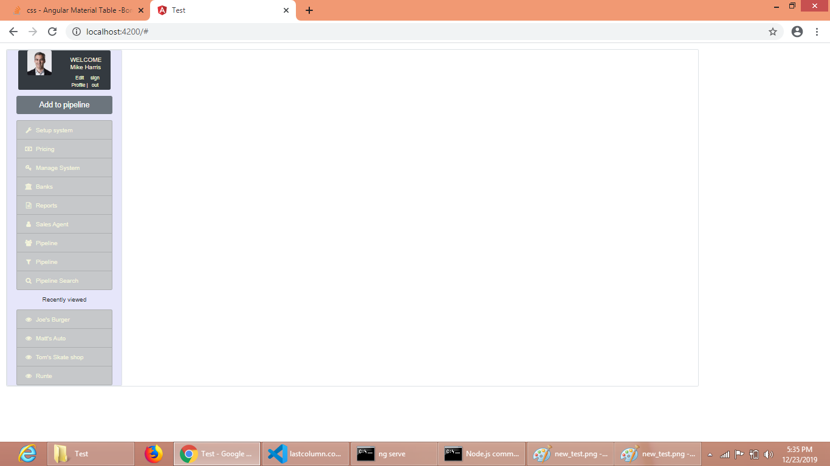

**Step2** : Menu “pipeline” selected

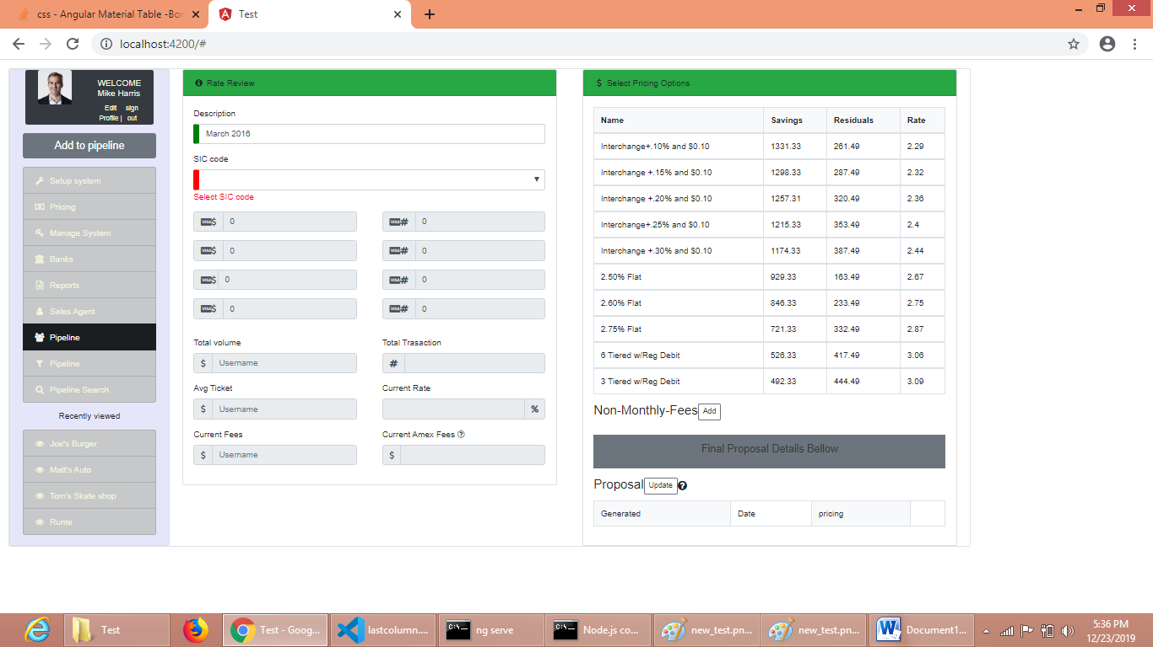

Note : Observe validation for SIC code.

**Step3**: Select SIC code

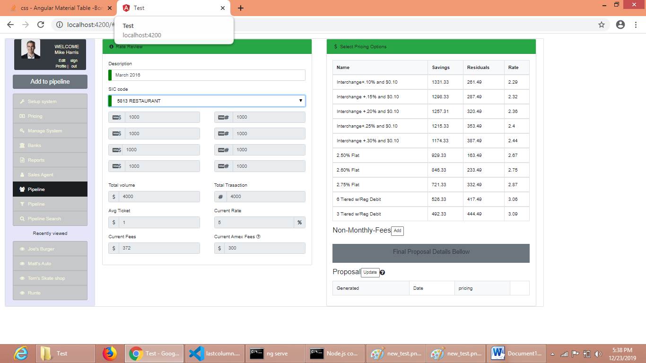

Note : Populated “Rate Review” values based on SIC code selection. Same data shown for all selections.

No other data-manipulation is included.

**Step4**: Hover over table

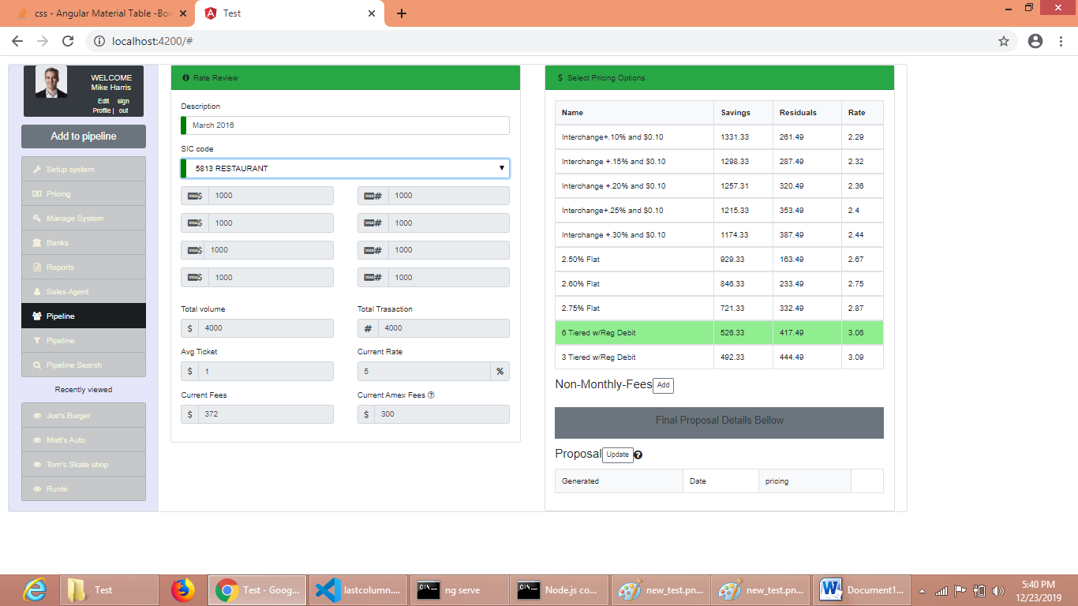

**Step5**: Loading “Final Proposal Details” values based on Pricing Option table row Selection. Values changes based on row selection.

