**Assignment 1:**

**Draw your Home Network Topology and explain how you are accessing the RPS Lab environment.**

Ans:

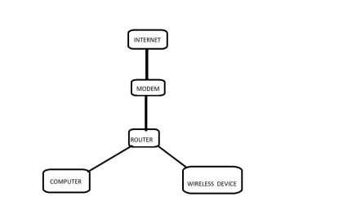Explanation:

**Internet:** This represents the external network, i.e., the internet.

**Modem:** This device connects your home network to the internet, usually provided by your Internet Service Provider (ISP). It may be a separate device or integrated into the router.

**Router:** The router connects multiple devices within your home network to the modem. It directs traffic between devices on your local network and the internet.

**PC:** A personal computer connected to the router via Ethernet cable.

**Wireless Devices:** These include smartphones, tablets, laptops, smart TVs, IoT devices, etc., connected to the router wirelessly through Wi-Fi.

This is a simple representation of a home network. Depending on the complexity of the network setup and the number of devices, additional components such as switches, access points, and network-attached storage (NAS) devices may be included.

**Assignment 2:**

**Identify a real-world application for both parallel computing and networked systems. Explain how these technologies are used and why they are important in that context.**

Ans: Real-World Application: Weather Forecasting

Parallel Computing:

Weather forecasting involves complex mathematical models that simulate the behavior of the atmosphere. These models require massive computational power to crunch through enormous amounts of data in a reasonable amount of time. Parallel computing is crucial in this context because it allows weather forecasting models to be broken down into smaller tasks that can be processed simultaneously by multiple processors or computers.

Parallel computing is used to divide the computational workload across a cluster of interconnected computers or a supercomputer. Each processor or node works on a subset of the data, performing calculations independently but collaboratively to produce a comprehensive weather forecast. This

significantly reduces the time required to generate forecasts, enabling meteorologists to provide timely and accurate predictions.

Networked Systems:

Weather forecasting also heavily relies on networked systems to gather real time data from various sources such as weather stations, satellites, radar systems, and ocean buoys. These systems continuously collect data on atmospheric conditions, including temperature, humidity, wind speed, and air pressure, from different geographical locations.

Networked systems facilitate the transmission of this data to central processing centers where it is ingested, processed, and integrated into weather forecasting models. By leveraging networks, meteorologists can access a vast array of data from diverse sources, enabling more comprehensive and accurate forecasts.

Importance:

Parallel computing and networked systems are critical in weather forecasting for several reasons:

Speed and Efficiency: Parallel computing accelerates the processing of complex weather models, allowing meteorologists to generate forecasts faster. This is crucial for providing timely warnings and preparing for extreme weather events.

Accuracy: By leveraging networked systems to gather data from multiple sources, weather forecasts can be based on a broader and more diverse dataset. This leads to more accurate predictions, improving public safety and resource allocation.

Scalability: The scalability of parallel computing and networked systems enables weather forecasting organizations to handle increasing volumes of data and computational tasks as technology advances and the demand for more detailed forecasts grows.

Resilience: Distributed computing architectures and redundant network connections enhance the resilience of weather forecasting systems against hardware failures, network disruptions, or other technical issues, ensuring continuous operation and availability of forecasts.

In summary, parallel computing and networked systems play integral roles in weather forecasting by enabling efficient processing of complex models and gathering real-time data from diverse sources. These technologies enhance the speed, accuracy, scalability, and resilience of weather forecasting systems, ultimately benefiting society by providing timely and reliable forecasts to mitigate the impacts of severe weather events.