**Assignment 1**

**Analyze a given business scenario and create an ER diagram that includes entities, relationships,**

**attributes, and cardinality. Ensure that the diagram reflects proper normalization up to the**

**third normal form**

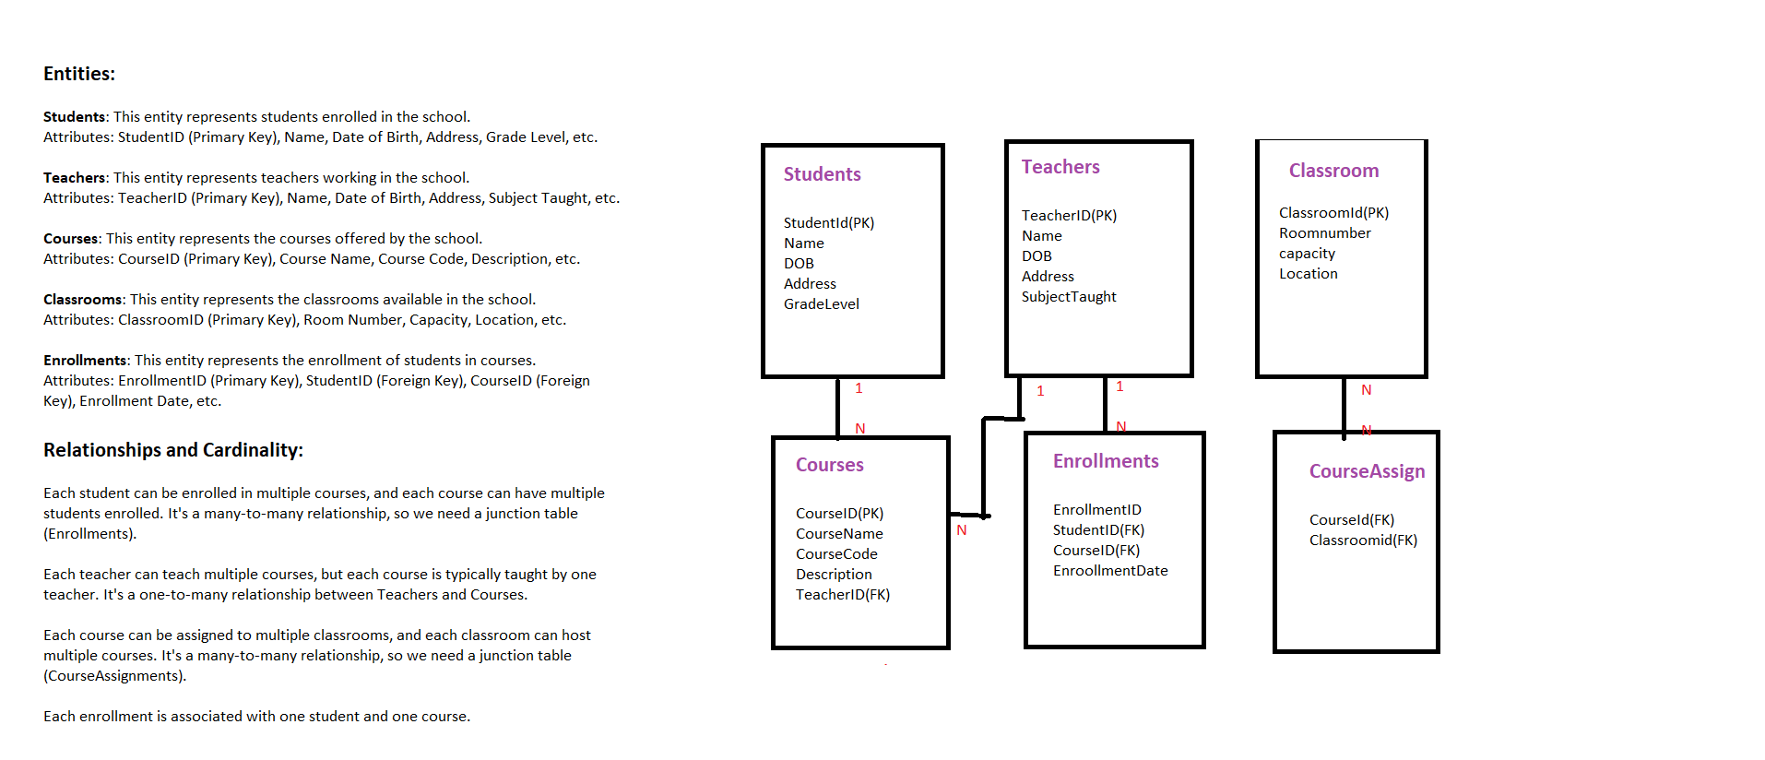

**Assignment 2: Design a database schema for a library system, including tables, fields, and constraints like NOT NULL, UNIQUE, and CHECK. Include primary and foreign keys to establish relationships between tables.**

**Tables:**

**1. Books**

**2. Authors**

**3. Members**

**4. BorrowingRecords**

**Fields and Constraints:**

**Books:**

**- book_id (Primary Key, NOT NULL)**

**- title (NOT NULL)**

**- isbn (UNIQUE, NOT NULL)**

**- publication_year (CHECK for valid year)**

**- genre**

**- total_copies (NOT NULL)**

**- available_copies (NOT NULL)**

**Authors:**

**- author_id (Primary Key, NOT NULL)**

**- author_name (NOT NULL)**

**- nationality**

**- birth_year**

**- death_year**

**- UNIQUE(author_name, nationality, birth_year) (to avoid duplicate authors)**

**Members:**

**- member_id (Primary Key, NOT NULL)**

**- member_name (NOT NULL)**

**- address**

**- email (UNIQUE, NOT NULL)**

**- phone_number**

**- registration_date (NOT NULL)**

**BorrowingRecords:**

**- record_id(Primary Key, NOT NULL)**

**- book_id (Foreign Key referencing Books.book_id, NOT NULL)**

**- member_id (Foreign Key referencing Members.member_id, NOT NULL)**

**- borrowing_date (NOT NULL)**

**- return_date**

**- due_date (NOT NULL)**

**\*Relationships:\***

**- One book can have multiple authors (One-to-Many relationship between Books and Authors).**

**- One member can borrow multiple books, and one book can be borrowed by multiple members (Many-**

**to-Many relationship between Members and Books through BorrowingRecords).**

**This schema ensures data integrity by enforcing constraints such as NOT NULL, UNIQUE, and CHECK.**

**Primary and foreign keys establish relationships between tables. Additionally, the schema supports**

**normalization by separating entities into distinct tables and avoiding data redundancy.**