Project Report

AI-Powered Medical Note-taking
Application



Course : ISBA 2410 Information Systems Analysis and Design
Under the Guidance of : Prof. Xiang (Shawn) Wan
Team : Ankita Dhekane | Emily Ros | Himanshu Jangra | Kush Shah | Oliver Gonsalves | Riya Koduru | Trupti Lone
Group : Group 2
Leavey School of Business, Santa Clara University
December 2025

Step 1.1: Define the App Based on a Trigger PointExplanation:
The application is being developed to resolve a significant operational and clinical problem in healthcare: doctors spend a substantial amount of time documenting patient encounters, which reduces the time available for direct patient care. Manual note-taking leads to delays, inconsistencies, incomplete records, and increased physician burnout. The proposed system addresses these issues by automating clinical documentation and improving accuracy, efficiency, and workflow.

Step 1.2: System Vision Document

1. Problem Description
Physicians in clinical environments face a heavy administrative burden due to manual documentation requirements. On average, doctors spend 40–60% of their time creating and updating clinical notes, which reduces the time available for meaningful patient interaction. Manual note-taking during consultations often leads to missed details, inconsistent documentation, delayed updates, and billing inaccuracies. In addition, typing while interacting with patients lowers engagement and can affect the quality of care. These inefficiencies contribute to physician burnout and negatively impact the accuracy, timeliness, and completeness of patient records. There is a clear need for an automated system that streamlines documentation while maintaining clinical accuracy and improving provider productivity.

2. System Capabilities
The proposed AI-powered medical note-taking system will include the following core capabilities:

a. Patient Profile and History Management
- Retrieve and display patient demographics, medical history, past visits, medications, allergies, and relevant background information.
- Provide a unified, structured view for easy reference during clinical encounters.

b. Clinical Visit Conversation Capture
- Record doctor–patient conversations during appointments.
- Convert captured audio into text using speech-to-text technology.
- Distinguish between patient and doctor speech and display the transcript in a dedicated consultation section.

c. Automated Structured Note Generation
- Analyze transcripts using medical NLP to extract key clinical details.
- Separate patient narratives (symptoms, concerns, history) from doctor assessment and plan (assessment, diagnosis, plan).
- Generate structured notes such as: Patient Narrative, Doctor Assessment and Plan, Visit Summary.

d. Post-Visit Documentation Tools
- Provide a scribble pad for free-form text entry.
- Capture and transcribe voice narration for supplementary notes.
- Allow physicians to edit, refine, and finalize visit notes.

e. Dashboard and Analytics
- Display aggregated insights including: visit history, diagnoses, follow-up timelines.
- Provide doctors and clinics with a visual summary of patient care patterns and workload.

3. Business Benefits

a. Increased Efficiency and Productivity
- Reduces time spent on manual documentation, allowing doctors to accommodate more patients.

b. Improved Documentation Accuracy
- Minimizes errors and missing information by capturing full conversations.
- Produces consistent, standardized notes aligned with clinical formats.

c. Enhanced Patient Experience
- Allows physicians to give full attention to the patient without typing interruptions.
- Improves communication, empathy, and trust during consultations.

d. Reduced Physician Burnout
- Decreases administrative workload, helping improve job satisfaction and work–life balance.

e. Better Clinical and Operational Decisions
- Dashboards provide insights that help clinics track follow-ups, identify trends, and improve overall patient management.

Step 2.1: Generate User Stories (minimal 10)
User Story ID | User Role | User Story
US-01 | Doctor | As a doctor, I want to view a patient’s medical history, previous visits, medications, and allergies so that I have complete context before and during the consultation.
US-02 | Doctor | As a doctor, I want the system to record my conversation with the patient so that I do not need to manually capture details during the visit.
US-03 | Doctor | As a doctor, I want the recorded audio to be converted into text so that I can easily review what was discussed.
US-04 | Doctor | As a doctor, I want the system to distinguish between my speech and the patient’s speech so that the transcript is organized and clear.
US-05 | Doctor | As a doctor, I want the system to automatically generate structured clinical notes from the conversation so that I can finalize documentation faster.
US-06 | Doctor | As a doctor, I want the generated notes to clearly separate what the patient reported from my assessment so that the information is easy to interpret.
US-07 | Doctor | As a doctor, I want to add additional notes or modifications after the visit using a scribble pad or free-text area so that I can refine the documentation.
US-08 | Doctor | As a doctor, I want to record short voice notes after the visit that the system will transcribe so that I can quickly add supplementary information.
US-09 | Doctor | As a doctor, I want to review, edit, and approve the generated notes so that the final documentation is accurate.
US-10 | Doctor | As a doctor, I want to view a dashboard summarizing key insights such as diagnoses, follow-ups, and visit history so that I can monitor patient trends and outstanding actions.
US-11 | Clinic Administrator | As a clinic administrator, I want to add or update patient demographic information so that records remain up to date.
US-12 | Clinic Administrator | As a clinic administrator, I want to view summaries of patient visits so that I can support clinical workflows and audits.
US-13 | Patient | As a patient, I want to be asked for consent before the system records my consultation so that my privacy and personal health information are protected.
US-13 | Patient | As a patient, I want to receive a summary of my visit so that I understand the diagnosis and follow-up actions.

Step 2.2: Based on the user story, generate Use Cases (minimal 10) and fully developed use case descriptions (minimal 1)

Use Cases :
 | Use Case | Brief Use Case Description
1. | View Patient Profile | Doctor views patient demographics, medical history, previous visits, medications, and allergies.
2. | Start Visit Session | Doctor opens a new visit record for a patient; system prepares to capture consultation data.
3. | Provide Recording Consent | Patient is informed about audio recording and either grants or denies consent; the system records the consent decision and only allows recording if consent is granted.
3. | Record Consultation | Doctor starts/stops audio recording during the visit; system securely stores the audio file.
4. | Transcribe Consultation | System converts recorded audio into text with speaker identification (doctor vs patient).
5. | Generate Structured Notes | System analyzes transcript and produces patient narrative, doctor assessment, and visit summary.
6. | Review & Edit Notes | Doctor reviews, modifies, and approves the automatically generated notes.
7. | Add Post-Visit Notes (keypad or Scribble Pad) | Doctor adds additional free-text notes after the visit for clarifications or follow-up details.
8. | Add Voice Narration | Doctor records short voice notes post-visit; system transcribes and appends them to the visit record.
9. | View Dashboard | Doctor views insights such as visit history, common diagnoses, follow-up reminders, and trends.
10. | Search Past Visits | Doctor searches and retrieves previous visit notes to review historical assessments and progress.
11. | Manage Patient Records (Admin) | Clinic administrator adds or updates patient demographic information (contact, address, etc.).
12. | View Visit Summaries (Admin) | Clinic administrator views visit summaries to support audits, compliance, and workflow reviews.
13. | View Visit Summaries (Patient) | Patient views the visit summary with diagnosis, treatment plan, and follow-up instructions.

Fully developed use case description :
a. Below is fully developed use case description for Use case 4: Record Consultation

Field | Description
Use Case Name: | Record Consultation
Scenario: | Capture the doctor–patient conversation during a clinical visit.
Triggering Event: | The doctor starts recording during an active patient visit.
Brief Description: | The doctor initiates audio recording during a consultation. The system captures the conversation, shows a recording indicator, and stores the audio securely under the patient’s active visit record. When the doctor stops the recording, the system saves the audio file and confirms successful upload. If there are any issues (e.g., microphone not available), the system notifies the doctor.
Actors: | Doctor (primary), System (supporting)
Related Use Cases : | Start Visit Session, Transcribe Consultation
Stakeholders: | Doctor : Wants hands-free documentation.  Patient : Expects transparency and privacy protection.  Clinic Administration : Requires secure and compliant storage of audio files.
Preconditions: | - Doctor is logged into the system.  - A patient visit session has been started.  - The device microphone is available and permission granted.  - The patient has provided consent for recording.
Postconditions: | - The audio file of the consultation is captured and stored securely.  - The recording is linked to the correct visit record.  - System confirms successful recording.
Flow of Activities: | Actor (Doctor) |  |  | System
 | - Opens patient visit session.
 | - Selects “Start Recording.” |  |  | 2.1 Activates microphone and begins recording.
 | - Conducts conversation with the patient. |  |  | 3.1 Continues recording audio.
 | - Selects “Stop Recording.” |  |  | 4.1 Stops recording.
 |  |  |  | 4.2 Saves audio file securely.
 |  |  |  | 4.3 Links audio file to visit record.
 | 5. View confirmation message. |  |  | 4.4 Sends “Recording saved successfully” message.
Exception Conditions: | Exception Condition  2 or 2.1 Microphone Permission Denied : System shows an error, requests microphone permission, recording does not start.  2 Microphone Hardware Not Found : System prevents recording, shows “Microphone not detected.”  4.2 Low Storage or Network Failure During Save : System displays warning, retries upload; if still failing, alerts doctor.  3 or 4 Doctor forgets to stop recording : System auto-stops after max duration (e.g., 60 minutes) and moves to step 4.2 automatically.  2.1 - 4.1 System crash during recording : System attempts to recover partial audio, notifies doctor upon restart.

b. Below is fully developed use case description for Use case 6: Review & Edit Notes

Field | Description
Use Case Name: | Review & Edit Notes
Scenario: | The doctor reviews AI-generated structured notes for a visit, edits them if needed, and finalizes the documentation.
Triggering Event: | The doctor selects “Review Notes” for a completed or transcribed visit.
Brief Description: | After structured notes are generated, the doctor opens the note for review. The system displays sections such as patient narrative, doctor assessment, and visit summary. The doctor can edit any field, add clarifications, or append additional information. Once satisfied, the doctor saves or approves the note, and the system marks it as the final version for that visit.
Actors: | Doctor (primary), System (supporting)
Related Use Cases : | Generate Structured Notes
Stakeholders: | Doctor : Wants accurate, editable notes that still save time compared to typing everything.  Patient : Benefits from clear and complete documentation of the visit. Clinic Administration : Needs finalized, high-quality notes for coding, billing, and audits.
Preconditions: | 1. Doctor is logged into the system.  2. A Visit record exists and has at least one draft Structured Note generated from transcription or manual entry.  3. Doctor has permission to edit notes for that visit.
Postconditions: | 1. Updated notes are saved and linked to the correct visit.  2. Note status is set to Draft or Final, depending on the doctor’s action.  3. A version history or timestamp is maintained for audit purposes.
Flow of Activities: | Actor (Doctor) |  |  | System
 | - Selects “Review Notes” for a specific visit. |  |  | 1.1 Retrieves the current StructuredNote for that visit (including sections like patient narrative, assessment, and summary)
 |  |  |  | 1.2 Displays the note in an editable form.
 | - Reads through the generated notes.
 | - Edits text in any section (e.g., corrects symptoms, updates assessment, modifies plan). |  |  | 3.1 Captures changes in the note fields in real time (or as a draft).
 | - Clicks “Save as Draft” or “Approve / Finalize Notes.” |  |  | 4.1 If Save as Draft: updates the structured note and sets status = “Draft.”
 |  |  |  | 4.2 If Approve / Finalize: saves edits, sets status = “Final,” and locks the note from further changes (Read only mode).
 | - Views confirmation. |  |  | 5.1 Displays a confirmation message such as “Notes saved successfully”.
Exception Conditions: | 1.1 No structured note exists for the visit : Shows message “No notes available yet. Please generate structured notes or create a new note”.  3 Network or save failure while editing : Displays error “Unable to save changes and attempts retry; if still failing, prompts doctor to copy content locally.  4.2 Doctor tries to edit a finalized note without permission : Prevents edits and shows This note is finalized. Create an addendum if you need to add more information.”

Step 2.3: Generate Use Case Diagrams (minimal 1) Use Case Diagram:
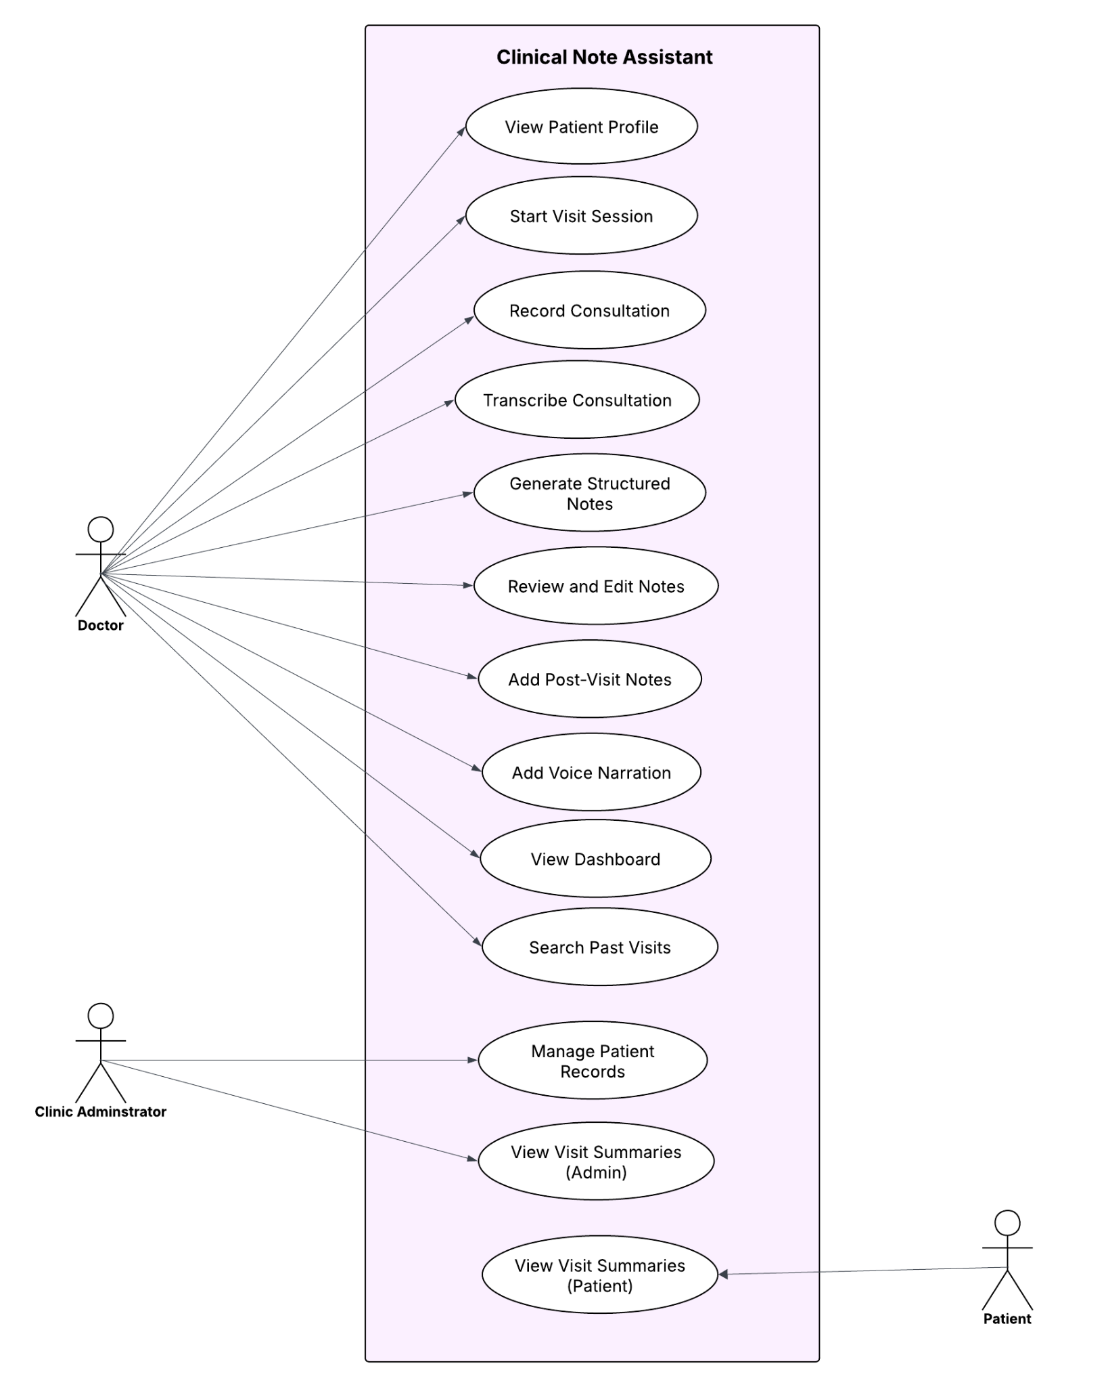
2.4: Generate Activity Diagrams (minimal 1) :
- Below activity diagram represents the combined flow of the following the flow of activities in the fully developed use case description for Use case 4: Record Consultation
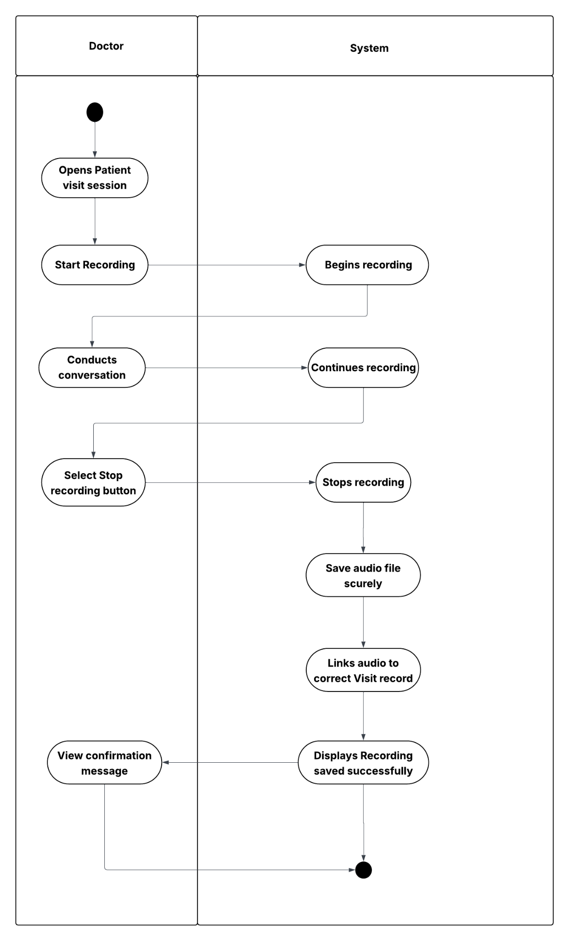
Fig. Activity Diagram

- Below activity diagram represents the combined flow of the following the flow of activities in the fully developed use case description for Use case 6: Review & Edit Notes
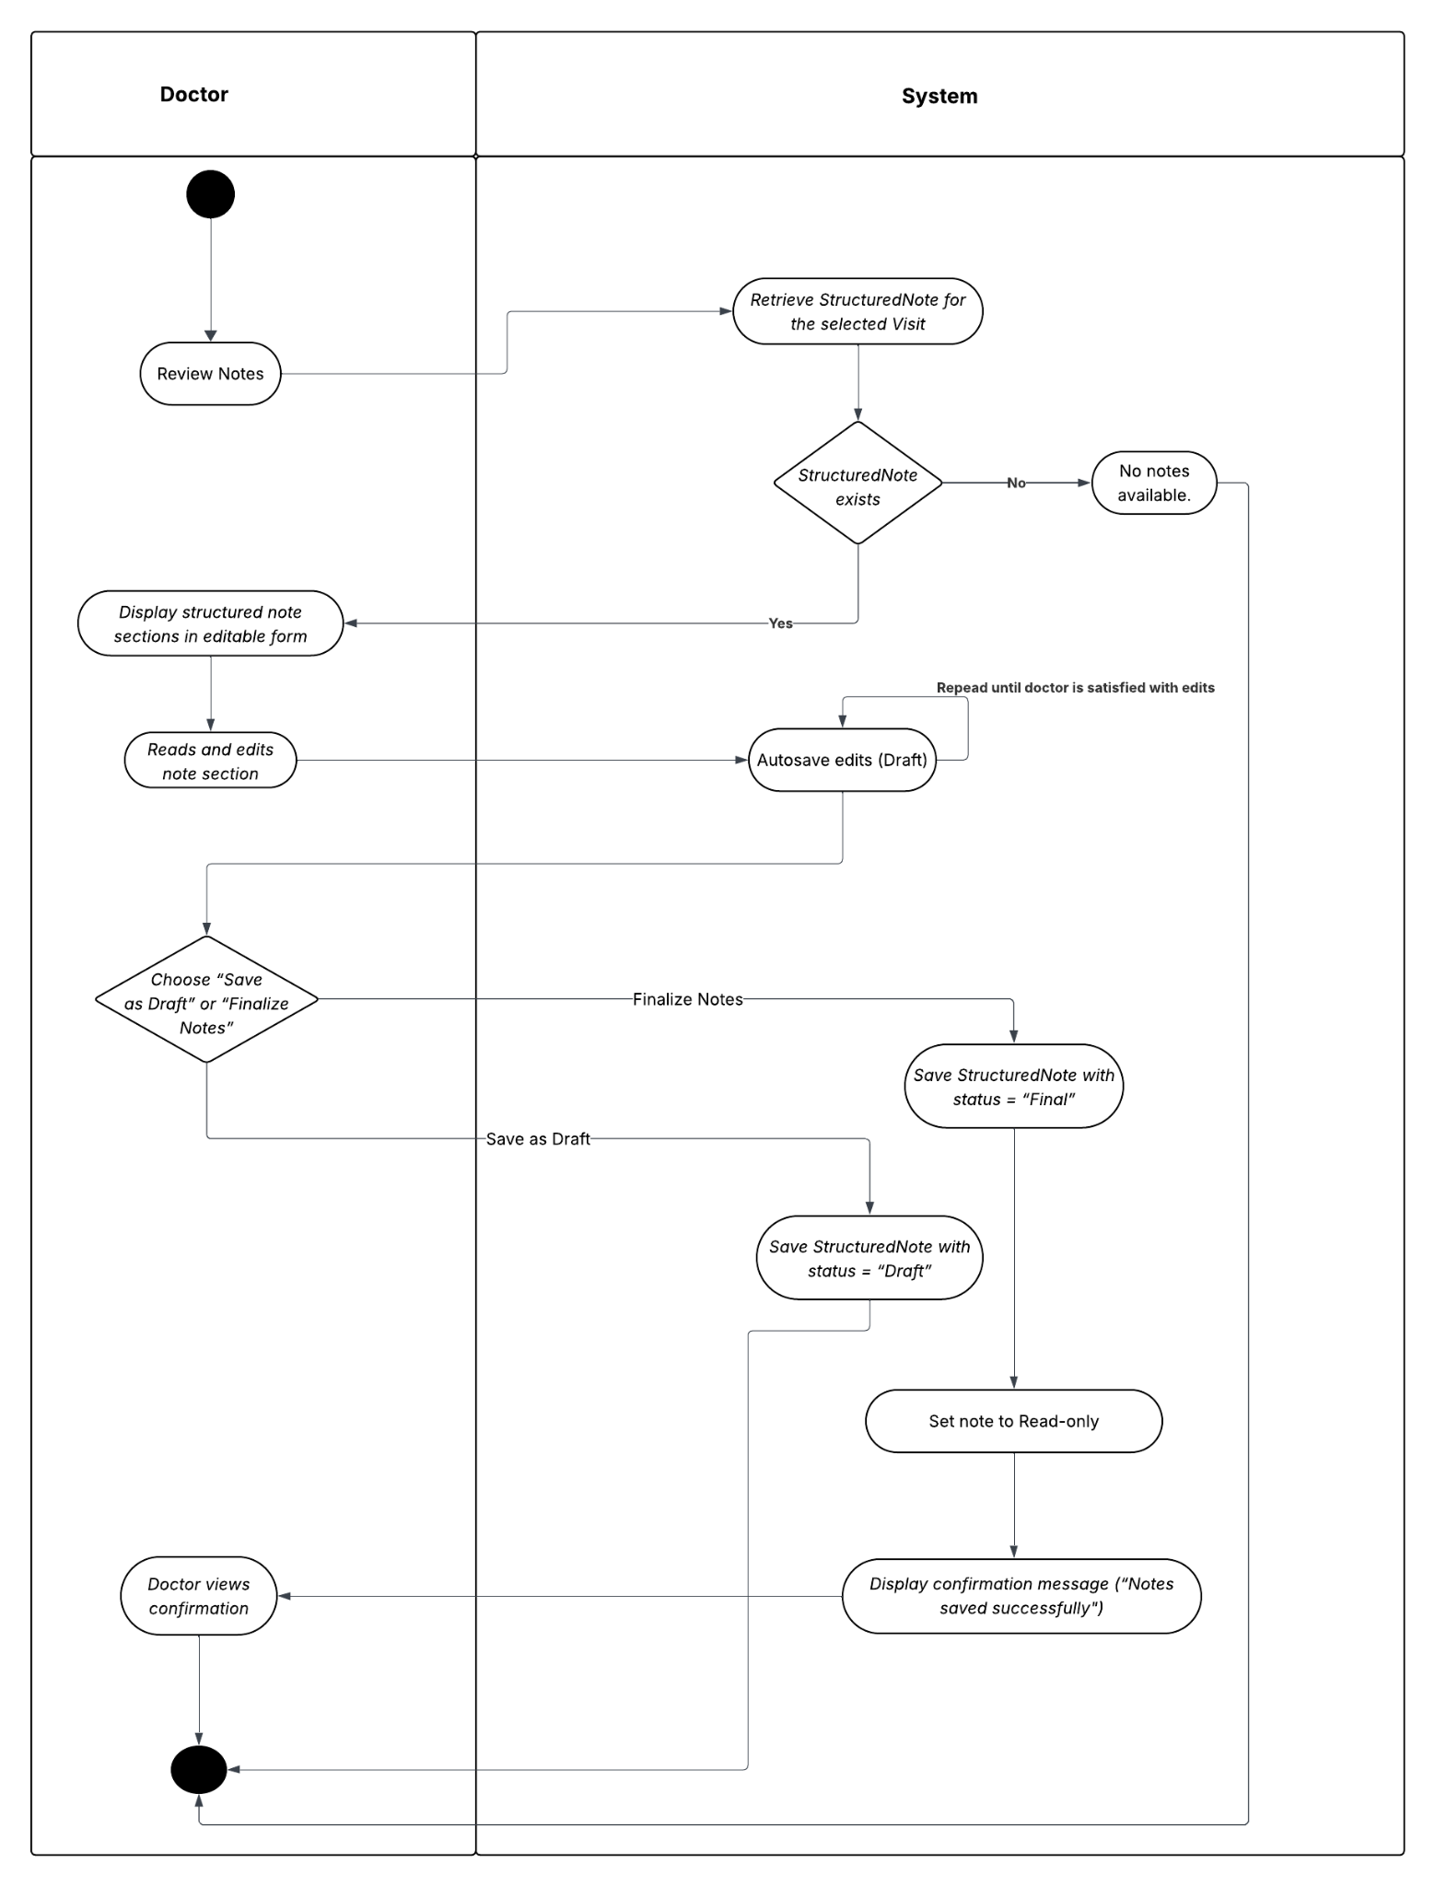
Fig. Activity Diagram
2.5: Generate System Sequence Diagrams (SSD) (minimal 1) :

SSD for the Consultation & Documentation Workflow
The SSD similarly depicts the system interactions for the Use case 4 : Record Consultation
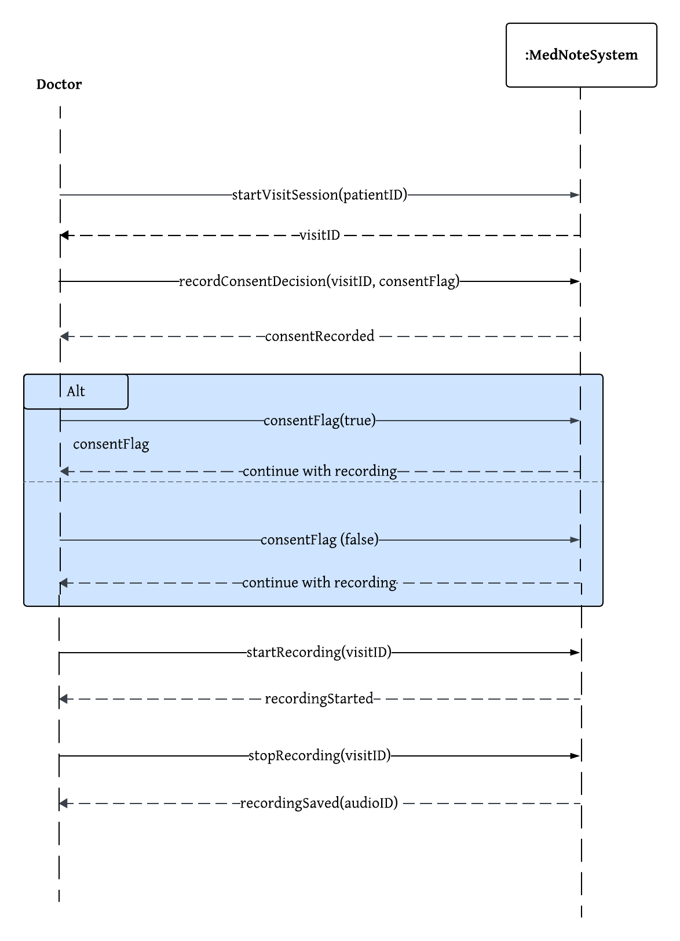
Fig. System Sequence Diagram
2.6 : Generate Domain Model Class Diagrams (minimal 1) :
This diagram shows the key data entities in our system and how they relate to each other.
- We start with a UserAccount, which is the parent for both Doctor and Admin.
This generalization allows us to reuse login and authentication for both roles while keeping their specific details separate.
- At the center is the Visit entity, which connects a Doctor and a Patient.
A doctor can have many visits, and a patient can also have many visits.
- Before recording, every visit must have a Consent entry linked to it.
- A Patient also has a MedicalProfile, which may include multiple Allergies and multiple Medications.
- All documentation generated during a visit is linked back to the Visit:
  - ConsultationRecording → the audio file
  - Transcript → text generated from the audio
  - StructuredNote → final organized clinical notes
  - ScribbleNote and VoiceNarration → optional extra notes added by the doctor
Overall, the diagram illustrates how users, visits, and all forms of documentation are connected, showing a full picture of the medical note-taking workflow.

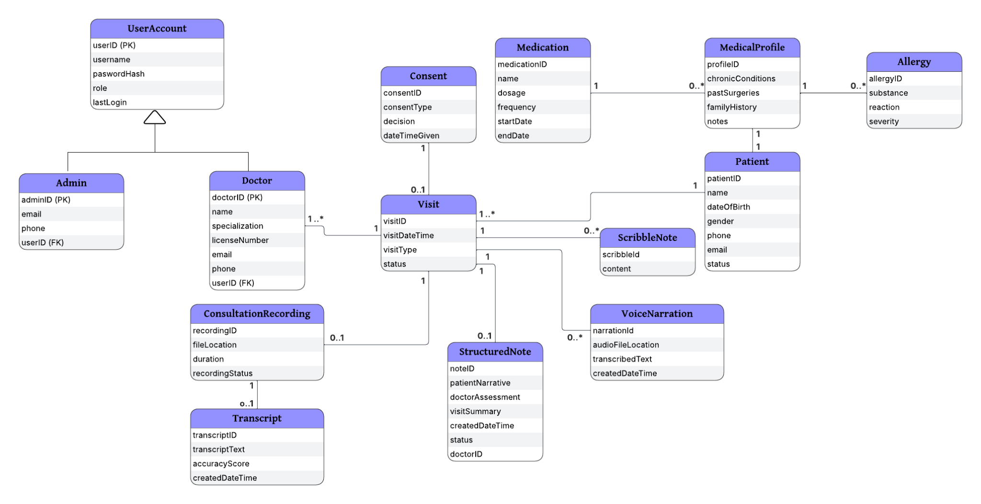
Fig. Domain Model Class Diagrams

2.7: Generate State Machine Diagrams (minimal 1) :
The state machine diagram models the lifecycle of the Visit domain class. All states such as VisitCreated, ConsentPending, Recording, Recorded, Transcribing, NotesDraft, and NotesFinal—represent changes in the status of a single Visit record. The Visit class is the central coordinating entity connected to ConsultationRecording, Transcript, StructuredNote, and Consent, which collectively support the transitions shown in the state machine.
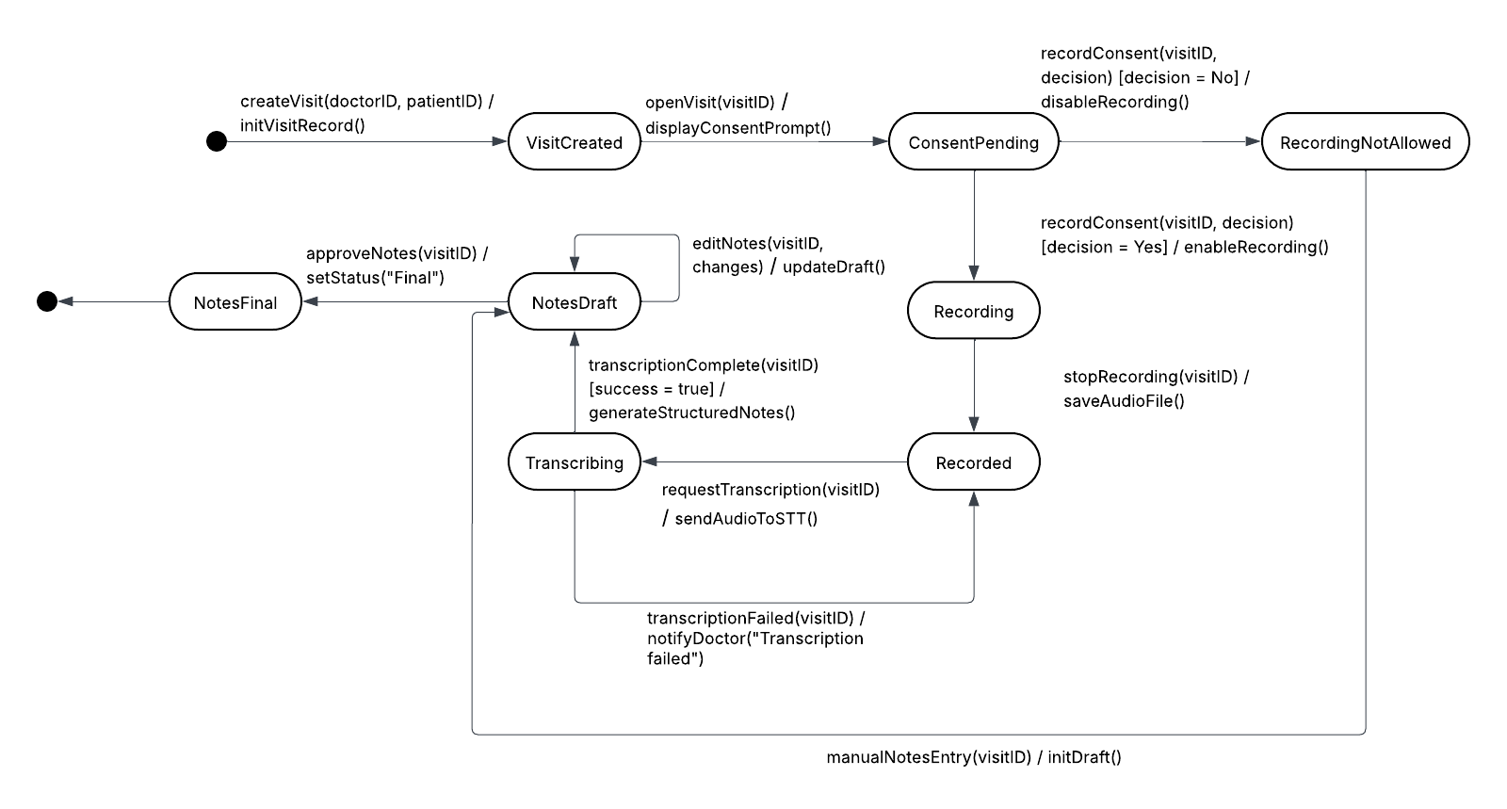
Fig. State Machine Diagrams
Overall, this diagram provides a clear sequence of how a visit progresses—from consent, to recording, to transcription, to final notes—capturing both normal workflow and error paths in a simple visual format.

Step 3.1: Build a Cost/Benefit Analysis chart (and state your assumptions)

1. Time Estimate for the Clinical Note Assistant Project

Subsystem Breakdown Based on Use Cases:
The subsystem breakdown estimates the total development effort required to build each functional component of the medical note-taking system. Each subsystem is associated with a set of use cases and is assigned an approximate effort in weeks. When these efforts are added together, the total project effort equals 40 weeks, assuming the work is completed sequentially by one team.

Subsystem | Functional Requirements (Use Cases) | Iterations Required | Estimated Time
Doctor Documentation Subsystem | 10 UCs (recording, transcription, structured notes, etc.) | 4 | 16 weeks
Patient Profile & Medical History Subsystem | 5 UCs | 2 | 8 weeks
Admin & Dashboard Subsystem | 4 UCs | 2 | 8 weeks
Total Development Time (1 team) | — | — | 32 weeks
Final Hardening & Acceptance Testing | — | 2 | 8 weeks
Total Project Time | — | — | 40 weeks (≈ 10 months)

2. Development Cost Estimate : Summary of Development Costs

Expense Category | Amount
Salaries/wages (PM + 6 devs/testers for 40 weeks) | $890,000
Equipment / Installation (laptops, cloud setup, STT/LLM integration tools) | $120,000
Training (HIPAA, secure coding, ML tools) | $40,000
Facilities (office, meeting rooms, utilities) | $50,000
Utilities (network, servers, electricity) | $30,000
Travel / Miscellaneous | $20,000
Licenses (STT/LLM dev licenses, API credits) | $25,000
Total Development Cost | $1,175,000

3. Estimated Annual Operating Costs :

Recurring Expense | Amount / Year
Connectivity / Hosting (AWS/GCP/Azure + storage of audio + transcripts) | $90,000
LLM + STT Usage (production-level inference costs) | $60,000
Maintenance Programming (1–2 developers) | $110,000
Help Desk / Support | $35,000
Total Annual Operating Cost | $295,000
4. Estimated Annual Tangible Benefits :
➤ Benefit 1: Reduced documentation time
Doctors save ~2 hours/day each.
Assume the clinic has 10 doctors.
- 2 hrs/day × 10 docs × 240 working days × $150/hr
= $720,000 annually saved
➤ Benefit 2: Reduced claim denial errors
Better notes → fewer insurance rejections → saves money.
Estimated: $110,000 annually
➤ Benefit 3: Faster billing cycle
Earlier submission → faster payment → reduced revenue leakage.
Estimated: $150,000 annually
➤ Benefit 4: Increased patient throughput
More time = more appointments.
If each doc sees 1 more patient/day @ $120 revenue × 10 docs × 240 days
= $288,000 annually
Total Annual Benefits = $1,268,000

5. 5-Year Cost/Benefit Spreadsheet (NPV + Payback Period+ROI+IRR)
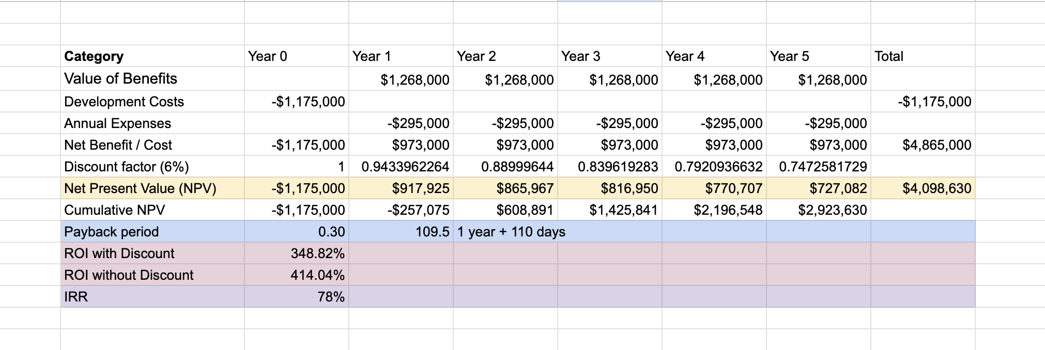
6. Assumptions (Mandatory Section)
General Assumptions
- Project duration is estimated at 40 weeks, including testing.
- The team consists of 1 PM, 1 Lead Developer, 2 Mobile Developers, 1 Backend Developer, 1 ML Engineer, 1 QA Tester.
- Salary estimations based on Bay Area averages.
- System lifespan considered 5 years.
- Discount rate of 6% is applied per university guidance.
Technical Assumptions
- Medical audio recorded at ~6 hours/day for 10 doctors.
- STT and LLM inference costs estimated using industry averages for enterprise API pricing.
- Hosting expected to use AWS/GCP with multi-region redundancy.
- Annual maintenance requires 1–2 FTEs.
Benefit Assumptions (tangible)
- Each doctor saves 2 hours/day from automated documentation.
- Improved note quality reduces claim denials by 20–30%.
- Throughput increases by 1 patient/day/doctor.
- Billing cycle improved by 1–3 days, increasing available working capital.
Step 3.2: Build a Project iteration schedule with a detailed task breakdown (need to consider
dependencies among tasks

The Work Breakdown Structure (WBS) decomposes the project into smaller, manageable tasks for each of the five Agile iterations. Each iteration includes planning, analysis, design, build, and testing activities. The WBS focuses on how the project will be executed and provides a clear roadmap for developers and stakeholders. The total timeline across all iterations is 20 weeks.

Iteration | Time Estimate | Use Cases Assigned to Iteration
1 | 4 weeks | 1. Start Visit Session  2. Capture Patient Consent  3. Record Consultation  4. Transcribe Consultation
2 | 4 weeks | 5. Generate Structured Notes  6. Review and Edit Notes  7. Add Post-Visit Notes (Scribble Pad)  8. Add Voice Narration
3 | 5 weeks | 9. View Dashboard  10. View Dashboard Analytics  11. Search Past Visits
4 | 4 weeks | 12. Manage Patient Records (Admin)  13. View Visit Summaries (Admin)  14. View Visit Summaries (Patient)
5 | 3 weeks | 15. System Integration  16. Final QA Testing  17. Harden System, tune database, deployment preparation
Total | 20 weeks

Step 3.3: Build a Work Breakdown Structure (WBS) :
The Work Breakdown Structure outlines how the project is divided into five structured iterations, each aligned with a specific subsystem and its related use cases. For every iteration, the work flows through a consistent lifecycle—planning, analysis, design, build, and testing—ensuring that requirements are understood before design begins, and development is validated through structured testing. This WBS provides a clear, phased roadmap for delivering core visit workflows, structured notes, dashboards, admin functions, and final system integration in an organized and manageable way.
Iteration 1 — Core Visit Workflow (Consent, Recording, Transcription)
Use Cases:
• Start Visit Session
• Capture Patient Consent
• Record Consultation
• Transcribe Consultation
I. Project Planning (0.5 day)
- Develop WBS for Iteration 1 – 0.25 day
- Build iteration schedule and assign work – 0.25 day
II. Analysis Tasks (4 days)
- Meet with doctors to understand visit workflow – 1 day
- Define consent requirements and compliance factors – 1 day
- Identify recording workflows and data fields (e.g., format, metadata) – 1 day
- Define transcription requirements and error-handling rules – 1 day
III. Design Tasks (3 days)
- Design Visit Session UI (start, pause, stop) – 1 day
- Design Consent Capture interface and validation logic – 1 day
- Define API workflows for recording → transcription – 1 day
IV. Build Tasks (10 days)
- Implement visit session creation – 1 day
- Build consent collection module – 2 days
- Build audio recording function – 3 days
- Integrate Speech-to-Text API and speaker ID – 2 days
- Build transcription pipeline and error handling – 2 days
V. Testing & Deployment Tasks (3 days)
- Prepare test scripts for recording and transcription – 1 day
- Conduct user acceptance testing with doctors – 1 day
- Release and stabilize Iteration 1 – 1 day
Iteration 2 — Structured Notes & Post-Visit Documentation
Use Cases:
• Generate Structured Notes
• Review & Edit Notes
• Add Post-Visit Notes (scribble pad)
• Add Voice Narration
I. Project Planning (0.5 day)
- Plan iteration tasks and assign responsibilities – 0.5 day
II. Analysis Tasks (3 days)
- Identify required note structure (SOAP, patient narrative, assessment) – 1 day
- Meet with clinical stakeholders to understand editing flow – 1 day
- Define scribble pad & voice narration requirements – 1 day
III. Design Tasks (4 days)
- Design note layout (sections for patient vs doctor narrative) – 1 day
- Create UI wireframes for note review and editing – 1 day
- Design scribble pad UI + handwriting storage logic – 1 day
- Design voice narration capture flow – 1 day
IV. Build Tasks (10 days)
- Implement note generation algorithm – 3 days
- Build Review/Edit Notes UI – 2 days
- Build scribble pad functionality – 2 days
- Build voice narration recording + STT integration – 3 days
V. Testing & Deployment (3 days)
- Internal QA on all note-related features – 1 day
- Physician testing & refinement – 1 day
- Release iteration and stabilize – 1 day
Iteration 3 — Dashboard, Analytics, Past Visit Search
Use Cases:
• View Dashboard
• View Dashboard Analytics
• Search Past Visits
I. Project Planning (0.5 day)
- Review previous iterations and define data needs – 0.5 day
II. Analysis Tasks (3 days)
- Define clinic KPIs (visit count, conditions, follow-ups) – 1 day
- Identify dashboard data sources – 1 day
- Define search filters for historical visits – 1 day
III. Design Tasks (3 days)
- Design dashboard UI layouts & charts – 1 day
- Define analytics aggregation logic – 1 day
- Design search results view – 1 day
IV. Build Tasks (10 days)
- Implement dashboard data API – 3 days
- Build analytics engine (aggregations, stats) – 3 days
- Build dashboard UI – 2 days
- Implement past visit search (filters + results) – 2 days
V. Testing & Deployment (3 days)
- QA for analytics accuracy – 1 day
- Doctor review and feedback – 1 day
- Release iteration – 1 day
Iteration 4 — Admin & Patient Functions
Use Cases:
• Manage Patient Records (Admin)
• View Visit Summaries (Admin)
• View Visit Summaries (Patient)
I. Project Planning (0.5 day)
- Confirm stakeholder requirements for admin and patient flows – 0.5 day
II. Analysis Tasks (3 days)
- Identify fields needed for patient record management – 1 day
- Define summary formats for admin vs patient – 1 day
- Meet with legal/compliance team (PHI access) – 1 day
III. Design Tasks (3 days)
- Design admin record management screens – 1 day
- Design summary view screens – 1 day
- Define authorization/permission boundaries – 1 day
IV. Build Tasks (10 days)
- Implement patient record CRUD – 4 days
- Build admin summary view – 2 days
- Build patient visit summary view – 2 days
- Implement permission checks – 2 days
V. Testing & Deployment (3 days)
- QA for admin and patient workflows – 1 day
- UAT with admin staff – 1 day
- Release iteration – 1 day
Iteration 5 — System Integration, QA & Final Hardening
Use Cases:
• Full system integration
• End-to-end testing
• Deployment preparation
I. Planning (0.5 day)
- Identify major risks and unresolved issues – 0.5 day
II. Integration Tasks (4 days)
- Integrate all modules: visit → notes → dashboard → admin – 2 days
- Validate API flows and fix inconsistencies – 2 days
III. Testing Tasks (5 days)
- Full regression suite – 2 days
- Load/performance testing – 1 day
- Security & access control testing – 1 day
- Fix defects – 1 day
IV. Deployment Preparation (3 days)
- Tune database & indexes – 1 day
- Prepare deployment scripts & documentation – 1 day
- Final acceptance testing & go-live approval – 1 day

The entire WBS covers approximately 19 weeks.

Step 3.4: Build a Project Network Diagram
The table summarizes all activities included in Iteration 1, along with their durations and task dependencies. Each activity is listed with a unique ID, a brief description, and the predecessor tasks that must be completed before it can begin. This structure helps clearly define how the work for this iteration is organized and how each task relates to the others.
ID | Task | Duration | Predecessor(s)
A1 | Develop WBS for Iteration 1 | 0.25 day | —
A2 | Build iteration schedule & assign work | 0.25 day | A1
B1 | Meet with doctors for workflow understanding | 1 day | A2
B2 | Define consent requirements | 1 day | B1
B3 | Identify recording workflows & metadata | 1 day | B2
B4 | Define transcription requirements | 1 day | B3
C1 | Design Visit Session UI | 1 day | B4
C2 | Design Consent Capture interface | 1 day | B4
C3 | Define API workflow for recording → transcription | 1 day | B4
D1 | Implement visit session creation | 1 day | C1
D2 | Build consent collection module | 2 days | C2
D3 | Build audio recording function | 3 days | C3
D4 | Integrate Speech-to-Text API & speaker ID | 2 days | D3
D5 | Build transcription pipeline | 2 days | D4
E1 | Prepare test scripts | 1 day | D5
E2 | Conduct UAT | 1 day | E1
E3 | Release & stabilize iteration | 1 day | E2

The corresponding PERT network diagram represents these same activities as nodes, using the durations shown in the table as each node’s estimated time. The diagram visually maps how tasks connect, where activities run in parallel, and how the overall workflow progresses through the iteration. It provides a clear overview of all tasks involved in Iteration 1 and how they collectively contribute to completing the core visit workflow.
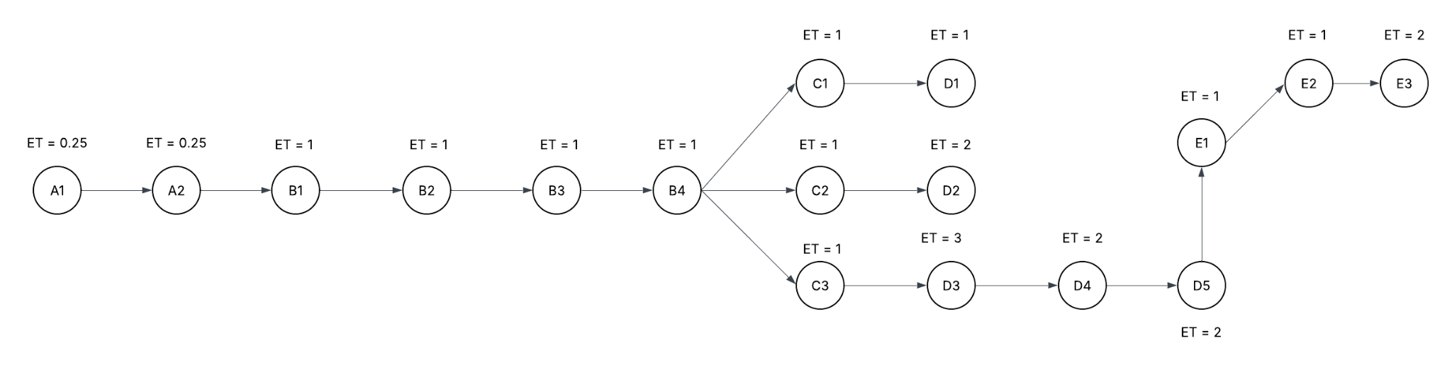
Fig. PERT Chart (Project Network Diagram)

Step 3.5: Build a Gantt chart (via ‘Onlinegantt https://www.onlinegantt.com/#/gantt’ or the tool of your
choice) that covers the full SDLC

This Gantt chart illustrates the full timeline for Iteration 1, which covers planning, analysis, design, development, and testing for the core visit workflow components—consent, recording, and transcription. It provides a week-by-week view of how the team progresses from requirement understanding to delivering a stable and test-ready iteration. The chart helps present a clear and organized overview of the effort required to complete this foundational workflow.

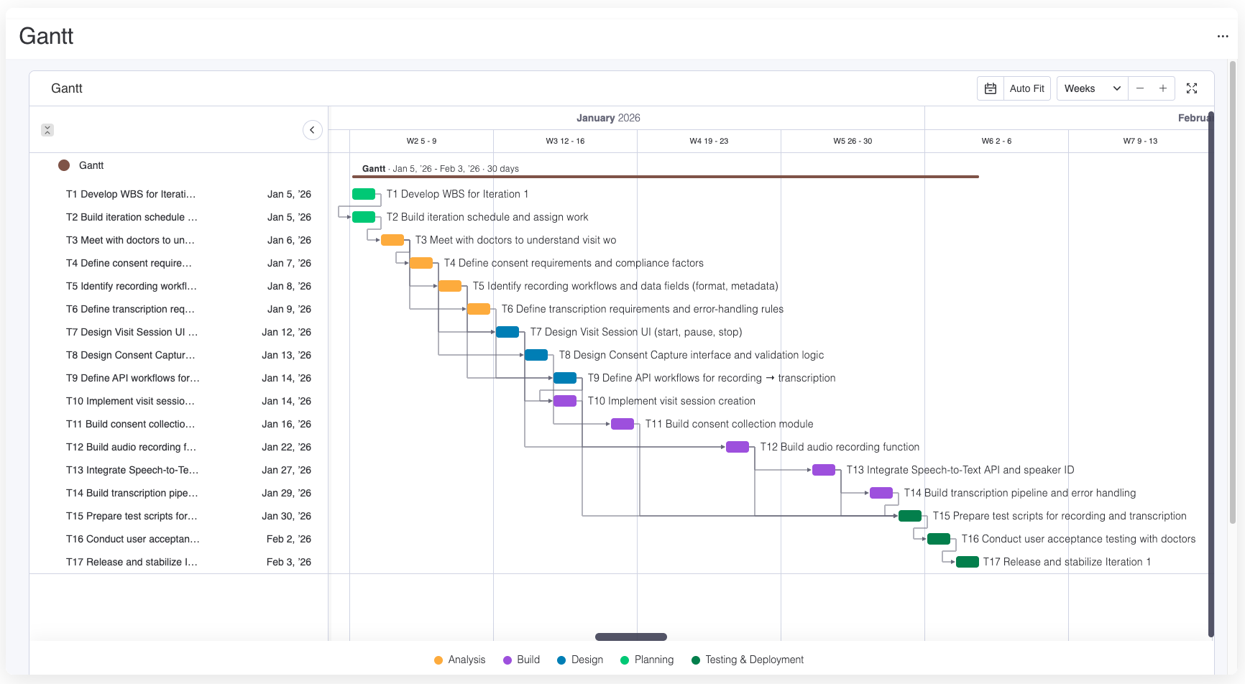Fig : Gantt Chart

Part 4. UI Design & Use Cases

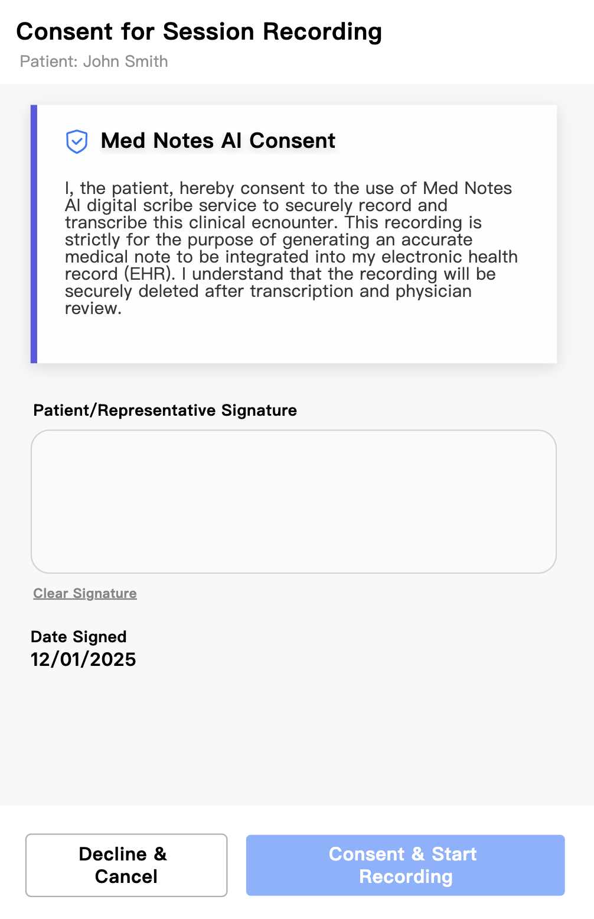
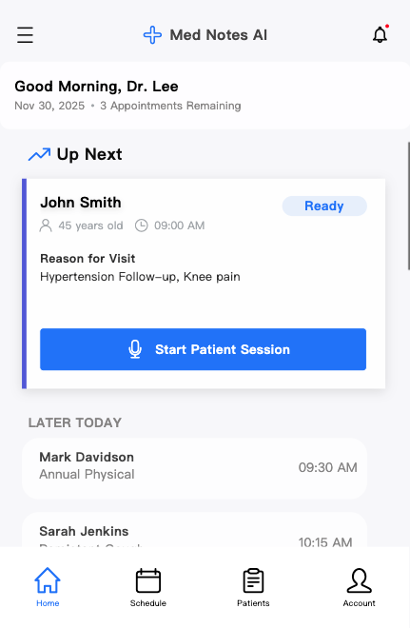
Use Case #1: Transcribe Consultation

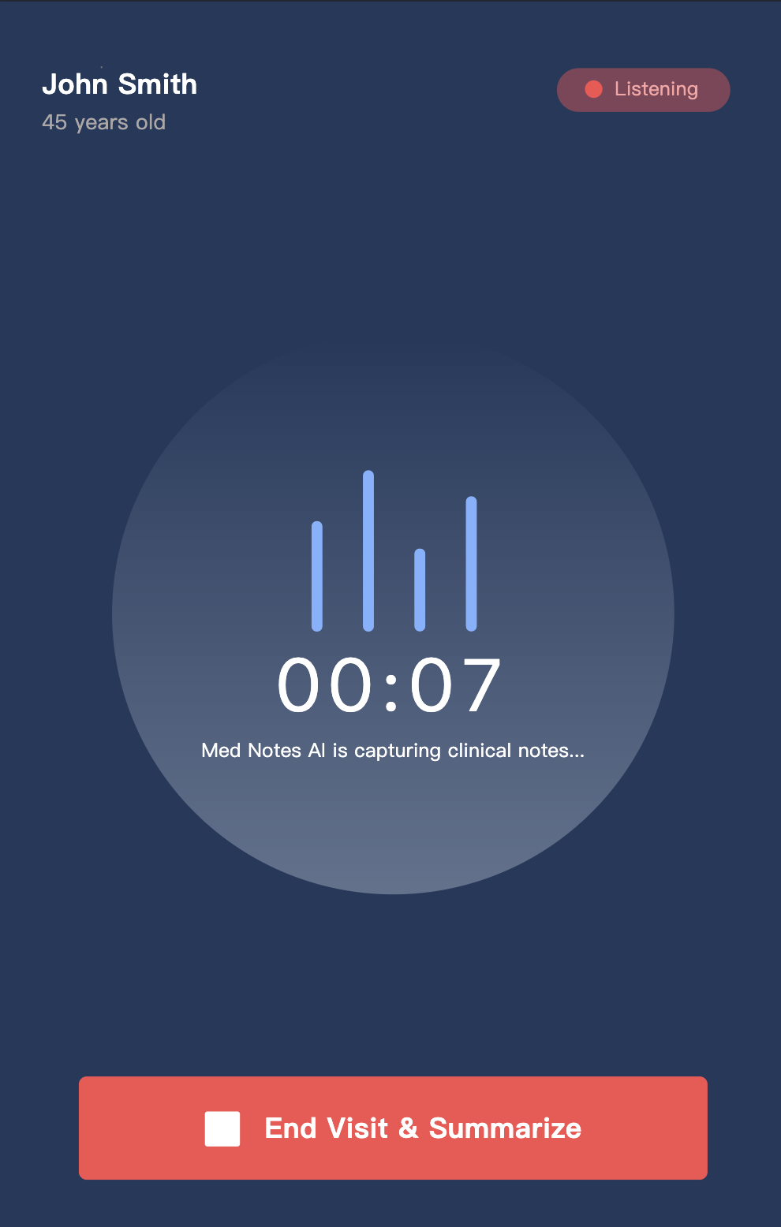
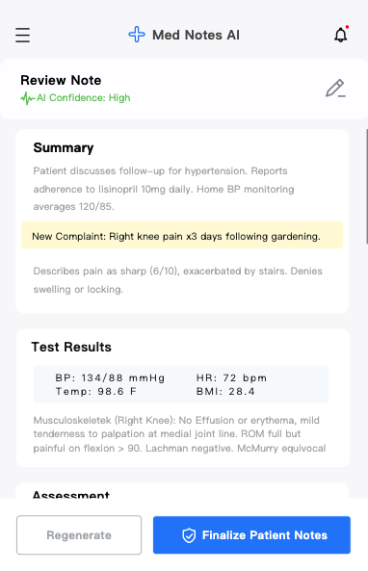

Use Case #2: View Patient Profile
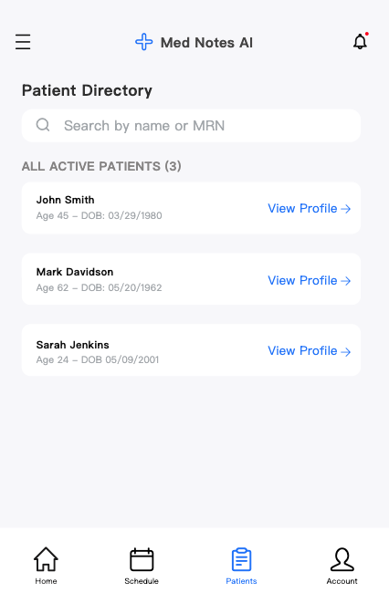

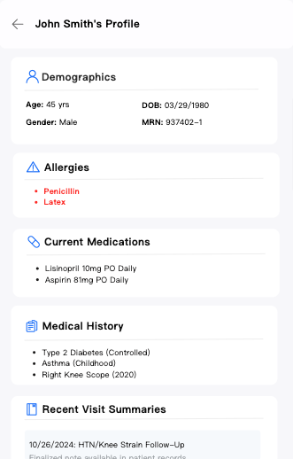

Conclusion
The AI-Powered Medical Note-Taking System presents a clear, practical, and financially attractive solution to the healthcare documentation burden. The system’s architecture, domain model, workflow designs, and development plan collectively demonstrate a technically robust approach to automating visit recording, transcription, and structured note generation.
Financial analysis shows strong justification, with substantial annual savings, improved billing accuracy, and a payback period of just over one year. The accompanying UI designs further highlight how the system delivers an intuitive and streamlined experience for clinicians.
Overall, this solution reduces physician workload, enhances documentation quality, and supports better patient care while offering excellent return on investment—making it a valuable and scalable tool for modern healthcare organizations.

