Step 3.4: Build a Project Network Diagram
The table summarizes all activities included in Iteration 1, along with their durations and task dependencies. Each activity is listed with a unique ID, a brief description, and the predecessor tasks that must be completed before it can begin. This structure helps clearly define how the work for this iteration is organized and how each task relates to the others.
ID | Task | Duration | Predecessor(s)
A1 | Develop WBS for Iteration 1 | 0.25 day | —
A2 | Build iteration schedule & assign work | 0.25 day | A1
B1 | Meet with doctors for workflow understanding | 1 day | A2
B2 | Define consent requirements | 1 day | B1
B3 | Identify recording workflows & metadata | 1 day | B2
B4 | Define transcription requirements | 1 day | B3
C1 | Design Visit Session UI | 1 day | B4
C2 | Design Consent Capture interface | 1 day | B4
C3 | Define API workflow for recording → transcription | 1 day | B4
D1 | Implement visit session creation | 1 day | C1
D2 | Build consent collection module | 2 days | C2
D3 | Build audio recording function | 3 days | C3
D4 | Integrate Speech-to-Text API & speaker ID | 2 days | D3
D5 | Build transcription pipeline | 2 days | D4
E1 | Prepare test scripts | 1 day | D5
E2 | Conduct UAT | 1 day | E1
E3 | Release & stabilize iteration | 1 day | E2

The corresponding PERT network diagram represents these same activities as nodes, using the durations shown in the table as each node’s estimated time. The diagram visually maps how tasks connect, where activities run in parallel, and how the overall workflow progresses through the iteration. It provides a clear overview of all tasks involved in Iteration 1 and how they collectively contribute to completing the core visit workflow.
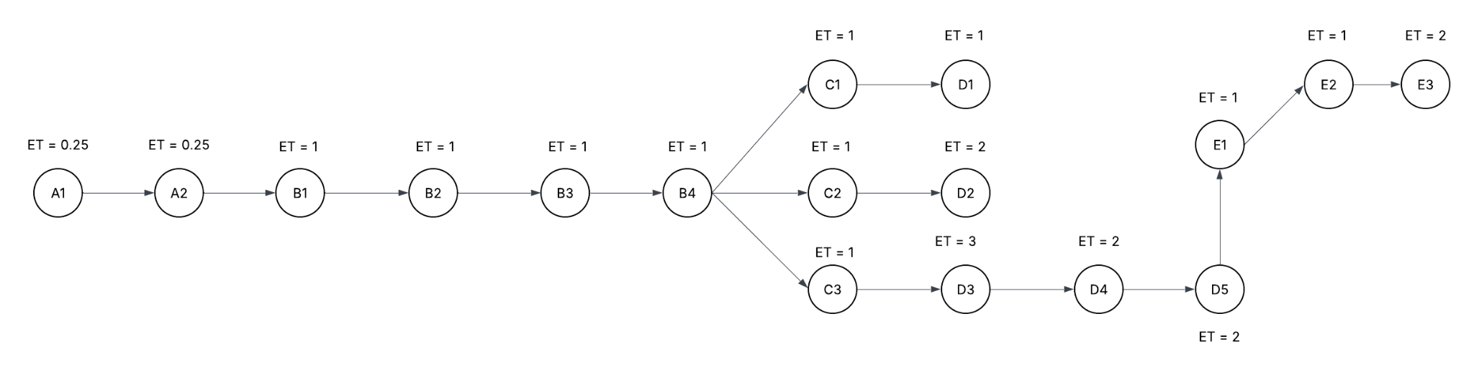
Fig. PERT chart (Project Network Diagram)

