Fully developed use case description for Use case 4: Record Consultation

Field | Description
Use Case Name: | Record Consultation
Scenario: | Capture the doctor–patient conversation during a clinical visit.
Triggering Event: | The doctor starts recording during an active patient visit.
Brief Description: | The doctor initiates audio recording during a consultation. The system captures the conversation, shows a recording indicator, and stores the audio securely under the patient’s active visit record. When the doctor stops the recording, the system saves the audio file and confirms successful upload. If there are any issues (e.g., microphone not available), the system notifies the doctor.
Actors: | Doctor (primary), System (supporting)
Related Use Cases : | Start Visit Session, Transcribe Consultation
Stakeholders: | Doctor : Wants hands-free documentation.  Patient : Expects transparency and privacy protection.  Clinic Administration : Requires secure and compliant storage of audio files.
Preconditions: | - Doctor is logged into the system.  - A patient visit session has been started.  - The device microphone is available and permission granted.  - The patient has provided consent for recording.
Postconditions: | - The audio file of the consultation is captured and stored securely.  - The recording is linked to the correct visit record.  - System confirms successful recording.
Flow of Activities: | Actor (Doctor) |  |  | System
 | - Opens patient visit session.
 | - Selects “Start Recording.” |  |  | 2.1 Activates microphone and begins recording.
 | - Conducts conversation with the patient. |  |  | 3.1 Continues recording audio.
 | - Selects “Stop Recording.” |  |  | 4.1 Stops recording.
 |  |  |  | 4.2 Saves audio file securely.
 |  |  |  | 4.3 Links audio file to visit record.
 | 5. View confirmation message. |  |  | 4.4 Sends “Recording saved successfully” message.
Exception Conditions: | Exception Condition  2 or 2.1 Microphone Permission Denied : System shows an error, requests microphone permission, recording does not start.  2 Microphone Hardware Not Found : System prevents recording, shows “Microphone not detected.”  4.2 Low Storage or Network Failure During Save : System displays warning, retries upload; if still failing, alerts doctor.  3 or 4 Doctor forgets to stop recording : System auto-stops after max duration (e.g., 60 minutes) and moves to step 4.2 automatically.  2.1 - 4.1 System crash during recording : System attempts to recover partial audio, notifies doctor upon restart.

Fully developed use case description for Use case 6: Review & Edit Notes

Field | Description
Use Case Name: | Review & Edit Notes
Scenario: | The doctor reviews AI-generated structured notes for a visit, edits them if needed, and finalizes the documentation.
Triggering Event: | The doctor selects “Review Notes” for a completed or transcribed visit.
Brief Description: | After structured notes are generated, the doctor opens the note for review. The system displays sections such as patient narrative, doctor assessment, and visit summary. The doctor can edit any field, add clarifications, or append additional information. Once satisfied, the doctor saves or approves the note, and the system marks it as the final version for that visit.
Actors: | Doctor (primary), System (supporting)
Related Use Cases : | Generate Structured Notes
Stakeholders: | Doctor : Wants accurate, editable notes that still save time compared to typing everything.  Patient : Benefits from clear and complete documentation of the visit. Clinic Administration : Needs finalized, high-quality notes for coding, billing, and audits.
Preconditions: | 1. Doctor is logged into the system.  2. A Visit record exists and has at least one draft Structured Note generated from transcription or manual entry.  3. Doctor has permission to edit notes for that visit.
Postconditions: | 1. Updated notes are saved and linked to the correct visit.  2. Note status is set to Draft or Final, depending on the doctor’s action.  3. A version history or timestamp is maintained for audit purposes.
Flow of Activities: | Actor (Doctor) |  |  | System
 | - Selects “Review Notes” for a specific visit. |  |  | 1.1 Retrieves the current StructuredNote for that visit (including sections like patient narrative, assessment, and summary)
 |  |  |  | 1.2 Displays the note in an editable form.
 | - Reads through the generated notes.
 | - Edits text in any section (e.g., corrects symptoms, updates assessment, modifies plan). |  |  | 3.1 Captures changes in the note fields in real time (or as a draft).
 | - Clicks “Save as Draft” or “Approve / Finalize Notes.” |  |  | 4.1 If Save as Draft: updates the structured note and sets status = “Draft.”
 |  |  |  | 4.2 If Approve / Finalize: saves edits, sets status = “Final,” and locks the note from further changes (or restricts to addendum only).
 | - Views confirmation. |  |  | 5.1 Displays a confirmation message such as “Notes saved successfully” or “Notes finalized for this visit.”
Exception Conditions: | 1.1 No structured note exists for the visit : Shows message “No notes available yet. Please generate structured notes or create a new note”.  3 Network or save failure while editing : Displays error “Unable to save changes and attempts retry; if still failing, prompts doctor to copy content locally.  4.2 Doctor tries to edit a finalized note without permission : Prevents edits and shows This note is finalized. Create an addendum if you need to add more information.”

2.4: Generate Activity Diagrams (minimal 1) :
- Below activity diagram represents the combined flow of the following the flow of activities in the fully developed use case description for Use case 4: Record Consultation
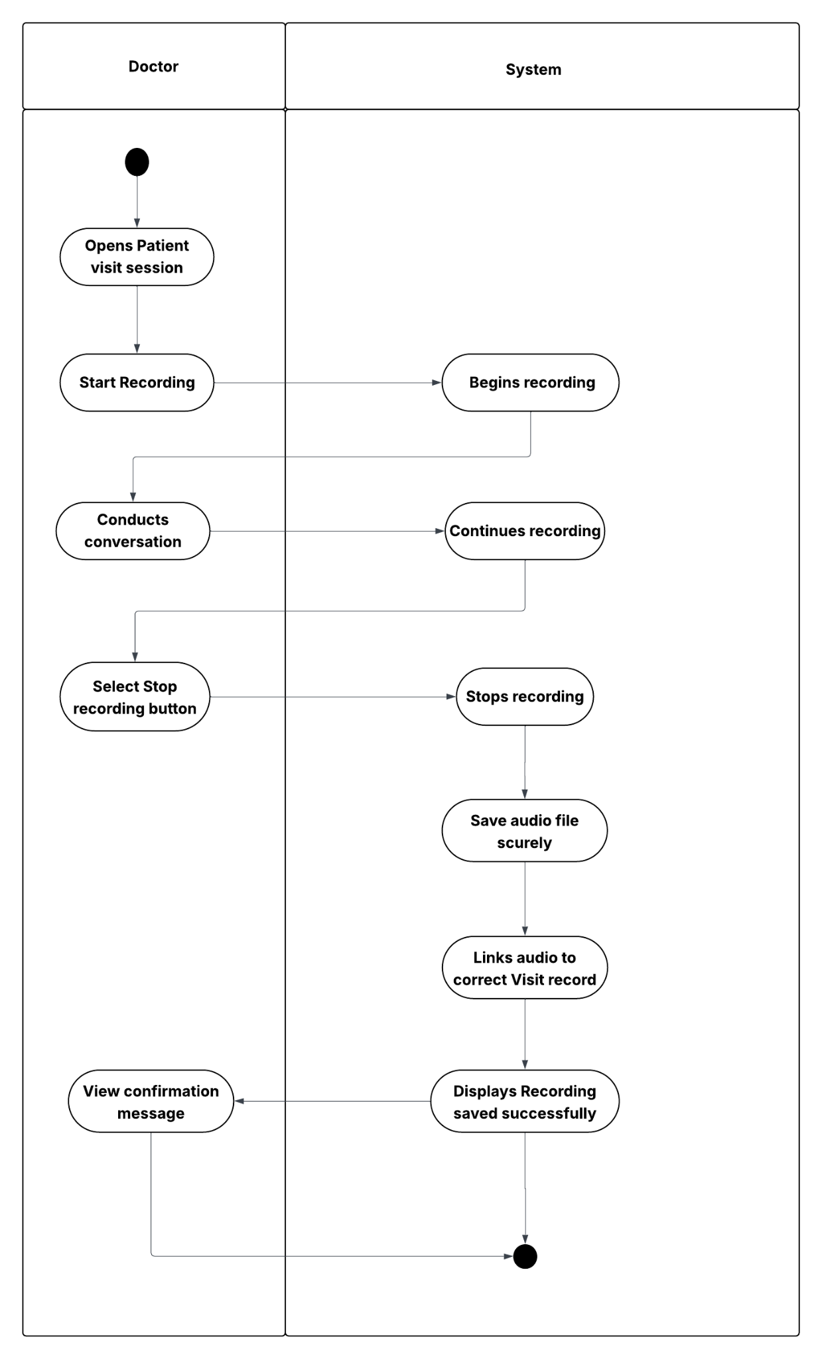

- Below activity diagram represents the combined flow of the following the flow of activities in the fully developed use case description for Use case 6: Review & Edit Notes
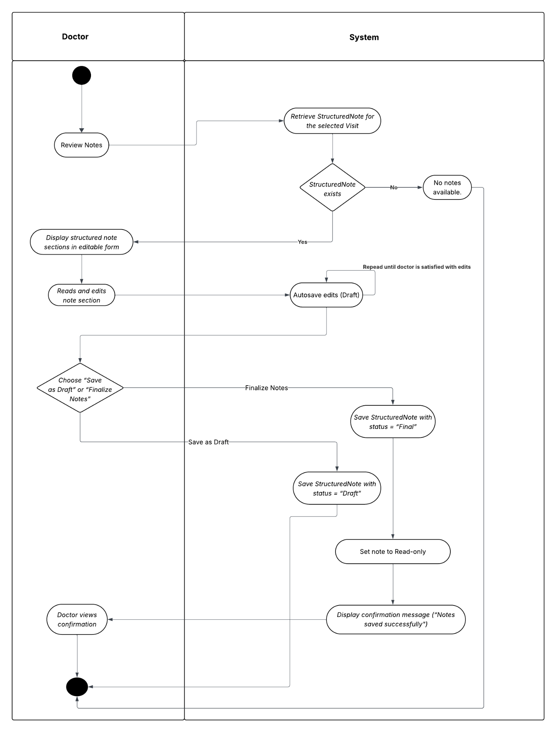

2.5: Generate System Sequence Diagrams (SSD) (minimal 1)

SSD for the Consultation & Documentation Workflow
The SSD similarly depicts the system interactions for the Use case 4 : Record Consultation
