Project Summary Report

AI-Powered House Tour and Realtor Voice Assistant



Company : Awaazai
🌐 www.awaaz.ai

Awaazai is a voice-first AI innovation studio transforming how people interact with digital platforms through intelligent, human-like conversations. The company pioneers voice-based assistants across industries such as leading banks, fintechs, and SMEs.
Faculty Advisor : Prof. Michele Samorani
Team : Maheshwari Bhandare | Kamya Krishnan | Trupti Lone
Leavey School of Business, Santa Clara University
May 2025

Project Scope and Objectives:

The objective of this project is to develop a voice-enabled AI assistant that guides prospective homebuyers through immersive, informative property tours. The system leverages conversational AI, real-time speech processing, and retrieval-augmented generation (RAG) to provide contextual information about property features, layout, and amenities. Core goals include:

- Automating narrated home tours using room images, floor plans, and property descriptions.

- Enabling natural voice interaction for buyer questions during the tour.

- Reducing dependency on physical agent presence while improving user engagement.

Work Plan and Timeline:

Phase 1 – Research & Design (Weeks 1–3):
- Defined AI pipeline: “Speech to Text “ (STT) → LLM → “Text to Speech” (TTS).
- Outlined architecture using LangChain and vector search.
- Prepared dataset structure for mapping floor plans, room images, and descriptions.
Phase 2 – Development & Integration (Weeks 4–7):
- Implemented house touring module that auto-generates narrated walkthroughs based on room images, layout, and listing details.
- Integrated voice generation using GPT-4o and ElevenLabs to produce natural, descriptive tour scripts.
- Developed voice interaction loop with real-time WebSocket and HTTP endpoints for STT and TTS.
- Synced room-level narration with user-triggered cues or sequential flow based on layout.
- Connected backend retrieval pipeline (FAISS + LangChain) with property knowledge base for accurate Q&A.
Phase 3 – Testing & Refinement (Weeks 8–9):
- Functional and latency testing across different home types.
- Voice tuning for natural tone and responsiveness.
- Real-world scenario validation for house tours and user queries.

Key Project Findings / Deliverables:

- A working prototype that auto-generates and delivers home tour scripts via voice.
Example : Below is the sample script for kitchen :
Welcome to the kitchen! As you step inside, you'll immediately feel the welcoming atmosphere created by the efficient use of space and modern design. To your left, the sleek quartz countertops catch your eye, complemented by custom wood cabinetry that provides plenty of storage for all your culinary tools.

Straight ahead, a large window lets in a generous amount of natural light, offering a delightful view of the outdoors while you prepare meals. The recessed lighting and a skylight ensure the space stays bright and airy, even after sunset. The stainless steel appliances are neatly integrated into the layout, making cooking a breeze.

The kitchen's design promotes easy movement, with a seamless flow into the adjacent dining area. This makes it perfect for both casual meals and entertaining guests. The warm wood flooring adds a touch of elegance, connecting the kitchen smoothly with other areas of the home.

Now, let's continue our tour into the dining area, where you'll find even more space to enjoy meals and gatherings.

- Real-time voice assistant that answers location-specific queries
Example: “ What type of restaurants are there nearby?”

- Backend knowledge base supporting dynamic property retrieval using FAISS and LangChain.

- Frontend voice recorder and player with continuous speech detection.

Benefits to the Sponsoring Company:

- Efficiency: Automates repetitive agent tasks, enabling 24/7 virtual tours.

- Scalability: Supports simultaneous property tours across multiple listings.

- Engagement: Enhances buyer experience through interactivity and convenience.

- Differentiation: Provides a competitive edge in digital-first real estate experiences.

Tech Stack:

Backend:

- FastAPI (Python) for API and routing
- FAISS for vector search
- LangChain for RAG integration
- Whisper for speech-to-text (STT)
- ElevenLabs for text-to-speech (TTS)

Front-end:

- React for UI/UX
- WebSockets for live streaming
- MediaRecorder library for user voice input
- HTML5 Audio APIs for voice playback and recording
- TailwindCSS for responsive design

Frontier Model:

- OpenAI GPT-4o for conversational intelligence and tour narration

- RAG pipeline for real-time content grounding using listing metadata

Real-time Conversation:

- WebSocket-based duplex communication between frontend and backend

- Whisper STT → GPT reasoning → ElevenLabs TTS

- VAD (Voice Activity Detection) integration for automatic speech trigger

Next Steps for Ongoing Project Success:

- Expand language support for multilingual buyers.

- Pilot deployment with selected agents and listings to gather user feedback.

Screenshots of the app:

The app has two major components: AI Home Tours and the Realtor Voice Assistant. AI Home Tours offers a guided, voice-enabled virtual house tour experience, allowing users to browse listings and explore homes room by room with narrated audio and visuals. The Realtor Voice Assistant enables natural, hands-free conversations by answering property-related questions in real time, enhancing the overall interactivity and accessibility of the platform.

AI Home Tours screenshots:
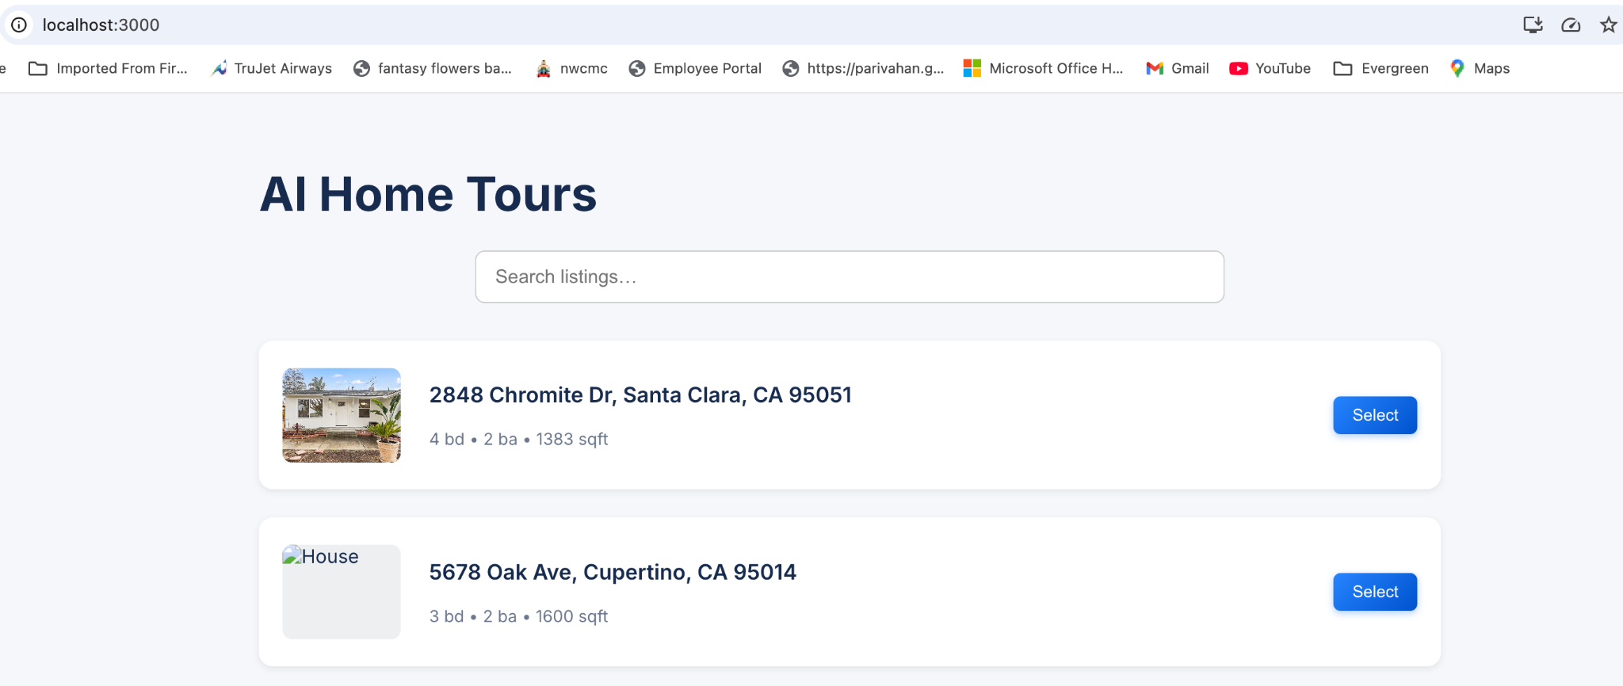
This screenshot displays the home listings available for tour. Each card shows the address, number of bedrooms and bathrooms, size in square feet, and a “Select” button to begin exploring the property.

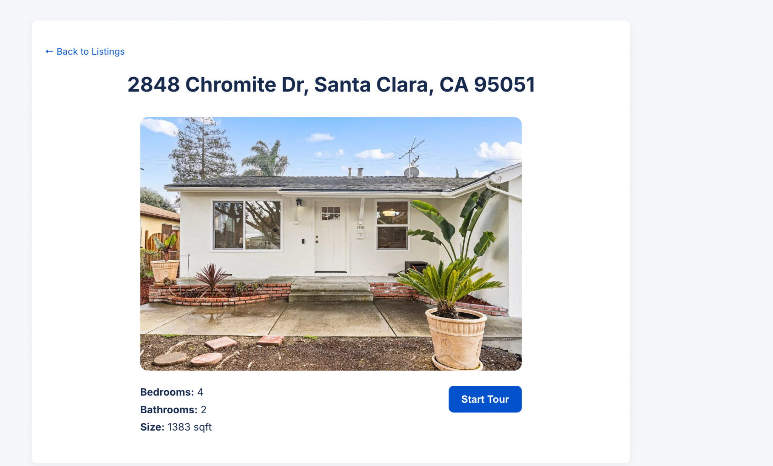
Once a property is selected, users are taken to a detailed view with an image, basic specifications, and a prominent “Start Tour” button to initiate the guided experience.

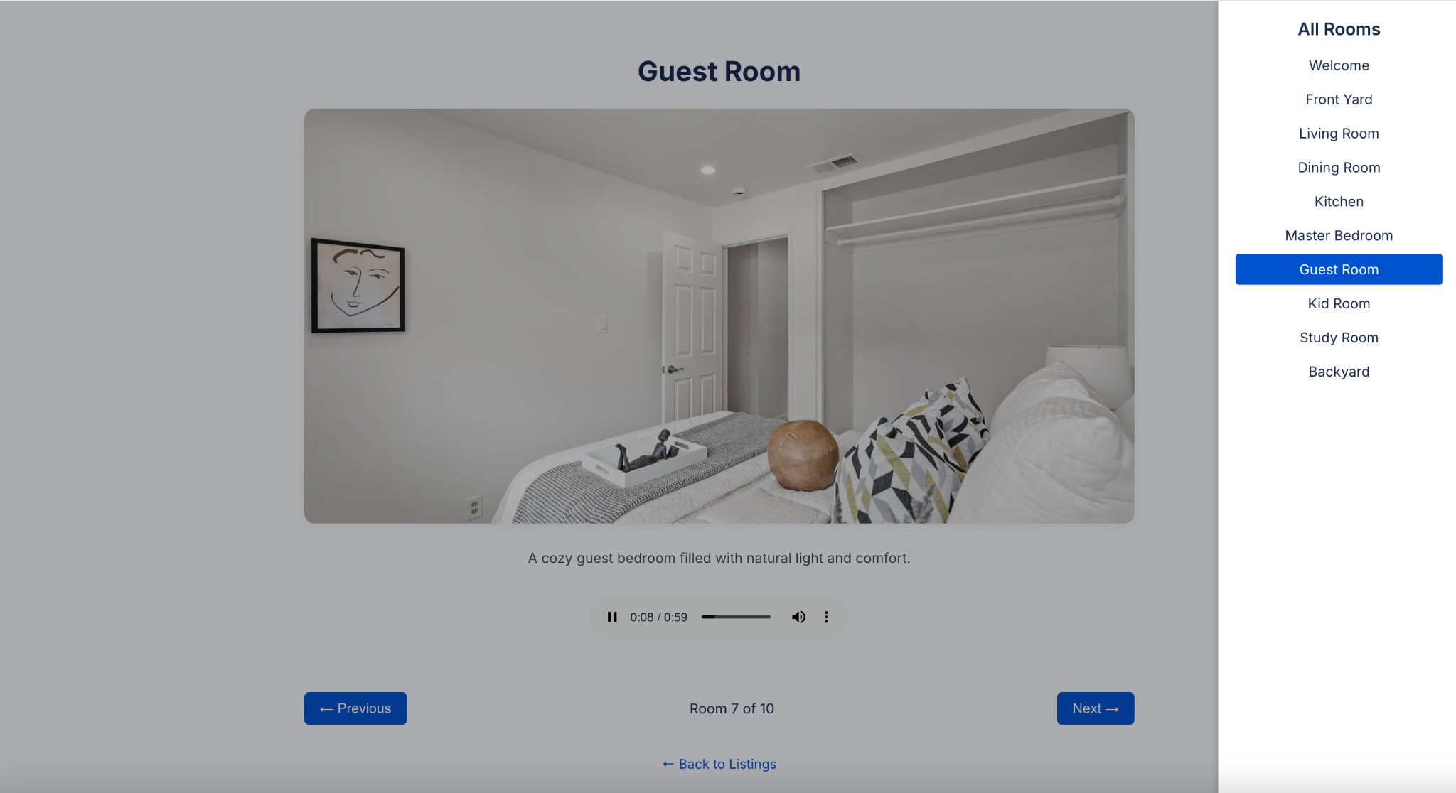
A side menu allows navigation across all rooms included in the tour, from the front yard to the backyard.

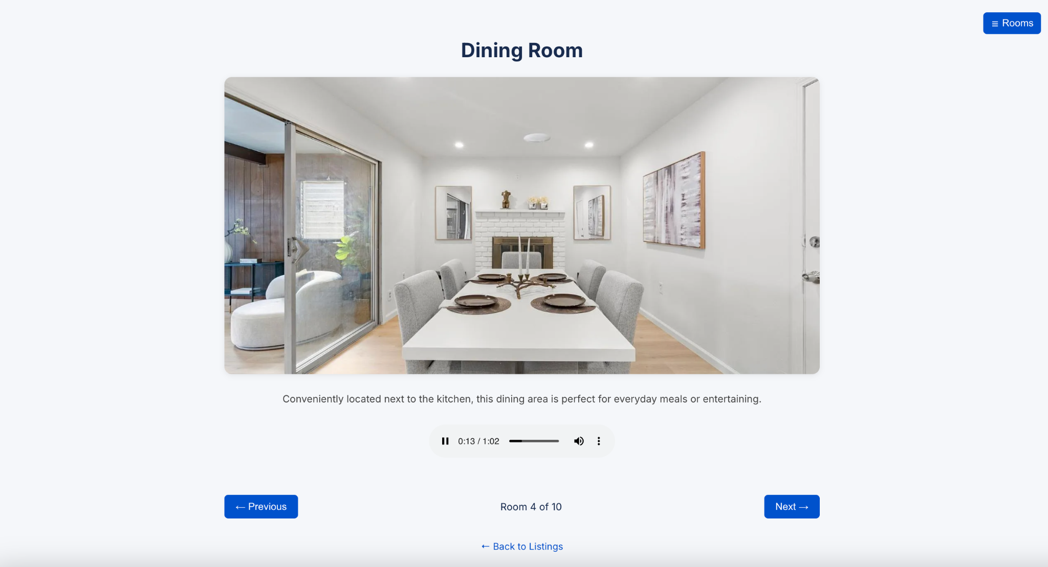

When a particular room is selected—either by clicking 'Next' or using the room menu (e.g., Dining Room)—the audio description starts automatically.

Voice Assistant screenshots:

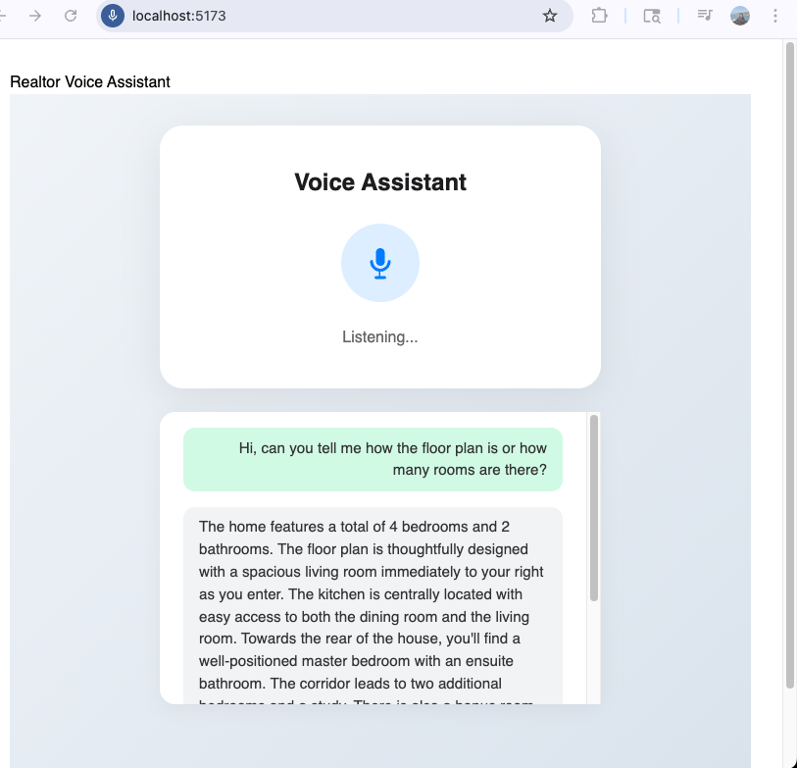
This screen shows the assistant responding to a user query about how many rooms are in the house. The assistant provides a clear, spoken summary and textual breakdown of all rooms, including bedrooms, bathrooms, and common areas.

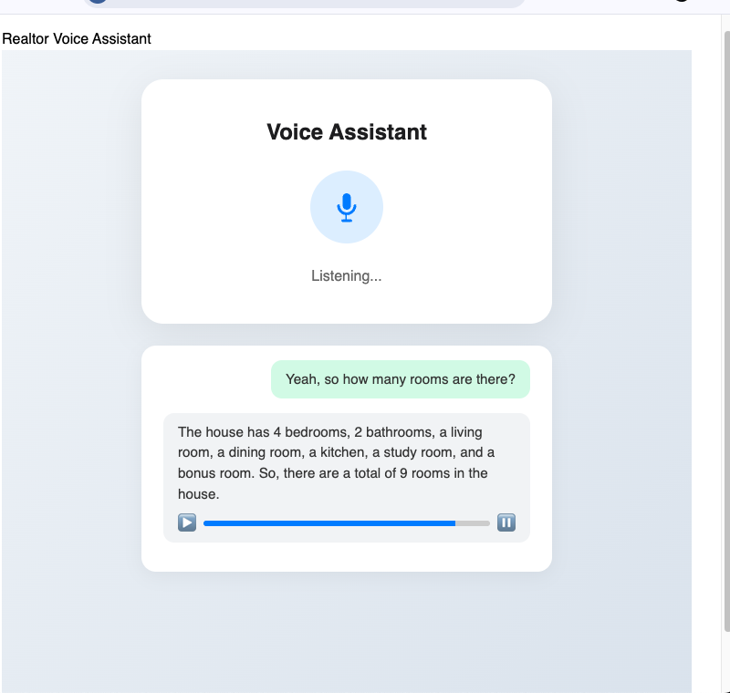

Here, the user inquires about the floor plan. The assistant delivers a detailed description of the house layout, including room placements and connectivity, demonstrating the assistant’s ability to provide nuanced property insights.

Conclusion

This project showcases a full-stack voice-enabled real estate assistant that combines cutting-edge AI technologies for seamless and intelligent user interaction. Leveraging Retrieval-Augmented Generation (RAG) via LangChain, speech-to-text using Groq and text-to-speech using ElevenLabs, and a lightweight FastAPI backend, the assistant can respond to natural language voice queries in real time.

A key feature of this solution is the House Tour module, which generates immersive, guided walkthrough scripts from property details and room descriptions. These narratives are synthesized into lifelike voice responses, offering users an experience similar to in-person home tours.

Together, the conversational assistant and house tour capabilities provide a scalable, human-like interface for digital property exploration—setting a strong foundation for future enhancements such as room navigation, appointment booking, and multilingual support.

Reference Links
https://python.langchain.com/
https://python.langchain.com/docs/use_cases/question_answering/how_to/retrieval_qa
https://platform.openai.com/docs/guides/gpt
https://platform.openai.com/docs/guides/speech-to-text
https://platform.openai.com/docs/guides/text-to-speech
https://docs.elevenlabs.io/
https://console.groq.com/docs
https://fastapi.tiangolo.com/
https://developer.mozilla.org/en-US/docs/Web/API/MediaRecorder
https://www.zillow.com/research/data/
https://rapidapi.com/blog/best-real-estate-apis/
https://huggingface.co/blog/rag

