Application Flow:

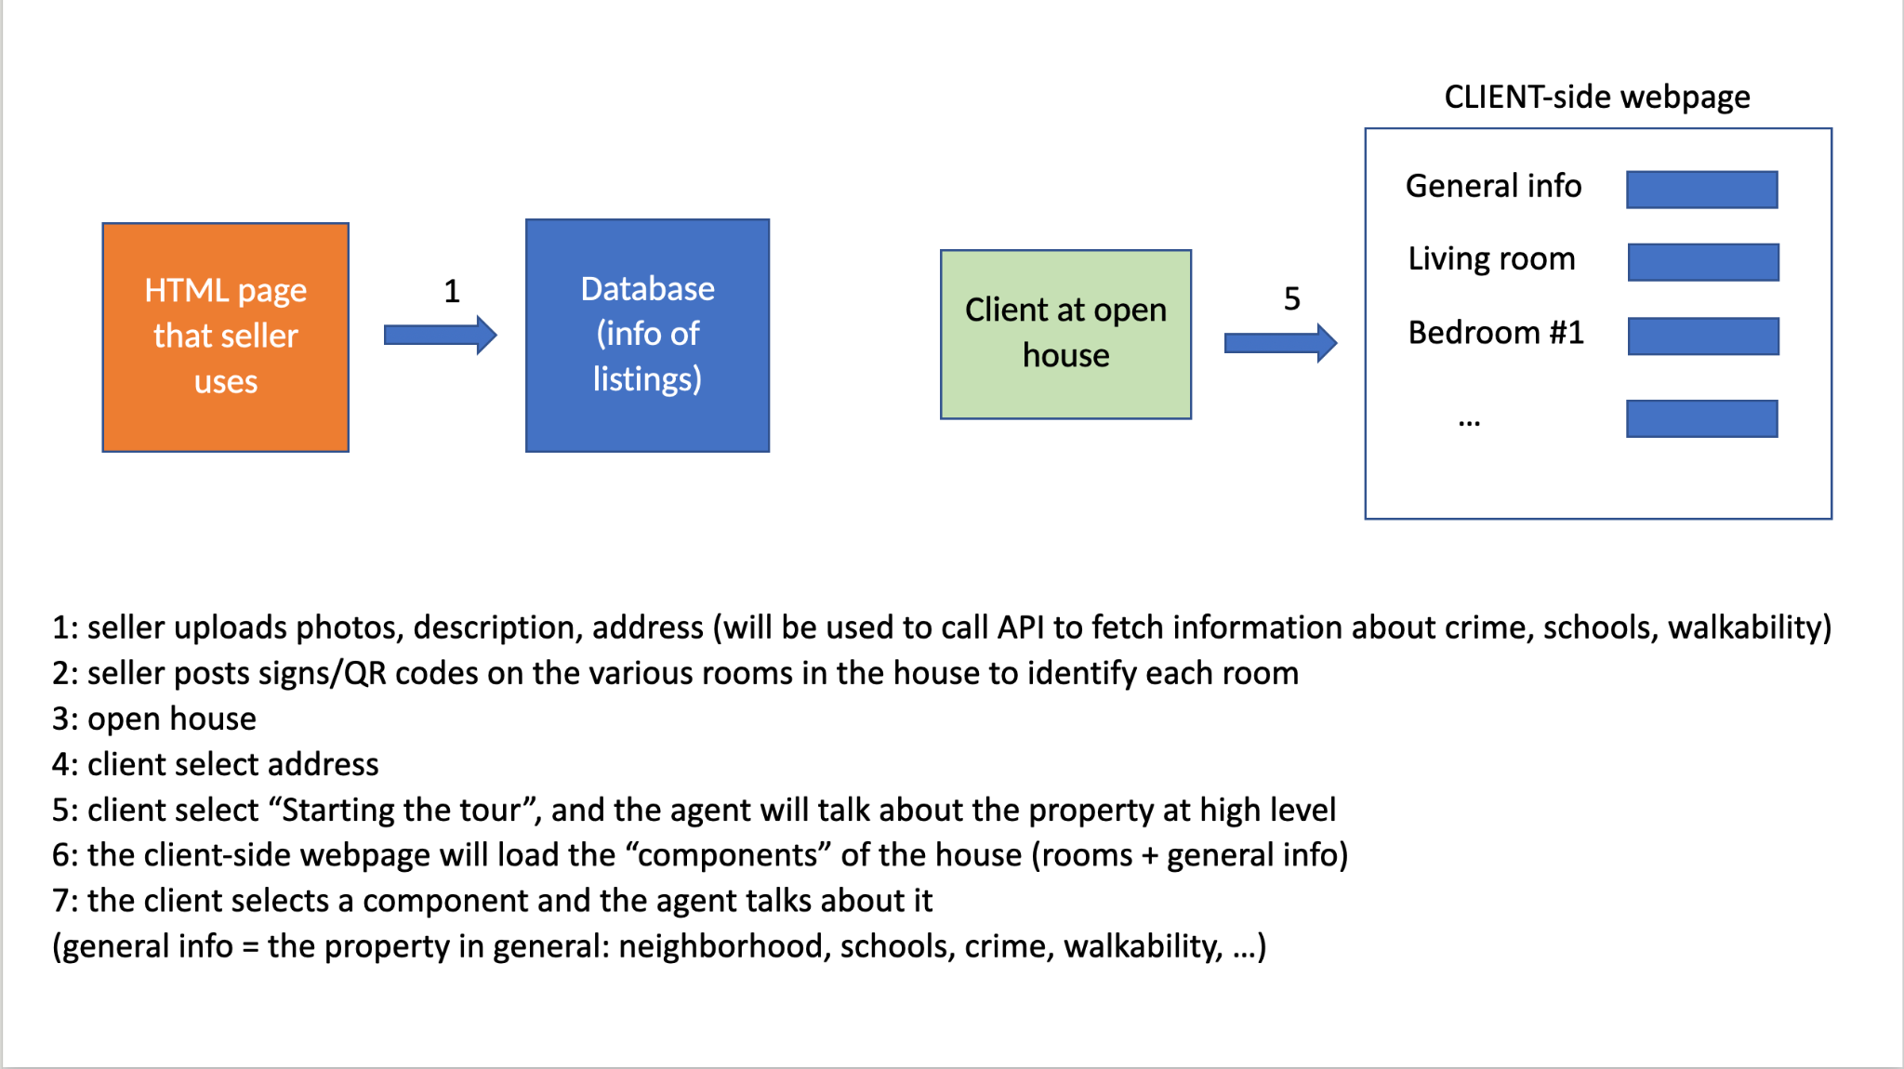

Tech stack:

Technical Specifications for the house tour:

User Persona : Customer

Mobile/Web app Login
Scan QR Code of location/ select location
AI to start conversation
Answer Q&A

User Persona : Real estate Agent
Mobile/ Web app login
Upload all the necessary documents, photos, videos

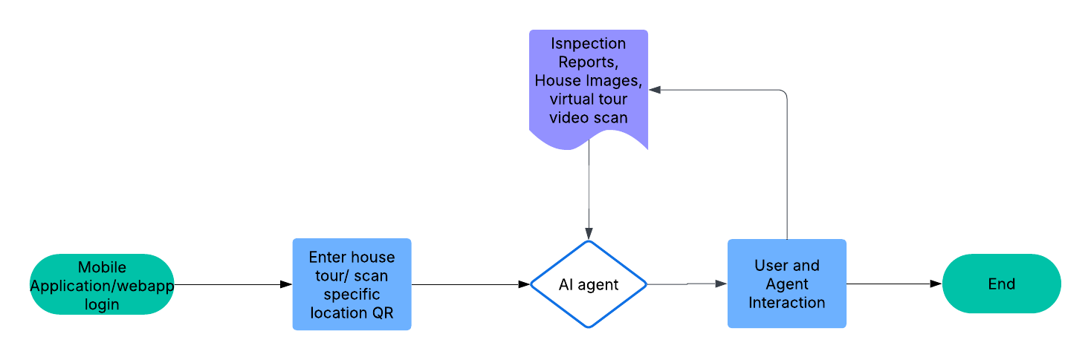

Flow Stages with Components
- Start
  - Terminator: User opens mobile/web app
  - Action: User logs in or enters as guest
- Property Access
  - Process: Scan QR
  - Decision: Determine room (Kitchen/Living Room etc.)
- Context Loading
  - Document: Fetch room-specific data
    - Floorplan data
    - Inspection reports (PDF)
    - House images & virtual scan (pre-uploaded)
- AI Agent Processing
  - Decision: Is user speaking or waiting for narration?
    - If narration: use room context + GPT → TTS
    - If query: use STT → GPT → TTS
- Voice Output / Conversation
  - Process: Voice Assistant speaks out room info
  - Loop: If user asks questions → go back to AI agent
- User Interaction (Optional)
  - Process: Click-to-ask feature or voice commands
  - Feedback or further clarification
- Session Logging
  - Data: Log user behavior + interest analytics
- End Tour
  - Terminator: Exit tour / move to next property

Tech Stack

Mobile app: React Native
Webapp: React
Backend: FastAPI Python
Database : PostgresQL
STT : Whisper/ Groq
TTS : OpenAI GPT-4
Context & Memory :LangChain, RAG
Connection : WebSockets

Example Tables:
users (id, name, email, role)
properties (id, address, owner_id, floorplan_img_url)
rooms (id, property_id, name, description_jsonb)
inspection_reports (id, property_id, pdf_url, summary_jsonb)
interactions (id, user_id, room_id, query, ai_response, timestamp)

