Business & Operational Overview: SMART Health

1. Executive Summary
SMART Health is a specialized Managed Service Provider (MSP) delivering IT Service Management (ITSM) to the small-to-medium size hospital and clinic market. By aligning technology operations with clinical business objectives—specifically patient safety, service continuity, and HIPAA compliance—SMART Health transforms IT from a reactive cost center into a strategic enabler.
2. The ITSM Framework (ITIL-Aligned)
SMART Health operates under the ITIL 4 framework, ensuring that services are delivered through structured, repeatable, and auditable processes.
A. The "Three Pillars" Model
- People: A tiered support structure ranging from Front-line Service Teams to specialized Clinical App Support, governed by a CDTO/CIO leadership layer to ensure clear accountability.
- Process: Standardized workflows for Incident Management (restoring service), Problem Management (root cause analysis), Change Management (minimizing clinical disruption), and Request Fulfillment.
- Technology: A centralized "System of Record" powered by Salesforce, supplemented by a modern Data & ML stack for operational intelligence.
B. Strategic Alignment
The service model is specifically tuned to the healthcare context:
- Patient Safety: High-priority routing for incidents impacting Life-Safety or EHR availability.
- Regulatory Compliance: Automated audit trails for access and data handling to satisfy HIPAA/HITECH requirements.
- Operational Continuity: SLA-driven response times to ensure clinics remain functional 24/7.
3. Technical Ecosystem
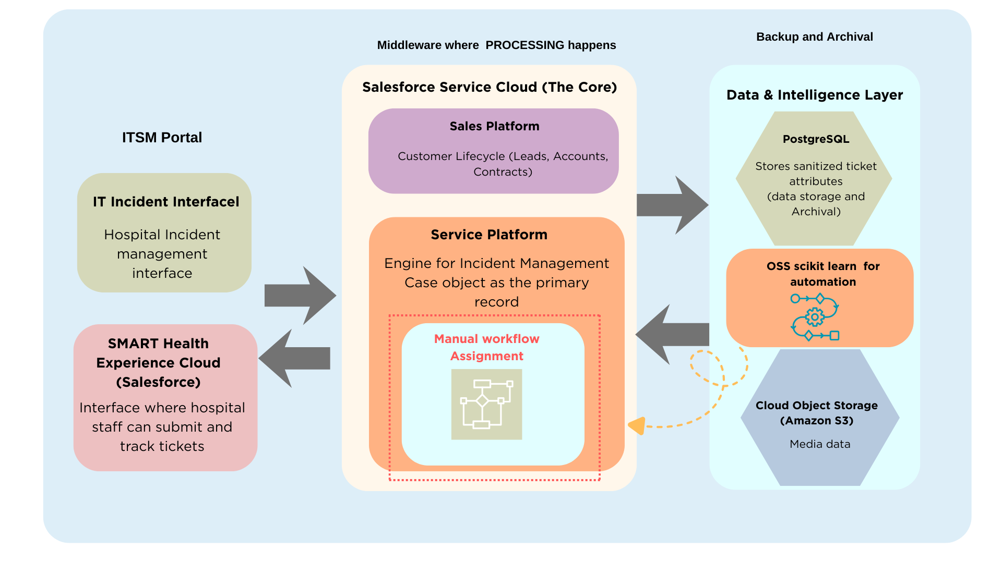

SMART Health utilizes a Single-Org, Multi-Tenant architecture. This allows for centralized management while maintaining strict data isolation between different hospital accounts.
I. Salesforce Service Cloud (The Core)
Salesforce acts as the primary engagement and record layer, split into three functional zones:
- Sales Platform: Manages the customer lifecycle (Leads, Accounts, Contracts) and feeds "Entitlement" data (SLA tiers) into the service layer.
- Service Platform: The engine for Incident Management. It utilizes the Case object as the primary record, managed through a specialized Service Console for IT agents.
- Experience Cloud (The Front Door): A secure, branded portal where hospital staff can submit and track tickets. Data separation is enforced at the Account level via Salesforce Sharing Rules.
II. Data & Intelligence Layer (The "OSS Project" Foundation)
To support advanced analytics and the upcoming Machine Learning integration, SMART Health maintains an off-platform data stack:
- Managed PostgreSQL: Stores sanitized ticket attributes, training labels, and model performance metadata. It acts as the "Feature Store" for the ML project.
- Cloud Object Storage (Amazon S3): A scalable "Data Lake" for raw historical exports, serialized scikit-learn model artifacts, and pipeline logs.

Services provided by SMART Health:

As a Managed Service Provider (MSP) like Smart Health, the short answer is yes, but your level of access is administrative and technical rather than clinical. You won't be "using" these portals to treat patients; you will be "managing" them to ensure they are functional, secure, and integrated.
In a professional IT environment, this is managed through Administrative Credentials and Super-User accounts. Here is how your access is segmented across those different portals:

1. EHR (Electronic Health Record) Access
You do not have a "Provider" account (like a doctor). Instead, you have Administrative/Support Access.
- What you can do: Reset passwords, unlock accounts, configure "Order Sets" for the hospital, and manage the integration between the EHR and the Lab or Pharmacy.
- The Safeguard: Your access is usually restricted to the "back-end" configuration. If you must remote into a doctor's screen to fix a bug, your platform should log that session as a "PHI-Sensitive Event."

2. Patient Portals & Kiosks
You generally have Environment Access.
- Kiosks: You have full "Root" access to the physical device. You manage the OS (Windows/Android), the security "wraparound" software that prevents patients from browsing the web, and the connectivity to the hospital Wi-Fi.
- Patient Portal: You manage the "Identity Provider" (how the patient logs in) and the server uptime. You don't see the patient's messages to their doctor, but you see the data flow to ensure the message was delivered.

3. Admin, Billing, and HR Portals
You have Service Account Access.
- Billing/Claims Portals: You manage the "Clearinghouse" connections (the digital pipes that send bills to insurance).
- HR Systems: You have high-level access here to enable your Automated Provisioning deliverable. When HR adds a name, your system sees it and automatically creates the corresponding accounts in the EHR and Email.

1. Core Managed IT Services
These are the "always-on" deliverables that form the foundation of our partnership with hospitals and clinics.
- 24/7/365 Managed Service Desk: A centralized "Digital Command Center" providing Tier 1–3 support for all technical and operational issues.
- Omnichannel Support: Integration with hospital communication tools like Slack, Microsoft Teams, and specialized web portals for instant ticket submission.
- Hybrid Support Delivery:
  - Offsite: Remote monitoring, cybersecurity patching, and server management.
  - Onsite: Dedicated "Resident Technicians" for physical hardware repair, clinical rounding, and face-to-face support.

2. Clinical System Stewardship
We manage the complex digital tools that doctors and nurses rely on for patient care.
- EHR/EMR Optimization: Full support for platforms like Epic or AthenaHealth, focusing on reducing lag and solving login/access issues.
- Interoperability Monitoring: Ensuring the seamless flow of data between different systems (e.g., Lab results syncing correctly to the Patient Chart).
- Device Lifecycle Management: Provisioning, securing, and maintaining "Endpoints" such as tablets and Workstations on Wheels (WOWs).

3. Automation & Workflow Optimization
This represents our "Growth Direction," utilizing scikit-learn and AI to improve hospital efficiency.
- AI-Driven Ticket Triage: Internal automation that categorizes and routes tickets instantly based on clinical urgency.
- Automated Provisioning: "One-click" onboarding for new staff and traveling nurses, automatically setting up email and EHR access.
- Workflow Analytics: Data-driven reporting that identifies operational bottlenecks (e.g., identifying why specific departments have higher hardware failure rates).

4. Facilities & Bio-Medical Support
We bridge the gap between traditional IT and the physical medical environment.
- Medical Device Connectivity: Managing the network integration for EKG machines, vitals monitors, and infusion pumps.
- Smart Building Technology: Oversight of Wi-Fi-enabled security cameras, smart locks, and thermostats.
- Specialized Environmental Monitoring: Automated alerts for "Smart Fridges" storing vaccines or lab samples to prevent loss due to temperature fluctuations.

5. Security, Compliance & Vendor Management
We act as a "Shield" to protect the hospital’s legal and digital interests.
- HIPAA Compliance & Auditing: Automated logging and disk encryption to ensure all data access meets federal standards.
- Disaster Recovery: Managed offsite backups with a guaranteed Recovery Time Objective (RTO) to get the hospital back online quickly after a failure.
- Vendor Liaison: We manage the relationships and technical escalations with third-party providers (ISPs, EHR vendors, and software firms).

4. Problem Statement & Project Integration

While the current ITSM model is robust, Incident Triage remains a manual, human-driven bottleneck. Currently, every ticket submitted via the Experience Cloud portal requires a human agent to read, categorize, and prioritize it before routing it to the Clinical Apps Tier 2 team.
The Proposed Augmentation
Machine Learning Augmentation Layer using scikit-learn.
- Function: Automated Category and Urgency prediction.
- Philosophy: "Human-in-the-loop" design. The ML provides decision support (e.g., suggesting a P1 priority for EHR outages) while preserving final human accountability.
- Value: Reduces Mean Time to Repair (MTTR) and ensures that critical patient-care issues are escalated instantly, strengthening the existing ITIL-aligned workflow.

Layer | Component | Technology | Role
User Interface | Service Portal | Salesforce Experience Cloud | Multi-tenant front-end for hospitals/clinics.
System of Record | CRM / ITSM | Salesforce Service Cloud | Core database for Cases, SLAs, and Customer Accounts.
Intelligence | ML Framework | scikit-learn (Python) | Powers the classification and urgency prediction models.
Data Orchestration | Pipeline | Apache Airflow / Python | Automates data extraction, model scoring, and updates.
Structured Data | Metadata DB | Managed PostgreSQL | Stores sanitized ticket features, labels, and model history.
Unstructured Data | Data Lake | Amazon S3 | Stores raw historical exports, training sets, and model artifacts.

Key Technical Considerations :
- Security (HIPAA): Data is "sanitized" before leaving Salesforce. No Patient Names or DOBs are stored in the S3 bucket or used for ML training.
- Human-in-the-Loop: The ML does not close tickets; it only categorizes them. This ensures high-stakes healthcare decisions are always verified by a human.
- Scalability: The "Single-Org" model allows SMART Health to add a new clinic as a new Account without needing to build a new ML pipeline.
Incident Management
- Information Technology (IT) : Computers, laptops, tablets, EHR access & login, Network / Wi-Fi, Printers & scanners, Software issues
- Clinical and Diagnostic Departments : Doctors (EHR access, patient records) : Nurses (medication systems, order entry), Emergency / ICU (critical system downtime), Lab systems (LIS issues), Radiology / PACS access.
E.g: “EHR not loading”, “Password reset”, “Printer not working”, “Internet is down”, “Patient chart missing”, “Lab results not showing”, “Order entry issue”
- Administrative Departments : Billing & insurance, Admissions & discharge, Scheduling
- IT / Operations : Network outages, Device or access provisioning, Security or login issues
- Biomedical / Medical Equipment (Limited): Often outsourced in small setups, covers Vital monitors, EKG machines, Scales, Printers attached to devices
E.g: “Blood pressure machine not working”, “EKG device calibration needed”
- Security & Access (Physical + Digital) : Badge access (if any), Alarm systems, Camera issues, Example tickets
E.g : “Badge not working”, “Alarm false alert”
- Telecom / Communications : Desk phones, VoIP, Fax machine
E.g :“Phone not ringing”, “Fax not sending”
- Vendor & Application Support : Not a department, but a ticket category EHR vendor, Billing software, Scheduling systems
Eg. “Athena down”, “Billing software error”

1. Clinical Operations (The "Mission Critical" Desk)
In a small setting, IT support is synonymous with "keeping the clinic open."
- EHR / EMR Support: Troubleshooting login issues, slow chart loading, or prescription (e-Prescribe) errors.
- Medical Equipment Connectivity: Ensuring vitals monitors, portable X-ray machines, and handheld scanners stay connected to the Wi-Fi.
- Telehealth Infrastructure: Managing the cameras, audio, and secure links for remote consultations.

2. Patient Access & Front Office
This is the "Revenue" side of the clinic. If these systems are down, the clinic can’t register patients or get paid.
- Admissions & Registration: Support for ID scanners, credit card readers, and patient-facing check-in kiosks.
- Scheduling & Billing: Tickets related to the practice management software, insurance verification portals, and merchant services.
- Patient Portal: Helping staff help patients with password resets or accessing lab results online.

3. Administrative & HR (The "People" Desk)
For a small hospital, "IT" often handles the entire onboarding/offboarding lifecycle.
- Onboarding: Automatically setting up email, EHR access, and badge access for a new traveling nurse or doctor.
- Compliance & HIPAA: Managing audit logs, disk encryption, and "locked" workstations to ensure the clinic stays legal.
- Staff Communications: Support for VoIP phones, secure messaging apps (like TigerConnect), and clinic-wide paging.

4. Facilities & Bio-Med (The "Physical" Desk)
In small organizations, the line between "IT" and "Maintenance" is often blurred.
- Smart Building Tech: Monitoring Wi-Fi-enabled thermostats, security cameras, and smart locks.
- Medical Device Inventory: Tracking when an EKG machine or infusion pump is due for its annual safety calibration.
- Pharmacy/Lab Storage: Alerts for "Smart Fridges" that store vaccines or lab samples (if the temperature fluctuates, it generates a high-priority IT ticket).

5. Infrastructure & Security (The "Backbone")
- Network & Wi-Fi: Maintaining the "Guest Wi-Fi" for patients vs. the "Secure Wi-Fi" for clinicians.
- Backups & Recovery: Ensuring that even if a small clinic gets hit by ransomware, they can restore patient data within hours.
- Endpoint Management: Patching the laptops and PCs found in exam rooms and nursing stations.

Task Category | Remote or Onsite? | Why?
Hardware Failure | Onsite | Replacing a frayed power cable on a heart monitor or swapping a broken tablet.
Clinical Rounding | Onsite | Walking the floors to ask nurses, "How is the tech working today?" (This builds the "Patient-Centered" trust).
Network Outage | Onsite | If the hospital's internet is down. You must be there to fix the physical router/switch.
New Hardware Setup | Onsite | Unboxing and configuring new workstations in the Emergency Department.
Software/EHR Updates | Remote | Can be pushed overnight via your platform's automation tools.

SMART Health Organizational & Functional Tree

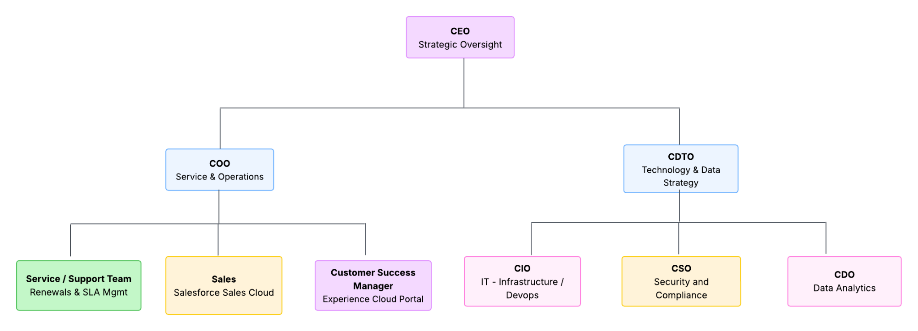

Persona / Role | Component Ownership | Key Responsibility in Workflow
Sales Team | Salesforce Sales Platform | Onboards new hospital Accounts and manages Contracts.
Customer Success | Experience Cloud Portal | Monitors portal health and ensures Dr. Patel is satisfied with the UI.
Service & Support | Salesforce Service Cloud | The primary users who act on the Case records and resolve incidents.
CIO / Infrastructure | Amazon S3 & API | Manages the S3 storage and the secure APIs that move data between systems.
CDO / Data Team | PostgreSQL & scikit-learn | Owns the ML pipeline, model retraining, and data sanitization.
CSO / Security | Encryption & HIPAA | Ensures the data in S3 and Postgres is encrypted and PII-free.

Extraction log contains ticket description, resolution type, extraction outcome, and in addition, each run 's log contains record count and execution timestamp

I want historical tickets related to infrastructure (physical, network, hw, or facilities related tickets)
Main body of the

Test requirements

QE
QC

Test req as a result
Validate
Test procedure

