This document describes the architecture and engineering practices used in the SmartHealth platform to support the development and deployment of machine learning–based ticket triage capabilities. It first explains the research-to-product transition model inspired by the HP Labs approach, followed by the DevOps infrastructure and SDLC practices used for software delivery. The document then presents the MLOps infrastructure used to manage the machine learning lifecycle and explains how DevOps and MLOps workflows are integrated. Finally, it introduces the testing strategy and test plan used to validate system reliability, regulatory compliance, and machine learning performance.
- Research-to-Product Transition (HP Labs Approach) - Extension
SmartHealth adopts a research-to-product transition model inspired by the HP Labs approach [5] , in which advanced technologies are first developed within a research environment and later operationalized by engineering teams responsible for production systems. This model allows organizations to innovate rapidly in research environments while ensuring that production deployments remain stable, secure, and maintainable.
Within SmartHealth, the research team under the Chief Data Officer (CDO) is responsible for developing machine learning models that support automated ticket categorization and PHI redaction. Using historical incident ticket data collected from SmartHealth service operations, the research team performs exploratory data analysis, feature engineering, and model experimentation using the Scikit-learn machine learning framework. These experiments aim to identify classification models capable of predicting ticket categories and recommending routing actions for incoming service requests.
In addition to developing models, the research team also establishes an experimental MLOps infrastructure that supports the lifecycle of machine learning experimentation. This infrastructure includes components such as data collection pipelines, feature engineering processes, automated model training workflows, model evaluation frameworks, and experiment tracking systems. The research environment therefore enables iterative experimentation while maintaining reproducibility through version-controlled code repositories and experiment metadata tracking.
Once the research team achieves acceptable performance benchmarks, the developed models and ML pipelines transition from the experimental environment to the operational infrastructure maintained by the engineering organization. This transition ensures that research artifacts—such as trained models, feature engineering pipelines, and model validation scripts—can be converted into production-grade machine learning services that operate within the SmartHealth platform.
This research-to-product transition reduces implementation risk while enabling SmartHealth to continuously leverage innovations developed by its internal data science team.
2. Current DevOps Infrastructure with SDLC and XP Practices
The SmartHealth production platform is supported by a DevOps infrastructure that follows Software Development Life Cycle (SDLC) governance combined with Extreme Programming (XP) engineering practices. DevOps integrates software development and IT operations in order to enable faster and more reliable delivery of software systems (Atlassian, 2024) [1] . Within SmartHealth, DevOps practices ensure that application services, APIs, and supporting infrastructure can be deployed and maintained in a consistent and automated manner.
From an SDLC perspective, the SmartHealth platform follows a lifecycle that includes planning, development, testing, deployment, and operational monitoring. Development activities are organized into Scrum-based sprints, where engineering teams deliver incremental improvements to the SmartHealth service platform. During each sprint, XP engineering practices are applied to ensure high code quality and rapid feedback cycles.
Key XP practices used in the SmartHealth development environment include:
- Test-Driven Development (TDD) to ensure that features are validated through automated tests.
- [Edit] Pair programming for high quality and rapid development
- Continuous Integration (CI) to automatically build and test application code whenever changes are committed to the repository.
- Frequent integration and small releases to reduce integration risk.
- Automated testing pipelines that validate system functionality before deployment.
The SmartHealth DevOps pipeline integrates these practices through a Git-based branching strategy, where development branches are continuously merged through CI pipelines. These pipelines build application components, run automated tests, and generate deployable artifacts. After passing the quality gates, the artifacts are deployed to staging environments and eventually promoted to production environments.
This DevOps infrastructure ensures that the SmartHealth platform maintains high reliability, consistent deployment processes, and rapid delivery of new service capabilities.
3. MLOps infrastructure:
MLOps infrastructure provides a systematic framework for managing the lifecycle of machine learning models from development to production. It extends traditional DevOps practices to machine learning systems by integrating processes such as data preparation, model training, validation, deployment, and monitoring into an automated and reproducible pipeline.
In a typical MLOps architecture, data scientists develop and experiment with models in a research environment, while version-controlled repositories and continuous integration pipelines ensure that code and model components are automatically tested and packaged. Automated ML pipelines then execute steps such as data processing, feature engineering, model training, and evaluation, producing validated models that are stored in a model registry. These models can be deployed as prediction services through continuous delivery mechanisms.
Once deployed, monitoring systems track model performance, detect data drift, and trigger retraining workflows when necessary. By combining automation, version control, and monitoring, MLOps infrastructure enables organizations to build scalable, reliable, and continuously improving machine learning systems. [2]. Figure 1 illustrates the overall MLOps infrastructure used to support the lifecycle of machine learning models within the SmartHealth platform.
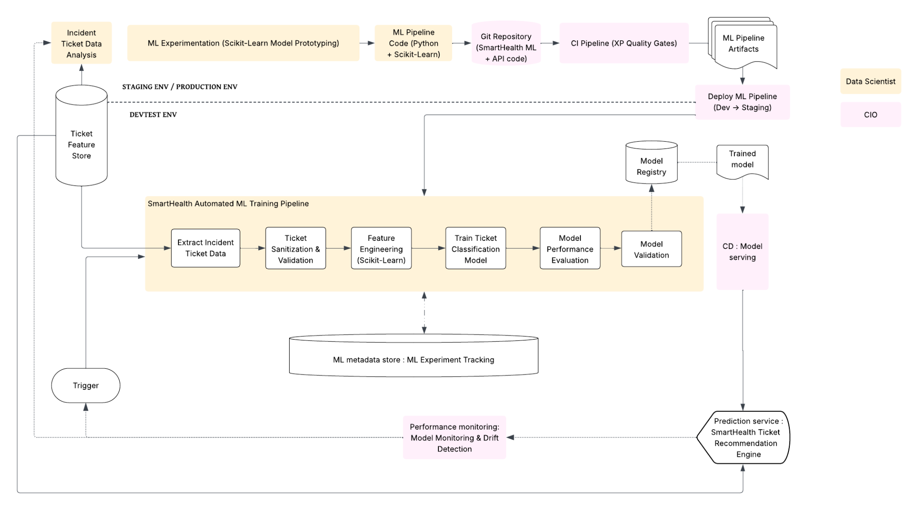
Figure 1. SmartHealth MLOps Infrastructure Overview
While the High-Level Design (HLD) describes the system-level components and data flow within the SmartHealth platform, the MLOps infrastructure focuses on the operational environment that supports the lifecycle of machine learning models. Together, they provide complementary views: the HLD explains the architecture of the system, while the MLOps infrastructure ensures that ML models can be developed, deployed, and monitored reliably within that architecture.
4. Integration of DevOps and MLOps in SmartHealth
While DevOps manages the lifecycle of traditional software applications, machine learning systems introduce additional complexities such as data dependencies, model training processes, and performance monitoring. To address these challenges, SmartHealth integrates MLOps practices into its existing DevOps infrastructure, enabling the organization to manage machine learning models in a similar automated and reproducible manner.
MLOps extends DevOps principles to the lifecycle of machine learning systems, including model training, validation, deployment, and monitoring (Google Cloud, 2023)[2]. Within SmartHealth, this integration allows machine learning pipelines to operate alongside the existing DevOps infrastructure while maintaining consistency with the organization’s SDLC governance model.
The integrated DevOps–MLOps workflow operates as follows:
- Model experimentation begins in the research environment, where data scientists analyze incident ticket data and develop classification models using Scikit-learn.
- ML pipeline code is stored within the SmartHealth Git repository, alongside supporting API components. This repository becomes the central source of truth for both application code and machine learning pipelines.
- Continuous Integration pipelines enforce XP quality gates, automatically testing feature engineering logic, model training routines, and sanitization workflows whenever code changes occur.
- Automated ML training pipelines process incident ticket data, performing data extraction, PHI sanitization, feature engineering, model training, and model evaluation.
- Validated models are registered within a Model Registry, enabling version control and traceability for deployed machine learning models.
- Model serving infrastructure deploys the approved model, exposing it as a prediction service used by the SmartHealth Ticket Recommendation Engine.
- Model monitoring continuously evaluates performance, detecting data drift or performance degradation and triggering retraining workflows when necessary.
Through this integration, SmartHealth creates a unified engineering workflow where DevOps pipelines manage infrastructure and application deployment, while MLOps pipelines manage the lifecycle of machine learning models. The combination of these practices enables SmartHealth to maintain scalable and reliable AI-driven services while continuously improving the accuracy and performance of its ticket triage system.

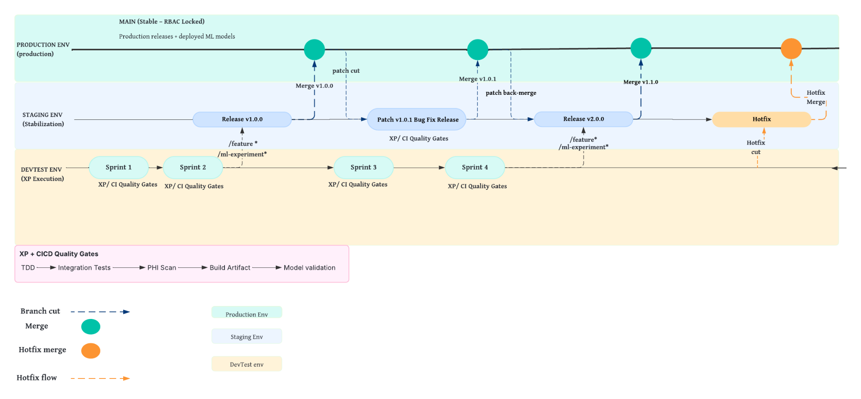
Fig. 2 Branching strategy in SmartHealth.

Figure 2 illustrates the integrated DevOps and MLOps branching strategy [4] [3] used in SmartHealth. Development and machine learning experimentation occur during sprint cycles in the DevTest environment through feature and ML-experiment branches, following XP practices and CI quality gates such as testing, PHI scanning, and model validation. In this workflow, the DevOps engineering team manages the CI/CD infrastructure, environment promotion, and deployment pipelines, while the MLOps and data science teams manage model development, training pipelines, and model validation processes. Stable builds are promoted to the staging environment through release branches for further validation before merging into the RBAC-protected main branch in production. This workflow ensures that both application code and ML models are deployed through a controlled, reproducible, and secure pipeline.

[1] DevOps is a set of practices that combines software development and IT operations to shorten development cycles and deliver high-quality software continuously. https://www.atlassian.com/devops

[2] MLOps is the practice of applying DevOps principles to machine learning systems to automate and manage the ML lifecycle, including training, deployment, and monitoring.
https://docs.cloud.google.com/architecture/mlops-continuous-delivery-and-automation-pipelines-in-machine-learning
[3] https://www.abtasty.com/blog/git-branching-strategies/
[4] ISBA2408 Winter 2026 RelBranchProjMgm.pdf
[5] HP Labs. Research and Innovation at HP Labs.
https://www.hpe.com/us/en/what-we-do/innovation-at-hpe/hpe-labs.html

The SmartHealth testing strategy connects business objectives, technical validation, and regulatory compliance requirements to clearly defined testing activities and measurable outcomes. By structuring the strategy around the WHY–WHAT–HOW framework, the plan ensures that each test directly supports operational goals such as improving triage efficiency, maintaining HIPAA compliance, and validating machine learning performance. This approach provides a systematic way to verify that the system is accurate, compliant, auditable, and reliable before production deployment.

Test Strategy :
The testing strategy aligns SmartHealth’s business objectives, technical requirements, and regulatory compliance goals with defined validation methods and measurable success metrics. Each testing activity ensures that the system meets operational performance targets, maintains HIPAA compliance, and delivers reliable machine learning–assisted triage recommendations.
WHY (Goal Type) | WHAT (Testing Strategy) | HOW (Success Metrics / Validation)
Business – Regulatory compliance (HIPAA) | PHI detection and redaction validation testing to ensure sensitive patient information is identified and sanitized before processing. | 100% of detected PHI fields are masked before storage or ML processing; no unsanitized ticket enters the ML pipeline.
Technical – ML model accuracy | Cross-validation and holdout dataset testing to evaluate category and priority prediction performance. | ≥ 80% overall classification accuracy for ticket category and priority on validation dataset.
Business – Reduce manual triage effort | End-to-end workflow and benchmark testing of ML-assisted triage recommendations. | ≥ 30% reduction in average triage time compared to baseline manual triage process.
Business – Improve routing accuracy | Resolution-path and routing recommendation validation testing. | ≥ 30% reduction in ticket misrouting or reassignment compared to historical baseline.
Business – Faster response to critical issues | Priority classification and escalation testing. | ≥ 25% improvement in response time for high-priority or critical tickets.
Technical – Confidence-aware decision support | Boundary and threshold testing for ML confidence scores. | Low-confidence recommendations are flagged 100% of the time and routed for manual review.
Technical – Human-in-the-loop control | Functional testing of accept/reject workflow for ML recommendations. | 100% of ML recommendations remain advisory only, and all accept/reject actions are logged with user ID and timestamp.
Business / Compliance – Auditability | Audit logging and traceability validation testing. | 100% of PHI actions, triage overrides, and escalation decisions recorded with timestamp and user ID.
Operational – Onsite technician efficiency | Onsite vs. remote classification and filtering tests. | Reduction in unnecessary onsite escalations; low-priority issues are filtered from onsite queues.
Technical – Reliability and production readiness | Regression, integration, and monitoring validation testing. | Stable release candidate with no critical defects, and monitoring/retraining mechanisms validated.
Reference
[1] ISBA2408 Winter 2026 Test Strategy.pdf

1. Test Data Types
To validate the SmartHealth platform, multiple categories of test data are used to simulate realistic ticket triage scenarios while ensuring HIPAA compliance and system reliability. Effective test data management ensures that systems can be validated using realistic datasets while preventing exposure of sensitive production information [1].
Sanitized Incident Ticket Data
- Historical service tickets with PHI removed or masked
- Used to test ML classification accuracy and routing recommendations
PHI Detection Test Data
- Ticket descriptions containing synthetic PHI elements (names, MRNs, identifiers)
- Used to validate PHI detection and redaction workflows
Ticket Classification Data
- Tickets representing different categories such as infrastructure issues, application failures, vendor-related incidents, and routine requests
- Used to validate category and priority prediction models
User Interaction Data
- Simulated triage decisions such as accepting or rejecting ML recommendations
- Used to validate human-in-the-loop workflows and audit logging
Onsite vs Remote Resolution Scenarios
- Test cases representing both remote-resolvable and onsite-required issues
- Used to validate ML-based filtering and routing logic
2. Data Creation Approaches
To ensure testing accuracy while maintaining regulatory compliance, SmartHealth uses multiple test data generation approaches. Synthetic and sanitized datasets allow testing teams to reproduce realistic scenarios while protecting sensitive information [2].
Synthetic Ticket Data
- Artificially generated incident tickets with controlled attributes such as category, priority, and resolution path
- Allows systematic testing of classification and routing logic
Production-Sanitized Data
- Real historical incident tickets that have undergone PHI redaction
- Provides realistic datasets for ML model evaluation and workflow validation
Edge Case Simulation
- Tickets containing incomplete descriptions, unusual keywords, or ambiguous routing information
- Used to test model robustness and error handling
PHI Injection Testing
- Controlled insertion of synthetic PHI patterns into ticket text
- Ensures PHI detection and redaction mechanisms function correctly
3. Test Environment
Testing activities are performed in isolated environments that replicate the SmartHealth production architecture while preventing exposure of sensitive operational data. Isolated testing environments and automated pipelines are considered best practices for validating software systems prior to deployment [4].
DevTest Environment
- Used for feature development and ML experimentation during sprint cycles
- Supports automated CI testing, feature branch validation, and ML pipeline experimentation
Staging Environment
- Used for integrated system testing before production release
- Validates end-to-end workflows including ticket ingestion, PHI sanitization, ML inference, and routing recommendations
Production-Simulated Monitoring Environment
- Used to evaluate monitoring workflows, model performance tracking, and retraining triggers
- Ensures the system can detect model drift and operational anomalies
CI/CD Infrastructure
- Automated pipelines execute testing workflows including unit tests, integration tests, PHI scanning, and model validation before deployment
4. Test Design Techniques
SmartHealth applies multiple software testing techniques to ensure system correctness, reliability, and compliance. Techniques such as boundary value analysis, equivalence partitioning, and state transition testing are commonly used to validate system behavior under different input conditions[4].
Boundary Value Analysis (BVA)
- Tests limits of ML confidence thresholds and routing decision boundaries
Example:
- Confidence score near threshold (0.49, 0.50, 0.51)
Equivalence Partitioning
- Groups similar ticket inputs into categories to reduce redundant test cases
Example partitions:
- PHI-present tickets
- PHI-free tickets
- Remote-resolvable issues
- Onsite-required issues
State Transition Testing
Used to validate workflow states across the ticket triage lifecycle.
Example states:
Ticket Ingested → PHI Scanned → Sanitized → Classified → Routed → Resolved
End-to-End Scenario Testing
Simulates the complete SmartHealth workflow.
Example scenario:
Ticket Submitted
→ PHI detection executed
→ PHI redaction applied
→ ML classification generated
→ Recommendation shown to consultant
→ Consultant accepts or rejects suggestion
→ Routing decision logged
5. Test Execution and Validation
Testing activities are integrated into the DevOps and MLOps CI/CD pipelines, ensuring that validation occurs automatically during development and release cycles. Continuous testing pipelines are commonly used in DevOps and MLOps environments to ensure reliability and maintain consistent system performance [3].
Key validation checks include:
- PHI detection and masking validation
- ML model accuracy testing
- Routing recommendation correctness
- Audit logging verification
- Monitoring and retraining trigger validation
References

[1] ISTQB. (2023). ISTQB Glossary of Testing Terms. Retrieved from
https://glossary.istqb.org
[2] TechTarget. (n.d.). Guide to Synthetic Test Data. Retrieved from
https://www.techtarget.com/searchsoftwarequality/tip/Guide-to-synthetic-test-data
[3] Google Cloud. (2023). MLOps: Continuous Delivery and Automation Pipelines in Machine Learning. Retrieved from
https://cloud.google.com/architecture/mlops-continuous-delivery-and-automation-pipelines-in-machine-learning
[4] Pressman, R. S., & Maxim, B. R. (2020). Software Engineering: A Practitioner’s Approach (9th ed.). McGraw-Hill.

