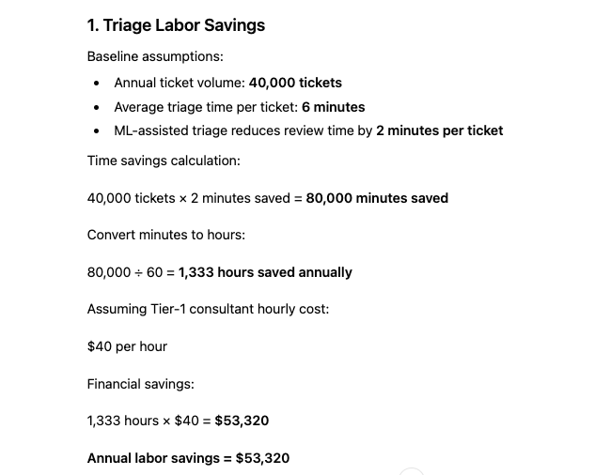

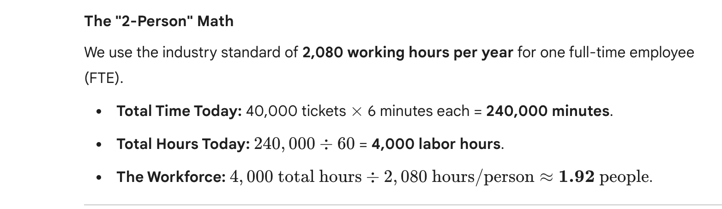
- Distributed Effort: We aren't saying two people sit in a room doing only this. We are saying that across the entire support team, the "tax" of manual triage adds up to the capacity of two full-time humans.
- The "Tax" on Talent: Right now, SmartHealth is paying $160,000 a year (2 people $\times$ $40/hr$) just to have humans act as "digital mail sorters."
- The Efficiency Gain: By moving from 6 minutes to 4 minutes per ticket, we "hire back" 0.65 of a person (1,333 hours) without actually adding anyone to the payroll.

Category | The "Before" (Problem) | The "After" (AI Solution) | Financial Impact
1) Triage Labor Savings | 6 mins/ticket spent on manual "mail sorting." | 4 mins/ticket; AI handles the heavy lifting. | $53,320 (1,333 hours saved)
2) Capacity Expansion | Hiring needed to handle more volume. | Current team handles 20,000 extra tickets. | $100,000 (New Revenue)
3) Quality & SLA | Human errors lead to fines and senior staff rework. | 50% fewer SLA fines; 40% less rework. | $28,000 (Penalty/Labor Savings)
4) Travel Avoidance | Wasted onsite trips for remote-fixable issues. | 30% reduction in unnecessary dispatches. | $27,000 (Transport Savings)
TOTAL ANNUAL BENEFIT |  |  | $208,320

1. Triage Labor Savings (The "Time Back" Category)
- The Idea: Right now, your team spends 6 minutes on every ticket just "sorting the mail."
- The Change: The AI does the heavy lifting, cutting that time down to 4 minutes.
- The Math: Saving 2 minutes on 40,000 tickets = 1,333 hours saved per year.
- The Value: Since you pay consultants $40/hour, that’s $53,320 worth of "wasted time" you just bought back.

2. Revenue Through Capacity Expansion (The "Growth" Category)
- The Idea: If you give your team those 1,333 hours back, what do they do with them? They solve more problems!
- The Change: Instead of hiring new people to grow, your current team can now handle 20,000 more tickets in that "found" time.
- The Value: Processing 20,000 more tickets is a massive growth opportunity worth $100,000 in new revenue.

3. SLA & Rework Reduction (The "Quality" Category)
- The Idea: Humans make mistakes. We misroute tickets, which causes delays (SLA breaches) and forces high-paid senior staff (Tier-2) to fix the errors (Rework).
- The Change: The AI is more accurate and consistent. It cuts those expensive penalties by 50% and reduces that "fix-it" work by 40%.
- The Value: Between fewer fines and less wasted effort from senior staff, you save $28,000.

4. Onsite Dispatch Avoidance (The "Travel" Category)
- The Idea: Sometimes we send a technician to a hospital for a "hardware" issue, only to find out it was a "software" fix that could have been done remotely. That’s a wasted trip.
- The Change: The AI gets better at identifying which issues actually need a person onsite. We cut unnecessary trips by 30%.
- The Value: At $150 per trip, avoiding those useless drives saves $27,000.

The Summary Pitch
"Think of it this way: Our revenue depends on Volume and Velocity.
- Velocity (Speed): We are shaving 2 minutes off every ticket (Category 1) and cutting travel time (Category 4).
- Volume (Capacity): Because we are faster, we can now handle 20,000 more tickets without hiring a single new person (Category 2).

To explain your costs clearly and confidently to the judges, focus on the fact that this is a low-upfront investment designed for long-term stability.
Here is the simple breakdown:

Initial Investment ($35,000): "Setting the Foundation"
We are considering this as a one-time "launch" cost. It covers three critical areas:
- People: Training our staff to work alongside the AI ($10,000).
- Technology: Building the actual connection between our ML models and our CRM, like Salesforce ($15,000).
- Safety: Setting up the "Compliance Shield" to validate that patient data is automatically scrubbed ($10,000).

Annual OPEX ($57,000): "Keeping the Engine Running"
This recurring cost ensures the system remains accurate and secure over time. It is broken down by:
- Compliance ($30,000): This is our largest bucket because healthcare requires constant auditing. This covers quarterly reviews to ensure we stay HIPAA-safe.
- Model Health ($9,000): AI models can "drift" over time. This pays for periodic retraining to keep accuracy above 80%.
- Infrastructure ($18,000): This covers the cloud computing power needed to process 40,000 tickets and the DevOps automation that keeps the system online 24/7.

The Pitch Logic
"Our cost structure is designed to be lean. We spend $35,000 upfront to build a secure, integrated foundation. After that, our $57,000 annual OPEX is heavily weighted toward Compliance and Auditing, because in healthcare IT, being 'fast' only matters if you are also 'safe.' Even with these recurring costs, the project generates a net benefit of over $116,000 in Year 1 alone."
Would you like me to help you summarize this into a single "Investment Summary" slide?

Annual Operating Cost (OPEX)

Breakdown:
- Monitoring & Compliance Oversight: $30,000
- Infrastructure & Model Maintenance & Updates: $15,000
- DevOps Operations: $12,000
Total Annual OPEX = $57,000
2. Annual Financial Benefits
SmartHealth generates value through four primary operational improvements.
1. Triage Labor Savings
Baseline assumptions:
- Annual ticket volume: 40,000 tickets
- Average triage time per ticket: 6 minutes
- ML-assisted triage reduces review time by 2 minutes per ticket
Time savings calculation:
40,000 tickets × 2 minutes saved = 80,000 minutes saved
Convert minutes to hours:
80,000 ÷ 60 = 1,333 hours saved annually
Assuming Tier-1 consultant hourly cost:
$40 per hour
Financial savings:
1,333 hours × $40 = $53,320
Annual labor savings = $53,320
2. Revenue Through Capacity Expansion
The time saved from triage allows consultants to resolve additional support tickets.
Available time:
1,333 hours = 79,980 minutes
Average ticket resolution time: 4 minutes per ticket
Additional ticket capacity:
79,980 ÷ 4 = ~20,000 additional tickets annually
Assuming average profit contribution per ticket:
$5 per ticket
Revenue generated:
20,000 × $5 = $100,000
Annual revenue gain = $100,000
3. SLA Compliance & Rework Reduction
Baseline assumptions:
- Approximately 80 SLA breaches per year
- Average cost per breach: $300
Baseline cost:
80 × $300 = $24,000
With improved routing accuracy:
Expected reduction in SLA breaches = 50%
Savings:
≈ $12,000
Additionally, improved classification reduces Tier-2 rework.
Estimated rework reduction savings:
≈ $16,000
Total benefit:
$28,000 annually
4. Onsite Dispatch Avoidance
Baseline assumptions:
- Approximate onsite dispatches per year: 600
- Average cost per dispatch: $150
Total dispatch cost:
600 × $150 = $90,000 annually
Improved classification identifies which incidents can be resolved remotely.
Assumed reduction:
30% fewer unnecessary dispatches
Savings:
$90,000 × 30% = $27,000
Annual dispatch cost savings = $27,000
3. Total Annual Benefits
Combining all operational improvements:
- Triage Labor Savings: $53,320
- Revenue Capacity Expansion: $100,000
- SLA & Rework Reduction: $28,000
- Onsite Dispatch Avoidance: $27,000
Total Annual Benefits = $208,320
4. Net Annual Benefit (Year 1)
Total first-year cost:
Initial Investment = $35,000
Annual OPEX = $57,000
Total Cost:
$35,000 + $57,000 = $92,000
Net benefit calculation:
$208,320 − $92,000 = $116,320
Net Annual Benefit (Year 1) = $116,320
5. Return on Investment (ROI)
ROI Formula:
ROI = Net Benefit ÷ Total Cost
Calculation:
$116,320 ÷ $92,000 = 1.264
ROI = 126.4%
6. Payback Period
Monthly net benefit:
$116,320 ÷ 12 = $9,693 per month
Payback calculation:
$92,000 ÷ $9,693 ≈ 9.5 months
Payback Period ≈ 9–10 months
7. Key Financial Summary
Metric | Value
Initial Investment | $35,000
Annual Operating Cost | $57,000
Total Annual Benefits | $208,320
Net Annual Benefit | $116,320
ROI | 126%
Payback Period | ~9.5 months

8. Conservative Scenario (Important for Judges)
Even if the revenue expansion benefit ($100K) is excluded, SmartHealth still produces measurable financial returns.
Remaining benefits:
- Labor Savings: $53,320
- SLA Reduction: $28,000
- Dispatch Reduction: $27,000
Total conservative benefit:
$108,320 annually
This still exceeds the $92,000 first-year cost, meaning the project remains financially viable even under conservative assumptions.

