ROLLNO: 1954

SUBJECT:PL305

NAME: TRUPTI TUKARAM SHETMANDREKAR

**Project title:**

**HOSPITAL MANAGEMENT SYSTEM**

**Introduction:**

The project Hospital Management is developed to computerize the Front Office Management of Hospital as well as for patient.

This system includes registration of patients, storing their details into the system and also computerized billing .The software has the facility to give a unique id for every patient and stores the details of every patient and the staff automatically.it lets patient to take appointment

**Objective:**

* Scheduling appointments for patients with doctor to make it convenient for both
* To computerize all details regarding patients and hospital
* Design a system for better patient care.
* Reduce hospital operating costs.
* The information of patient should kept up to date and should kept in system for historical purpose

“Hospital Management System” is developed to computerize the following functions that are performed by the system:

**Admin:**

* Admin can add new doctor specialization.
* Admin can register new doctor through this system.
* Admin can register new patient through this system.
* Administrator can add new doctors in the system and can also check all the doctors list of the hospital.
* This system is keeps records of Patient’s.
* Admin can issue bill
* Admin can check feedback
* Cancel the appointment if doctor is not available.
* Can cancel email and password
* View appointments details

**Doctor:**

* Check appointments
* Cancel appointment is doctor has other appointment or doctor is not available
* Update profile
* Change password

**Patient:**

* Register
* Book appointments
* Cancel appointment
* Give feedback to the doctor
* View list of all doctors
* View appointment details
* Manage profile
* Change password

**Requirement:**

Front end : Html ,css , javascript

Serverside script: Php

Database : MySql

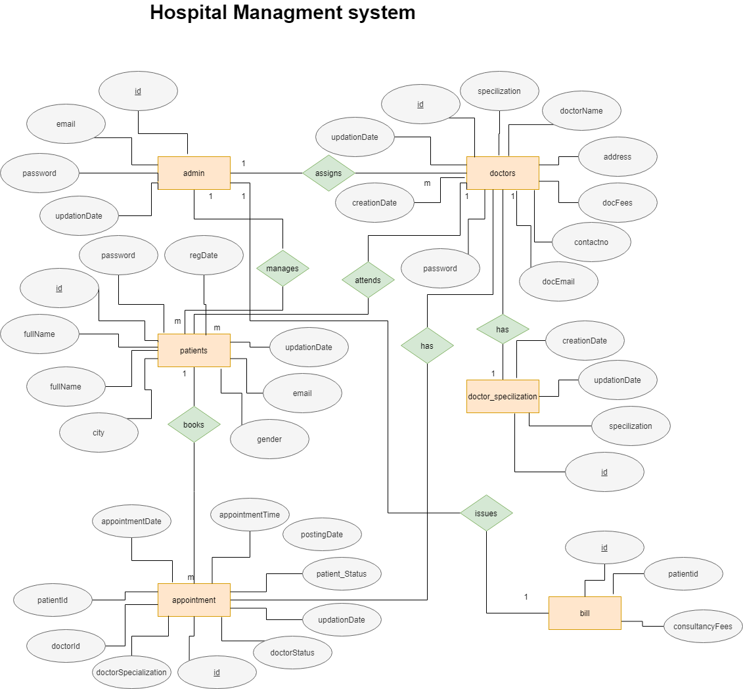 It has one more table to store feedbacks

Feedback(id ,doctorname , doctorspecialization, patientname,q1,q2,q3,q4,q5,total,percentage)

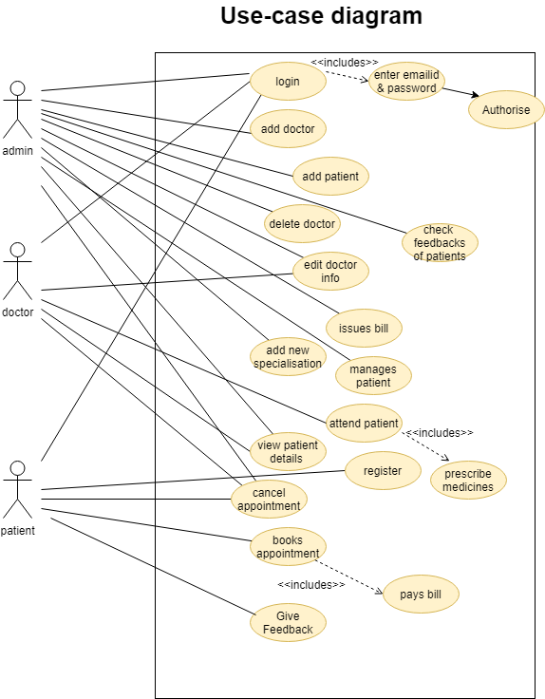

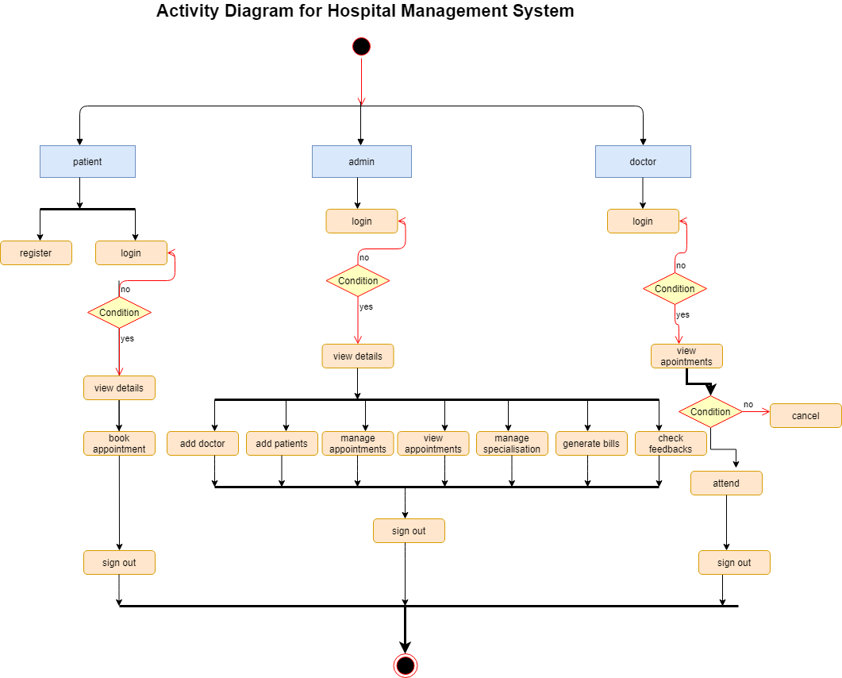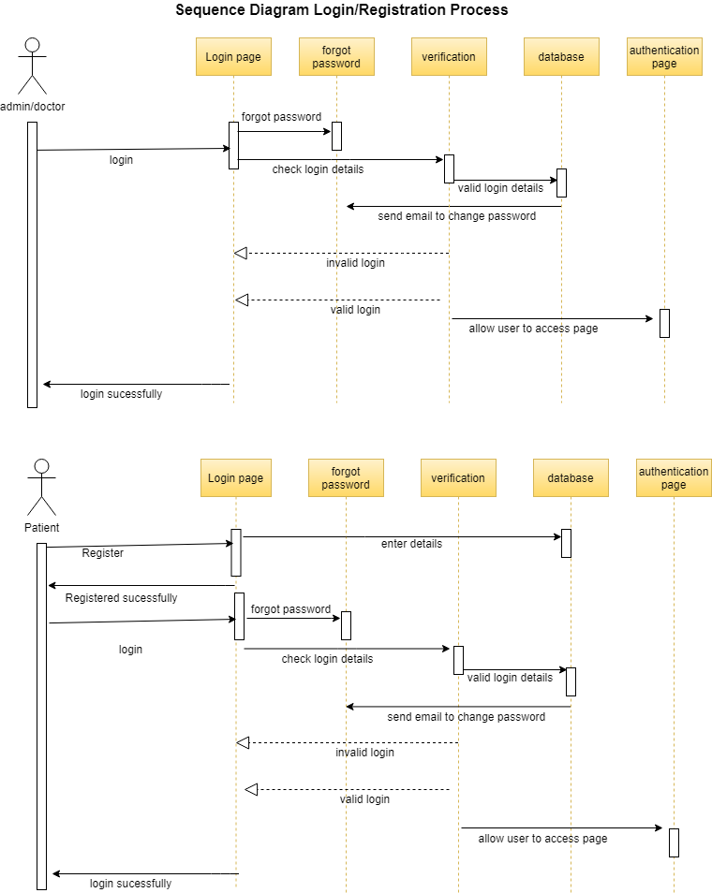

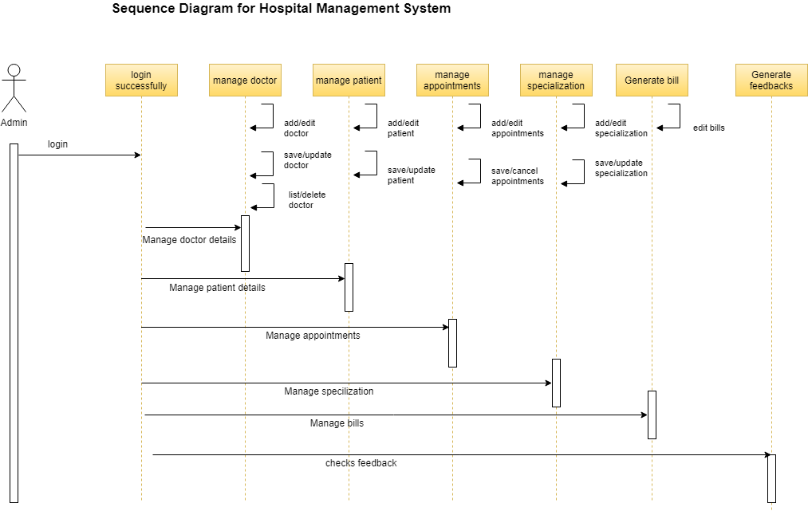 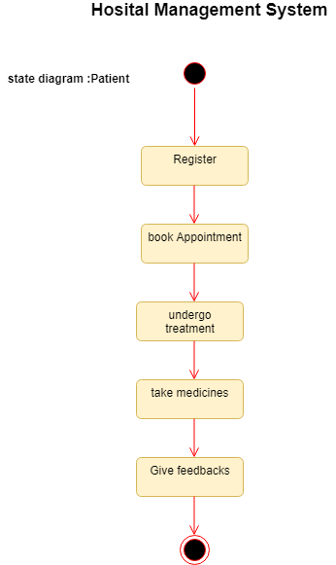

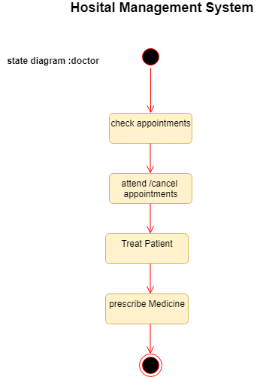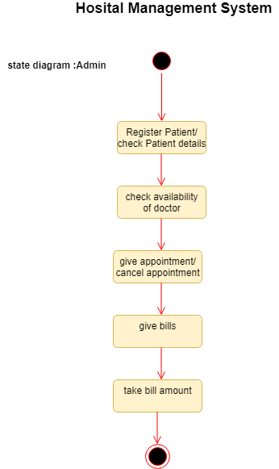

**Reports:**

It will check the feedback

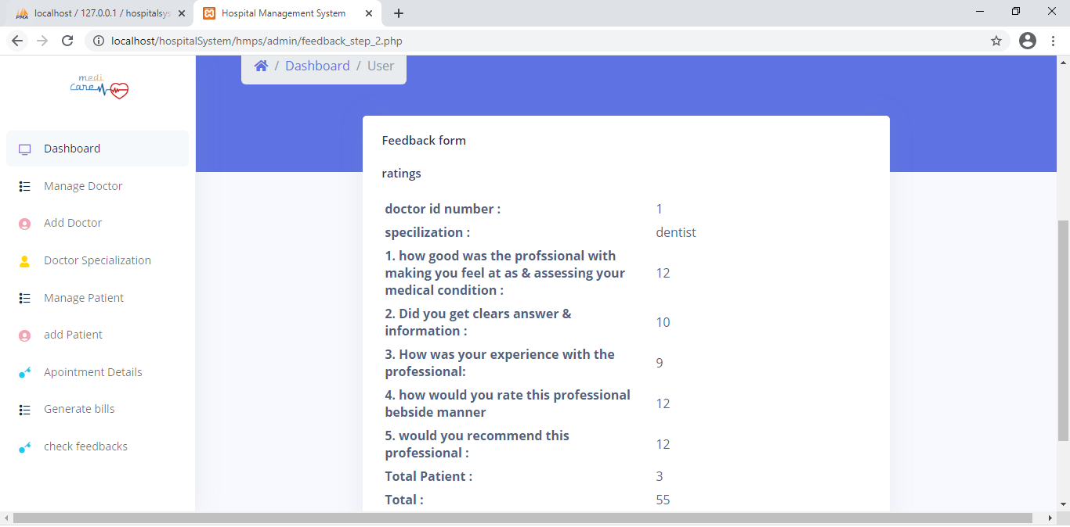

It will generate bills for the patients

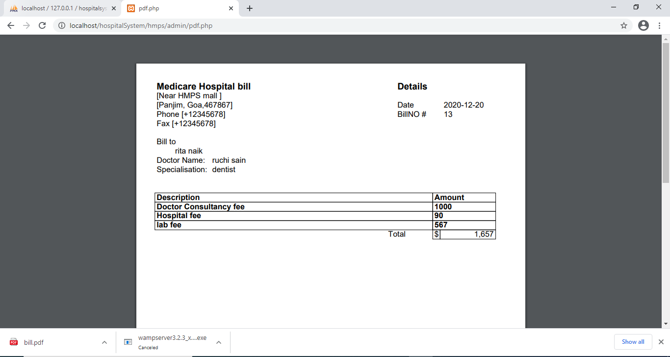

Home page:

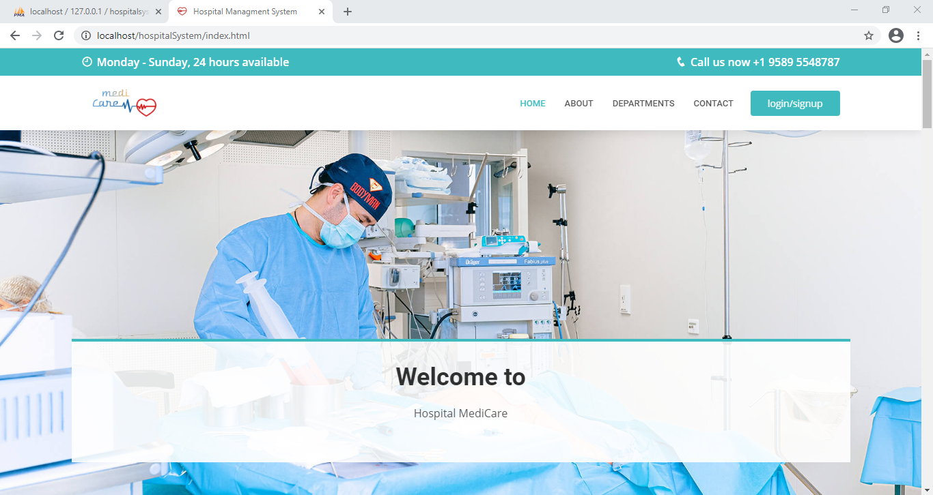

Login for all 3 users:

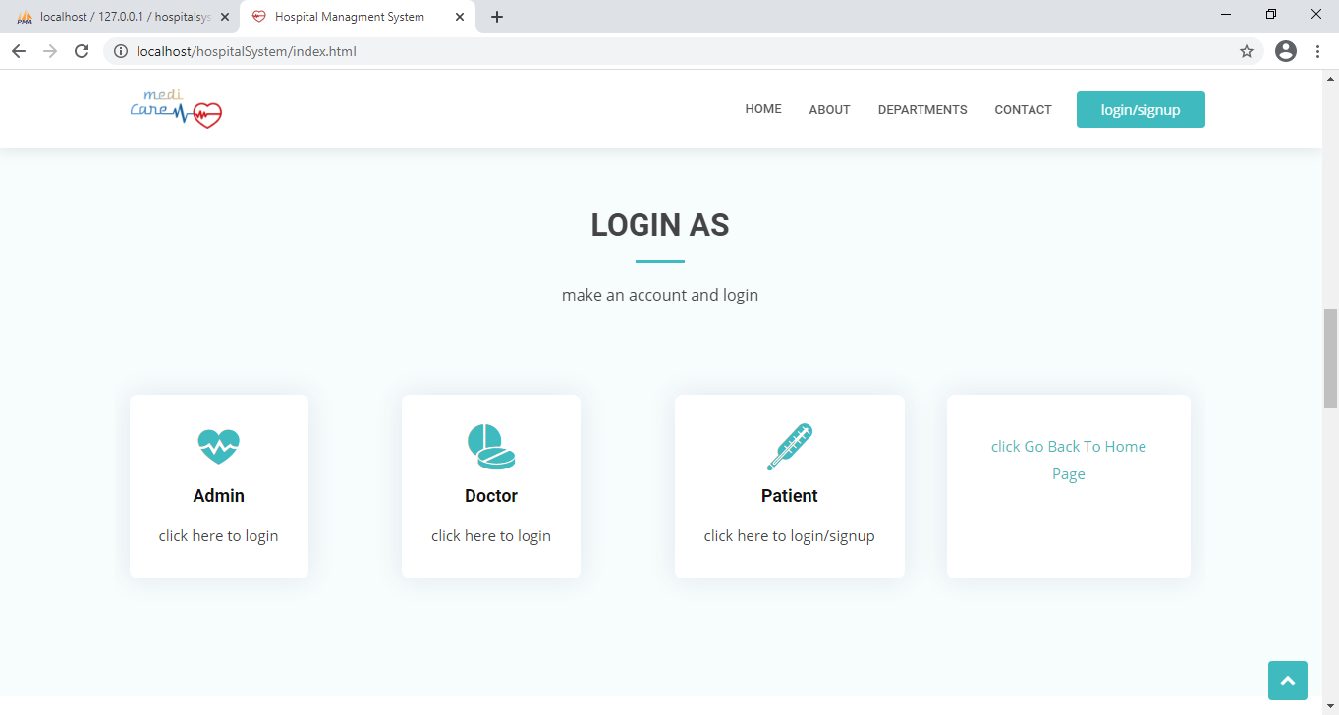

Admin login form

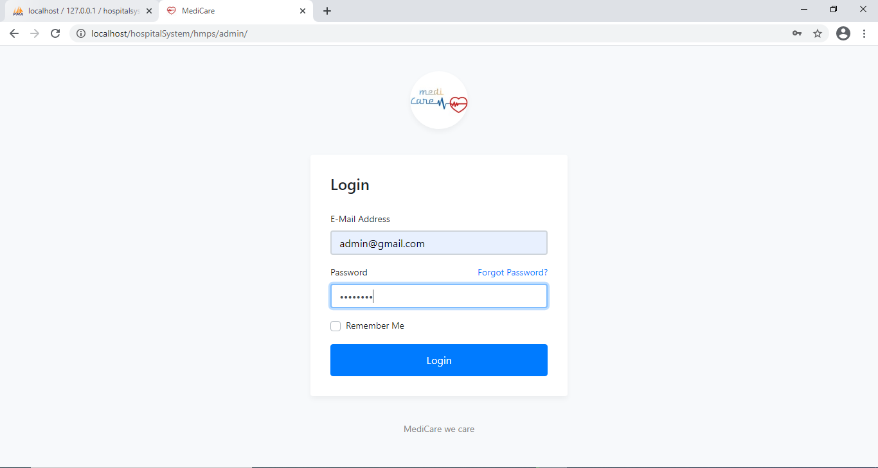

Admin dashboard:

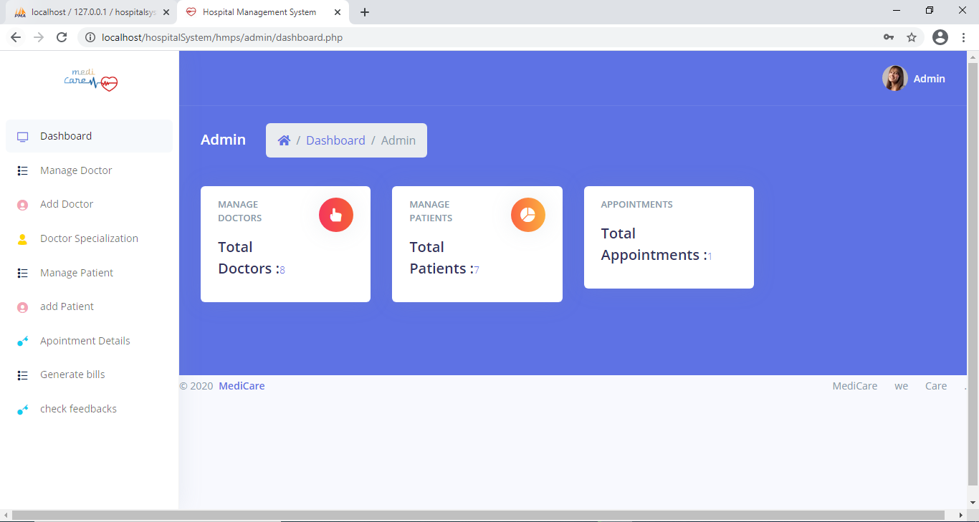

Manage doctor

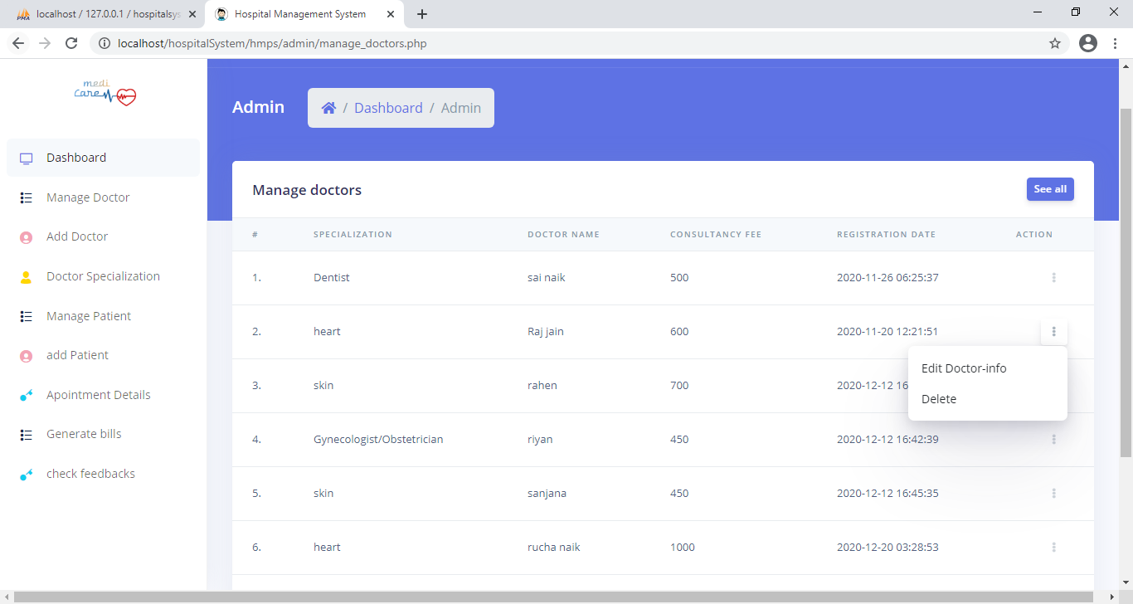

Edit doctor details:

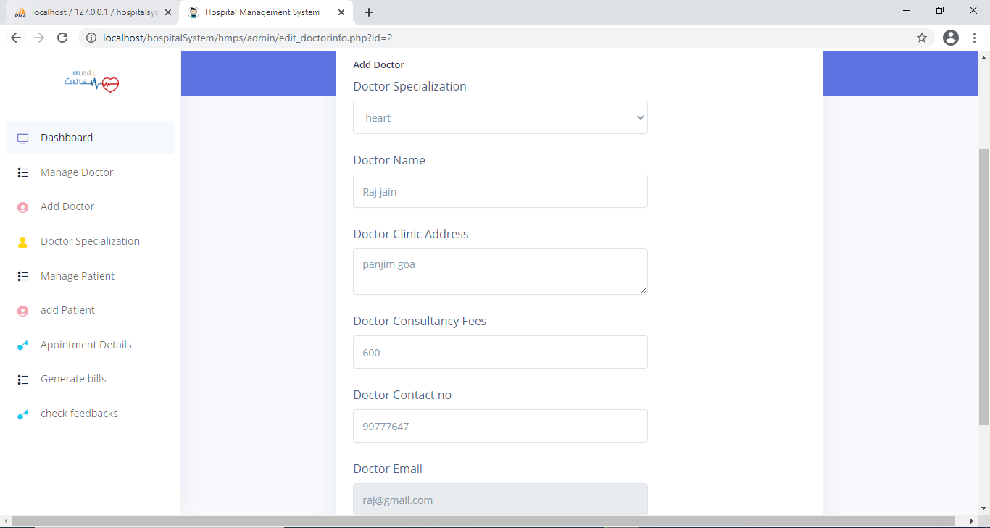

Add doctor:

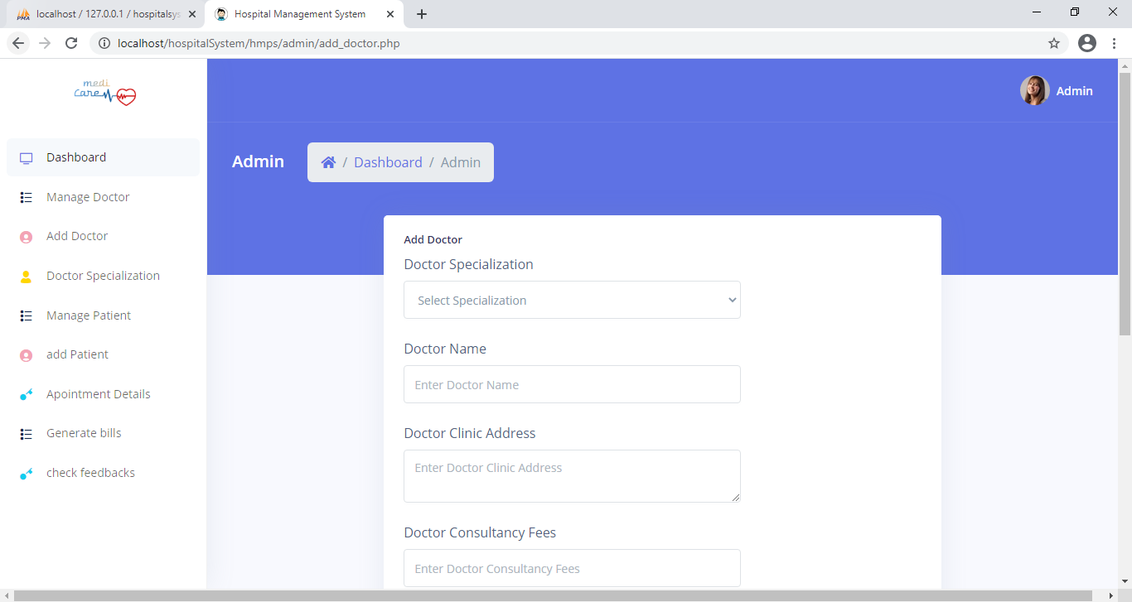

Add new specialization:

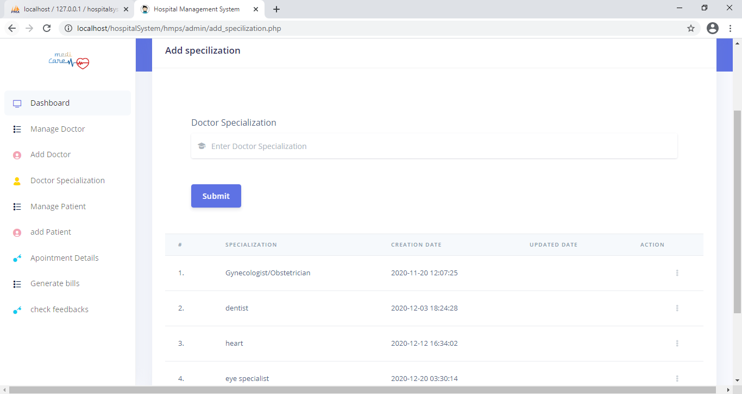

Manage patient

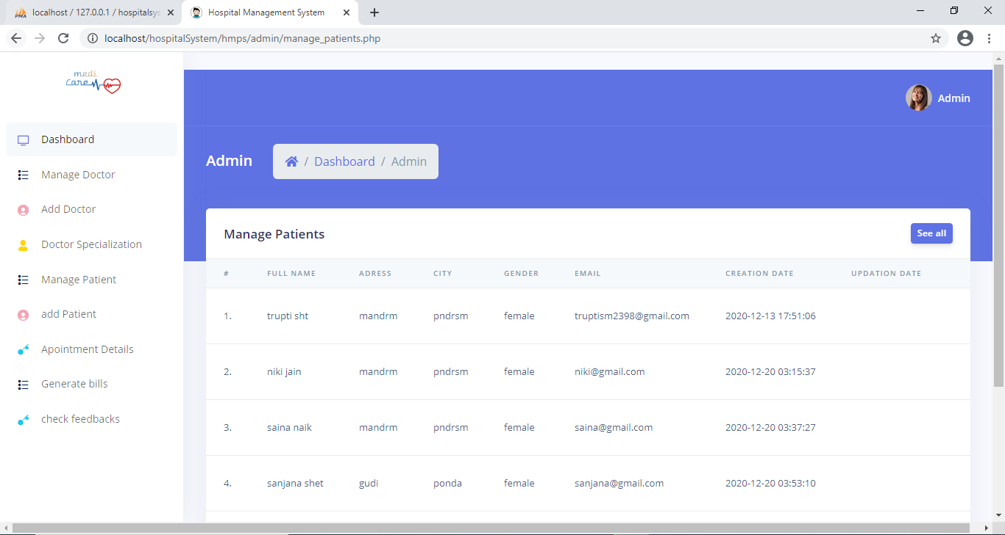

Add patient:

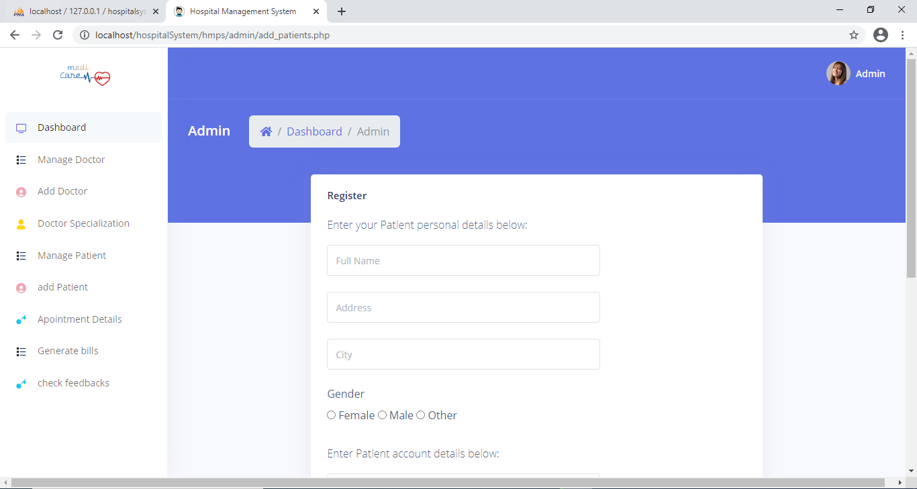

Appointment details:

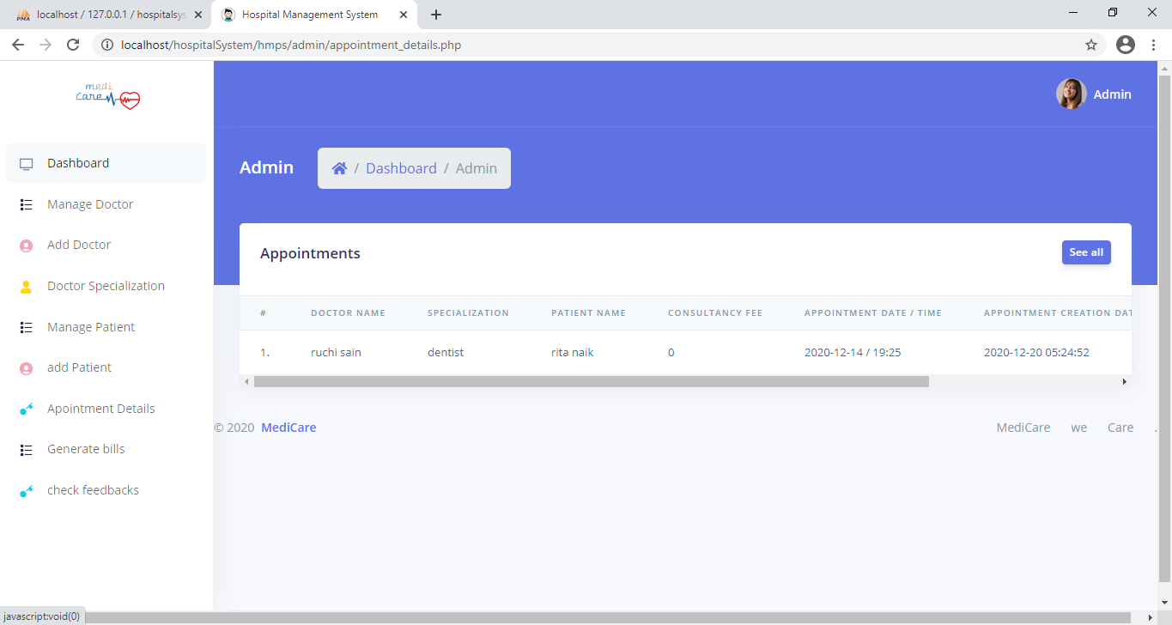

Generate bills:

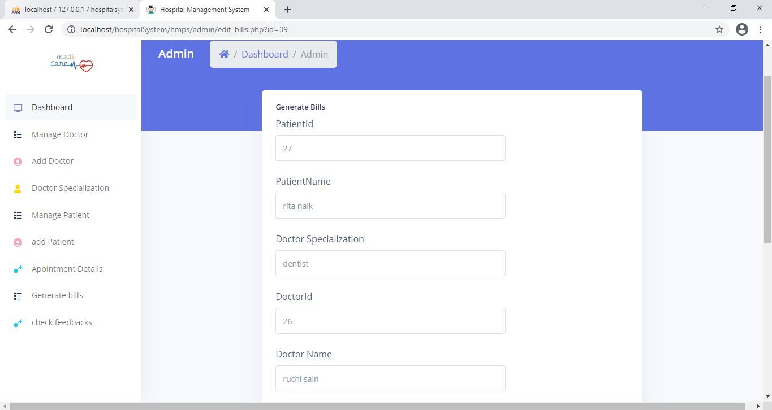

Bill pdf generation & download:



Check Feedback form of particular doctor:

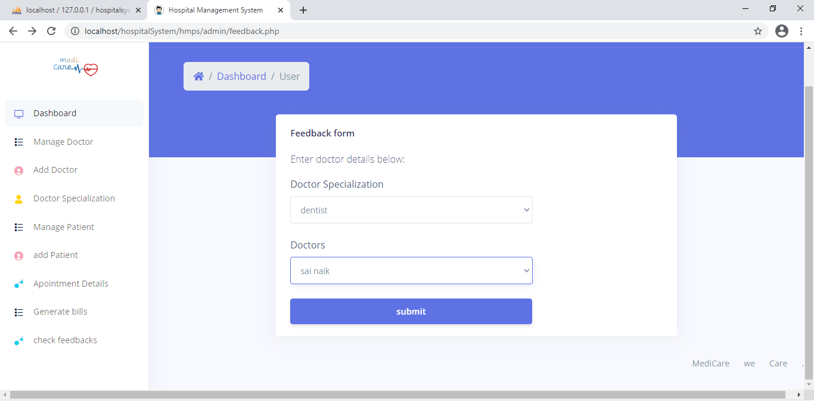

Feedbacks:



Edit details:

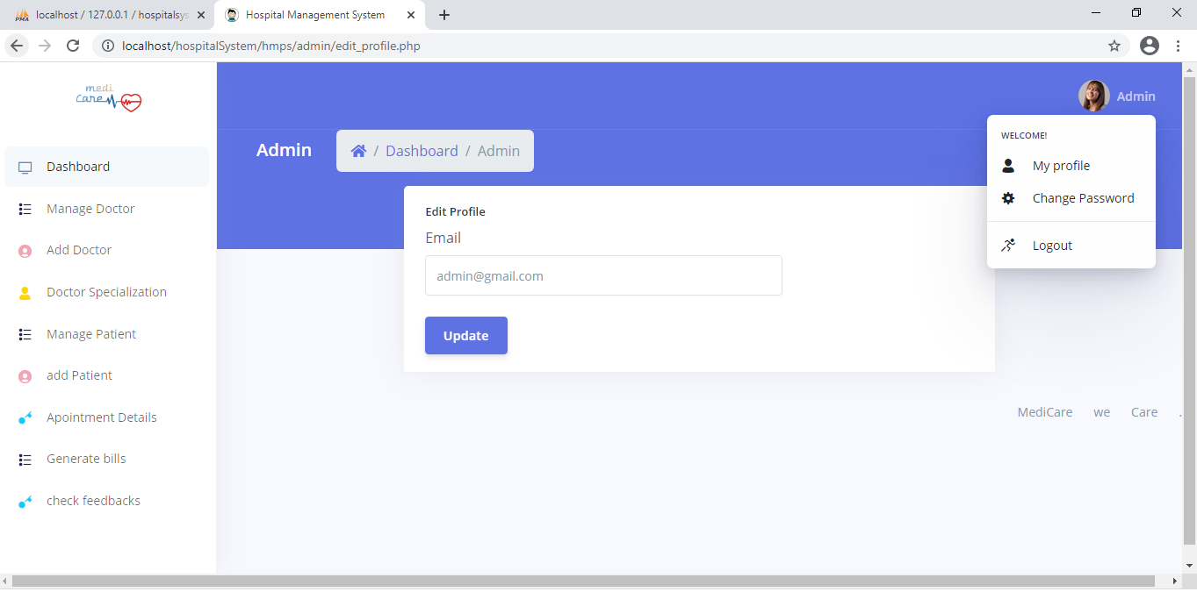

Change password:

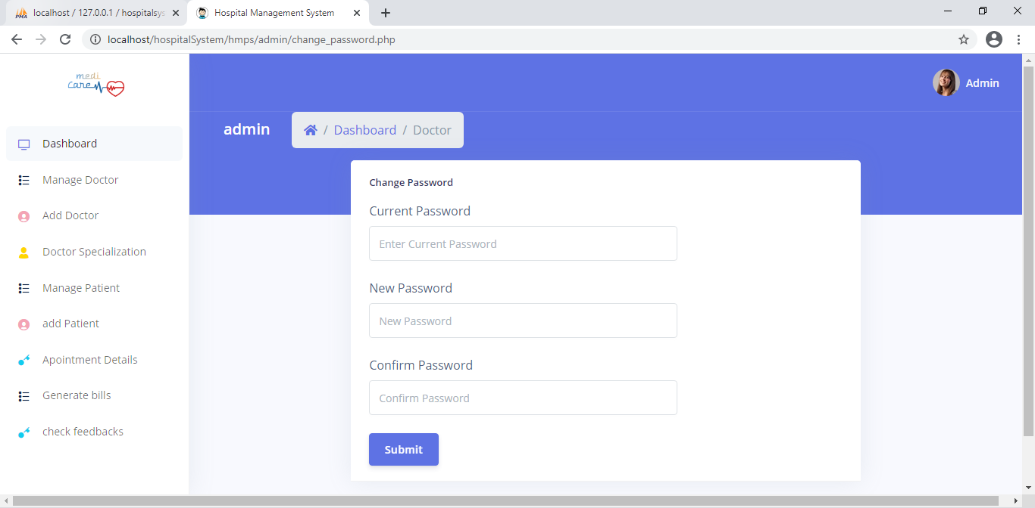

Doctor login form:

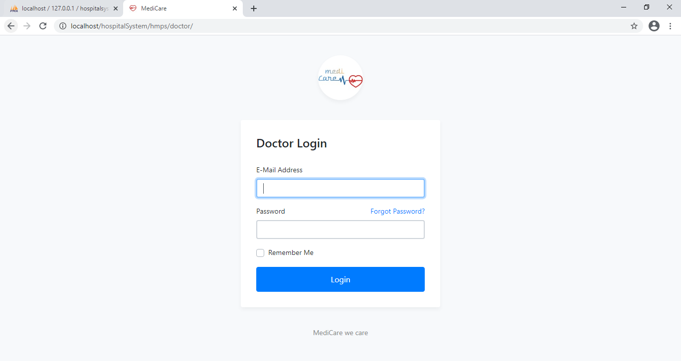

Doctor dashboard:

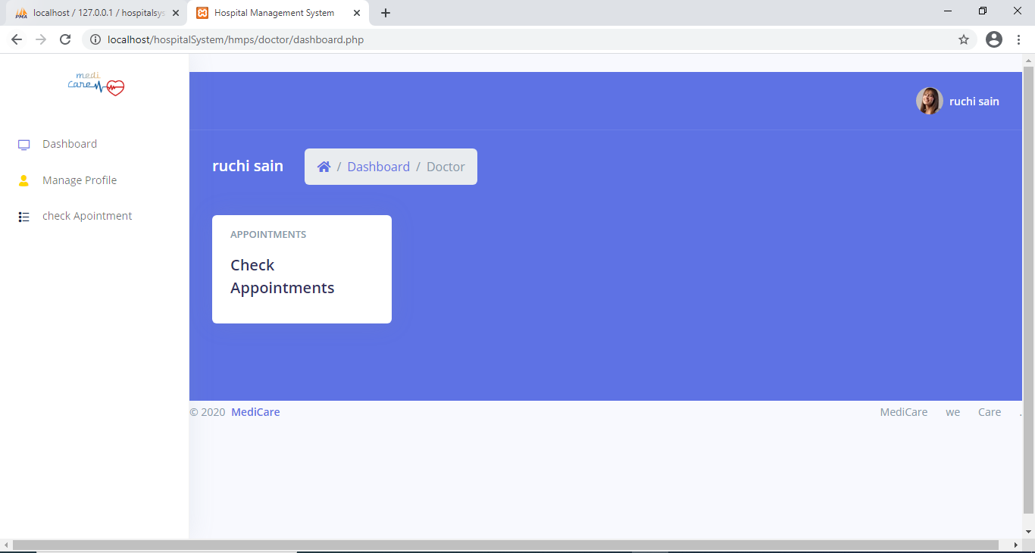

Check appointment:

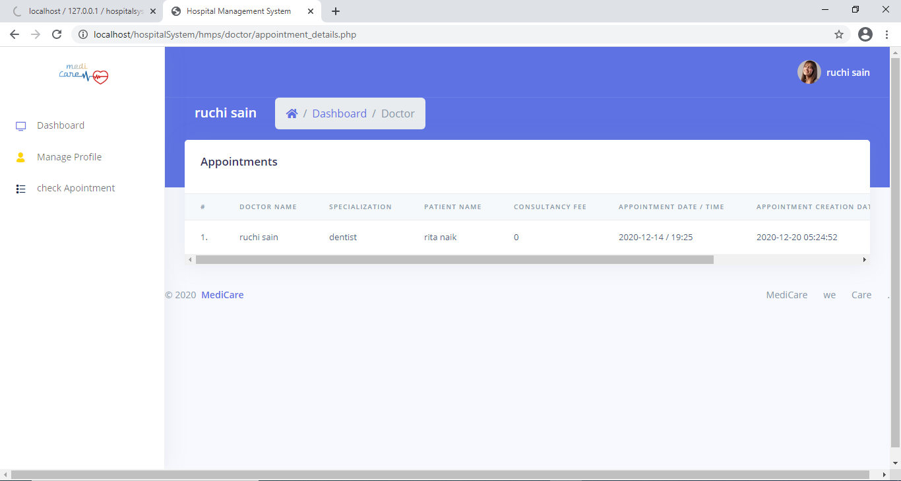

Manage profile:

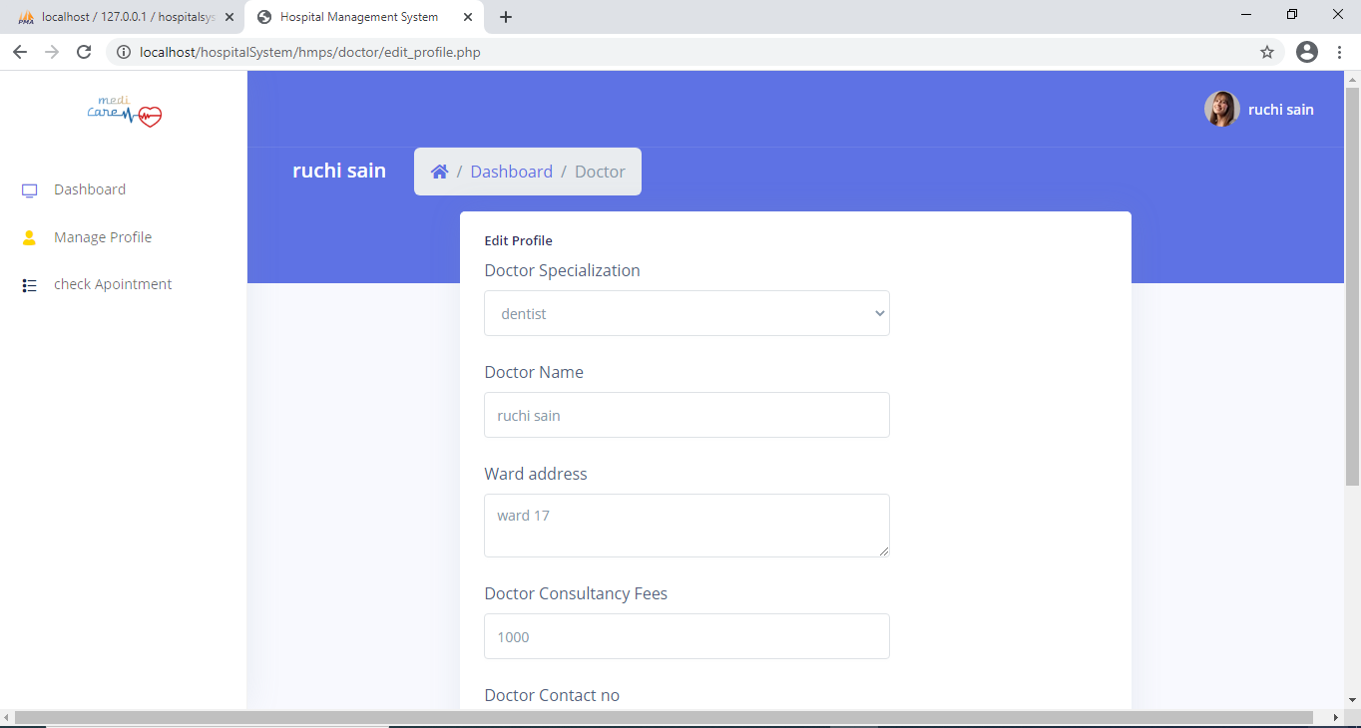

Change password:

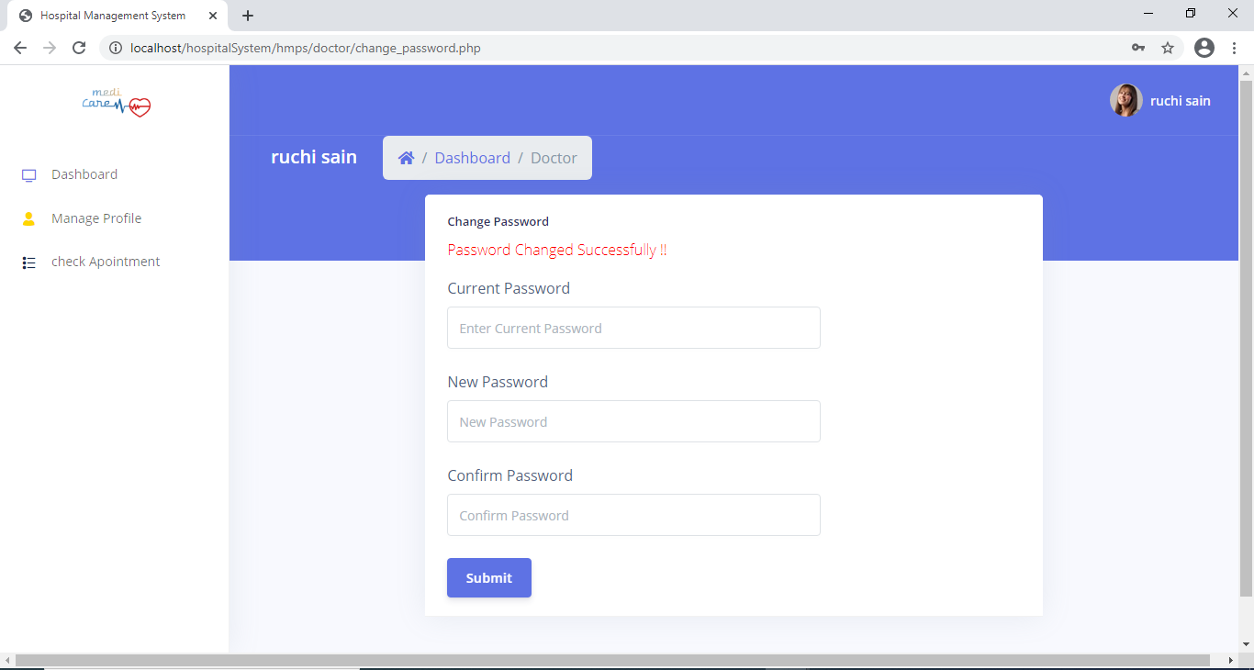

Patient login:

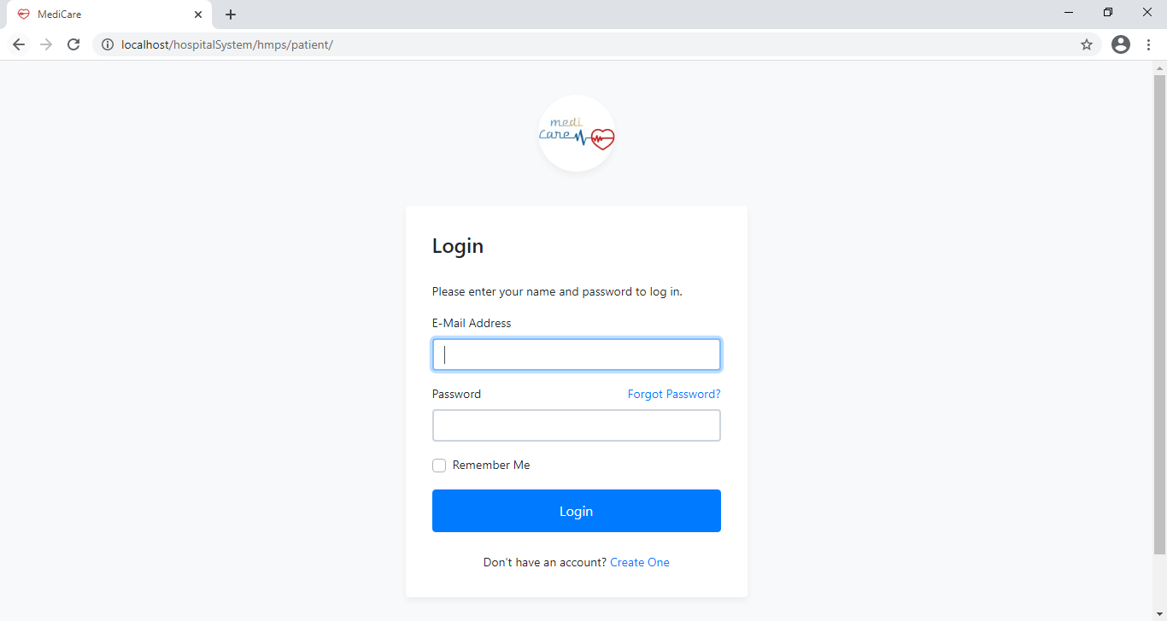

Patient registration form :

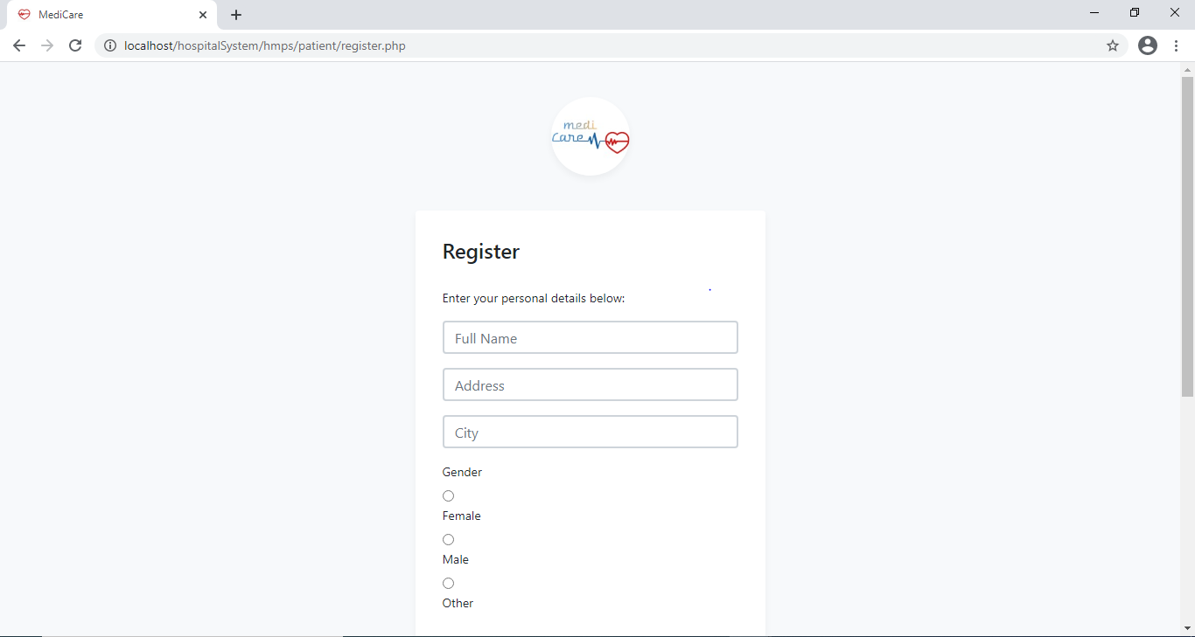

Patient dashboard:

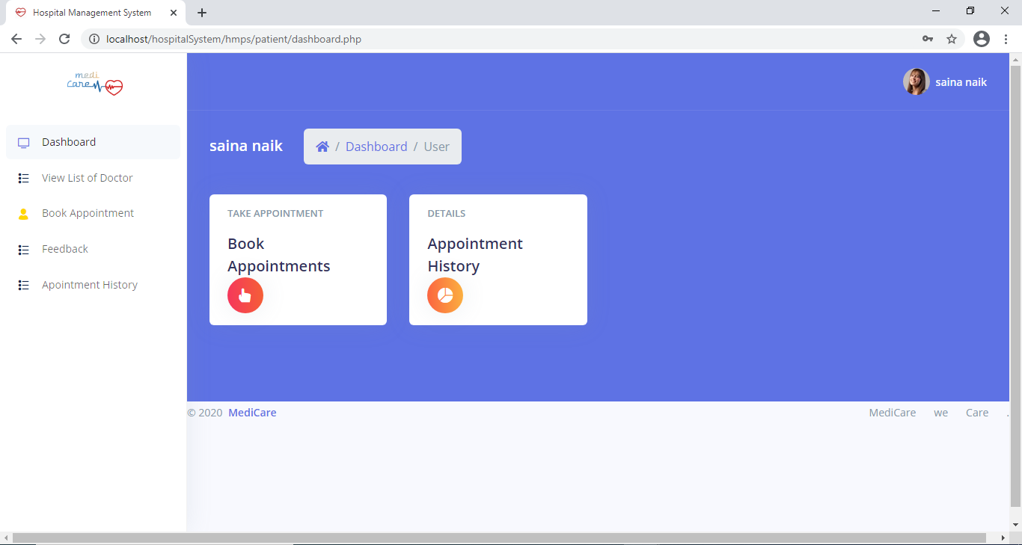

List of all doctors present:

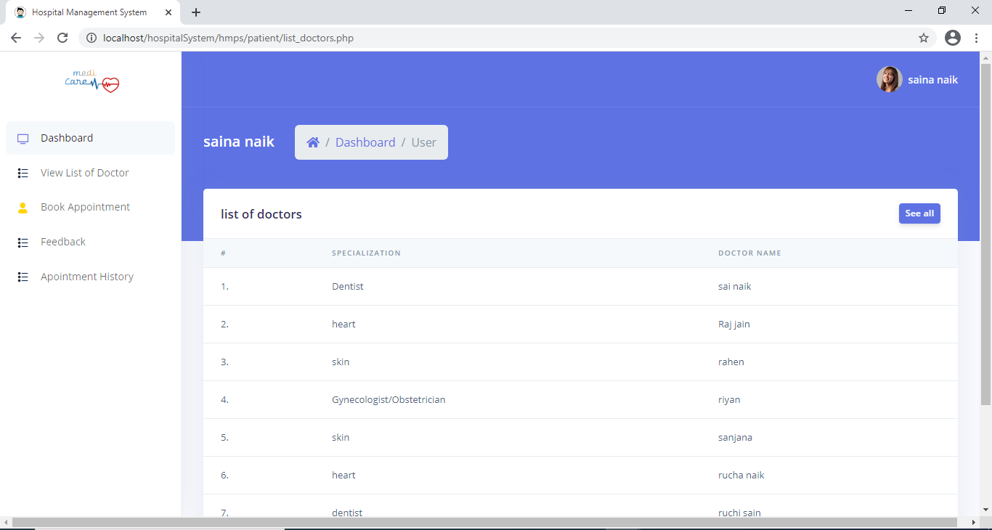

Book appointments:

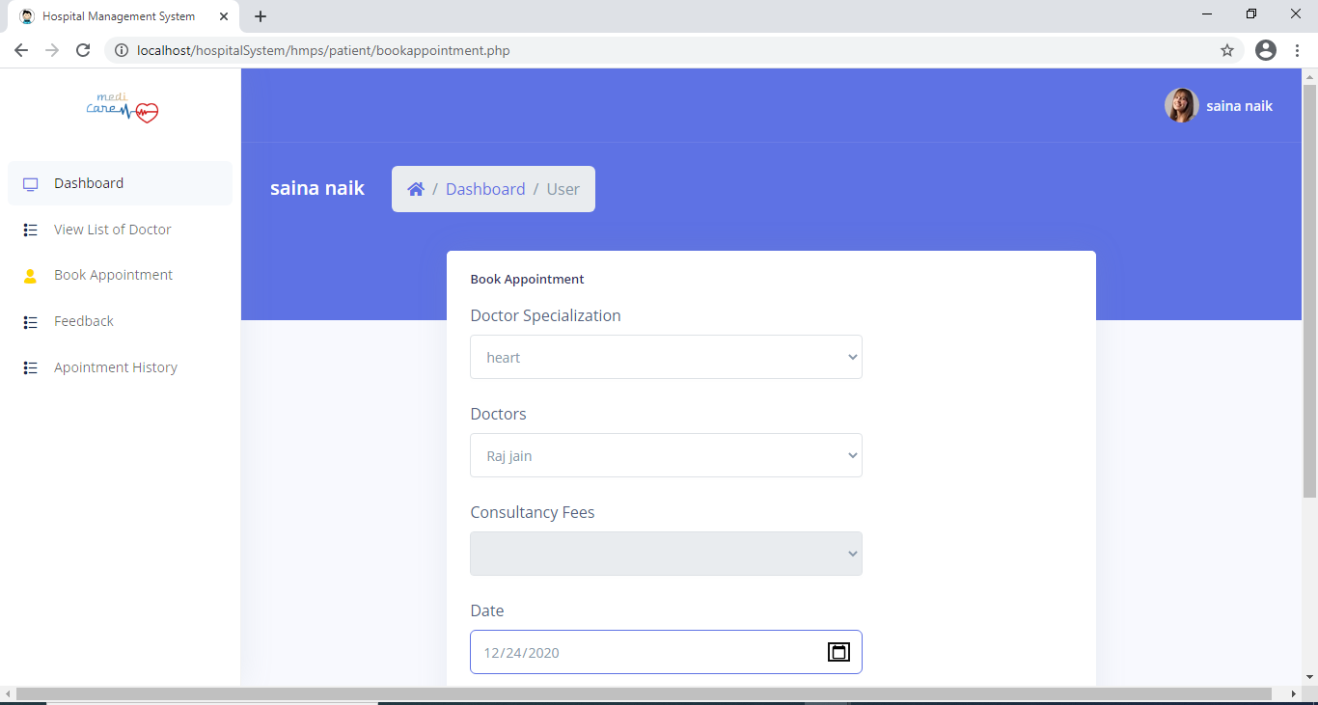

Appointment history:

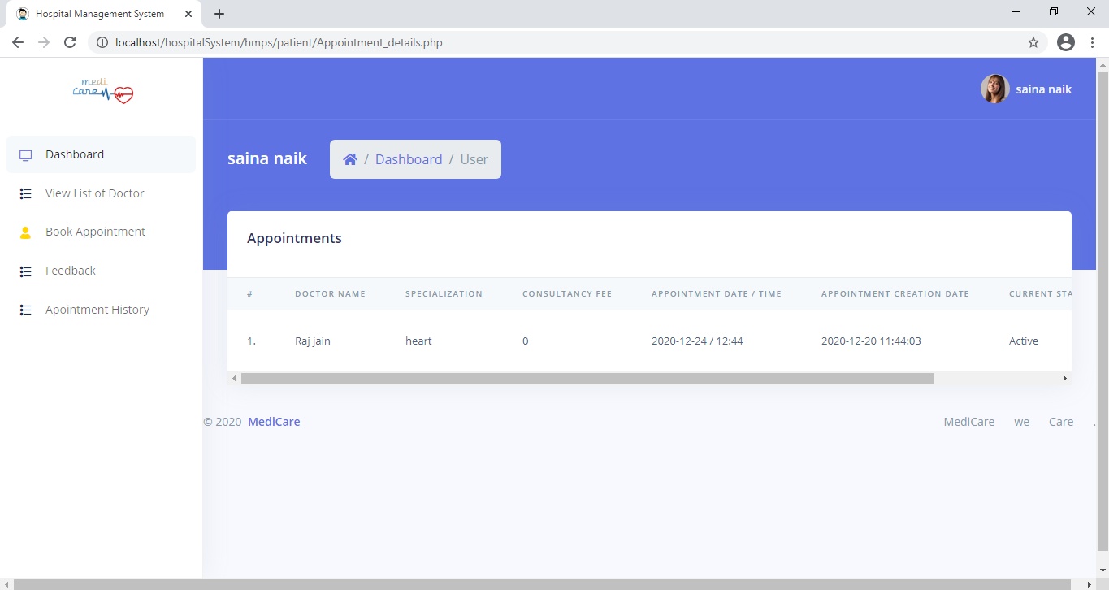

Feedback form:

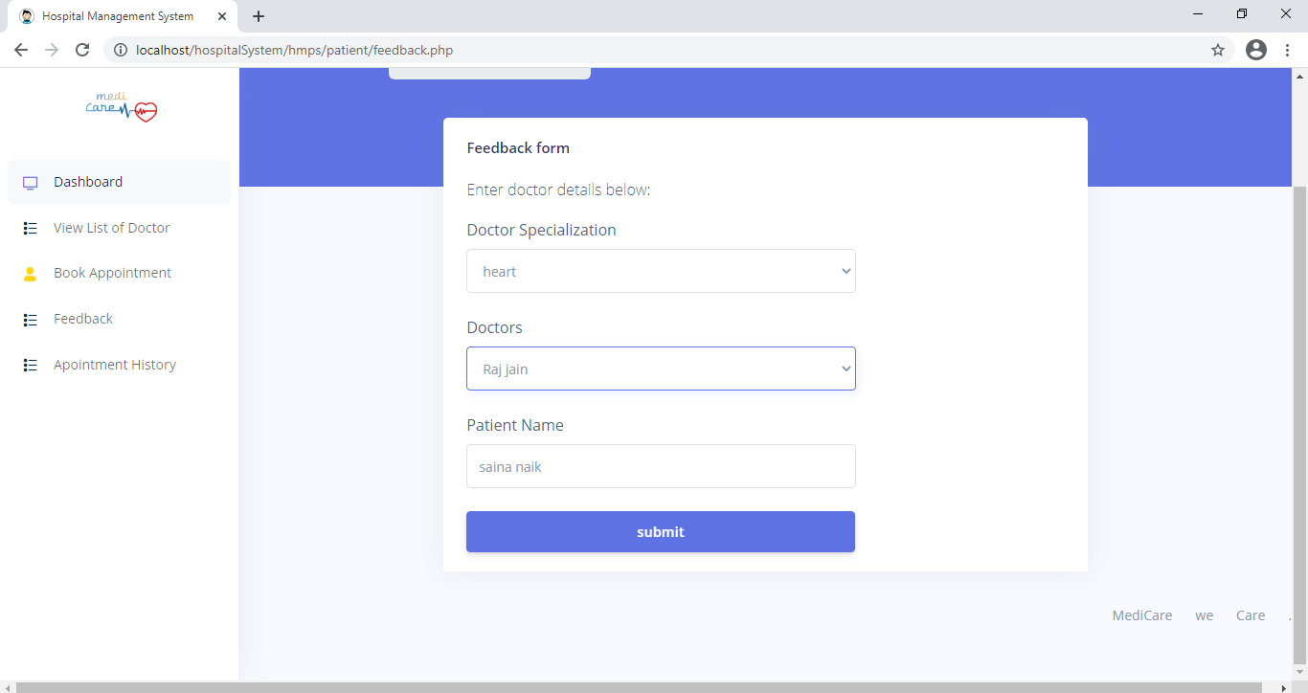

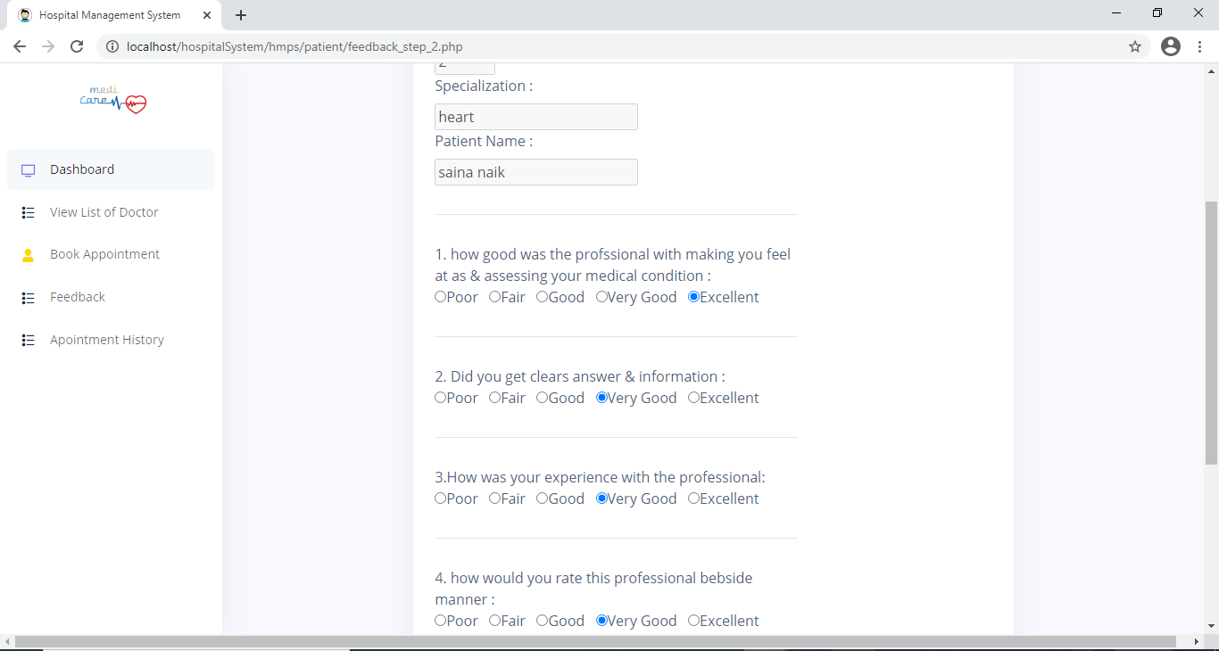

Edit profile:

