**Project title:**

**HOSPITAL MANAGEMENT SYSTEM**

**Introduction:**

The project Hospital Management system includes registration of patients, storing their details into the system and also computerized billing .The software has the facility to give a unique id for every patient and stores the details of every patient and the staff automatically.it lets patient to take appointment. To computerize the Front Office Management of Hospital as well as for patient.

“Hospital Management System” is developed to computerize the following functions that are performed by the system:

* Using this hospital management system user can take online Appointments with the doctors.
* Admin can register new patient through this system.
* This system is keep records of Patient’s.
* Admin can also check the availability of the doctors in the hospital.
* Administrator can add new doctors in the system and can also check all the doctors list of the hospital.
* Admin can issue bill

**Objective:**

* Scheduling appointments for patients with doctor to make it convenient for both
* To computerize all details regarding patients and hospital
* Design a system for better patient care.
* Reduce hospital operating costs.
* The information of patient should kept up to date and should kept in system for historical purpose

**Requirement:**

Front end : Html ,css , javascript

Serverside script: Php

Database : MySql

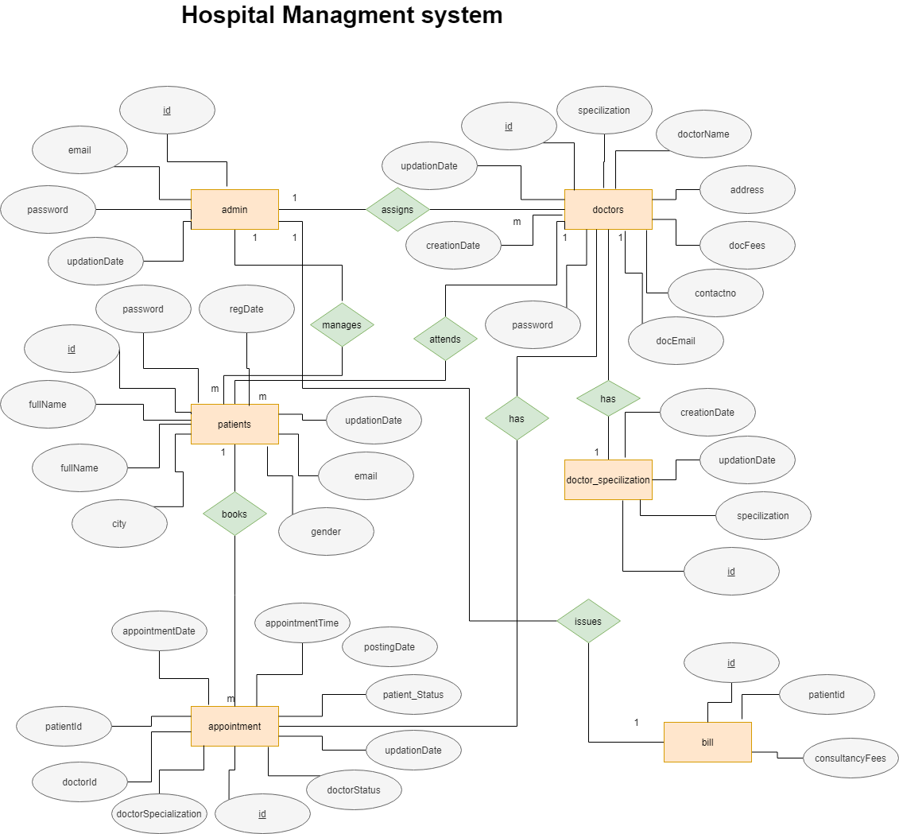

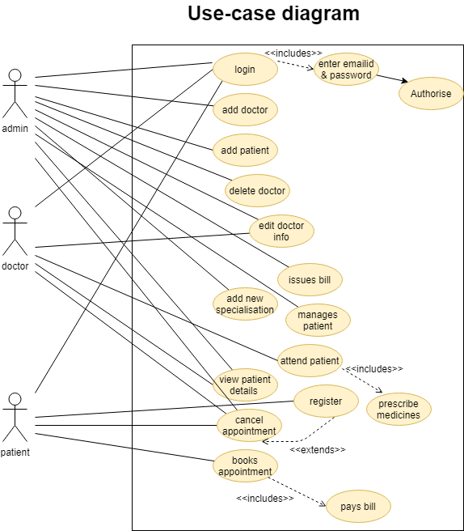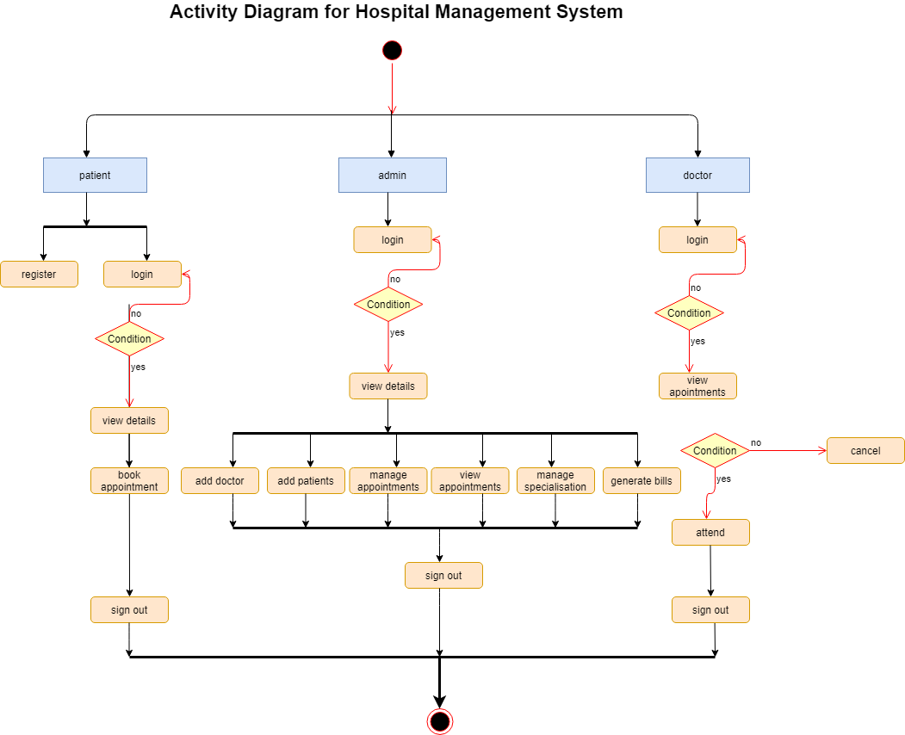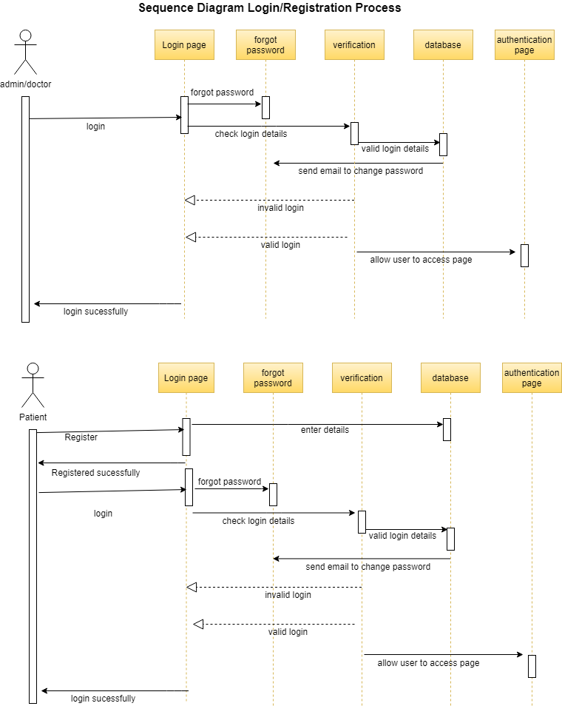

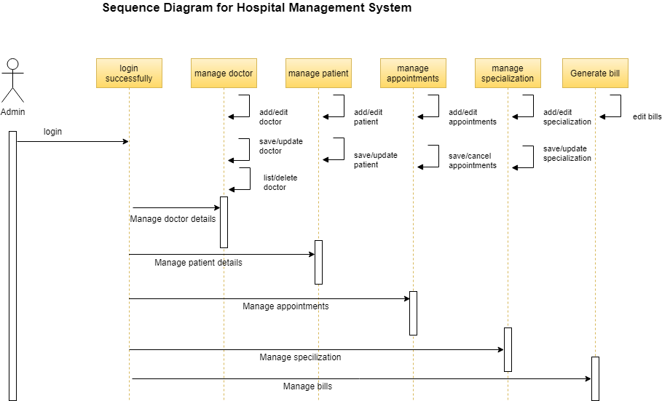

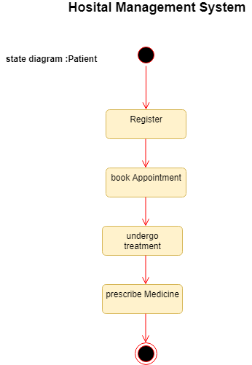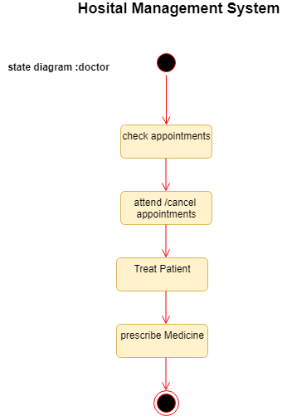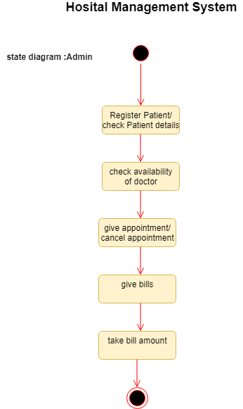

**Reports:**

It will generate bills for the patients