**Wireless Notice Board Using Bluetooth Instructions to operate the notice board**

1. 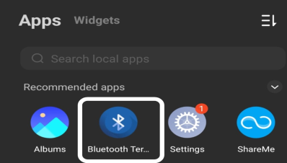Download the app “**Bluetooth Terminal”** from Google play store

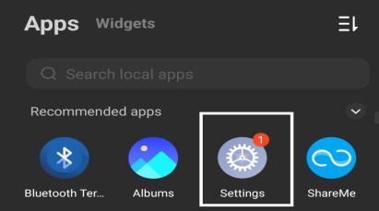

1. Go to **Phone Settings**
2. 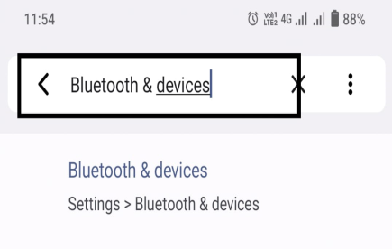Search for “**Bluetooth”** in search bar

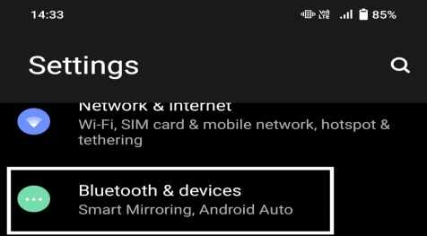

1. Click on “**Bluetooth & Devices”**
2. 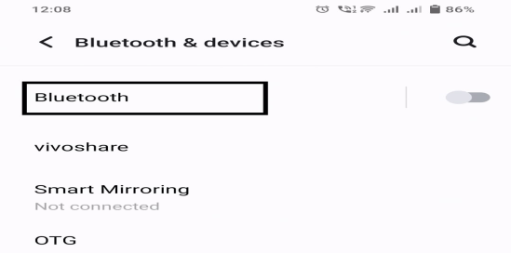Click on “**Bluetooth”**

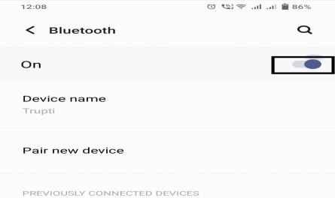

1. Turn on “Bluetooth”

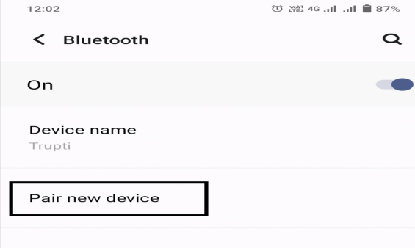

1. Click on **Pair New Device** for pairing device
2. 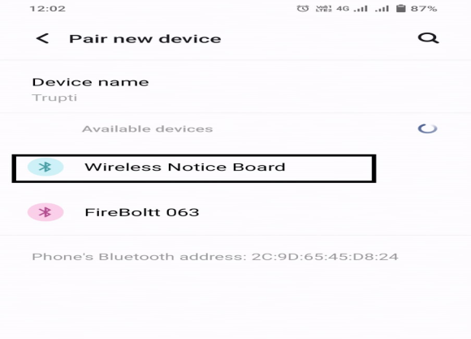Select **Wireless Notice Board** Bluetooth device and pair it.

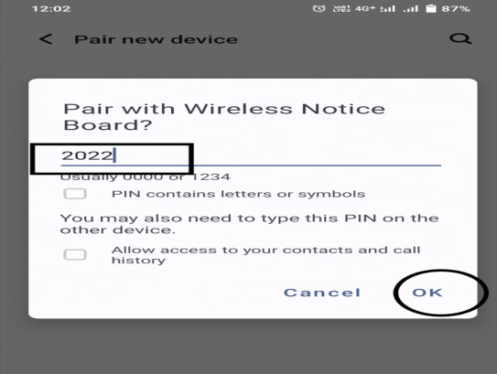

1. Enter the password **2022**
2. Open Bluetooth Terminal App click on

**Three Dots** right side upward

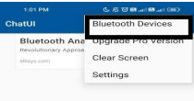

1. Click Bluetooth Devices
2. 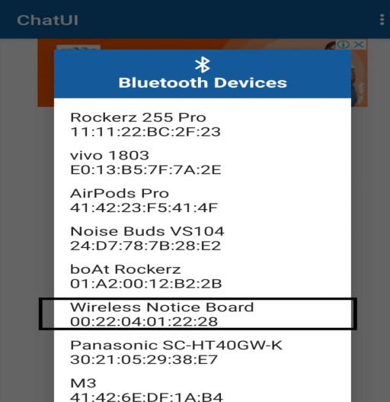Click on **Wireless Notice Board**
3. Type your message at the clipboard and press the send button

