- write a SQL query to find Employees who have the biggest salary in their Department

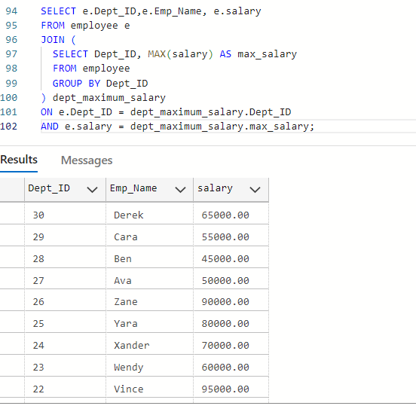
- write a SQL query to find Departments that have less than 3 people in it

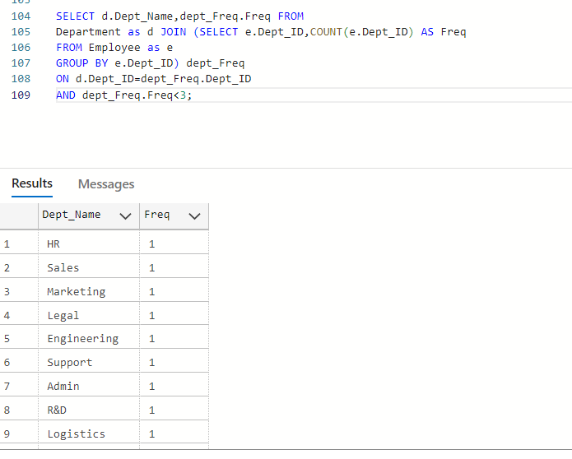

- write a SQL query to find All Department along with the number of people there

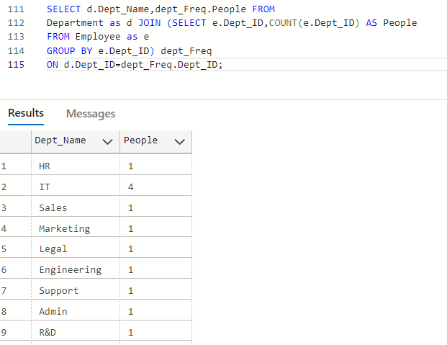
- write a SQL query to find All Department along with the total salary there

