Assignment 2 - Hospital Nursing Intervention Pilot Program
Student: Trusha Sonawane
Course: ALY6030
Instructor: Anis Sharafoddini
Date: 11/22/2025

1. Fact & Dimension Identification
1.1 Dimensions
bed_type.csv
- bed_id – Dimension (primary key)
- bed_code – Dimension
- bed_desc – Dimension
business.csv
- ims_org_id – Dimension (primary key)
- business_name – Dimension
- bed_cluster_id – Dimension
1.2 Facts (bed_fact.csv)
- license_beds – Fact
- census_beds – Fact
- staffed_beds – Fact

2. Star Schema Overview
The schema links the bed_fact table to business (hospital information) and bed_type (bed categories). The fact table holds numeric values, while the two dimension tables add descriptive context.
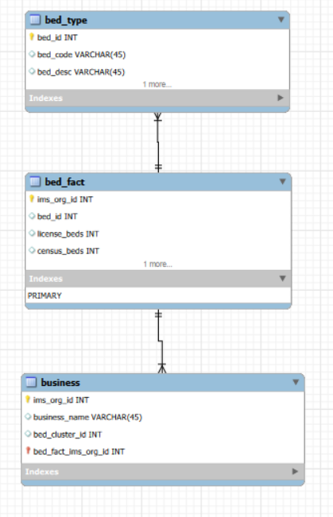

3. Analysis of ICU or SICU Hospitals (Step 4a)
Top 10 Hospitals – Licensed Beds (ICU OR SICU)
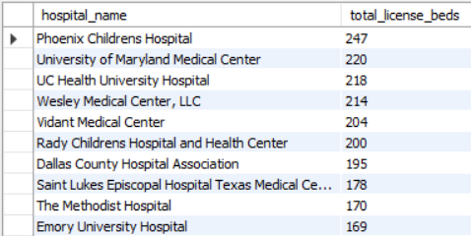

Top 10 Hospitals – Census Beds (Proxy Used)
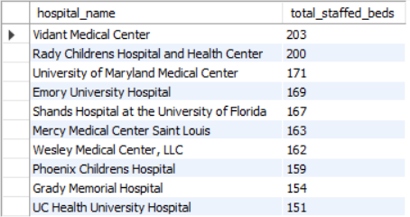

Top 10 Hospitals – Staffed Beds (ICU OR SICU)
Same ranking as census proxy (staffed beds were used for both).

Top 10 – Licensed Beds (ICU AND SICU)
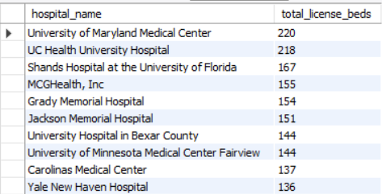

Top 10 – Census Beds (ICU AND SICU)
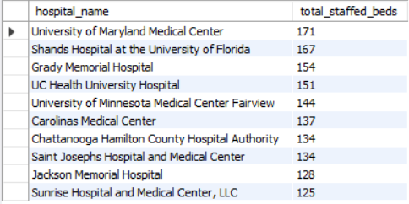

Top 10 – Staffed Beds (ICU AND SICU)
Detailed Explanation of Results & Final Recommendation
Purpose of the Analysis
The primary objective of this analysis was to identify hospitals best suited for a pilot program aimed at increasing nurse staffing in ICU and SICU units. Given that hiring nurses is a resource-intensive intervention, Leadership sought to focus on hospitals where the impact would be greatest.
To determine optimal sites, ICU and SICU bed volume was analyzed across three metrics:
- Licensed Beds – Maximum bed capacity approved by the state
- Census Beds – Beds currently occupied/active
- Staffed Beds – Beds fully operational with available nursing staff
For interventions targeting nurse-to-patient ratios, staffed beds provide the most meaningful measure, as they represent the actual operational demand on nursing resources.

Detailed Interpretation of Results
1. ICU or SICU Analysis (Step 4a)
This analysis included hospitals with either ICU or SICU beds (or both). Key findings:
A. Highest Licensed Capacity
- Hospitals such as Phoenix Children’s Hospital and University of Maryland Medical Center showed high licensed capacity, reflecting large structural capability.
- However, licensed capacity alone does not ensure operational readiness.
B. Highest Staffed/Census Capacity
- When focusing on operational beds (staffed), top performers were:
  - Vidant Medical Center
  - Rady Children’s Hospital
  - University of Maryland Medical Center
Insight: Hospitals with high staffed beds indicate active patient care demand and the most urgent need for additional nursing resources.
Consistent High Performers:
- University of Maryland Medical Center
- UC Health University Hospital
- Shands Hospital at the University of Florida
These hospitals consistently ranked highly across ICU and SICU measures.

2. ICU and SICU Combined Analysis (Step 5a)
This step focused on hospitals with both ICU and SICU units, critical for Leadership’s dual-unit intervention.
A. Licensed Bed Volume (ICU & SICU)
- University of Maryland Medical Center and UC Health University Hospital led in structural capacity.
B. Census/Staffed Bed Volume (ICU & SICU)
- Top hospitals based on actual operational demand were:
  - University of Maryland Medical Center
  - Shands Hospital at the University of Florida
  - Grady Memorial Hospital
  - UC Health University Hospital
Insight: Hospitals excelling in both Step 4a and 5a demonstrate the necessary infrastructure and operational load for effective nurse staffing interventions.

Final Recommendation (Step 5b)
Recommended Pilot Hospitals:
- University of Maryland Medical Center
- Shands Hospital at the University of Florida
Rationale:
- Consistent High Performance Across All Metrics
  - Top-tier across licensed, census, and staffed beds
  - Balanced performance, not limited to a single metric
- Strong Dual ICU & SICU Capability
  - Both hospitals have substantial numbers of ICU and SICU beds
  - Aligns directly with Leadership’s requirement for dual-unit critical care
- High Staffed Bed Counts = Immediate Nursing Need
  - Reflects operational demand and nurse workload
  - Highest potential benefit from increased staffing
- Potential for Impact & Measurable Results
  - Likely improvements in patient outcomes, care quality, and operational performance
  - Clear opportunity to measure intervention effectiveness
- Practicality & Feasibility
  - Established critical-care infrastructure
  - High bed counts and patient throughput enable smooth pilot implementation
Summary:
Selecting University of Maryland Medical Center and Shands Hospital at the University of Florida ensures maximum patient care benefit, strong alignment with Leadership priorities, and reliable data for evaluating the success of the nursing intervention.

