Assignment 3: EDA on Global Suicide Dataset
Trusha S
ALY6040 – Module 3
Northeastern University: College of Professional Studies
2025 – 04 – 30

Introduction

Introduction
This report investigates global suicide patterns using the "Suicide Rates Overview 1985 to 2016" dataset, with the goal of predicting whether a country's suicide rate is increasing or not. It applies data mining techniques to examine key demographic and socio-economic indicators such as age group, sex, generation, GDP per capita, population, and suicides per 100,000 individuals.
Two machine learning algorithms—Decision Tree and Random Forest—were used for classification. The Decision Tree model offers clear, rule-based insights, while the Random Forest model enhances accuracy and highlights feature importance. The analytical process included data cleaning, transformation, encoding, model training, evaluation, and visualization. These insights aim to support evidence-based mental health policies and contribute to broader public health strategies worldwide.
Dataset Overview
The dataset consists of 27,820 observations collected from 101 countries over a span of 31 years (1985–2016). It enables robust longitudinal analysis of global suicide trends. Each record captures key socio-demographic and economic indicators such as age group, gender, population, suicide count, and GDP per capita, offering a comprehensive view of underlying patterns.
Although the Human Development Index (HDI) was initially included, it was removed due to excessive missing values, which could have undermined the integrity and reliability of the analysis. This careful exclusion underscores the emphasis on maintaining a clean and analytically sound dataset, suitable for predictive modeling and trend analysis in global mental health research.

Data Preparation

Cleaning and Preprocessing
To maintain a tidy and consistent analytical setup, the process began with resetting the R workspace. This step ensures that any leftover variables or objects from prior sessions are completely cleared out, preventing unintended interference with new analyses. By doing so, the environment remains fresh and fully reproducible, allowing for accurate results without hidden dependencies from previous work:
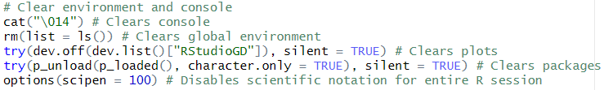
Next, with a clean workspace, I loaded essential libraries and imported the dataset, ensuring seamless data handling for efficient and accurate analysis:
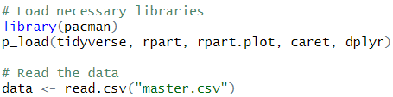
A preliminary review showed the "hdi" column contained 70% missing values (19,456 out of 27,820), making it statistically unreliable. As shown in the code snippet, the column was removed using select(-hdi), and remaining missing entries were eliminated using na.omit(). This ensures cleaner, bias-free data aligned with standard preprocessing practices for maintaining analytical integrity.
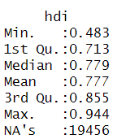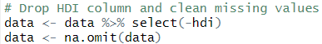
Data Analysis

Explanatory Data Analysis (EDA)

Descriptive Statistics
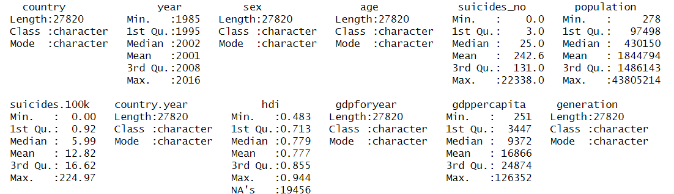
- Country
This dataset sheds light on suicide rates across 101 countries, providing a broad view of how socio-economic factors impact mental health worldwide. With 27,820 records analyzed, it offers a well-rounded representation of diverse populations, fostering a deeper understanding of global trends.

- Year
Covering the years 1985 to 2016, this dataset provides a consistent timeline for analyzing suicide trends. With a median year of 2002—closely matching the average—it reflects balanced data distribution across the decades for reliable long-term insights.
- Sex
This dataset, with 27,820 records, separates suicide rates by gender, offering distinct insights for males and females. This breakdown is vital for uncovering mental health disparities, understanding societal pressures, and shaping targeted, gender-specific prevention strategies.
- Age
By breaking down suicide rates by age group, this dataset helps highlight which age brackets face higher risks. This age-based insight empowers policymakers to design targeted interventions that address the social, economic, and mental health needs of each group.
- Number of Suicides(Suicides_No)
The suicide counts per record span from 0 to 22,338, showing a heavily skewed distribution. With a median of just 25 compared to a mean of 242.6, the data underscores extreme regional disparities and urgent mental health challenges in some areas.
- Population
Population figures in the dataset range from 278 to 4.38 million, covering both rural communities and major cities. With a median of 430,150, it offers a broad lens to analyze mental health patterns across diverse population scales and settings.
- Suicides per 100k Population (Suicides.100k)
This rate per 100,000 people ensures fair comparisons of suicide levels across countries, regardless of size. With a mean of 12.82, the data highlights notable regional differences, as the skewed distribution points to areas facing heightened suicide challenges.
- Country-Year (Country.Year)
By linking country and year, this variable enables easy tracking of suicide trends over time within each nation. It supports long-term analysis tied to policy shifts, economic changes, and mental health efforts, with insights drawn from 27,820 unique records.
- Human Development Index (HDI)
HDI scores, ranging from 0.483 to 0.944, reflect a nation’s socio-economic development. However, with over 70% missing data (19,456 records), this variable was excluded to preserve analytical integrity and ensure statistically reliable outcomes in the study.
- GDP for Year
Annual GDP figures offer essential economic context to the suicide data, helping researchers explore broader socio-economic influences on mental health. This variable supports comparative insights across nations and time, drawn from a comprehensive set of 27,820 records.
- GDP per Capita
GDP per capita spans from $251 to $126,352, with a mean of $16,866, reflecting global economic diversity. The right-skewed distribution reveals that a majority of countries fall below the average, emphasizing widespread economic inequality in the dataset.
- Generation
Generational grouping enables the study of suicide trends across life stages, helping identify behavioral shifts, societal pressures, and long-term stressors impacting mental health over time. This perspective draws from a robust dataset of 27,820 individual records for deeper cohort analysis.

An outlier analysis uncovered unusually high suicide counts (over 20,000) and extreme GDP per capita values. These anomalies likely stem from high-population nations or reflect distinct socio-economic circumstances, warranting careful interpretation during deeper mental health trend analysis.

Feature Engineering
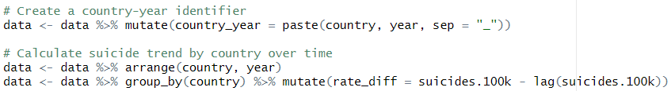
To analyze suicide trends over time, a unique country_year identifier was created and the dataset was chronologically arranged by country and year. As shown in the code, the rate_diff variable was computed using lag() to capture year-over-year changes in suicide rates per country—essential for temporal trend analysis.
Target Variable Creation
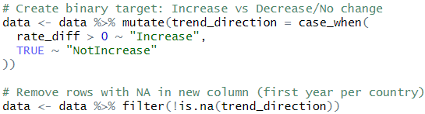
To enable classification, a new binary variable trend_direction was created—labeling suicide rate changes as "Increase" or "NotIncrease" using case_when(). As visualized, rows with missing trend data (typically the first year per country) were removed to ensure valid comparisons.
Categorical Encoding
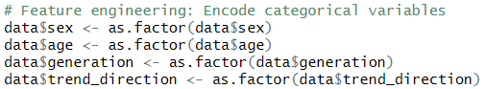
To prepare the data for modeling, key variables like sex, age, generation, and trend_direction were converted to factors, ensuring they're correctly interpreted as categorical rather than numeric by classification algorithms.
Feature Selection for Modeling
Key features—suicide rate, GDP per capita, population, sex, age, generation, and trend_direction—were selected to build a focused and interpretable classification model.
Data Splitting
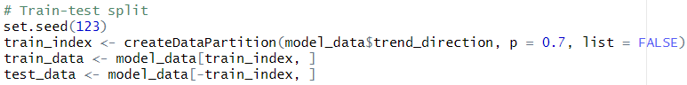
To evaluate model performance, the data was split into 70% training and 30% testing sets using createDataPartition(), ensuring reproducibility with set.seed(123).
Decision Tree Model
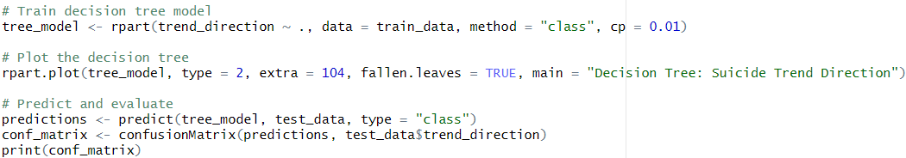
Model Training
A decision tree model was built using rpart(), with cp = 0.01 to control complexity and avoid overfitting, ensuring the model remains both interpretable and generalizable.
Tree Visualization
The decision tree is visualized using rpart.plot() with type = 2 for labeled splits, extra = 104 to display class probabilities and percentages, and fallen.leaves = TRUE for a clean, bottom-aligned leaf layout.
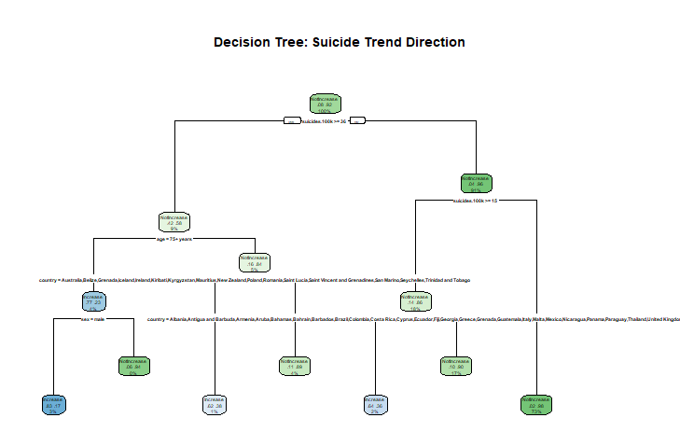
The model uses demographic branching (e.g., age > 75) which is consistent with global research showing higher suicide rates among the elderly.
The decision tree model is an interpretable tool that begins with the most significant predictor—suicides.100k, split at a threshold of 14. This root node identifies high-risk levels early. Further splits refine predictions using age, sex, and country clusters, reflecting strong socio-demographic patterns tied to suicide trends. Countries like Australia, Germany, and the UK formed distinct clusters, reinforcing how national context and population attributes shape suicide rate predictions.
Evaluation
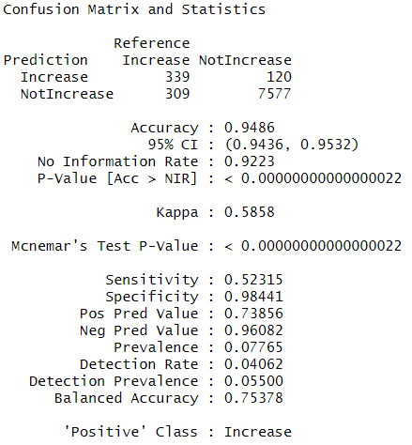
From the confusion matrix:
Accuracy: 94.86%
Sensitivity (Recall for Increase): 52.31%
Specificity (Recall for NotIncrease): 98.44%
Kappa: 0.586 (moderate agreement)
Balanced Accuracy: 75.38%
The model excels at correctly identifying when suicide trends are not increasing (high specificity), but it performs poorly in detecting actual increases (low sensitivity). This imbalance is crucial for policymakers, as failing to catch rising trends can lead to missed opportunities for early intervention—making false negatives a greater concern than false positives.
Limitations:
- The decision tree may underfit the data due to pruning (cp = 0.01), making it too cautious and possibly missing important patterns.
- Additionally, its low sensitivity suggests a bias toward predicting the majority class (NotIncrease), likely driven by class imbalance in the dataset.

Random Forest Model
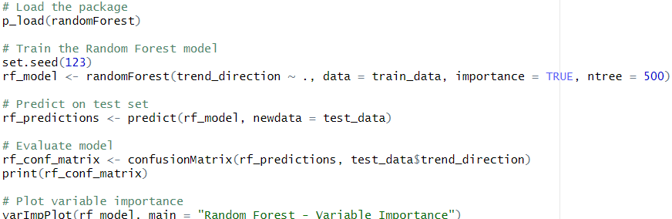
Training
This code trains a Random Forest model using 500 trees (ntree = 500) to improve prediction accuracy. Setting importance = TRUE helps identify which features most influence trend_direction.
Prediction & Evaluation
We then use the trained Random Forest model to predict on the test set, then evaluates its accuracy and class performance using a confusion matrix for clear comparison.
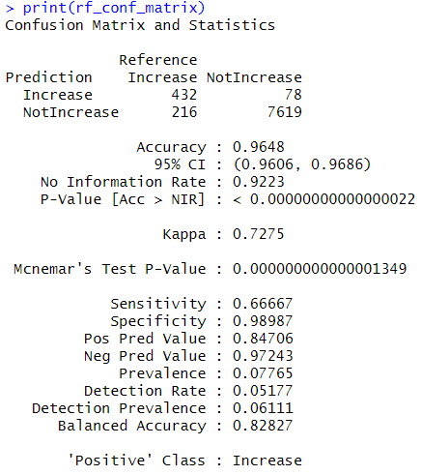
The Random Forest significantly outperformed the decision tree:
Accuracy: 96.48%
Sensitivity: 66.67%
Specificity: 98.99%
Kappa: 0.727 (substantial agreement)
Balanced Accuracy: 82.83%
The improved performance is driven by the ensemble structure of the model, which reduces variance and boosts generalization. Notably, sensitivity increased from 52% to 66%, making it more effective at identifying rising suicide trends—an essential gain for timely policy response and prevention.
Variable Importance Visualization
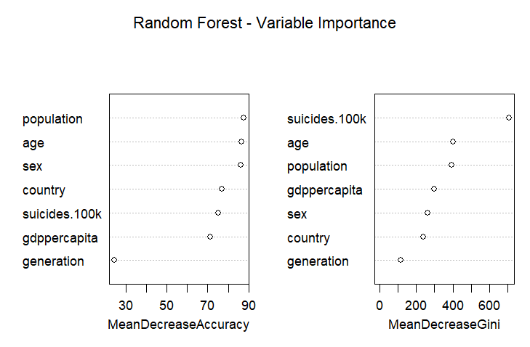
The varImpPlot() reveals the most influential features as follows:
suicides.100k,
age,
population,
GDP per capita,
and sex.
These variables significantly boost model accuracy and split quality, highlighting their strong role in predicting suicide trends.
The findings confirm that suicide rates, along with economic and demographic factors, are key drivers of trend prediction. Notably, generation had minimal impact, likely because its information overlaps with age, reducing its unique contribution to the model’s decision-making process.
Strengths:
- Random Forest shows higher sensitivity, making it more effective at detecting rising suicide trends.
- It also provides valuable feature importance scores, offering deeper insight into key predictors.
- Its robustness ensures stability even with noisy or outlier-prone data, enhancing model reliability in real-world scenarios.
Comparative Interpretation
Metric | Decision Tree | Random Forest
Accuracy | 94.86% | 96.48%
Sensitivity (Increase) | 52.31% | 66.67%
Specificity | 98.44% | 98.99%
Kappa | 0.586 | 0.727
Balanced Accuracy | 75.38% | 82.83%
Although both models perform well, Random Forest stands out for its higher accuracy and stronger detection of minority class patterns, making it more reliable for identifying subtle but critical suicide trend shifts.
Contextual Implications
The results are both statistically significant (p-value < 2.2e-16) and practically actionable. Countries or groups identified with increasing suicide trends should be prioritized for targeted interventions.
For example, nations with low GDP per capita and rising suicide rates may need urgent mental health support. Additionally, elderly individuals (75+) and males frequently appear in decision paths, aligning with WHO's identification of high-risk demographics. These insights offer clear direction for data-driven policy and resource allocation.

Conclusion

Conclusion
This study applied supervised machine learning algorithms—Decision Tree and Random Forest—to classify whether a country’s suicide rate is increasing based on key socio-economic and demographic variables. While the Decision Tree model offered clarity and transparency in its decision paths, it struggled with sensitivity, particularly in capturing the minority class. Conversely, the Random Forest model proved more robust and accurate, especially in detecting upward trends in suicide rates. It also revealed meaningful variable importance, reaffirming the influence of factors like age, GDP per capita, and population on mental health outcomes.
From a broader lens, this analysis exemplifies how data-driven approaches can enhance public health strategies. By identifying high-risk regions and demographics, policymakers and mental health organizations can design timely, evidence-based interventions. Future work should aim to improve model sensitivity by incorporating time-series elements, handling class imbalance, and enriching the feature space with cultural or healthcare-related variables. Ultimately, this project emphasizes how predictive analytics can drive proactive solutions to critical global issues like suicide prevention, especially when combined with real-time dashboards or policy tools.

Recommendations
- Address Class Imbalance: Apply techniques like SMOTE or stratified sampling to improve the model’s ability to detect less frequent, high-risk suicide trends.
- Model Explainability: Integrate SHAP values with Random Forest to improve transparency and better understand feature influence on each prediction.
- Time Series Extension: Use ARIMA or Prophet models to capture temporal dynamics and forecast future suicide trends more accurately over time.

Works Cited

References
- Bluman, A. (2018). Elementary Statistics: A Step-by-Step Approach (10th ed.). McGraw-Hill.
- Kabacoff, R. (2022). R in Action: Data Analysis and Graphics with R and tidyverse (3rd ed.). Manning Publications.
- World Health Organization (2023). Suicide Worldwide in 2023: Global Health Estimates.
- Kaggle Dataset by Russel Yates. https://www.kaggle.com/datasets/russellyates88/suicide-rates-overview-1985-to-2016

