Assignment 2: EDA on Global Suicide Dataset
Group 04
ALY6040 – Module 2
Northeastern University: College of Professional Studies
2025 – 04 – 21

Introduction

Introduction
This report presents a detailed exploratory data analysis (EDA) of the dataset titled "Suicide Rates Overview 1985 to 2016." The analysis focuses on uncovering patterns and trends in global suicide statistics over three decades, examining demographic dimensions such as gender, age, and generational groups. Additionally, it explores the impact of socio-economic factors—most notably Gross Domestic Product (GDP)—on suicide rates. The insights gained from this study aim to support the development of effective public health strategies and advance mental health initiatives on a global scale.
Dataset Overview
The dataset comprises 27,820 records collected from 101 countries spanning the years 1985 to 2016, making it a rich source for longitudinal analysis. Each entry includes attributes such as gender, age group, population size, number of suicides, and GDP metrics. Notably, the dataset originally included the Human Development Index (HDI), but this variable was excluded due to substantial missing data, which could otherwise compromise the quality of analysis.

Data Preparation

Cleaning and Preprocessing
To ensure a clean and reproducible analytical environment, the first step was to reset the R workspace, removing any lingering variables or objects from previous sessions:
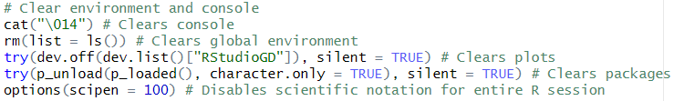
Next, I proceeded to load the necessary libraries and import the dataset for analysis:
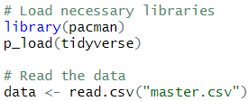
A preliminary examination of the dataset's structure and summary revealed that the "hdi" column contained a significant amount of missing data:
- Missing values in "hdi": 19,456 out of 27,820 entries (approximately 70%).
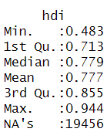
Given the extent of missingness, any attempts to impute these values would risk introducing considerable bias and potentially skewing the results of subsequent analyses. Therefore, the decision was made to remove the "hdi" column entirely:
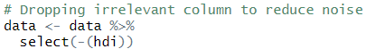
This approach aligns with established best practices in data preprocessing, where variables with excessive missing data and no viable method for imputation are excluded to maintain analytical integrity.
Data Analysis

Explanatory Data Analysis (EDA)

Structure of the Dataset
The dataset comprises 27,820 entries collected across 101 countries and spans the years 1985 to 2016. It includes demographic details such as gender, age group, and generation, along with core metrics like the number of suicides ("suicides_no"), suicide rates per 100k population ("suicides.100k"), total population, and GDP per capita.
Upon inspection, no duplicate rows were found, indicating the integrity of the dataset. After removing the "hdi" variable due to its high proportion of missing values, the dataset was largely clean, with categorical and numeric variables presented in consistent and standard formats, making it well-suited for further analysis.

Descriptive Statistics
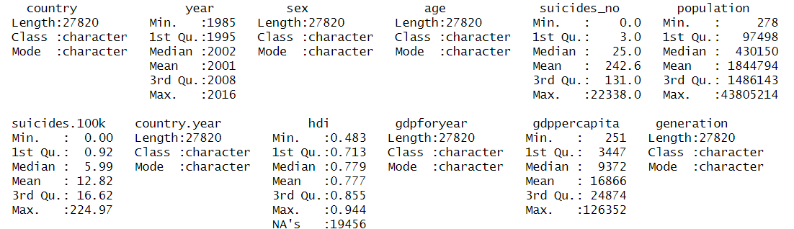
- Country
The dataset provides insights into suicide rates across 101 countries, offering a global perspective on socio-economic factors influencing mental health. A total of 27,820 records have been analyzed, ensuring a diverse representation.
- Year
Spanning over three decades, from 1985 to 2016, the dataset captures long-term trends in suicide rates. With the median year being 2002, which closely aligns with the mean, the distribution of data across the timeline remains consistent.
- Sex
This dataset distinguishes suicide rates based on gender, providing separate insights for males and females. Such segmentation is crucial for identifying societal pressures, mental health disparities, and designing gender-specific intervention strategies. It includes 27,820 entries.
- Age
By categorizing suicide rates into distinct age groups, this dataset enables the identification of age-specific risks. Such segmentation supports policymakers in addressing unique challenges faced by various demographics—social, economic, or psychological. A total of 27,820 entries are included..
- Number of Suicides(Suicides_No)
The number of reported suicides per record ranges from 0 to 22,338, revealing a highly skewed distribution. The median value of 25 is notably lower than the mean of 242.6, highlighting disparities in suicide rates, with some regions facing critical mental health challenges.
- Population
Population data spans from 278 individuals to 4.38 million, capturing cases from both densely populated urban areas and sparsely populated rural regions. With a median population of 430,150, the dataset is versatile for analyzing mental health trends across varying population sizes.

- Suicides per 100k Population (Suicides.100k)
Standardized by population size, this variable allows equitable comparisons of suicide rates across different countries. The mean rate is 12.82 suicides per 100,000 individuals, although the skewed distribution reflects significant regional variations.
- Country-Year (Country.Year)
The combined variable of country and year simplifies tracking suicide rate trends over time for each nation. Researchers can leverage this for longitudinal analyses, correlating trends with socio-economic shifts, policy changes, and mental health initiatives. This category comprises 27,820 records.
- Human Development Index (HDI)
HDI values range from 0.483 to 0.944, serving as an indicator of a country’s socio-economic conditions. However, with 70% of the data (19,456 entries) missing, this variable was excluded from further analysis to maintain statistical validity.
- GDP for Year
The annual GDP provides economic context to the suicide data, serving as a backdrop for understanding broader socio-economic influences. The dataset includes 27,820 records..
- GDP per Capita
GDP per capita ranges from a minimum of 251 to a maximum of 126,352, with a mean value of 16,866. The skewed right distribution indicates that many countries fall below the global average.
- Generation
Generational categorization allows for analysis of suicide trends across different life stages. This segmentation aids researchers in uncovering behavioral patterns, societal shifts, and long-term stressors affecting mental health across cohorts. The dataset includes 27,820 entries.

A notable outlier check revealed some high suicide counts (e.g., >20,000) and GDP per capita values. These may correspond to high-population countries or unique socio-economic conditions.

Visualizations and Insights

1. Suicide Rates by Age and Gender
The analysis reveals a clear upward trend in suicide rates as age increases, with the highest rates observed in the 75+ age group. Additionally, males consistently exhibit higher suicide rates across all age brackets, underscoring a marked gender disparity that persists throughout different stages of life.
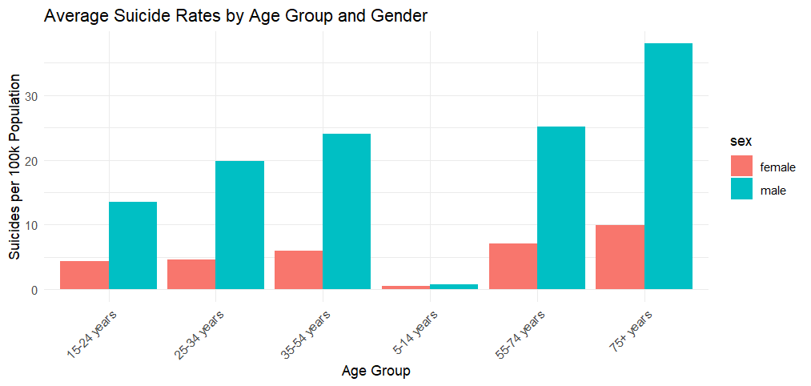A bar chart showing male suicides increase significantly with age.

2. Time Trends by Generation
Throughout the observed timeframe, the Baby Boomers and Generation X cohorts reported the highest suicide numbers. However, a significant decline in suicide numbers is evident after 2010 across most generational groups. This trend may be attributed to factors such as improved policies, greater awareness, or shifts in reporting practices.
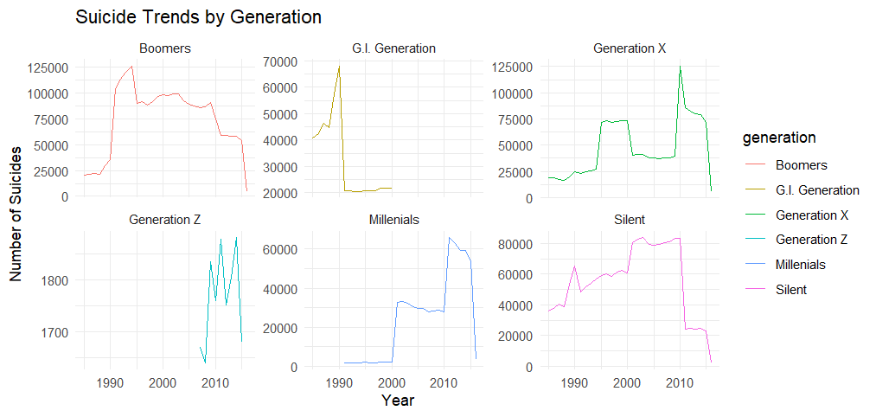A line chart depicting suicide rates fluctuate distinctly across generations over time.

3. Top Countries by Total Suicides
Russia, the United States, and Japan emerge as the leading contributors to global suicide rates, reflecting their historically high prevalence and diverse socio-economic contexts. These findings underscore the importance of conducting country-specific analyses and implementing culturally tailored interventions to address the unique challenges faced by each nation.
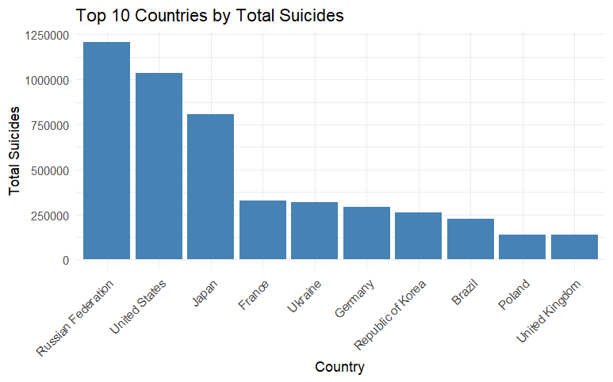
A bar graph showing the Russian Federation leads in total suicides among top ten countries.

Overview Of What Was Done
The analysis began with data cleaning, including the removal of a variable with an excessive proportion of missing values to ensure data quality. This was followed by an exploratory visual analysis to uncover patterns and trends. Key insights were then identified, focusing on demographic, geographic, and economic dimensions.
Conclusion

Conclusion
This exploratory data analysis offered valuable insights into global suicide trends, focusing on demographic and economic factors. Through visualizations and statistical summaries, a clearer understanding emerged of who is most vulnerable, as well as the timing and geographic context of risk factors. The decision to exclude the "hdi" variable, given its extensive missing data, was both pragmatic and statistically justified.
The findings highlight the intricate nature of suicide as a worldwide issue, emphasizing the need for more detailed, region-specific, and demographically sensitive investigations. Moving forward, the next phase will involve advanced statistical modelling and integrating findings into policy frameworks to develop actionable, impactful strategies.

Key Findings
- Gender Disparity: Globally, males face a significantly higher risk of suicide compared to females, highlighting a persistent gender gap.
- Age Impact: Suicide rates increase with age, peaking in the older population groups.
- GDP Connection: Higher wealth, as measured by GDP, does not inherently act as a safeguard against suicide, suggesting complex underlying factors.
- Temporal Trends: Suicide rates reached their highest during specific periods, particularly from the late 1990s to the 2000s.

Recommendations
- Outlier Analysis: Conduct a deeper examination of entries with unusually high or low suicide counts to ensure data reliability and detect potential anomalies.
- Feature Engineering: Develop regional and categorical aggregates to enhance the richness of the dataset and enable more robust modeling.
- Clustering Techniques: Apply clustering methods to identify countries with similar trends or characteristics, fostering comparative insights.
- Policy Integration: Overlay mental health policy milestones or conflict-related data to provide contextual depth and strengthen analytical outcomes.
Works Cited

References
- Bluman, A. (2018). Elementary Statistics: A Step-by-Step Approach (10th ed.). McGraw-Hill.
- Kabacoff, R. (2022). R in Action: Data Analysis and Graphics with R and tidyverse (3rd ed.). Manning Publications.
- World Health Organization (2023). Suicide Worldwide in 2023: Global Health Estimates.
- Kaggle Dataset by Russel Yates. https://www.kaggle.com/datasets/russellyates88/suicide-rates-overview-1985-to-2016

