**PRACTICAL: 4**

**AIM:**

Block.one: Creating a Multi Node EOSIO Blockchain

**THEORY:**

EOSIO is a high-performance, open-source blockchain platform designed for building and deploying decentralized applications (dApps). It supports smart contracts and offers near-instant transaction processing with minimal fees. The EOSIO ecosystem relies on several key components like nodeos, cleos, and keosd to manage blockchain operations.

In a **single-node blockchain**, all operations—block production, validation, and transactions—are handled by a single instance of nodeos. While this setup is useful for development or testing, it doesn't reflect how real-world blockchains operate, which typically involve **multiple interconnected nodes** to ensure **redundancy**, **consensus**, and **fault tolerance**.

A **multi-node EOSIO blockchain** replicates the behavior of a decentralized network. Each node can serve a different role—such as a block producer, peer, or API endpoint—and they communicate through peer-to-peer (P2P) protocols.

**Key Components in EOSIO**

* **nodeos**: The core daemon that runs an EOSIO node. It can produce blocks, validate transactions, and store blockchain data.
* **cleos**: A command-line tool used to interact with the blockchain. It allows developers to create accounts, deploy smart contracts, and transfer tokens.
* **keosd**: The wallet daemon that securely manages private keys needed for signing transactions.

**System Contracts**

EOSIO uses **system smart contracts** to manage core functionalities such as:

* **eosio.bios**: Helps with initial blockchain bootstrapping.
* **eosio.token**: Manages token creation and transfers.
* **eosio.system**: Implements governance rules like voting and staking.

Deploying a multi-node blockchain is essential for understanding how decentralized networks function. It provides:

* **Redundancy**: If one node fails, others continue operating.
* **Scalability**: Load can be distributed across nodes.
* **Security**: Multiple nodes make the system harder to compromise.
* **Realistic Testing**: It simulates a real blockchain environment with inter-node communication.

**CODE:**

|  |
| --- |
| * sudo apt update * curl -LO <https://github.com/eosio/eos/releases/download/v2.1.0/eosio_2.1.0-1-ubuntu-20.04_amd64.deb> * sudo apt install ./eosio_2.1.0-1-ubuntu-20.04_amd64.deb * nodeos –version * cleos version client * keosd -v * keosd --unlock-timeout 999999999 & * cleos wallet create --file my_wallet_password * cleos wallet list * cleos wallet open * cleos wallet unlock <my_wallet_password * cleos wallet import --private-key 5KQwrPbwdL6PhXujxW37FSSQZ1JiwsST4cqQzDeyXtP79zkvFD3 * sudo apt install build-essential * curl -LO <https://github.com/eosio/eosio.cdt/releases/download/v1.8.1/eosio.cdt_1.8.1-1-ubuntu-18.04_amd64.deb> * sudo apt install ./eosio.cdt_1.8.1-1-ubuntu-18.04_amd64.deb * eosio-cpp –version * sudo apt install cmake * git clone [https://github.com/EOSIO/eosio.contracts.git \](https://github.com/EOSIO/eosio.contracts.git%20\) --branch release/1.9.x --single-branch * cd eosio.contracts * ./build.sh -e /usr/opt/eosio/2.1.0 -c /usr/opt/eosio.cdt/1.8.1 * cd ~ * git clone https://github.com/EOSIO/eos.git \ * --branch release/2.1.x --single-branch * cd eos/contracts/contracts/eosio.boot * cmake . * make * cd ~ * mkdir nodes * cat >nodes/genesis.json * cat nodes/genesis.json * mkdir nodes/00-boot * tail -f nodes/00-boot/00.log * cleos get account eosio * cleos create account eosio eosio.bpay EOS6MRyAjQq8ud7hVNYcfnVPJqcVpscN5So8BhtHuGYqET5GDW5CV * cleos create account eosio eosio.msig EOS6MRyAjQq8ud7hVNYcfnVPJqcVpscN5So8BhtHuGYqET5GDW5CV * cleos create account eosio eosio.names EOS6MRyAjQq8ud7hVNYcfnVPJqcVpscN5So8BhtHuGYqET5GDW5CV * cleos create account eosio eosio.ram EOS6MRyAjQq8ud7hVNYcfnVPJqcVpscN5So8BhtHuGYqET5GDW5CV * cleos create account eosio eosio.ramfee EOS6MRyAjQq8ud7hVNYcfnVPJqcVpscN5So8BhtHuGYqET5GDW5CV * cleos create account eosio eosio.saving EOS6MRyAjQq8ud7hVNYcfnVPJqcVpscN5So8BhtHuGYqET5GDW5CV * cleos create account eosio eosio.stake EOS6MRyAjQq8ud7hVNYcfnVPJqcVpscN5So8BhtHuGYqET5GDW5CV * cleos create account eosio eosio.token EOS6MRyAjQq8ud7hVNYcfnVPJqcVpscN5So8BhtHuGYqET5GDW5CV * cleos create account eosio eosio.vpay EOS6MRyAjQq8ud7hVNYcfnVPJqcVpscN5So8BhtHuGYqET5GDW5CV * cleos create account eosio eosio.rex EOS6MRyAjQq8ud7hVNYcfnVPJqcVpscN5So8BhtHuGYqET5GDW5CV * cleos set contract eosio.token ~/eosio.contracts/build/contracts/eosio.token/ * cleos set contract eosio.msig ~/eosio.contracts/build/contracts/eosio.msig/ * cleos push action eosio.token create '["eosio", "10000000000.0000 SYS"]' -p eosio.token * cleos push action eosio.token issue '["eosio", "1000000000.0000 SYS", "memo"]' -p eosio * sudo apt install jq * curl -X POST http://127.0.0.1:8888/v1/producer/get_supported_protocol_features -d '{"exclude_disabled": false, "exclude_unactivatable": false}' | jq | more * curl -X POST http://127.0.0.1:8888/v1/producer/schedule_protocol_feature_activations -d '{"protocol_features_to_activate": ["0ec7e080177b2c02b278d5088611686b49d739925a92d9bfcacd7fc6b74053bd"]}' * cleos set contract eosio ~/eos/contracts/contracts/eosio.boot/ * # KV_DATABASE * cleos push action eosio activate '["825ee6288fb1373eab1b5187ec2f04f6eacb39cb3a97f356a07c91622dd61d16"]' -p eosio * # ACTION_RETURN_VALUE * cleos push action eosio activate '["c3a6138c5061cf291310887c0b5c71fcaffeab90d5deb50d3b9e687cead45071"]' -p eosio * # CONFIGURABLE_WASM_LIMITS * cleos push action eosio activate '["bf61537fd21c61a60e542a5d66c3f6a78da0589336868307f94a82bccea84e88"]' -p eosio * # BLOCKCHAIN_PARAMETERS * cleos push action eosio activate '["5443fcf88330c586bc0e5f3dee10e7f63c76c00249c87fe4fbf7f38c082006b4"]' -p eosio * # GET_SENDER * cleos push action eosio activate '["f0af56d2c5a48d60a4a5b5c903edfb7db3a736a94ed589d0b797df33ff9d3e1d"]' -p eosio * # FORWARD_SETCODE * cleos push action eosio activate '["2652f5f96006294109b3dd0bbde63693f55324af452b799ee137a81a905eed25"]' -p eosio * # ONLY_BILL_FIRST_AUTHORIZER * cleos push action eosio activate '["8ba52fe7a3956c5cd3a656a3174b931d3bb2abb45578befc59f283ecd816a405"]' -p eosio * # RESTRICT_ACTION_TO_SELF * cleos push action eosio activate '["ad9e3d8f650687709fd68f4b90b41f7d825a365b02c23a636cef88ac2ac00c43"]' -p eosio * # DISALLOW_EMPTY_PRODUCER_SCHEDULE * cleos push action eosio activate '["68dcaa34c0517d19666e6b33add67351d8c5f69e999ca1e37931bc410a297428"]' -p eosio * # FIX_LINKAUTH_RESTRICTION * cleos push action eosio activate '["e0fb64b1085cc5538970158d05a009c24e276fb94e1a0bf6a528b48fbc4ff526"]' -p eosio * # REPLACE_DEFERRED * cleos push action eosio activate '["ef43112c6543b88db2283a2e077278c315ae2c84719a8b25f25cc88565fbea99"]' -p eosio * # NO_DUPLICATE_DEFERRED_ID * cleos push action eosio activate '["4a90c00d55454dc5b059055ca213579c6ea856967712a56017487886a4d4cc0f"]' -p eosio * # ONLY_LINK_TO_EXISTING_PERMISSION * cleos push action eosio activate '["1a99a59d87e06e09ec5b028a9cbb7749b4a5ad8819004365d02dc4379a8b7241"]' -p eosio * # RAM_RESTRICTIONS * cleos push action eosio activate '["4e7bf348da00a945489b2a681749eb56f5de00b900014e137ddae39f48f69d67"]' -p eosio * # WEBAUTHN_KEY * cleos push action eosio activate '["4fca8bd82bbd181e714e283f83e1b45d95ca5af40fb89ad3977b653c448f78c2"]' -p eosio * # WTMSIG_BLOCK_SIGNATURES * cleos push action eosio activate '["299dcb6af692324b899b39f16d5a530a33062804e41f09dc97e9f156b4476707"]' -p eosio * cleos set contract eosio ~/eosio.contracts/build/contracts/eosio.system/ * cleos push action eosio setpriv '["eosio.msig", 1]' -p eosio * cleos push action eosio init '["0", "4,SYS"]' -p eosio * cleos wallet import --private-key 5KLGj1HGRWbk5xNmoKfrcrQHXvcVJBPdAckoiJgFftXSJjLPp7b * cleos wallet import --private-key 5K6qk1KaCYYWX86UhAfUsbMwhGPUqrqHrZEQDjs9ekP5j6LgHUu * cleos wallet import --private-key 5JCStvbRgUZ6hjyfUiUaxt5iU3HP6zC1kwx3W7SweaEGvs4EPfQ * cleos wallet import --private-key 5JJjaKnAb9KM2vkkJDgrYXoeUEdGgWtB5WK1a38wrmKnS3KtkS6 * cleos system newaccount --transfer eosio producer.one EOS8imf2TDq6FKtLZ8mvXPWcd6EF2rQwo8zKdLNzsbU9EiMSt9Lwz --stake-net "50000000.0000 SYS" --stake-cpu "50000000.0000 SYS" --buy-ram-kbytes 8192 * cleos system newaccount --transfer eosio producer.two EOS7Ef4kuyTbXbtSPP5Bgethvo6pbitpuEz2RMWhXb8LXxEgcR7MC --stake-net "50000000.0000 SYS" --stake-cpu "50000000.0000 SYS" --buy-ram-kbytes 8192 * cleos system newaccount --transfer eosio produc.three EOS5n442Qz4yVc4LbdPCDnxNSseAiUCrNjRxAfPhUvM8tWS5svid6 --stake-net "50000000.0000 SYS" --stake-cpu "50000000.0000 SYS" --buy-ram-kbytes 8192 * cleos system newaccount --transfer eosio produce.four EOS5y3Tm1czTCia3o3JidVKmC78J9gRQU8qHjmRjFxTyhh2vxvF5d --stake-net "50000000.0000 SYS" --stake-cpu "50000000.0000 SYS" --buy-ram-kbytes 8192 * cleos system regproducer producer.one EOS8imf2TDq6FKtLZ8mvXPWcd6EF2rQwo8zKdLNzsbU9EiMSt9Lwz https://producer.one.com/EOS8imf2TDq6FKtLZ8mvXPWcd6EF2rQwo8zKdLNzsbU9EiMSt9Lwz * cleos system regproducer producer.two EOS7Ef4kuyTbXbtSPP5Bgethvo6pbitpuEz2RMWhXb8LXxEgcR7MC https://producer.two.com/EOS7Ef4kuyTbXbtSPP5Bgethvo6pbitpuEz2RMWhXb8LXxEgcR7MC * cleos system regproducer produc.three EOS5n442Qz4yVc4LbdPCDnxNSseAiUCrNjRxAfPhUvM8tWS5svid6 https://produc.three.com/EOS5n442Qz4yVc4LbdPCDnxNSseAiUCrNjRxAfPhUvM8tWS5svid6 * cleos system regproducer produce.four EOS5y3Tm1czTCia3o3JidVKmC78J9gRQU8qHjmRjFxTyhh2vxvF5d <https://produce.four.com/EOS5y3Tm1czTCia3o3JidVKmC78J9gRQU8qHjmRjFxTyhh2vxvF5d> * cleos system listproducers * mkdir nodes/01-node nodes/02-node nodes/03-node nodes/04-node * nodeos \ * --plugin eosio::http_plugin --plugin eosio::chain_api_plugin --plugin eosio::chain_plugin --plugin eosio::producer_api_plugin --plugin eosio::producer_plugin --plugin eosio::history_plugin --plugin eosio::history_api_plugin --plugin eosio::net_api_plugin \ * --contracts-console \ * --max-transaction-time=200 \ * --chain-state-db-size-mb 1024 \ * --enable-stale-production \ * --producer-name producer.one \ * --genesis-json ~/nodes/genesis.json \ * --blocks-dir ~/nodes/01-node/blocks \ * --config-dir ~/nodes/01-node \ * --data-dir ~/nodes/01-node \ * --http-server-address 127.0.0.1:8889 \ * --p2p-listen-endpoint 127.0.0.1:9877 \ * --signature-provider EOS8imf2TDq6FKtLZ8mvXPWcd6EF2rQwo8zKdLNzsbU9EiMSt9Lwz=KEY:5KLGj1HGRWbk5xNmoKfrcrQHXvcVJBPdAckoiJgFftXSJjLPp7b \ * --p2p-peer-address 127.0.0.1:9876 \ * >>~/nodes/01-node/01.log 2>&1 & * cat nodes/01-node/01.log | grep :9876 -C 3 * nodeos \ * --plugin eosio::http_plugin --plugin eosio::chain_api_plugin --plugin eosio::chain_plugin --plugin eosio::producer_api_plugin --plugin eosio::producer_plugin --plugin eosio::history_plugin --plugin eosio::history_api_plugin --plugin eosio::net_api_plugin \ * --contracts-console \ * --max-transaction-time=200 \ * --chain-state-db-size-mb 1024 \ * --enable-stale-production \ * --producer-name producer.two \ * --genesis-json ~/nodes/genesis.json \ * --blocks-dir ~/nodes/02-node/blocks \ * --config-dir ~/nodes/02-node \ * --data-dir ~/nodes/02-node \ * --http-server-address 127.0.0.1:8890 \ * --p2p-listen-endpoint 127.0.0.1:9878 \ * --signature-provider EOS7Ef4kuyTbXbtSPP5Bgethvo6pbitpuEz2RMWhXb8LXxEgcR7MC=KEY:5K6qk1KaCYYWX86UhAfUsbMwhGPUqrqHrZEQDjs9ekP5j6LgHUu \ * --p2p-peer-address 127.0.0.1:9876 \ * --p2p-peer-address 127.0.0.1:9877 \ * >>~/nodes/02-node/02.log 2>&1 & * cat nodes/02-node/02.log | grep :9877 -C 3 * nodeos \ * --plugin eosio::http_plugin --plugin eosio::chain_api_plugin --plugin eosio::chain_plugin --plugin eosio::producer_api_plugin --plugin eosio::producer_plugin --plugin eosio::history_plugin --plugin eosio::history_api_plugin --plugin eosio::net_api_plugin \ * --contracts-console \ * --max-transaction-time=200 \ * --chain-state-db-size-mb 1024 \ * --enable-stale-production \ * --producer-name produc.three \ * --genesis-json ~/nodes/genesis.json \ * --blocks-dir ~/nodes/03-node/blocks \ * --config-dir ~/nodes/03-node \ * --data-dir ~/nodes/03-node \ * --http-server-address 127.0.0.1:8891 \ * --p2p-listen-endpoint 127.0.0.1:9879 \ * --signature-provider EOS5n442Qz4yVc4LbdPCDnxNSseAiUCrNjRxAfPhUvM8tWS5svid6=KEY:5JCStvbRgUZ6hjyfUiUaxt5iU3HP6zC1kwx3W7SweaEGvs4EPfQ \ * --p2p-peer-address 127.0.0.1:9876 \ * --p2p-peer-address 127.0.0.1:9877 \ * --p2p-peer-address 127.0.0.1:9878 \ * >>~/nodes/03-node/03.log 2>&1 & * cat nodes/03-node/03.log | grep :9878 -C 3 * nodeos \ * --plugin eosio::http_plugin --plugin eosio::chain_api_plugin --plugin eosio::chain_plugin --plugin eosio::producer_api_plugin --plugin eosio::producer_plugin --plugin eosio::history_plugin --plugin eosio::history_api_plugin --plugin eosio::net_api_plugin \ * --contracts-console \ * --max-transaction-time=200 \ * --chain-state-db-size-mb 1024 \ * --enable-stale-production \ * --producer-name produce.four \ * --genesis-json ~/nodes/genesis.json \ * --blocks-dir ~/nodes/04-node/blocks \ * --config-dir ~/nodes/04-node \ * --data-dir ~/nodes/04-node \ * --http-server-address 127.0.0.1:8892 \ * --p2p-listen-endpoint 127.0.0.1:9880 \ * --signature-provider EOS5y3Tm1czTCia3o3JidVKmC78J9gRQU8qHjmRjFxTyhh2vxvF5d=KEY:5JJjaKnAb9KM2vkkJDgrYXoeUEdGgWtB5WK1a38wrmKnS3KtkS6 \ * --p2p-peer-address 127.0.0.1:9876 \ * --p2p-peer-address 127.0.0.1:9877 \ * --p2p-peer-address 127.0.0.1:9878 \ * --p2p-peer-address 127.0.0.1:9879 \ * >>~/nodes/04-node/04.log 2>&1 & * cat nodes/04-node/04.log | grep :9879 -C 3 * cleos system voteproducer prods producer.one producer.one producer.two produc.three produce.four * cleos system voteproducer prods producer.two producer.two produc.three produce.four * cleos system voteproducer prods produc.three produc.three produce.four * cleos system voteproducer prods produce.four produce.four * cleos system listproducers * tail -f nodes/01-node/01.log | grep Produced * tail -f nodes/00-boot/00.log | grep Produced * cleos get account eosio * cleos push action eosio updateauth '{"account": "eosio", "permission": "owner", "parent": "", "auth": {"threshold": 1, "keys": [], "waits": [], "accounts": [{"weight": 1, "permission": {"actor": "eosio.prods", "permission": "active"}}]}}' -p eosio@owner * cleos push action eosio updateauth '{"account": "eosio", "permission": "active", "parent": "owner", "auth": {"threshold": 1, "keys": [], "waits": [], "accounts": [{"weight": 1, "permission": {"actor": "eosio.prods", "permission": "active"}}]}}' -p eosio@active * cleos get account eosio * cleos push action eosio updateauth '{"account": "eosio.bpay", "permission": "owner", "parent": "", "auth": {"threshold": 1, "keys": [], "waits": [], "accounts": [{"weight": 1, "permission": {"actor": "eosio", "permission": "active"}}]}}' -p eosio.bpay@owner * cleos push action eosio updateauth '{"account": "eosio.bpay", "permission": "active", "parent": "owner", "auth": {"threshold": 1, "keys": [], "waits": [], "accounts": [{"weight": 1, "permission": {"actor": "eosio", "permission": "active"}}]}}' -p eosio.bpay@active * cleos push action eosio updateauth '{"account": "eosio.msig", "permission": "owner", "parent": "", "auth": {"threshold": 1, "keys": [], "waits": [], "accounts": [{"weight": 1, "permission": {"actor": "eosio", "permission": "active"}}]}}' -p eosio.msig@owner * cleos push action eosio updateauth '{"account": "eosio.msig", "permission": "active", "parent": "owner", "auth": {"threshold": 1, "keys": [], "waits": [], "accounts": [{"weight": 1, "permission": {"actor": "eosio", "permission": "active"}}]}}' -p eosio.msig@active * cleos push action eosio updateauth '{"account": "eosio.names", "permission": "owner", "parent": "", "auth": {"threshold": 1, "keys": [], "waits": [], "accounts": [{"weight": 1, "permission": {"actor": "eosio", "permission": "active"}}]}}' -p eosio.names@owner * cleos push action eosio updateauth '{"account": "eosio.names", "permission": "active", "parent": "owner", "auth": {"threshold": 1, "keys": [], "waits": [], "accounts": [{"weight": 1, "permission": {"actor": "eosio", "permission": "active"}}]}}' -p eosio.names@active * cleos push action eosio updateauth '{"account": "eosio.ram", "permission": "owner", "parent": "", "auth": {"threshold": 1, "keys": [], "waits": [], "accounts": [{"weight": 1, "permission": {"actor": "eosio", "permission": "active"}}]}}' -p eosio.ram@owner * cleos push action eosio updateauth '{"account": "eosio.ram", "permission": "active", "parent": "owner", "auth": {"threshold": 1, "keys": [], "waits": [], "accounts": [{"weight": 1, "permission": {"actor": "eosio", "permission": "active"}}]}}' -p eosio.ram@active * cleos push action eosio updateauth '{"account": "eosio.ramfee", "permission": "owner", "parent": "", "auth": {"threshold": 1, "keys": [], "waits": [], "accounts": [{"weight": 1, "permission": {"actor": "eosio", "permission": "active"}}]}}' -p eosio.ramfee@owner * cleos push action eosio updateauth '{"account": "eosio.ramfee", "permission": "active", "parent": "owner", "auth": {"threshold": 1, "keys": [], "waits": [], "accounts": [{"weight": 1, "permission": {"actor": "eosio", "permission": "active"}}]}}' -p eosio.ramfee@active * cleos push action eosio updateauth '{"account": "eosio.saving", "permission": "owner", "parent": "", "auth": {"threshold": 1, "keys": [], "waits": [], "accounts": [{"weight": 1, "permission": {"actor": "eosio", "permission": "active"}}]}}' -p eosio.saving@owner * cleos push action eosio updateauth '{"account": "eosio.saving", "permission": "active", "parent": "owner", "auth": {"threshold": 1, "keys": [], "waits": [], "accounts": [{"weight": 1, "permission": {"actor": "eosio", "permission": "active"}}]}}' -p eosio.saving@active * cleos push action eosio updateauth '{"account": "eosio.stake", "permission": "owner", "parent": "", "auth": {"threshold": 1, "keys": [], "waits": [], "accounts": [{"weight": 1, "permission": {"actor": "eosio", "permission": "active"}}]}}' -p eosio.stake@owner * cleos push action eosio updateauth '{"account": "eosio.stake", "permission": "active", "parent": "owner", "auth": {"threshold": 1, "keys": [], "waits": [], "accounts": [{"weight": 1, "permission": {"actor": "eosio", "permission": "active"}}]}}' -p eosio.stake@active * cleos push action eosio updateauth '{"account": "eosio.token", "permission": "owner", "parent": "", "auth": {"threshold": 1, "keys": [], "waits": [], "accounts": [{"weight": 1, "permission": {"actor": "eosio", "permission": "active"}}]}}' -p eosio.token@owner * cleos push action eosio updateauth '{"account": "eosio.token", "permission": "active", "parent": "owner", "auth": {"threshold": 1, "keys": [], "waits": [], "accounts": [{"weight": 1, "permission": {"actor": "eosio", "permission": "active"}}]}}' -p eosio.token@active * cleos push action eosio updateauth '{"account": "eosio.vpay", "permission": "owner", "parent": "", "auth": {"threshold": 1, "keys": [], "waits": [], "accounts": [{"weight": 1, "permission": {"actor": "eosio", "permission": "active"}}]}}' -p eosio.vpay@owner * cleos push action eosio updateauth '{"account": "eosio.vpay", "permission": "active", "parent": "owner", "auth": {"threshold": 1, "keys": [], "waits": [], "accounts": [{"weight": 1, "permission": {"actor": "eosio", "permission": "active"}}]}}' -p eosio.vpay@active * cleos push action eosio updateauth '{"account": "eosio.rex", "permission": "owner", "parent": "", "auth": {"threshold": 1, "keys": [], "waits": [], "accounts": [{"weight": 1, "permission": {"actor": "eosio", "permission": "active"}}]}}' -p eosio.rex@owner * cleos push action eosio updateauth '{"account": "eosio.rex", "permission": "active", "parent": "owner", "auth": {"threshold": 1, "keys": [], "waits": [], "accounts": [{"weight": 1, "permission": {"actor": "eosio", "permission": "active"}}]}}' -p [eosio.rex@active](mailto:eosio.rex@active) |

**OUTPUT:**

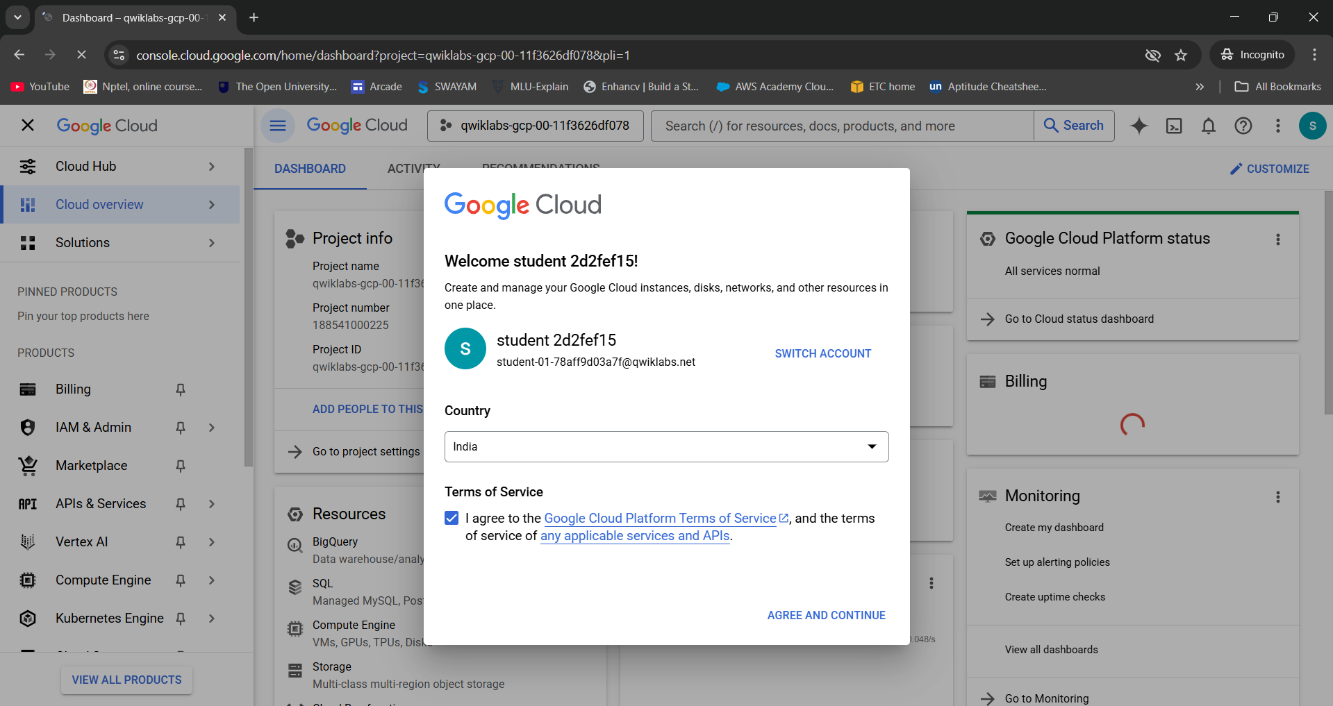

Figure 1:Start Lab

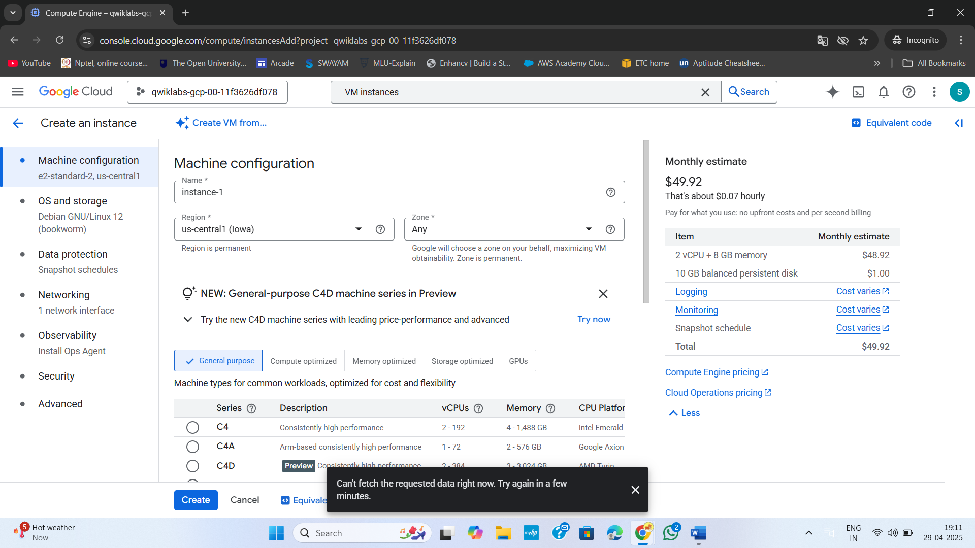

Figure 2:Create a VM instance

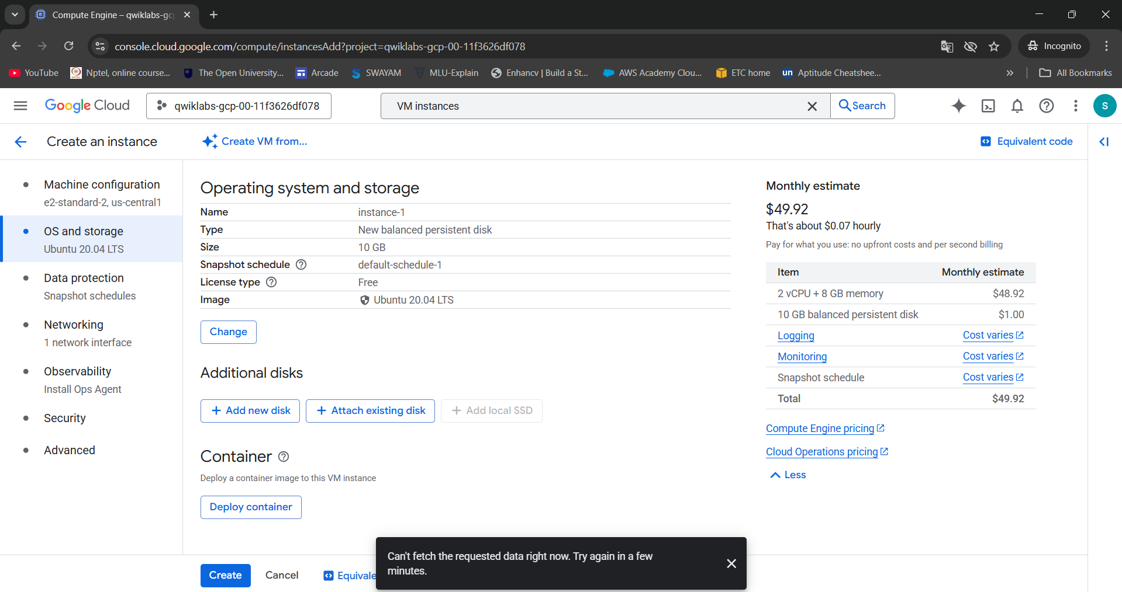

Figure 3:Change operating system to Linux

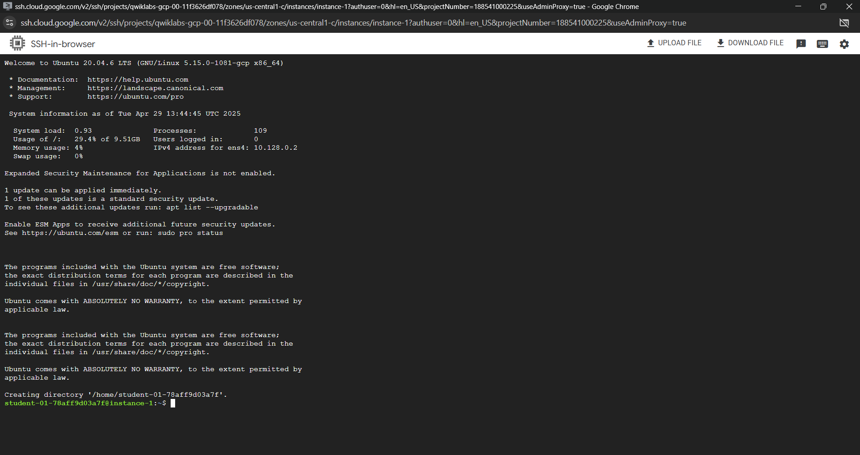

Figure 4:Connect VM with SSH

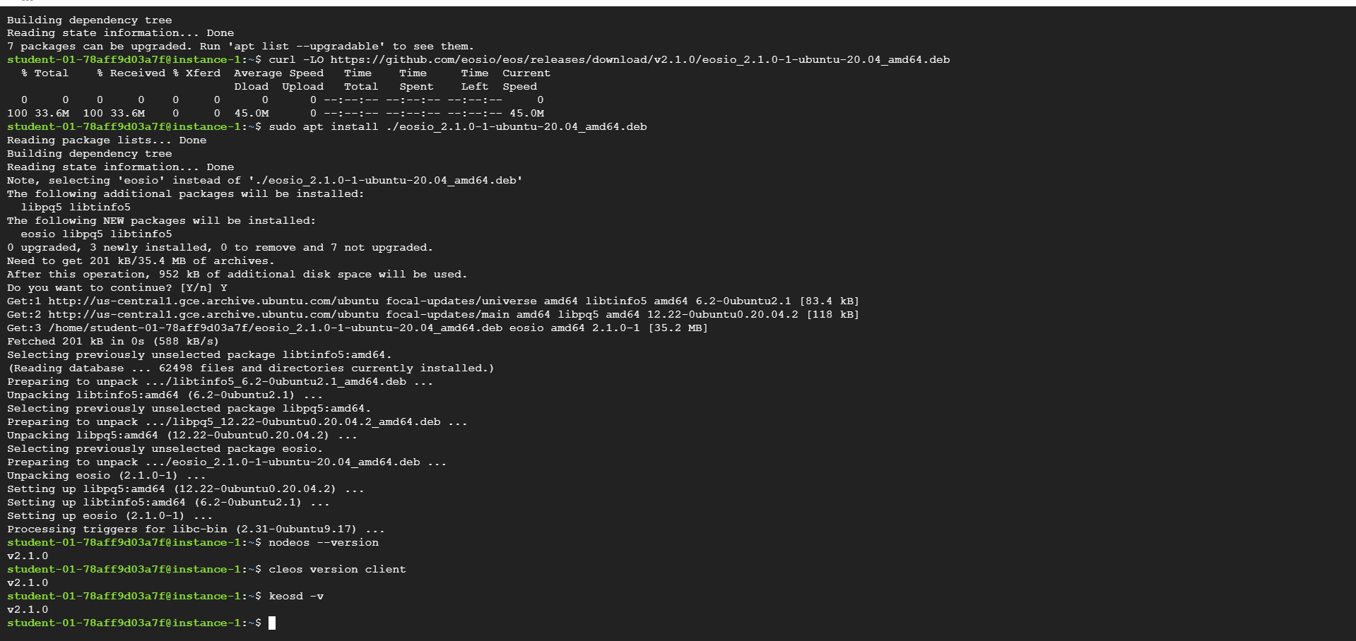

Figure 5:Install the EOSIO platform

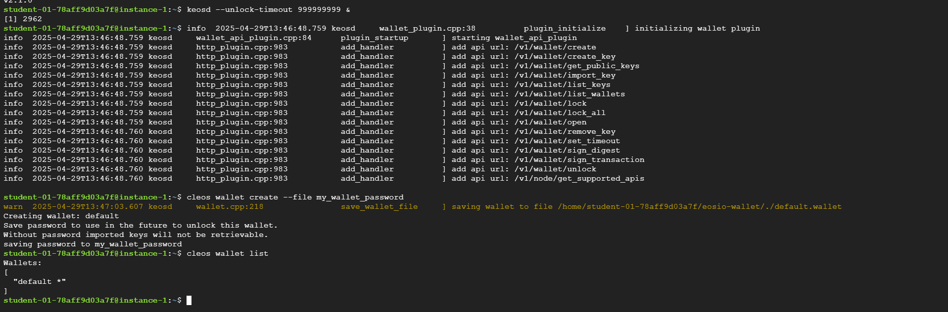

Figure 6:Create a default wallet



Figure 7:Add the private key of the EOSIO system account to the wallet

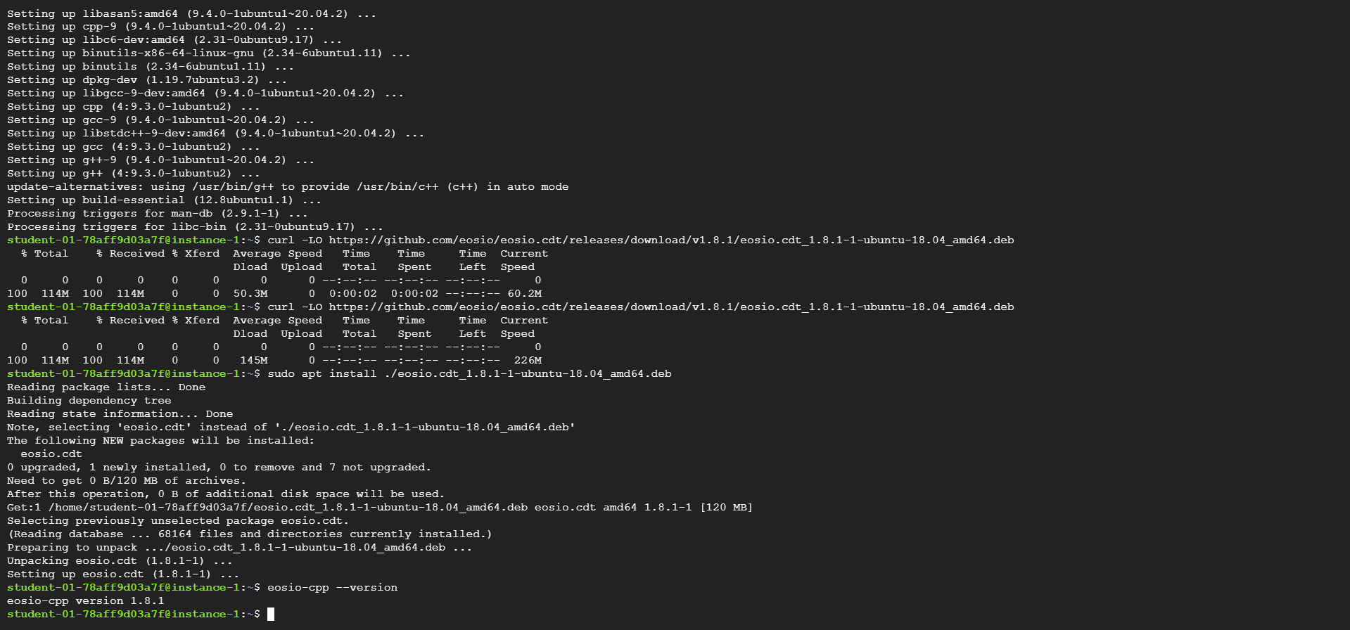

Figure 8:Install the EOSIO Contract Development Toolkit (CDT)

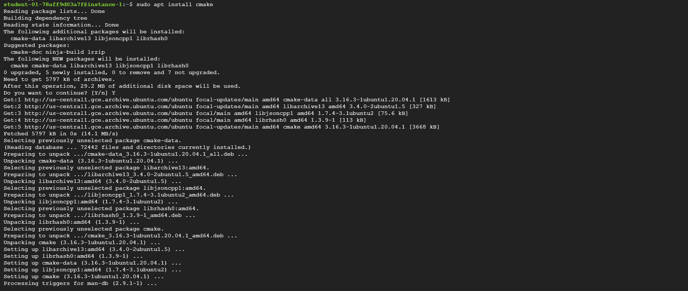

Figure 9:Install CMake

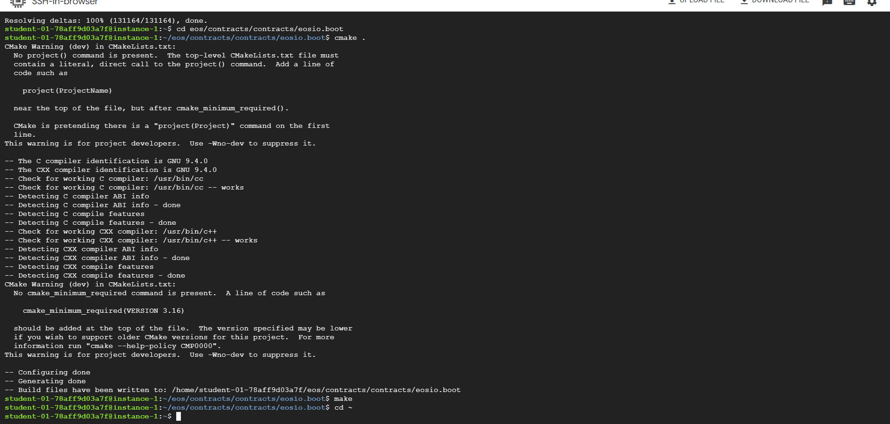

Figure 10:Build the system contracts and eosio.boot

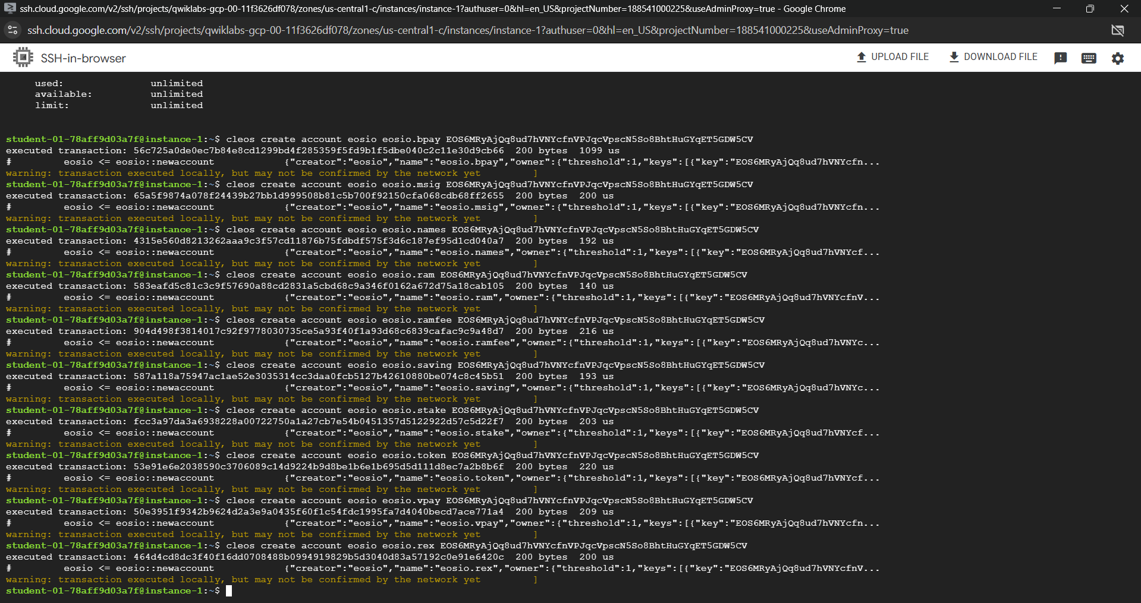

Figure 11:Start the boot node and create system accounts

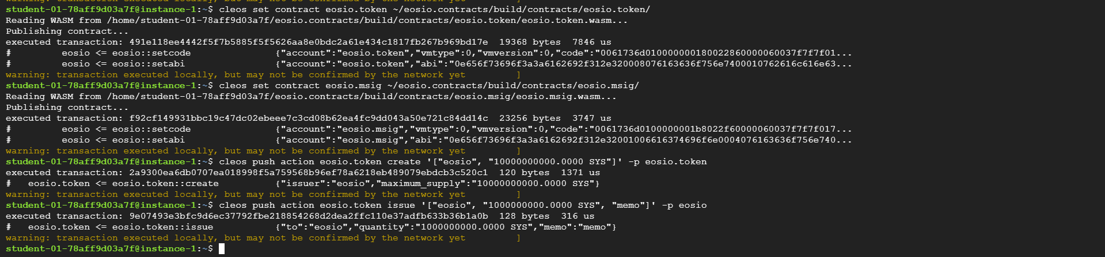

Figure 12:Deploy the eosio.token, eosio.msig contracts, and create/issue the SYS token

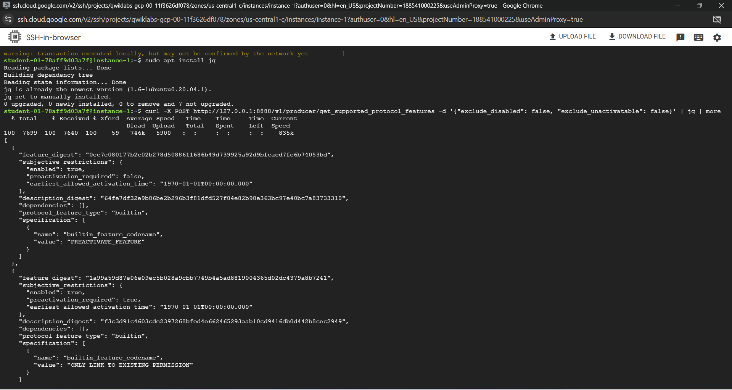

Figure 13: Command sends an HTTP POST request to the get_supported_protocol_features endpoint provided by the Producer API plugin

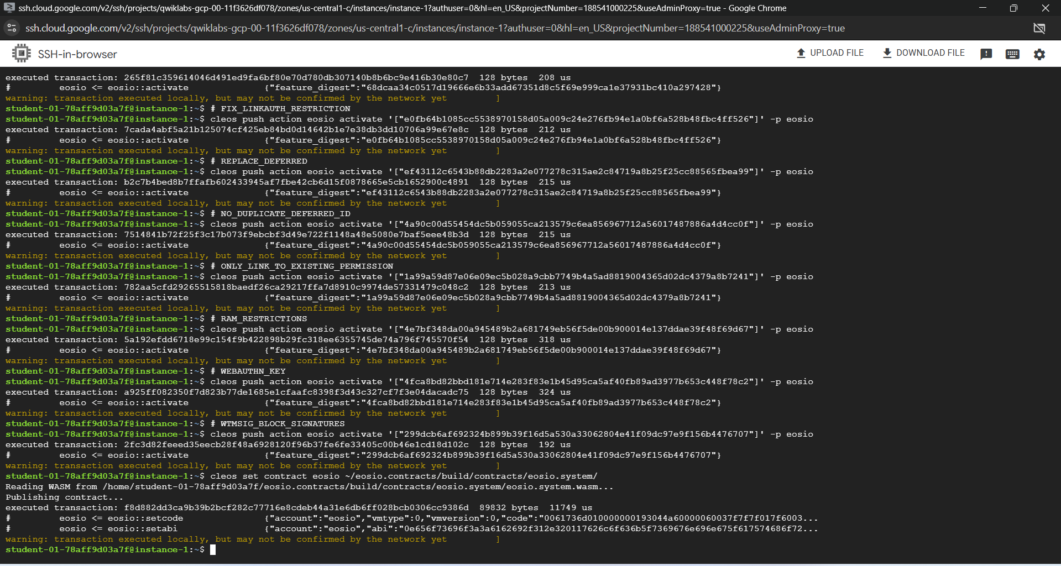

Figure 14:Activate protocol features and deploy eosio.boot and eosio.system contracts

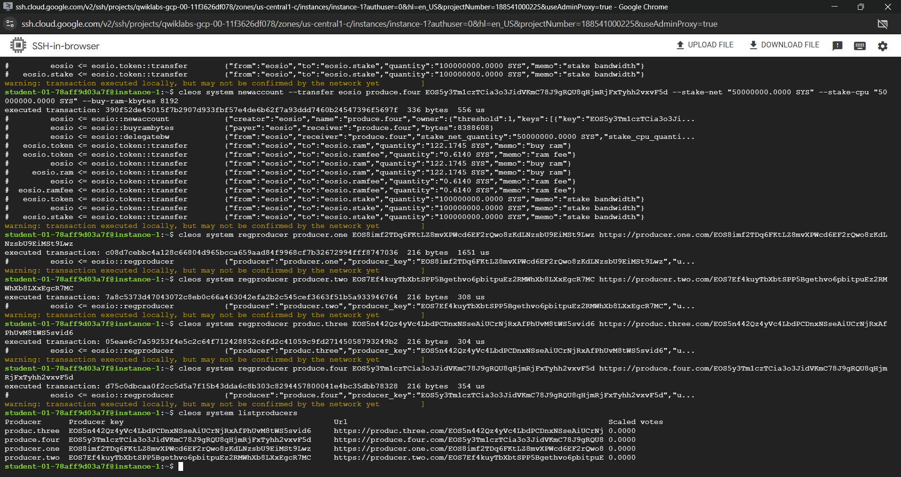

Figure 15:Create the block producer accounts

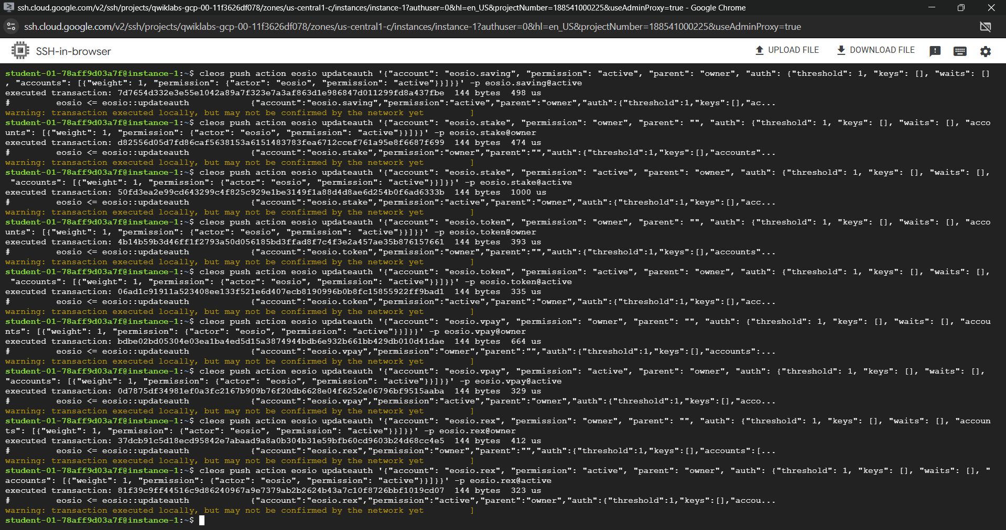

Figure 16:Transition from single-node producer to multi-node producers

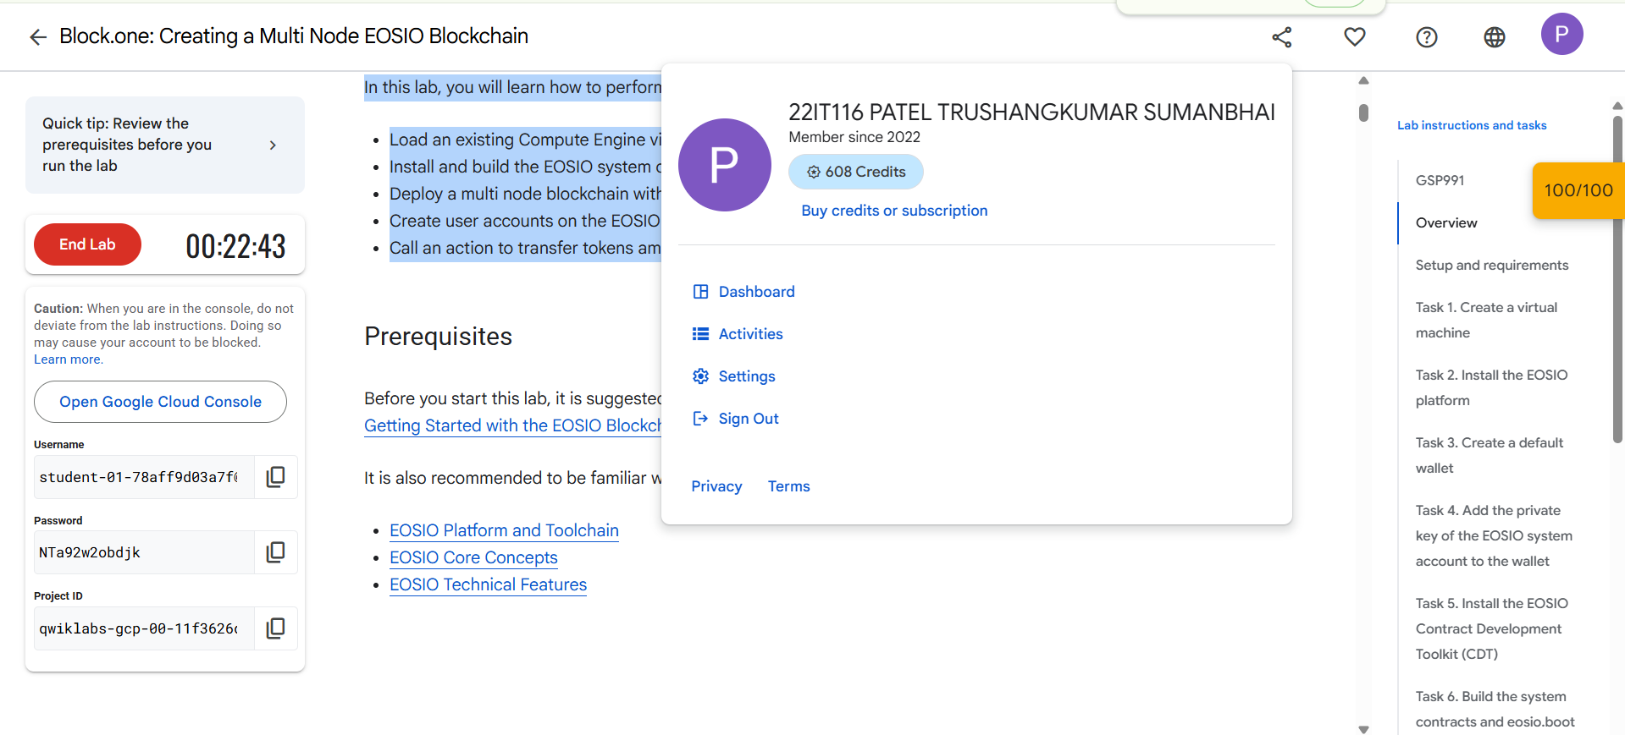

Figure 17:End Lab

**LATEST APPLICATIONS:**

* Decentralized Finance (DeFi)
* Supply Chain Management
* Digital Identity Verification
* Digital Voting
* Gaming and NFTs

**LEARNING OUTCOME:**

In this practical, I learned how to deploy a multi-node EOSIO blockchain network and connect nodes using peer-to-peer settings. I managed system contracts, created user accounts, and performed token transfers. I also gained hands-on experience with EOSIO tools like cleos and nodeos, deepening my understanding of decentralized blockchain infrastructures.

**REFERENCES:**

1. [https://www.cloudskillsboost.google/focuses/23108?](https://www.cloudskillsboost.google/focuses/23108?catalog_rank=%7B%22rank%22%3A1%2C%22num_filters%22%3A0%2C%22has_search%22%3Atrue%7D&parent=catalog&search_id=44984843)