**PRACTICAL: 5**

**AIM:**

Block.one: Getting Started with The EOSIO Blockchain

**THEORY:**

EOSIO is a next-generation blockchain platform designed to support scalable, secure, and high-performance decentralized applications (dApps). Developed by Block.one, EOSIO features a unique consensus mechanism called Delegated Proof of Stake (DPoS), enabling high transaction throughput and low latency, which makes it ideal for enterprise-grade applications.

An EOSIO blockchain is a deterministic state machine that stores transactions in cryptographically linked blocks. Each new block references the hash of the previous block, making the chain immutable and tamper-proof. EOSIO supports smart contracts and is designed to be flexible and modular.

EOSIO uses DPoS to achieve consensus. In this model:

* Stakeholders vote to elect block producers (delegates).
* These producers are responsible for validating transactions and producing blocks.
* The model ensures decentralization while maintaining high performance and fast block times.

**Accounts and Wallets**

* An **account** in EOSIO is a named identity that interacts with the blockchain by sending or receiving actions and transactions.
* Each account is associated with a set of **public/private keys**.
* A **wallet** securely stores these keys and is required to sign blockchain transactions.
* Permissions can be configured hierarchically, allowing fine-grained control over account actions.

**Node Types**

* **nodeos**: The core daemon of an EOSIO node that processes blockchain data.
* **keosd**: The wallet manager responsible for managing keys and signing transactions.
* **cleos**: A command-line interface tool used to interact with nodeos and keosd.

**CODE:**

|  |
| --- |
| * sudo apt update * curl -LO <https://github.com/eosio/eos/releases/download/v2.1.0/eosio_2.1.0-1-ubuntu-20.04_amd64.deb> * sudo apt install ./eosio_2.1.0-1-ubuntu-20.04_amd64.deb * nodeos –version * cleos version client * keosd -v * nodeos -e -p eosio --plugin eosio::chain_api_plugin --plugin eosio::history_api_plugin --contracts-console >> nodeos.log 2>&1 & * tail -f nodeos.log * cleos wallet create --name my_wallet --file my_wallet_password * cat my_wallet_password * cleos wallet list * cleos wallet open --name my_wallet * cleos wallet unlock --name my_wallet --password YOUR_PASSWORD * cleos wallet import --name my_wallet --private-key 5KQwrPbwdL6PhXujxW37FSSQZ1JiwsST4cqQzDeyXtP79zkvFD3 * curl -LO <https://github.com/eosio/eosio.cdt/releases/download/v1.8.1/eosio.cdt_1.8.1-1-ubuntu-20.04_amd64.deb> * sudo apt install ./eosio.cdt_1.8.1-1-ubuntu-20.04_amd64.deb * eosio-cpp –version * cleos wallet open --name my_wallet * export wallet_password=$(cat my_wallet_password) * echo $wallet_password * cleos wallet unlock --name my_wallet --password $wallet_password * cleos create key --file my_keypair1 * cat my_keypair1 * cleos wallet import --name my_wallet --private-key YOUR_PRIVATE_KEY * cleos create account eosio bob YOUR_PUBLIC_KEY |

**OUTPUT:**

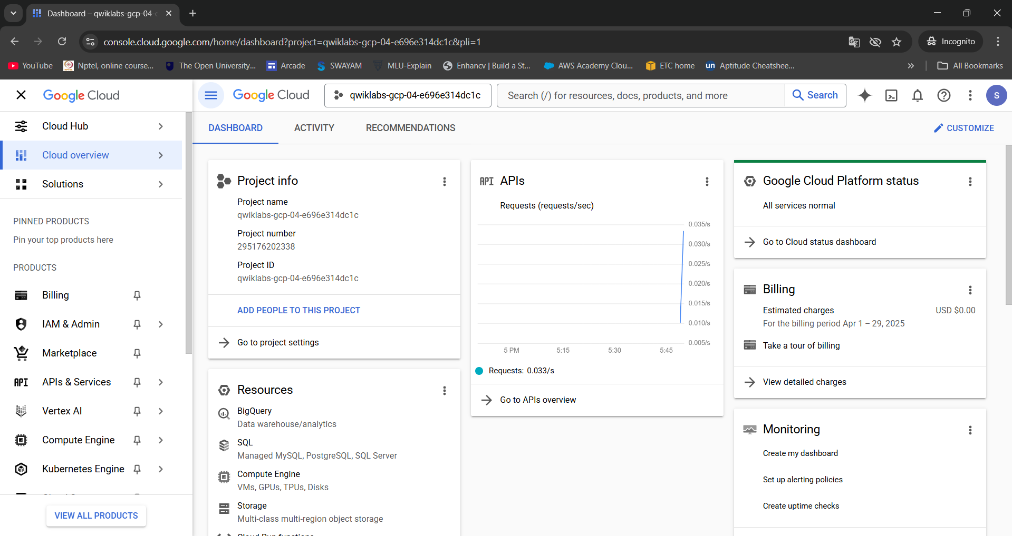

Figure 1:Start the Lab

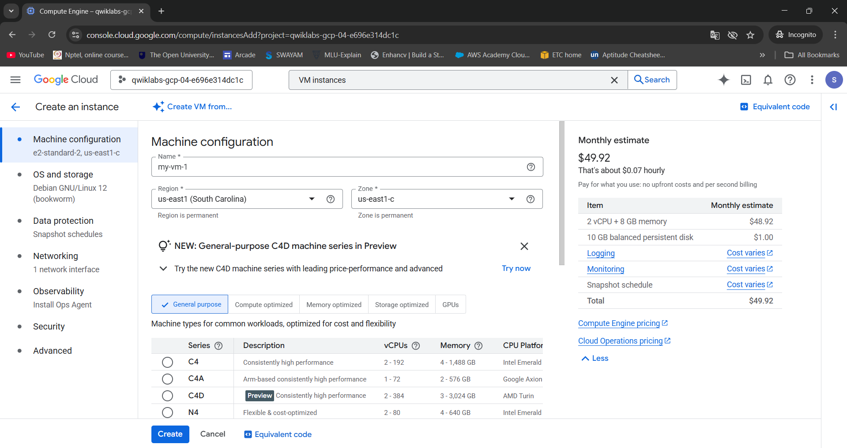

Figure 2:Create an instance

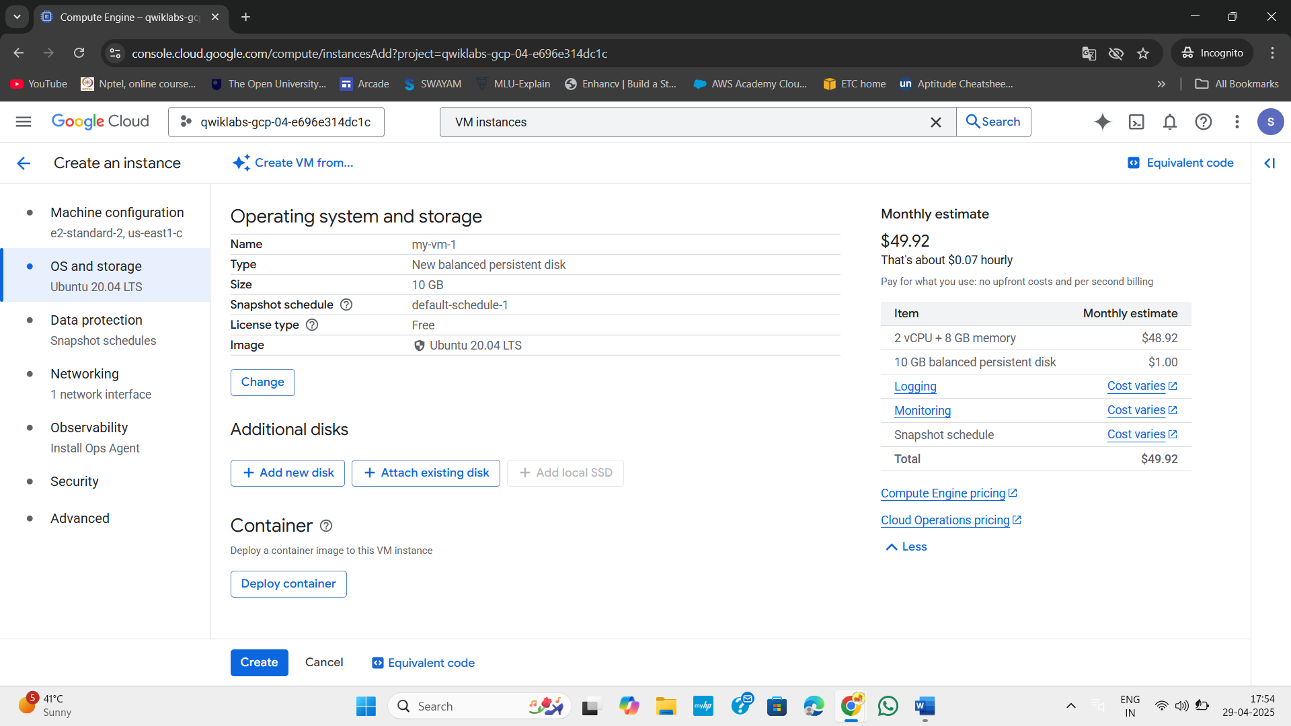

Figure 3:Change operating system to linux

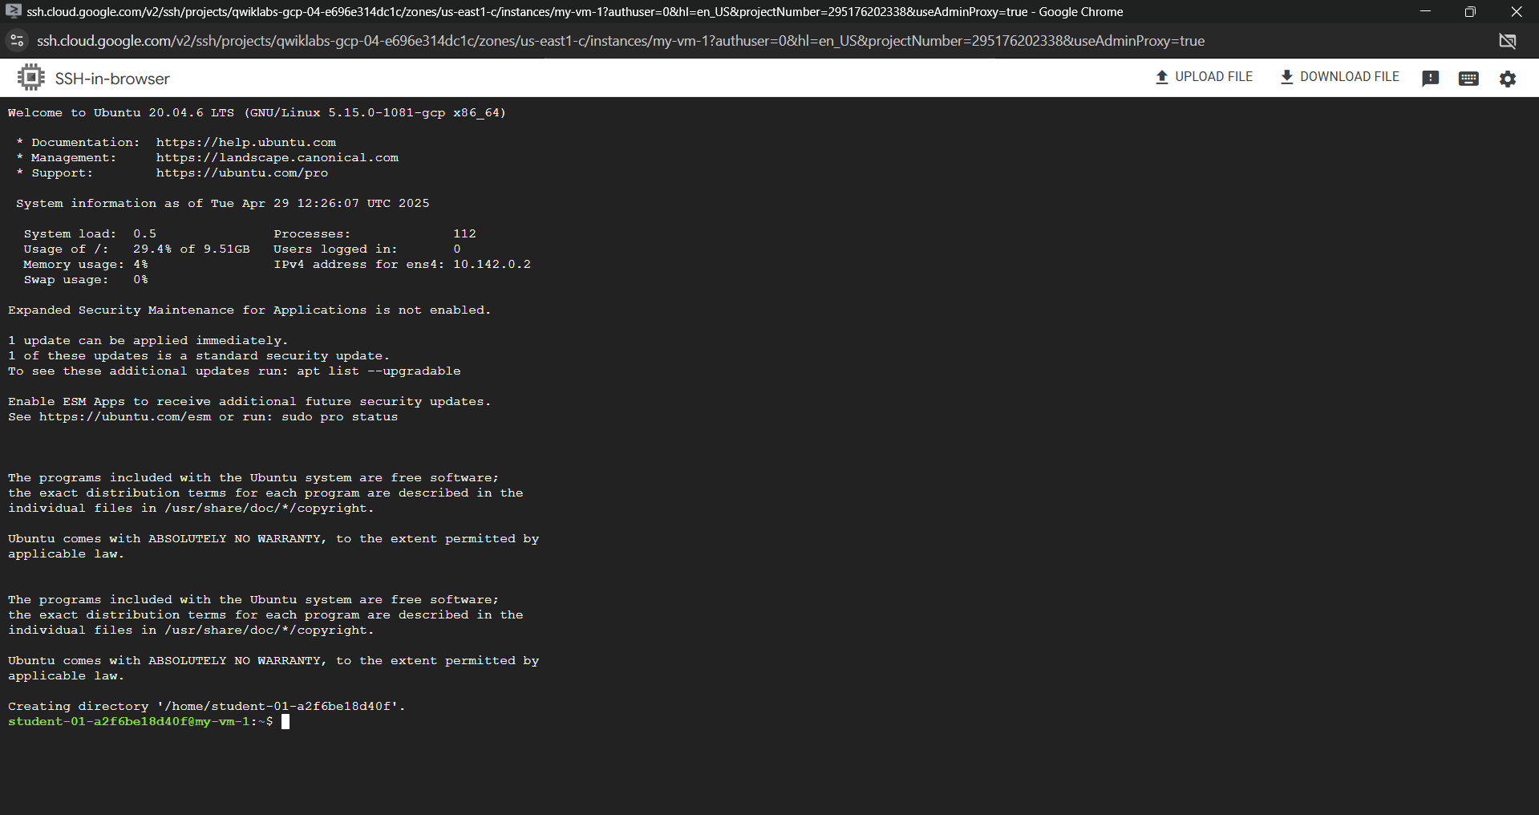

Figure 4:Click SSH for my-vm-1

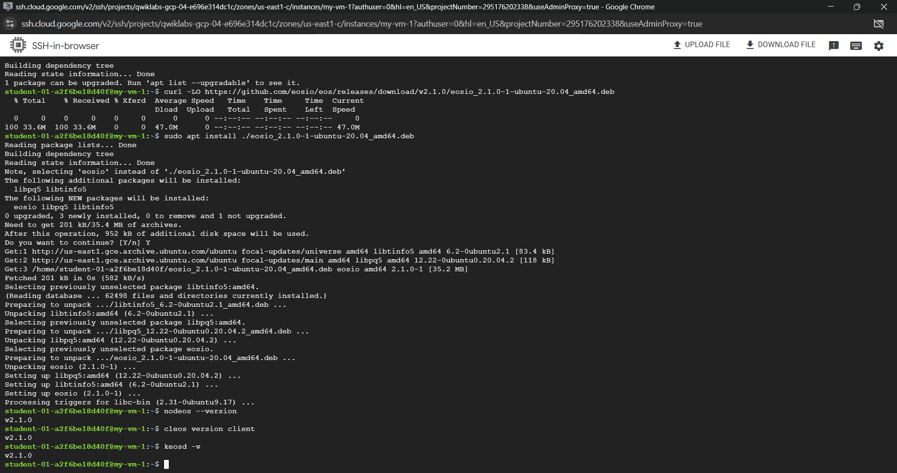

Figure 5:Install the EOSIO platform

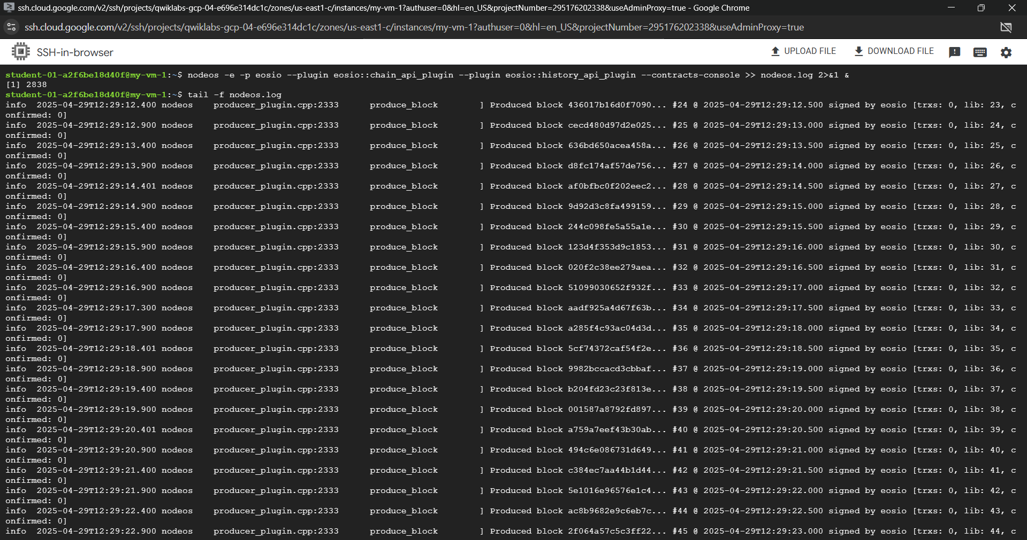

Figure 6:Run a local single node blockchain

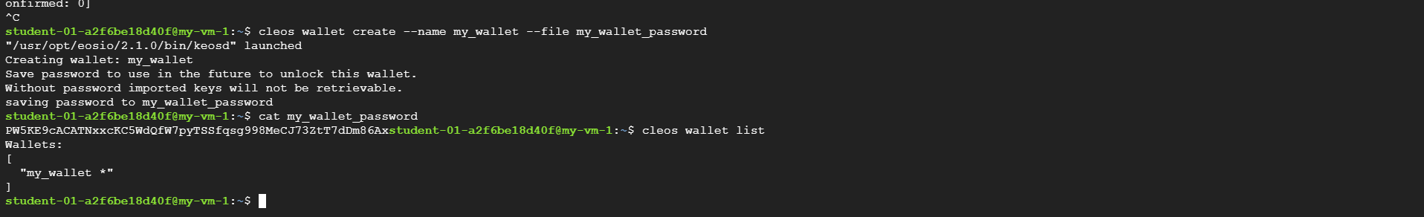

Figure 7:Create wallet

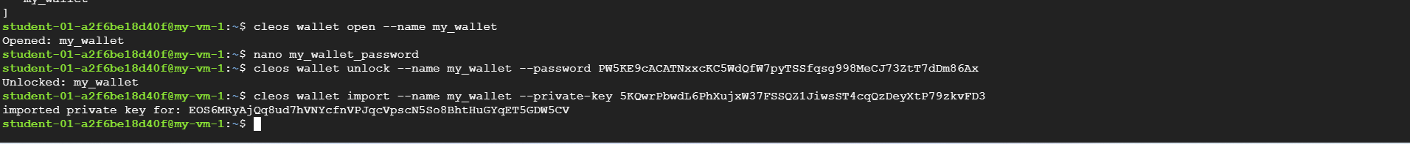

Figure 8:Add the EOSIO system account private key to the new wallet

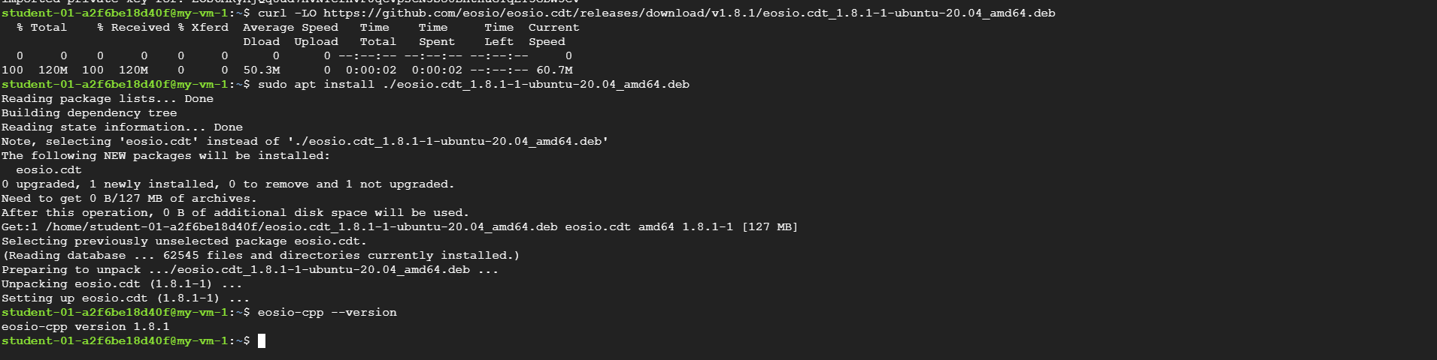

Figure 9:Install the EOSIO Contract Development Toolkit (CDT)

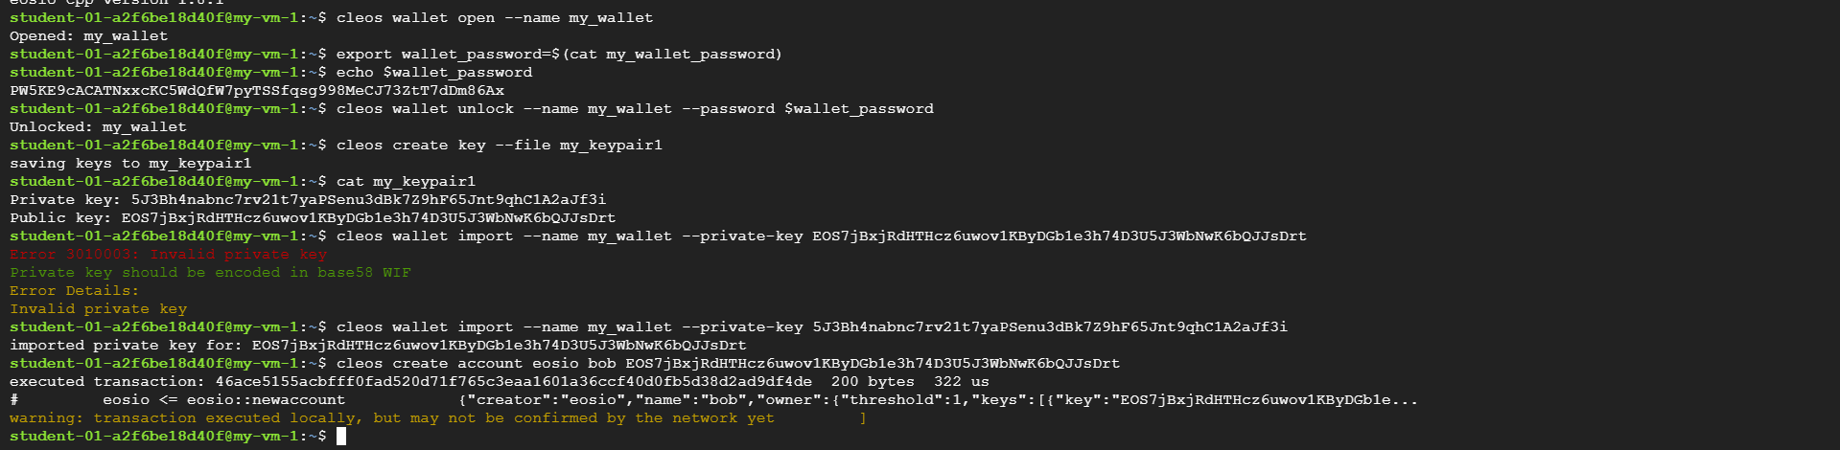

Figure 10:Create a blockchain account

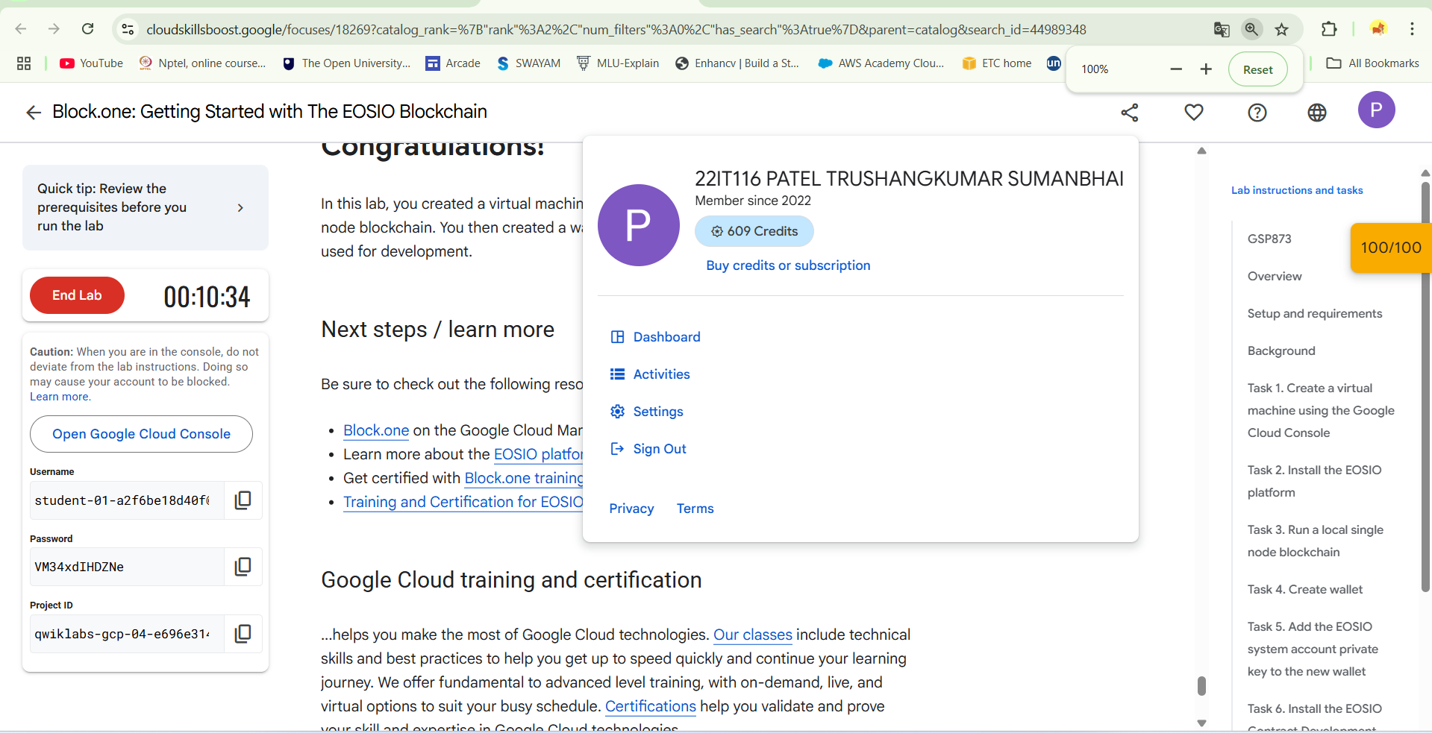

Figure 11:End Lab

**LATEST APPLICATIONS:**

* Decentralized Finance (DeFi)
* Supply Chain Management
* Digital Identity & Voting
* Gaming and NFTs

**LEARNING OUTCOME:**

In this practical, I learned how to set up a single-node blockchain, manage wallets and keys, and create blockchain accounts. I also gained an understanding of consensus mechanisms like DPoS. Additionally, I was introduced to smart contract development tools, which will help me in real-world blockchain application development.

**REFERENCES:**

1. [https://www.cloudskillsboost.google/focuses/18269](https://www.cloudskillsboost.google/focuses/18269?catalog_rank=%7B%22rank%22%3A2%2C%22num_filters%22%3A0%2C%22has_search%22%3Atrue%7D&parent=catalog&search_id=44989348)