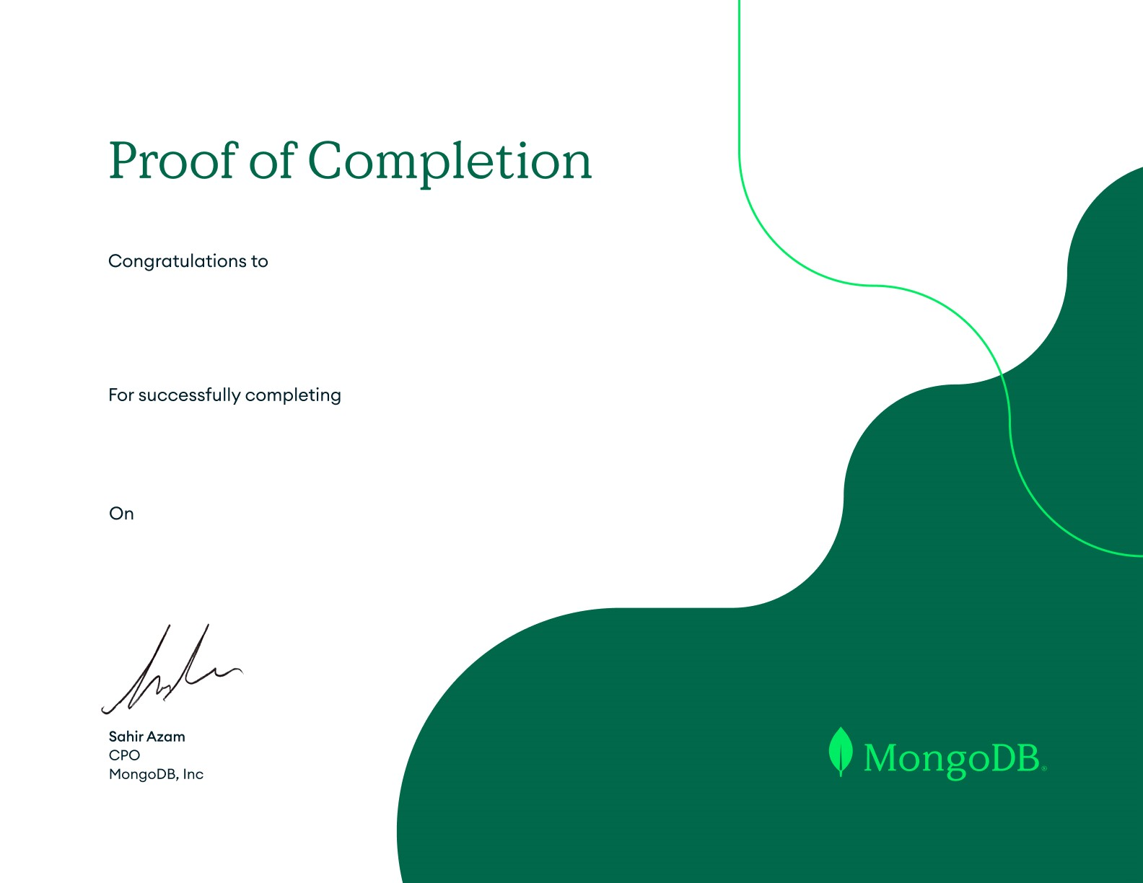

22

IT116 PATEL TRUSHANGKUMAR SUMANBHAI

MongoDB Atlas Search

MDBuvs1bq0pb8

01-09-2024



22

IT116 PATEL TRUSHANGKUMAR SUMANBHAI

MongoDB Transactions

MDBn4gy0uj0ub

01-09-2024



22

IT116 PATEL TRUSHANGKUMAR SUMANBHAI

Getting Started with MongoDB Atlas

MDBpgt0er820w

01-04-2024



22

IT116 PATEL TRUSHANGKUMAR SUMANBHAI

MongoDB CRUD Operations: Replace and Delete Documents

MDBp23fyxose0

01-04-2024



22

IT116 PATEL TRUSHANGKUMAR SUMANBHAI

MongoDB and the Document Model

MDB62u3u8g8xi

01-04-2024



22

IT116 PATEL TRUSHANGKUMAR SUMANBHAI

MongoDB Data Modeling Intro

MDB0zug6yhm51

01-04-2024



22

IT116 PATEL TRUSHANGKUMAR SUMANBHAI

MongoDB CRUD Operations in Node.js

MDB6hdbhkjxt2

01-04-2024



22

IT116 PATEL TRUSHANGKUMAR SUMANBHAI

MongoDB Indexes

MDBx7urcnythc

01-04-2024



22

IT116 PATEL TRUSHANGKUMAR SUMANBHAI

Connecting to MongoDB in Node.js

MDBrgyr7zhme4

01-04-2024



22

IT116 PATEL TRUSHANGKUMAR SUMANBHAI

MongoDB Aggregation

MDBhn5btnq27x

01-04-2024



22

IT116 PATEL TRUSHANGKUMAR SUMANBHAI

MongoDB Node.js Developer Path

MDBiex7llg7w4

01-04-2024



22

IT116 PATEL TRUSHANGKUMAR SUMANBHAI

MongoDB Aggregation with Node.js

MDByl3eoqnq45

01-04-2024



22

IT116 PATEL TRUSHANGKUMAR SUMANBHAI

MongoDB CRUD Operations: Insert and Find Documents

MDB1fetjahjhf

01-04-2024



22

IT116 PATEL TRUSHANGKUMAR SUMANBHAI

Connecting to a MongoDB Database

MDBqpe6hd16m5

01-04-2024



22

IT116 PATEL TRUSHANGKUMAR SUMANBHAI

MongoDB CRUD Operations: Modifying Query Results

MDBz34ygjv9y2

01-04-2024