**Task**

**Aim:** Event Emitter in Node js

Build a real-time file monitoring system using the fs module to watch a specific directory and emit custom events through an Event Emitter when new files are created, existing files are modified, or files are deleted.

**Description:**

In Node.js, the Event Emitter is a core module that facilitates communication between objects by allowing them to emit and listen for custom events. It plays a crucial role in implementing an asynchronous, event-driven paradigm. Objects that extend the Event Emitter class can emit named events, and other objects can register listeners to respond to those events, enabling effective decoupling and modularization in Node.js applications.

**Source Code:**

const fs = require('fs');

const path = require('path');

const EventEmitter = require('events');

class FileMonitor extends EventEmitter {

  constructor(directory) {

    super();

    this.directory = directory;

  }

  startMonitoring() {

    fs.watch(this.directory, (eventType, filename) => {

      const filePath = path.join(this.directory, filename);

      if (eventType === 'rename') {

        if (fs.existsSync(filePath)) {

          this.emit('fileCreated', filePath);

        } else {

          this.emit('fileDeleted', filePath);

        }

      } else if (eventType === 'change') {

        this.emit('fileModified', filePath);

      }

    });

    this.on('error', (err) => {

      console.error(`Error in FileMonitor: ${err.message}`);

    });

  }

}

// Usage example

const directoryToMonitor = 'C:\\SEM-4\\FSWD\\WEEK-4';  // Double backslashes for Windows

const fileMonitor = new FileMonitor(directoryToMonitor);

fileMonitor.on('fileCreated', (filePath) => {

  console.log(`File created: ${filePath}`);

});

fileMonitor.on('fileModified', (filePath) => {

  console.log(`File modified: ${filePath}`);

});

fileMonitor.on('fileDeleted', (filePath) => {

  console.log(`File deleted: ${filePath}`);

});

fileMonitor.on('error', (err) => {

  console.error(`Error in FileMonitor: ${err.message}`);

});

fileMonitor.startMonitoring();

**Output:**

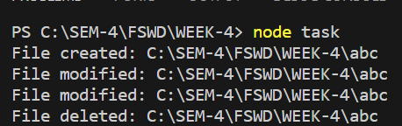

**Learning Outcome:**

In this task we learn about event emitter.