Reporting No:1 Week No:1 From :22/05/2025 To:30/05/2025 College ID: 22IT116

Project Title: performance analysis of app

**WEEKLY REPORT**

**Work done in last week ( Attach supporting Documents):**

22/05/2025 Thursday

|  |  |
| --- | --- |
| 9:30 – 11:30 | Introduction: What to Do During an Internship and About the Project |
| 12:00– 2:30 | Completed "Quick Blockchain Refresher" section (Modules 2.1–2.10) from KBA course. |
| 3:00– 5:00 | Studied Docker basics and container lifecycle (Modules 3.1–3.5). |

23/05/2025 Friday

|  |  |
| --- | --- |
| 9:30 – 11:30 | Hands-on setup of Docker for Fabric networks. |
| 12:00– 2:30 | Covered real-world blockchain case studies (Modules 4.1–5.2). |
| 3:00– 5:00 | Studied transparency, traceability, fraud prevention in blockchain (Modules 6.1–6.5). |

26/05/2025 Monday

|  |  |
| --- | --- |
| 9:30 – 11:30 | Explored Hyperledger implementations like Corda, Ethereum, and Fabric (Modules 8.1–8.4). |
| 12:00– 2:30 | Completed "Why Hyperledger Fabric" (Modules 10.1–10.7). |
| 3:00– 5:00 | Studied Fabric Network Architecture (Modules 11.1–11.10). |

27/05/2025 Tuesday

|  |  |
| --- | --- |
| 9:30 – 11:30 | Practiced orderer setup and channel creation. |
| 12:00– 2:30 | Learned about peers, client nodes, and endorsement logic (Modules 12.1–12.10). |
| 3:00– 5:00 | Studied PKI, MSP, and certificate authorities (Modules 13.1–13.7). |

28/05/2025 Wednesday

|  |  |
| --- | --- |
| 9:30 – 11:30 | Explored Fabric transaction flow and message passing (Modules 14.1–14.9). |
| 12:00– 2:30 | Bootstrapped the Fabric network with VSCode (Modules 15.1–15.8). |
| 3:00– 5:00 | Completed hands-on car auction network and related solution (Modules 16.1–16.3). |

29/05/2025 Thursday

|  |  |
| --- | --- |
| 9:30 – 11:30 | Learned about chaincode basics and transaction lifecycles (Modules 18.1–19.4). |
| 12:00– 2:30 | Studied writing and deploying chaincode (Modules 20.1–22.7). |
| 3:00– 5:00 | Completed exercises on PDC and rich queries (Modules 24.1–25.2). |

30/05/2025 Friday

|  |  |
| --- | --- |
| 9:30 – 11:30 | Finalized chaincode development (Module 26.1). |
| 12:00– 2:30 | Completed Assessments 2 & 3 and reviewed RAFT consensus (Modules 28.1, 33.1, 40.1–40.5). |
| 3:00– 5:00 | Started LFS270 course: Completed Course Introduction (Module 1). |

**Reason for incomplete work:**

1. No major tasks remained incomplete. However, detailed exploration of some advanced modules from the LFS270 course (such as Fabric CA setup and production-level deployment strategies) was deferred to next week due to the extensive time needed for hands-on lab configuration and system setup compatibility issues.

**Plans for next week:**

1. Progress through **Module 2 to 5** of the LFS270 course:
   1. Deep dive into Hyperledger Fabric architecture and components.
   2. Study Certificate Authorities (CAs), Ordering Services, and network configuration best practices.
2. Complete hands-on labs:
   1. Set up a basic network using cryptogen and configtxgen.
   2. Deploy and test smart contracts using Fabric CLI.
3. Explore advanced features:
   1. Identity management using Fabric CA.
   2. Integrating applications with Fabric SDKs.
4. Begin drafting initial proposal for a **capstone project** using Hyperledger Fabric:
   1. Define use-case, architecture, roles, and transaction model.

**References:**

1. KBA : <https://learn.kba.ai/course/certified-hyperledger-fabric-developer/>
2. Linux Foundation : [trainingportal.linuxfoundation.org/hyperledger-fabric-design-develop-and-deploy-lfs270](https://trainingportal.linuxfoundation.org/learn/course/hyperledger-fabric-design-develop-and-deploy-lfs270/course-introduction/course-information)

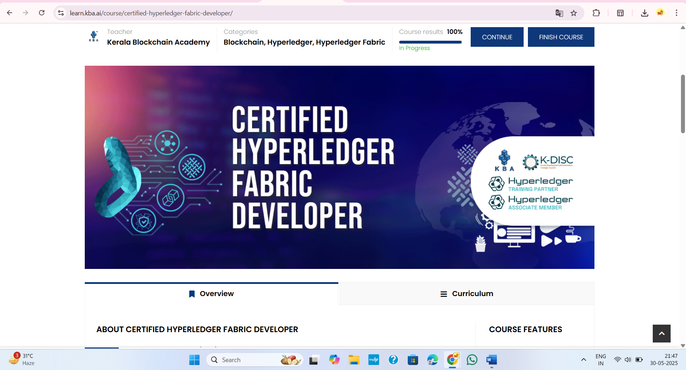

Figure 1:Complete the Certified Hyperledger Fabric Developer course 100%

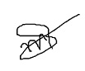

|  |  |
| --- | --- |
|  |  |
| **Signature of External Guide** | **Signature of Internal Guide** |

Student Id: 22IT116

Student Name: TRUSHANGKUMAR SUMANBHAI PATEL