Reporting No:3 Week No:3 From :09/06/2025 To:13/06/2025 College ID: 22IT116

Project Title: performance analysis of app

**WEEKLY REPORT**

**Work done in last week ( Attach supporting Documents):**

09/06/2025 Monday

|  |  |
| --- | --- |
| 9:30 – 11:30 | *Completed theoretical overview of Modules 21 & 22: Production Deployment, Security and Performance.* |
| 12:00– 2:30 | Watched implementation demos and reviewed Fabric network deployment strategies. |
| 3:00– 5:00 | *Installed required software on Ubuntu (Docker, Node.js, VSCode).* |

10/06/2025 Tuesday

|  |  |
| --- | --- |
| 9:30 – 11:30 | *Studied Hyperledger Fabric Production Deployment concepts.* |
| 12:00– 2:30 | *L*earned security and performance features in Hyperledger Fabric. |
| 3:00– 5:00 | *Reviewed smart contract architecture in enterprise environments.* |

11/06/2025 Wednesday

|  |  |
| --- | --- |
| 9:30 – 11:30 | Read about State-Based Endorsement Policies. |
| 12:00– 2:30 | Started setup for test network to deploy state-based chaincode. |
| 3:00– 5:00 | Faced setup errors due to Ubuntu crashing during configuration. |

12/06/2025 Thursday

|  |  |
| --- | --- |
| 9:30 – 11:30 | Troubleshot system issues; Ubuntu not loading properly. |
| 12:00– 2:30 | Backed up files and formatted the drive. |
| 3:00– 5:00 | *Removed Windows OS completely and installed Ubuntu as the sole operating system.* |

13/06/2025 Friday

|  |  |
| --- | --- |
| 9:30 – 11:30 | Installed all required development tools on fresh Ubuntu system. |
| 12:00– 2:30 | Reinstalled Docker, Fabric samples, and environment dependencies. |
| 3:00– 5:00 | Validated development setup and started re-implementation of Fabric chaincode labs. |

**Reason for incomplete work:**

1. Hands-on implementation was delayed due to Ubuntu OS failure and the need to completely format the system and install Ubuntu in place of Windows. This caused a setback in lab execution and testing.

**Plans for next week:**

1. Complete pending labs on State-Based Endorsement and Private Data Collections.
2. Begin Fabric CA configuration and implementation.
3. Run Fabric Gateway application integration lab.

**References:**

1. Linux Foundation : [trainingportal.linuxfoundation.org/hyperledger-fabric-design-develop-and-deploy-lfs270](https://trainingportal.linuxfoundation.org/learn/course/hyperledger-fabric-design-develop-and-deploy-lfs270/course-introduction/course-information)

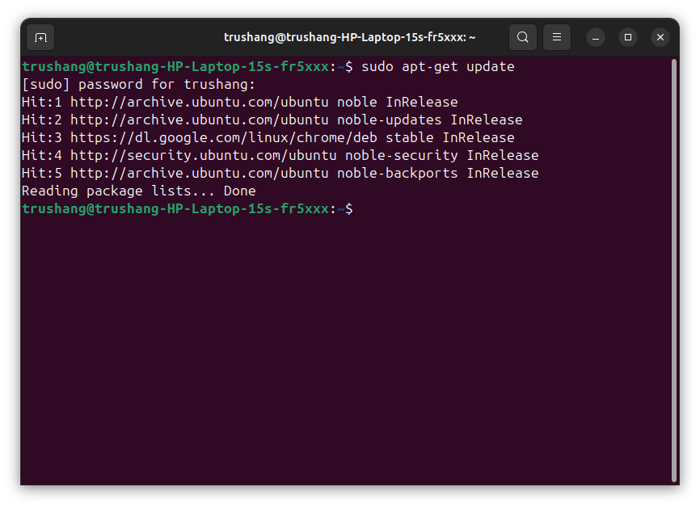

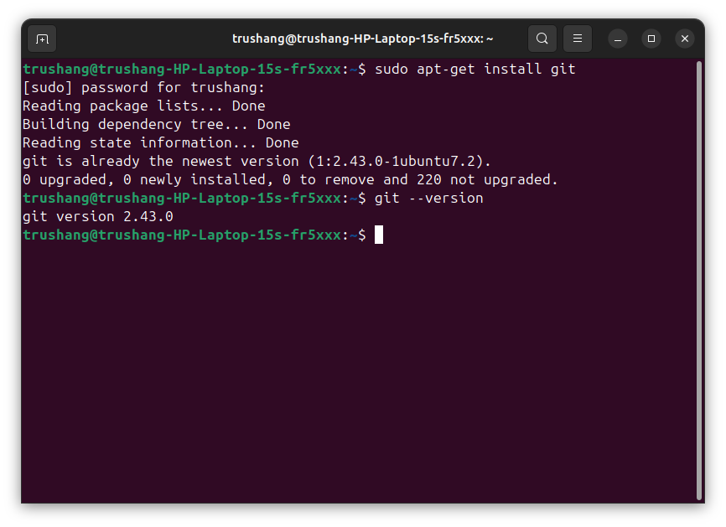

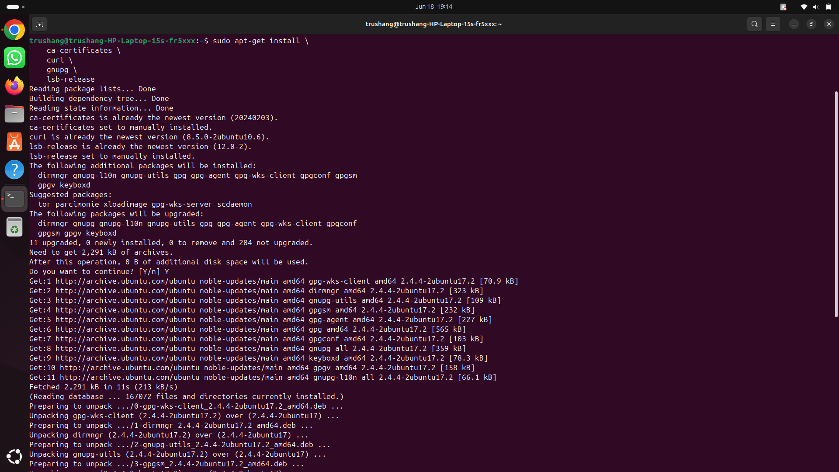

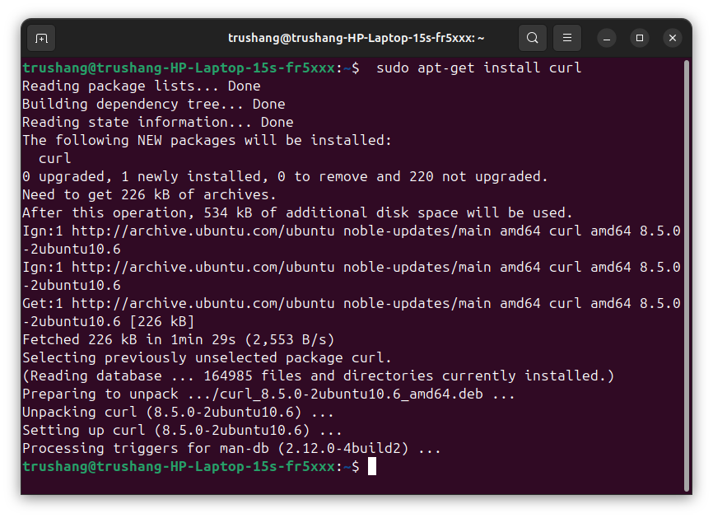





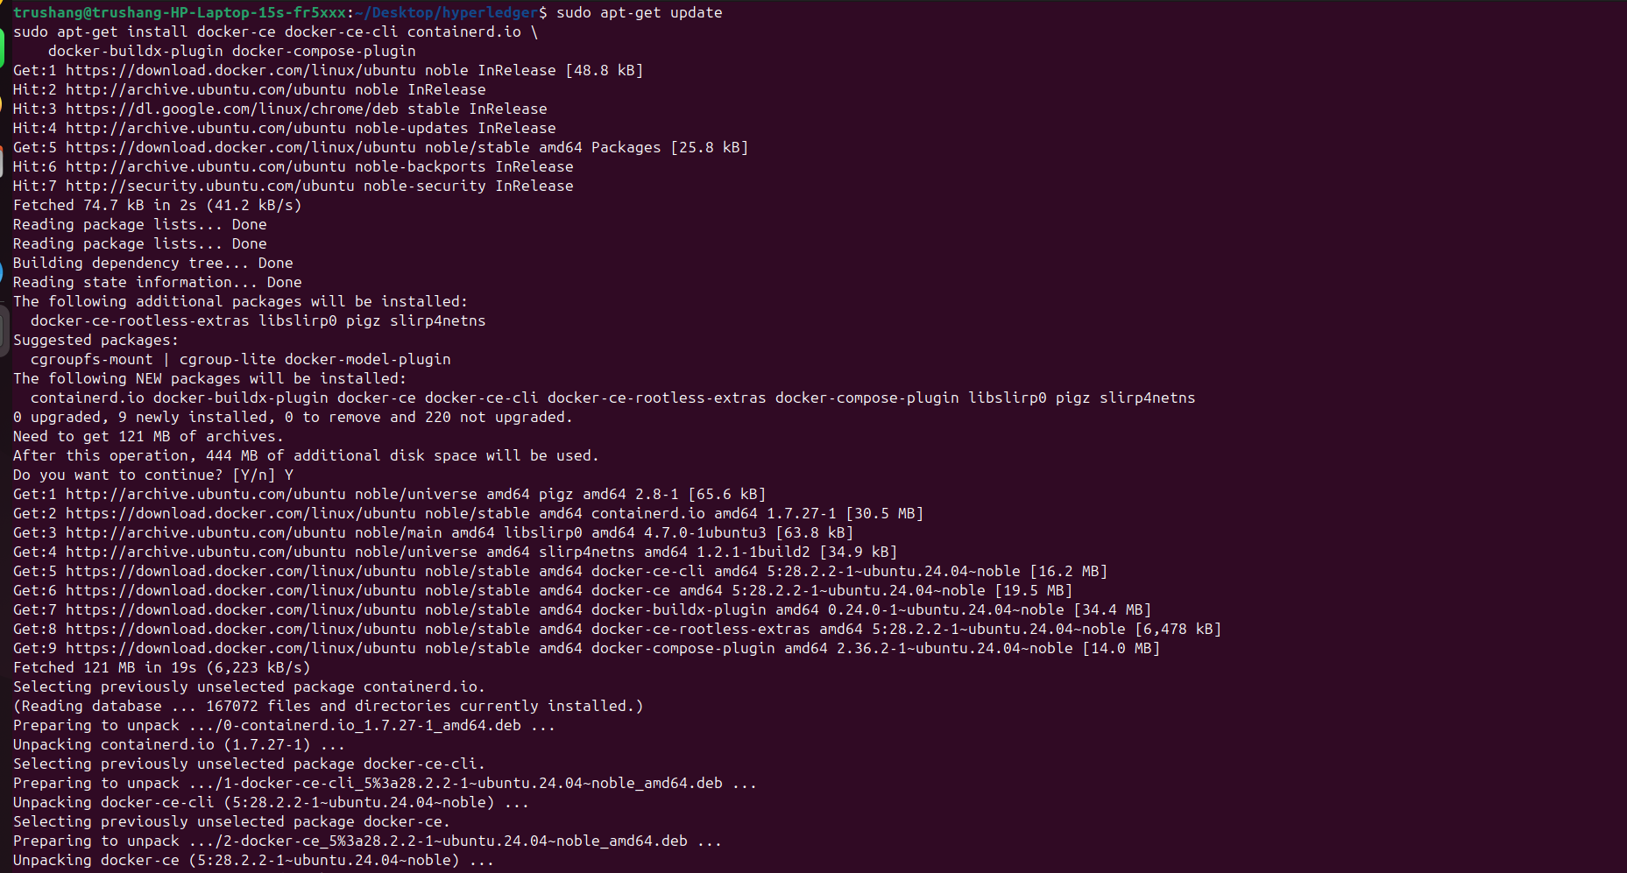



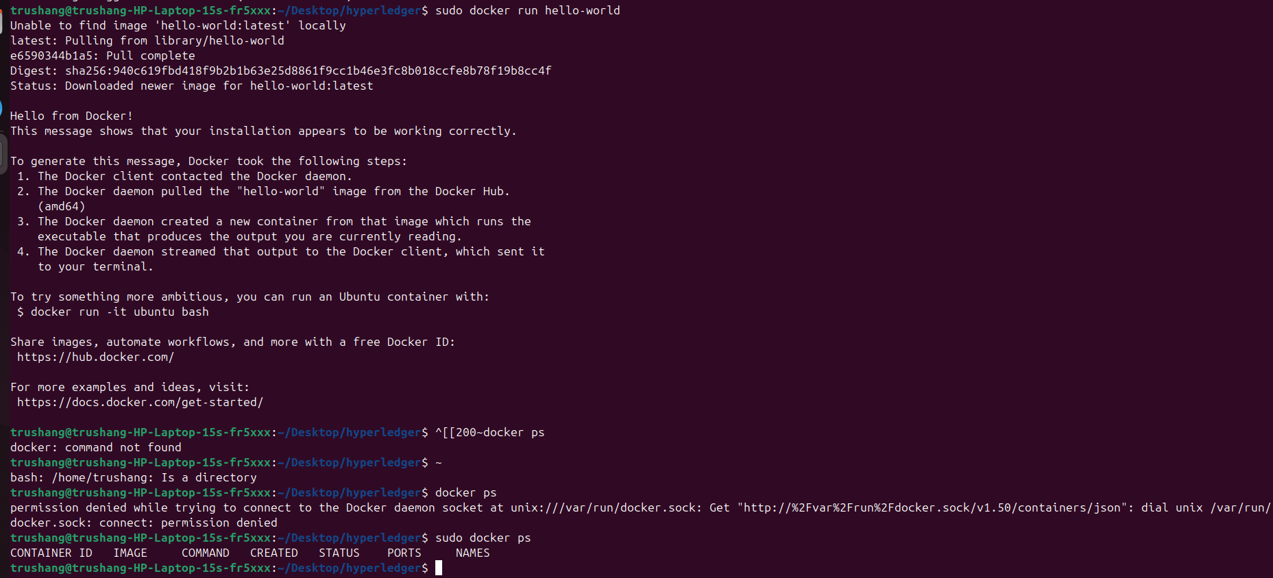

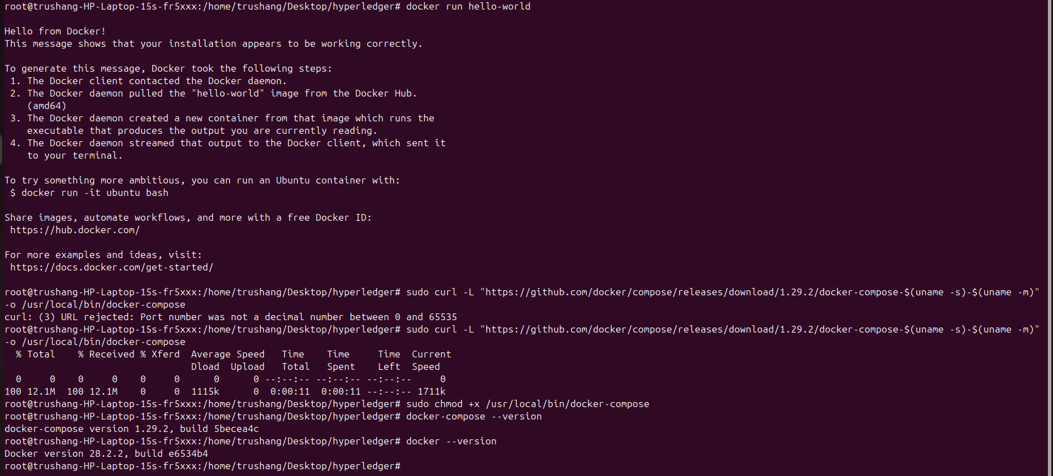

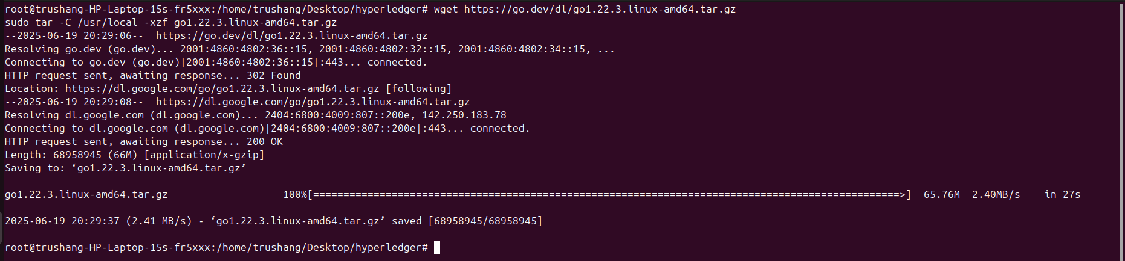

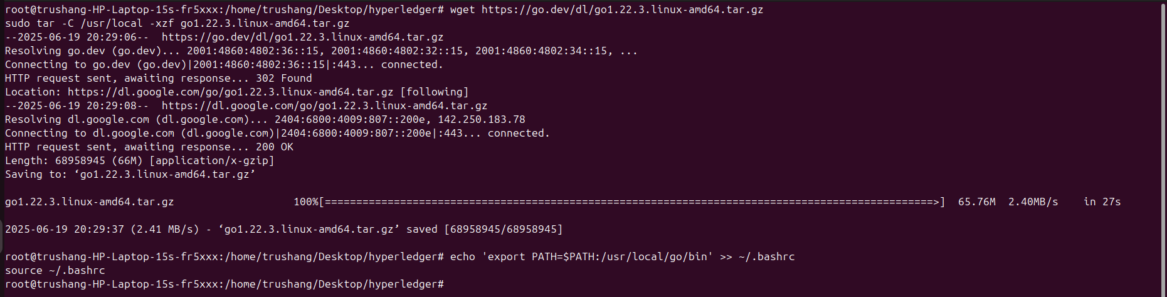



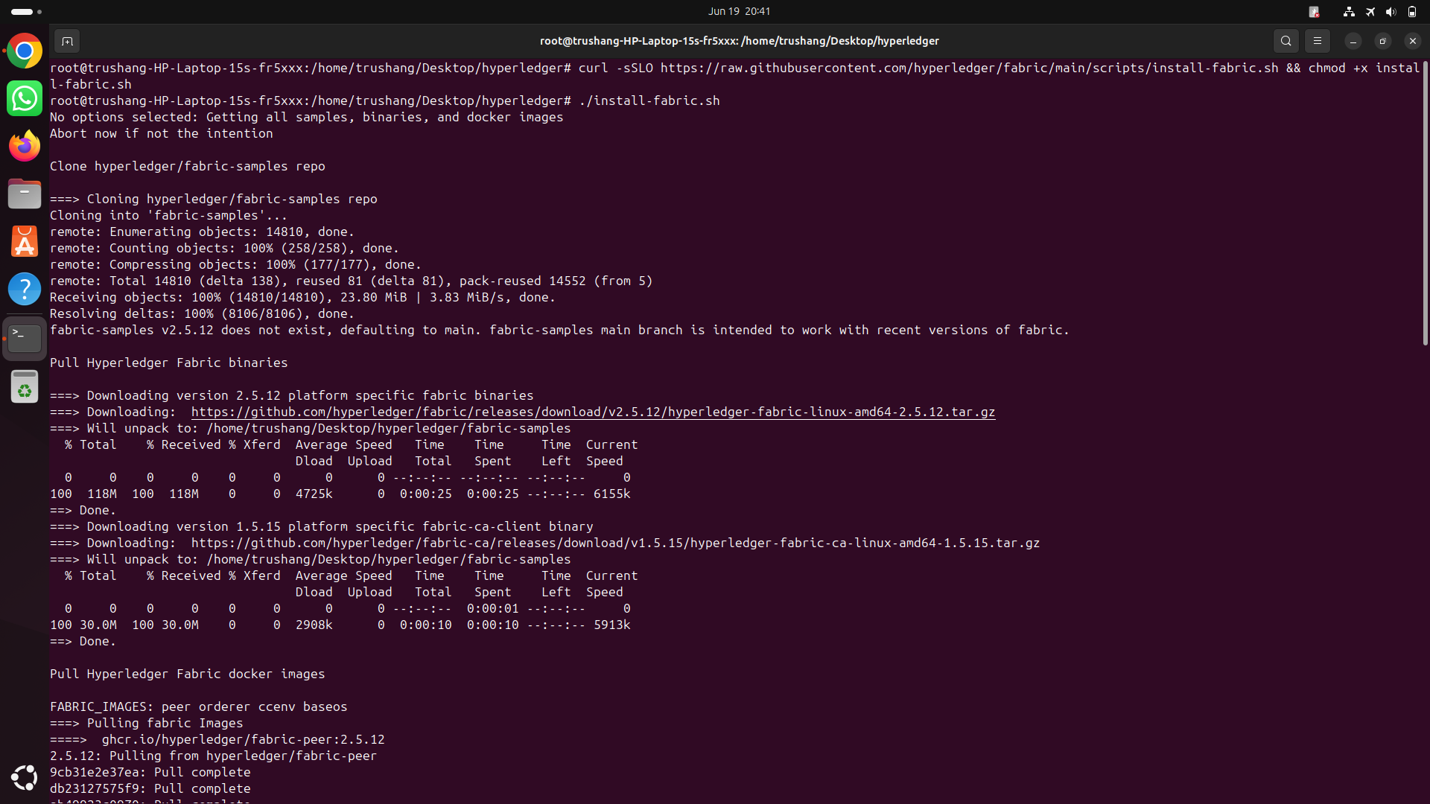

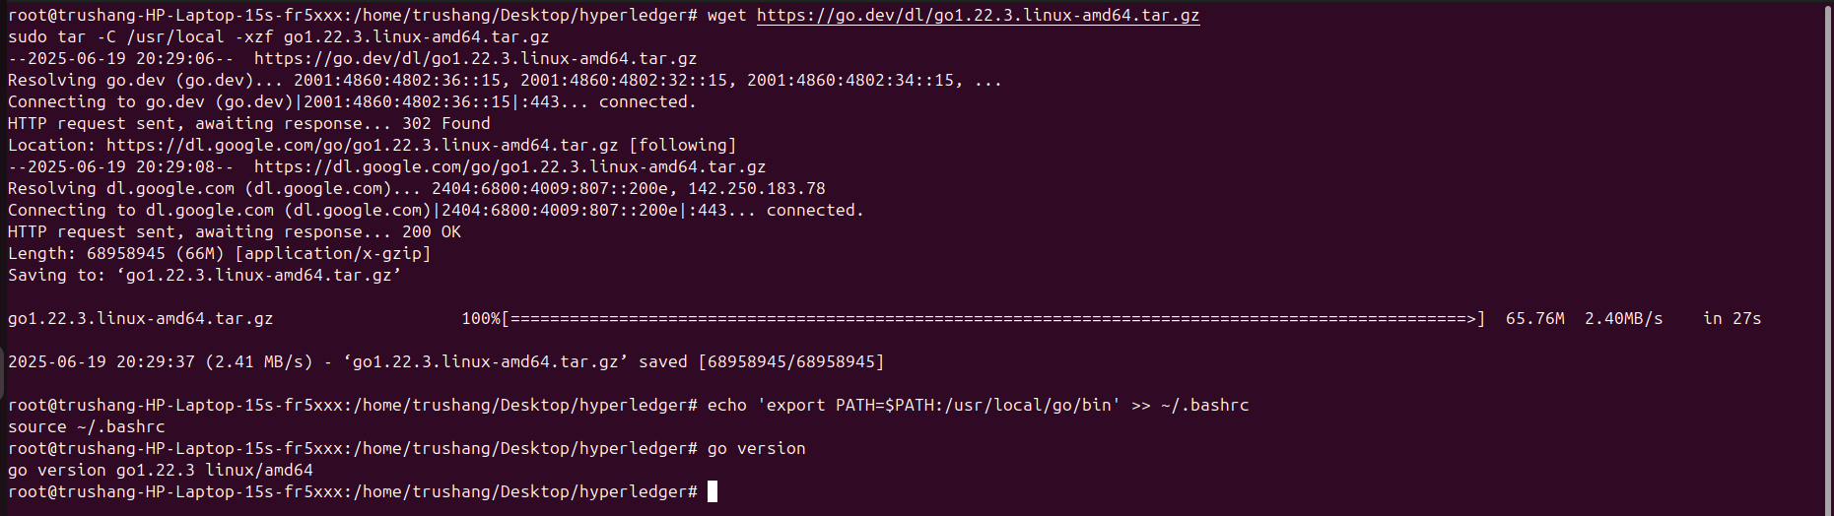

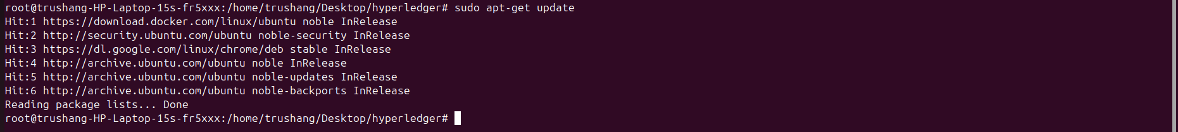

**Signature of External Guide Signature of Internal Guide**

Student Id: 22IT116

Student Name: TRUSHANGKUMAR SUMANBHAI PATEL