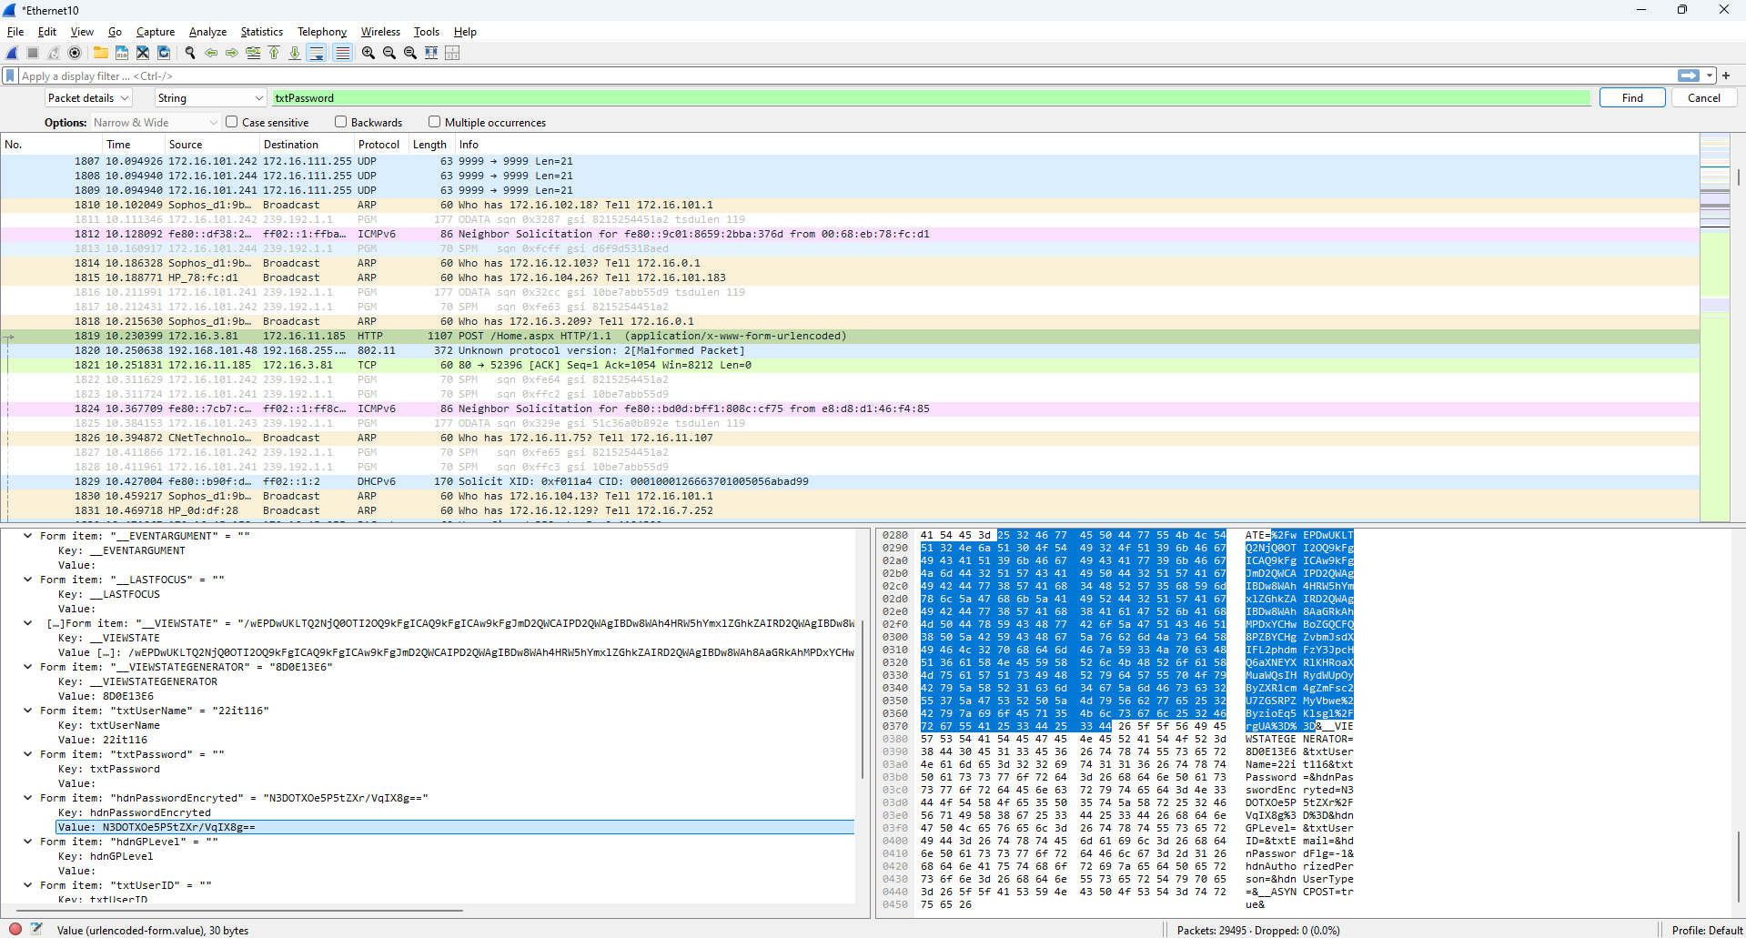

Figure 1: Getting Hash Value of E-Governance login password

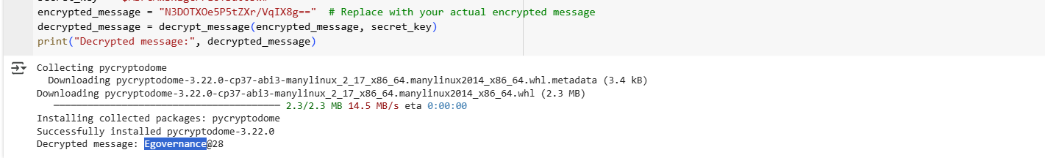

Figure 2: Decrypt the Hash Password

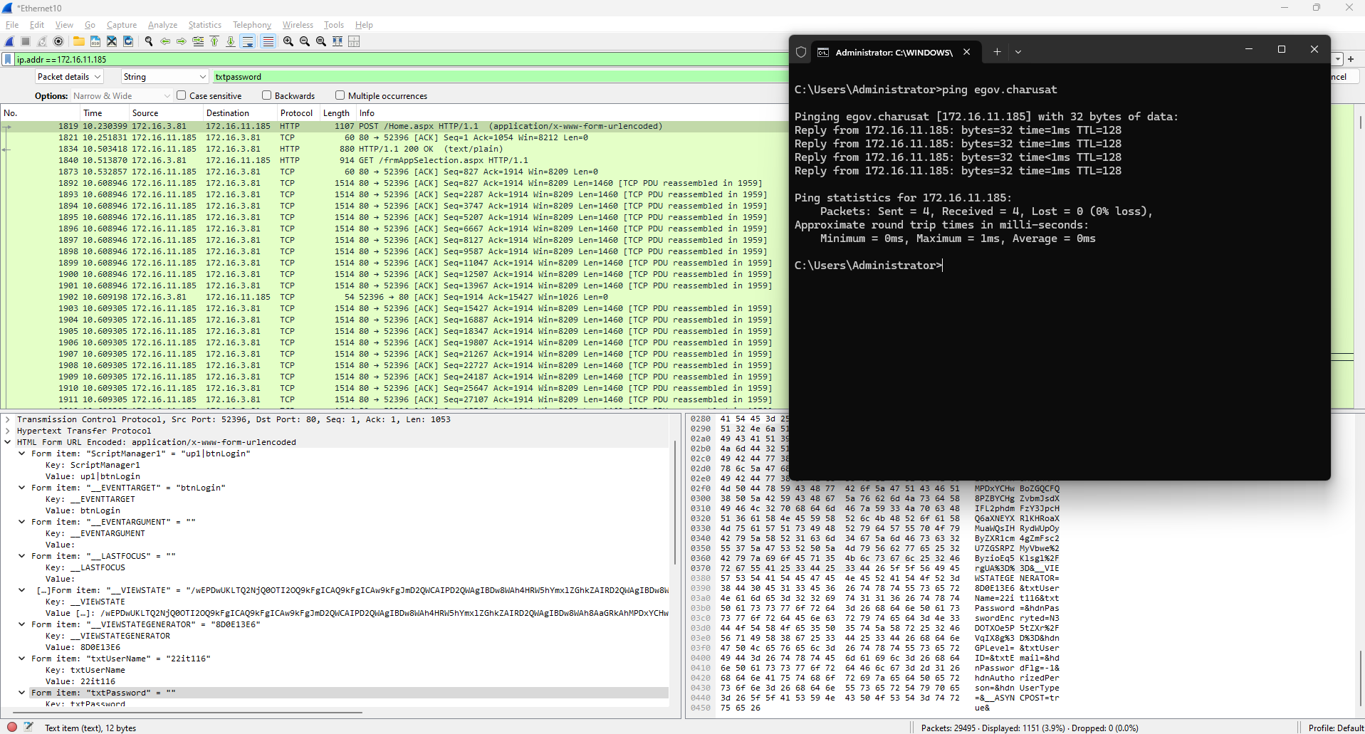

Figure 3: Flitter packet by IP address

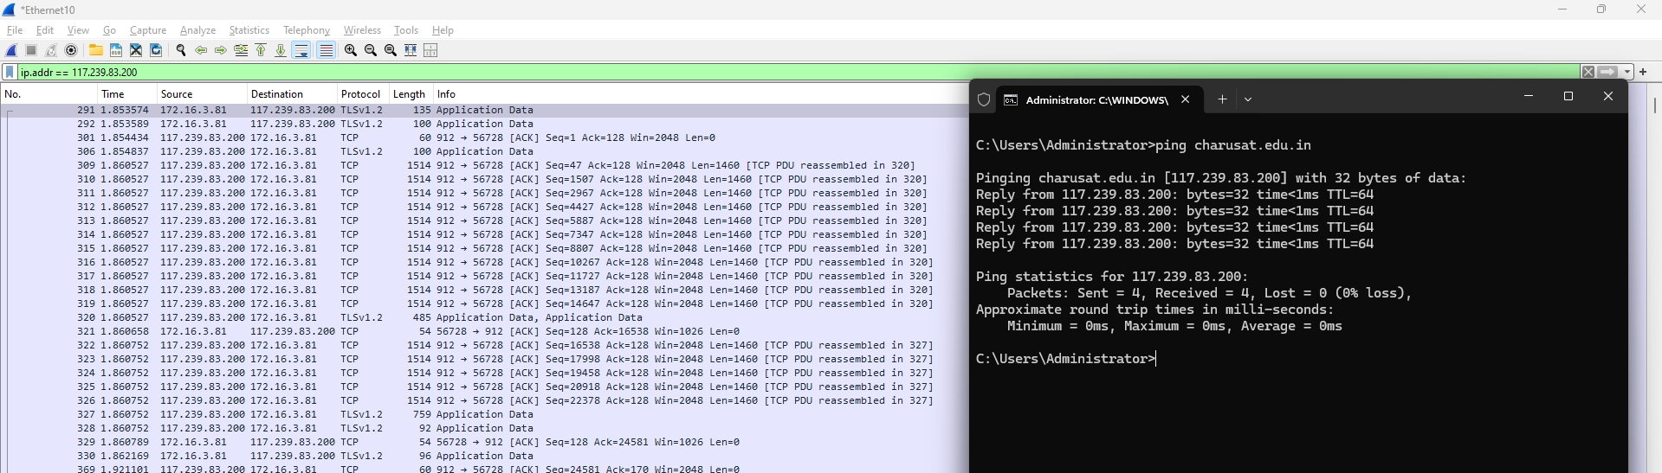

Figure 4: Check the E governance Host website IP and Apply filter for IP address

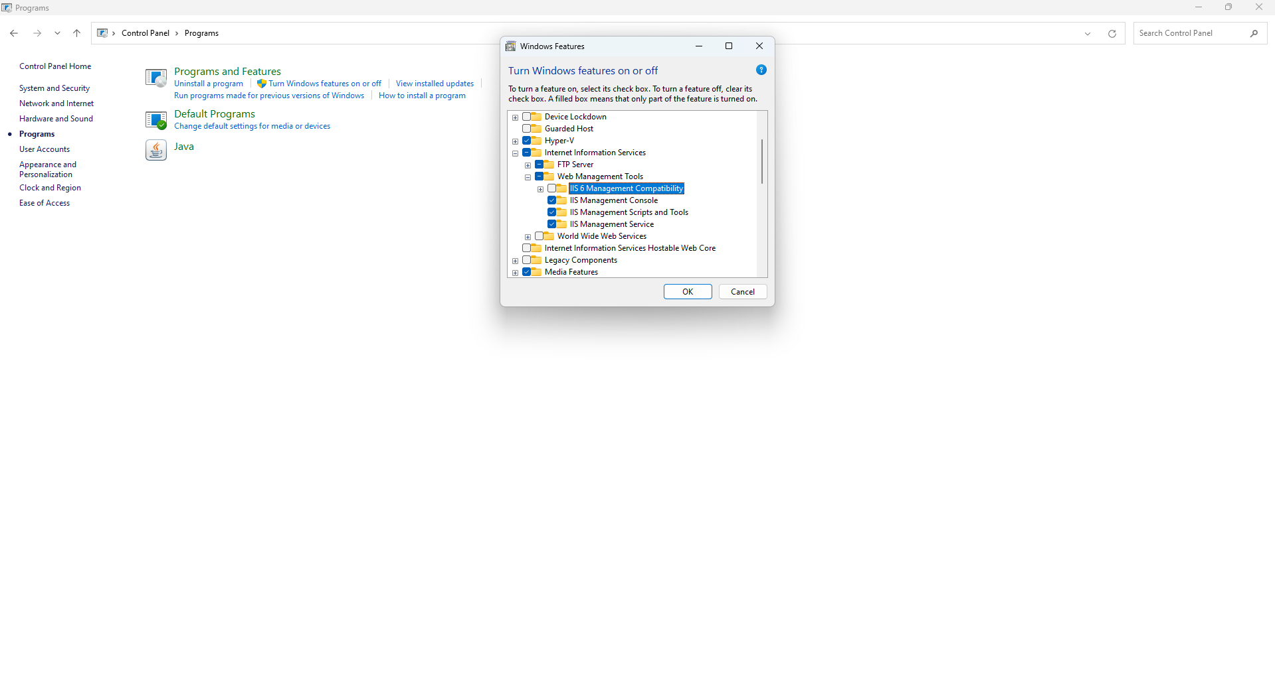

Figure 5: Open Windows Features and Check FTP service (Control Panel -> Programs -> Turn Windows features on or off -> FTP Services

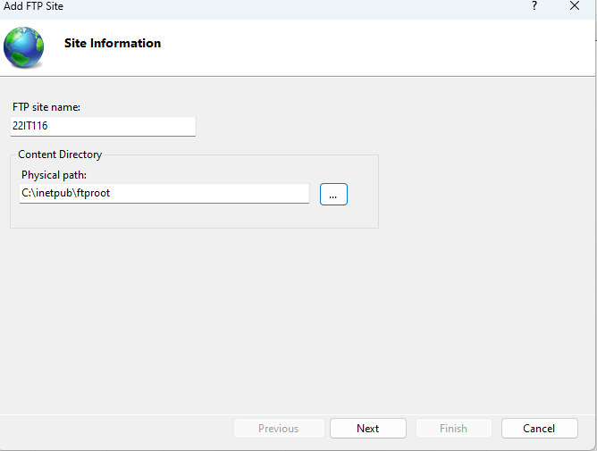

Figure 6: Enter a name for FTP site and specify the path to the folder that you want to use for FTP

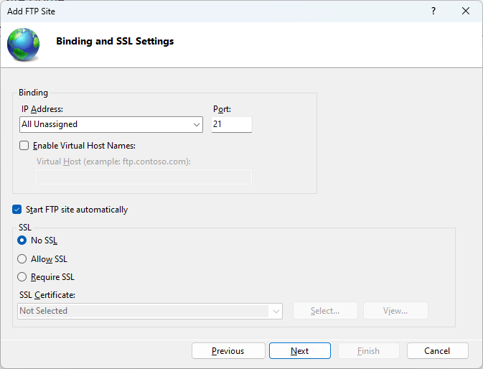

Figure 7: **Configure Binding and SSL**

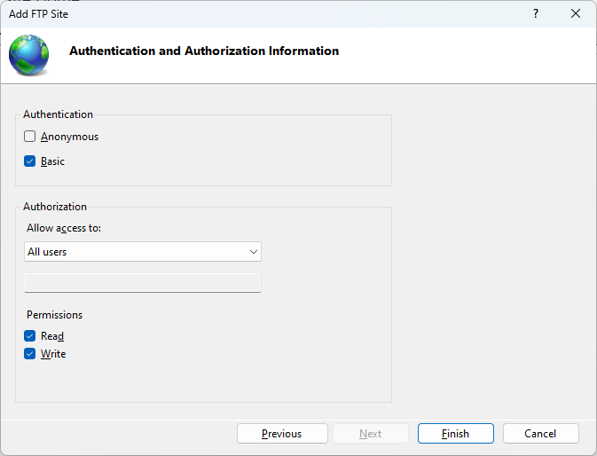

Figure 8: Click Finish to create the FTP site and start it

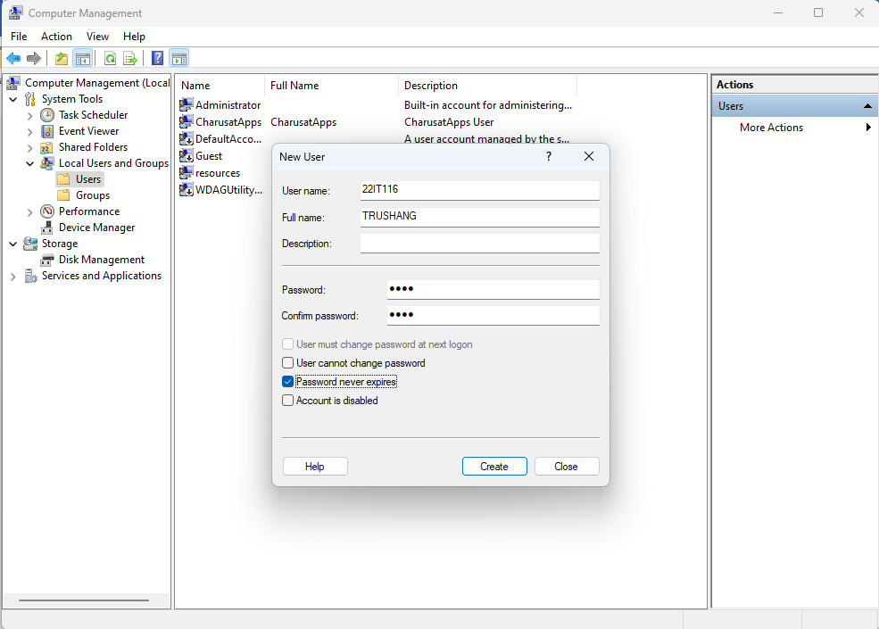

Figure 9: Create a user in computer management (Computer management ->Local Users & Groups -> User-> New User)

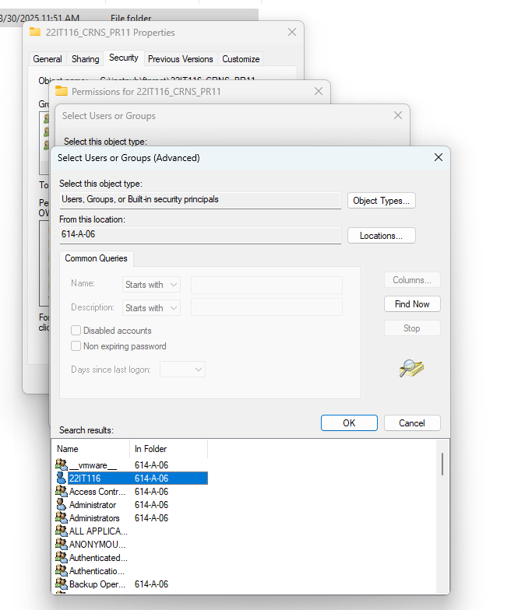

Figure 10: Create a folder and Give permission to user which created in previous step

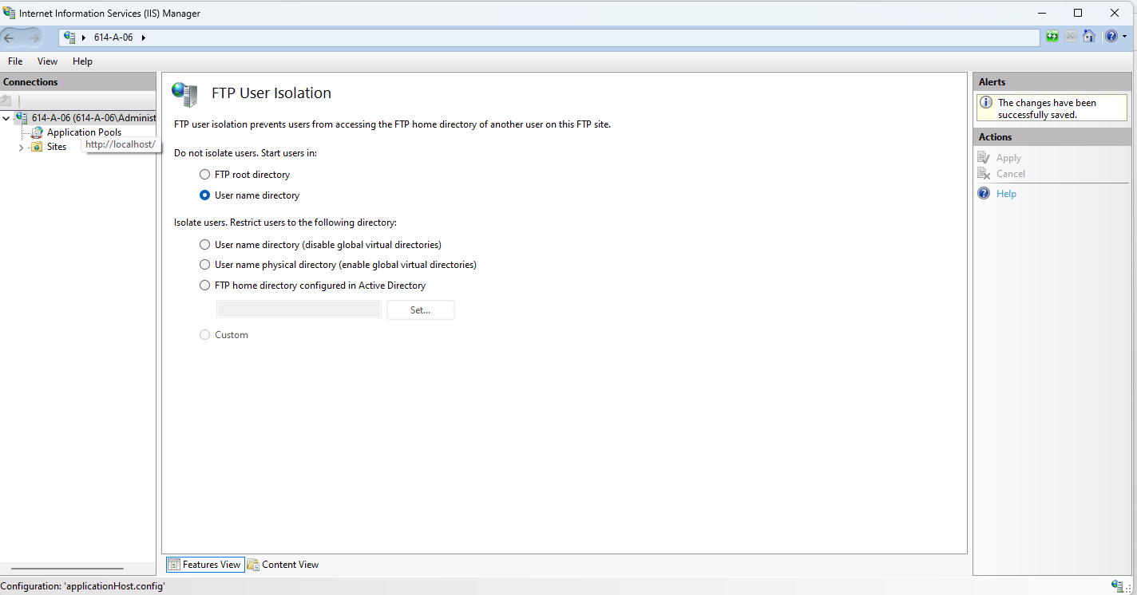

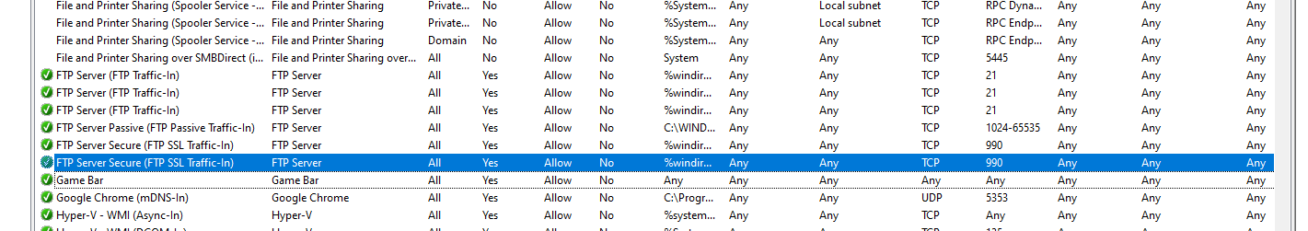

Figure 11: Enable FTP server rule

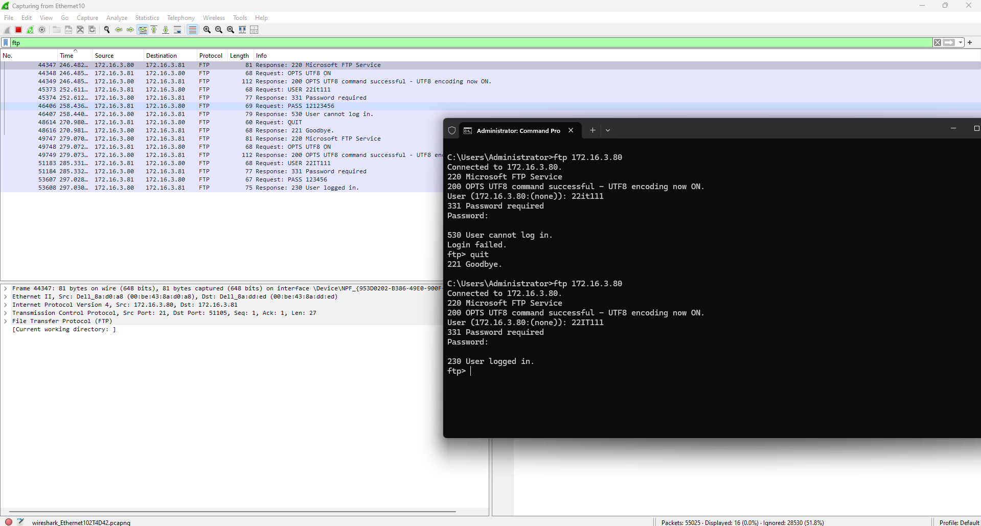

Figure :

