PRACTICAL: 11

# AIM:

# Wireshark is an open-source tool for profiling network traffic and analysing packets. It is often referred to as a network analyzer, network protocol analyzer, or sniffer. Wireshark intercepts traffic and converts that binary traffic into a human-readable format. Network administrators, Network security engineers, QA engineers, Developers, and other people who troubleshoot network problems, examine security problems, verify network applications, debug protocol implementations, and learn network protocol internals, respectively, can use it. A practical approach to study Wireshark from network security concept.

# THEORY:

Wireshark is a powerful, open-source network protocol analyzer that allows users to capture, analyze, and troubleshoot network traffic. It is a widely used tool in the field of cybersecurity, providing valuable insights into network activity and potential security threats.

Network security is a critical aspect of modern computing, as the increasing reliance on interconnected devices and networks has made organizations more vulnerable to various security threats. Understanding the fundamentals of network security is essential for effectively detecting and mitigating these threats.

**Common Network Security Threats**

* Unauthorized access: Attackers attempting to gain unauthorized access to network resources or systems.
* Eavesdropping: Intercepting and monitoring network traffic to gather sensitive information.
* Denial-of-Service (DoS) attacks: Attempts to disrupt or overwhelm a network or system, rendering it unavailable to legitimate users.
* Malware propagation: The spread of malicious software, such as viruses, worms, or trojans, through the network.

Effective network monitoring and analysis are crucial for identifying and addressing security threats. By analyzing network traffic, security professionals can detect anomalies, identify potential vulnerabilities, and take appropriate actions to mitigate risks.

**Wireshark's Role in Cybersecurity**

Wireshark is a valuable tool for cybersecurity professionals, as it provides a comprehensive view of network activity, allowing them to:

* Identify and analyze network security incidents
* Detect and investigate suspicious network traffic
* Troubleshoot network issues and performance problems
* Validate the effectiveness of security controls and policies

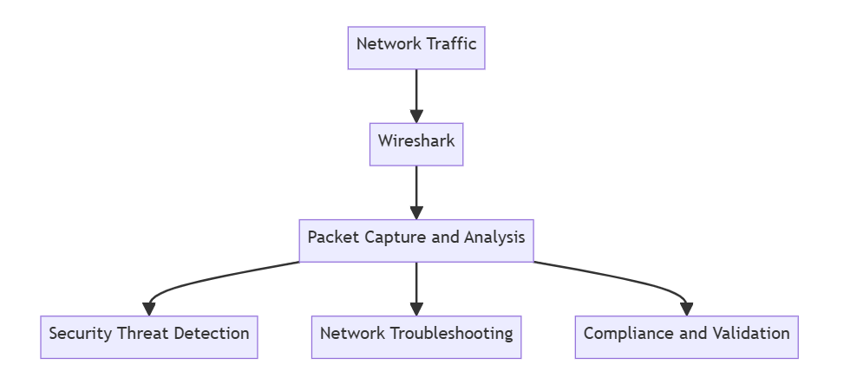

By understanding the fundamentals of network security and mastering the use of Wireshark, cybersecurity professionals can effectively detect and respond to network security threats, ensuring the overall security and integrity of their organization's network infrastructure.

# CODE:

**N/A**

**OUTPUT:**

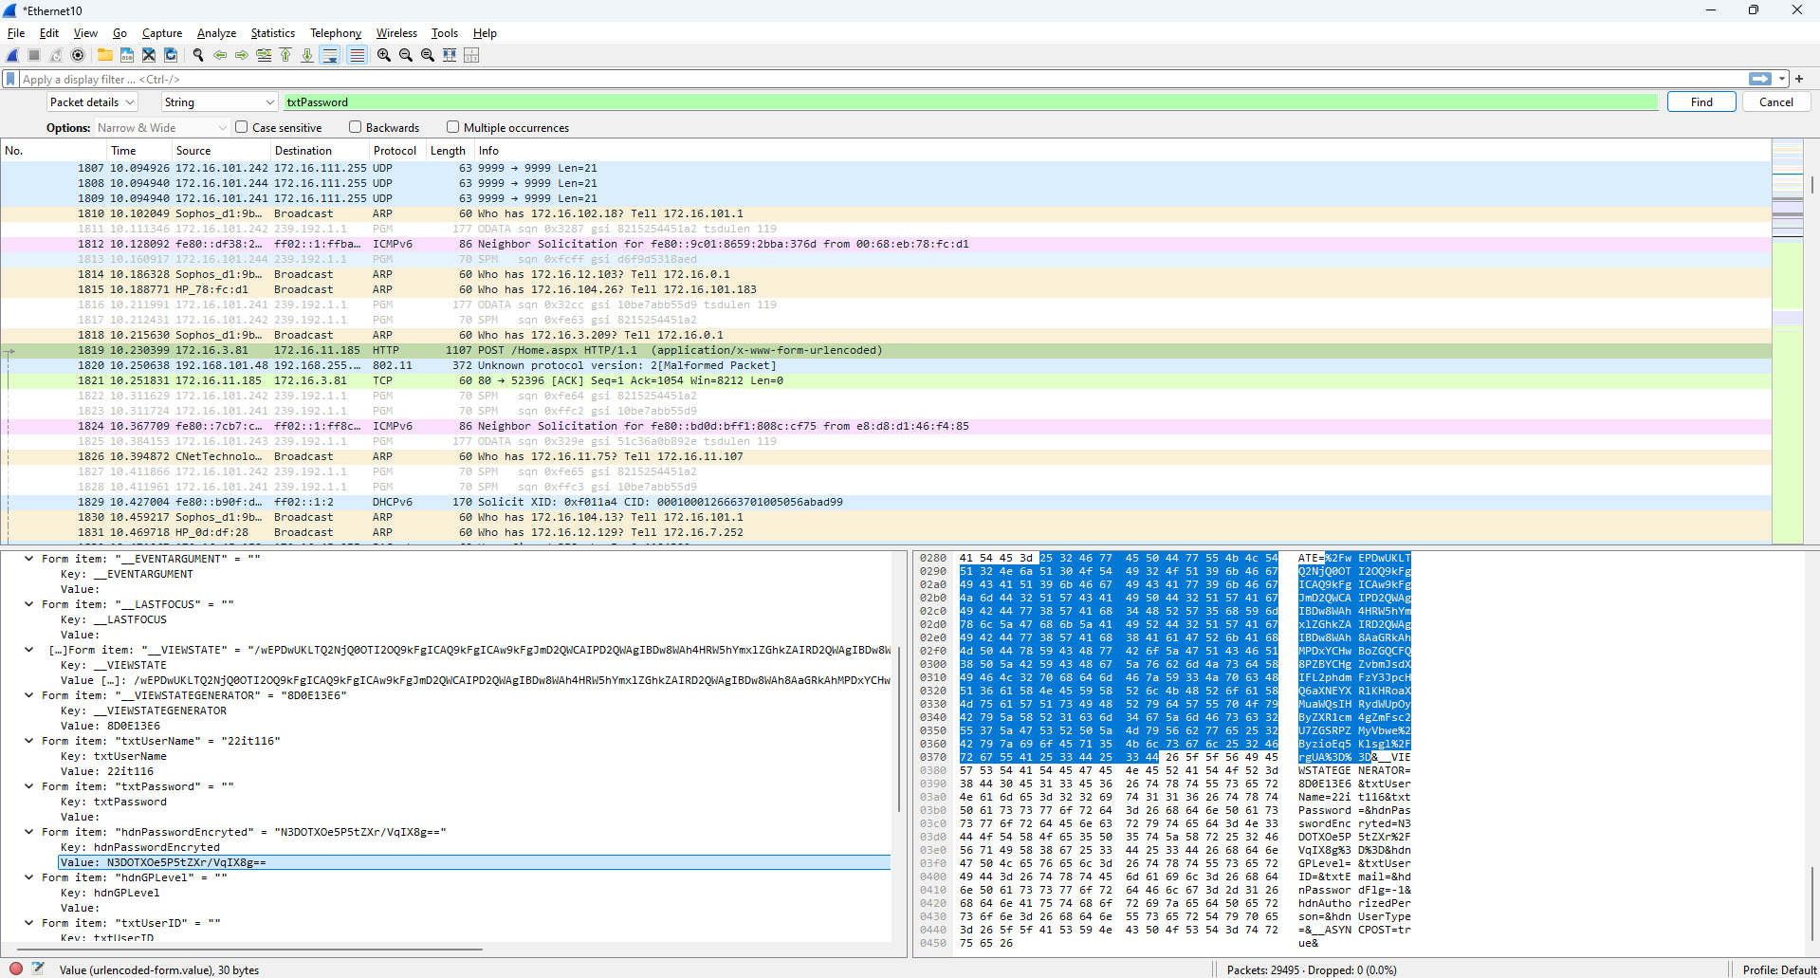

Figure 1: Getting Hash Value of E-Governance login password

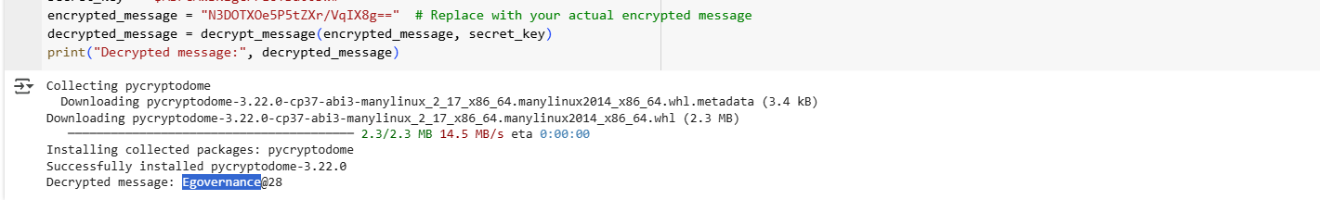

Figure 2: Decrypt the Hash Password

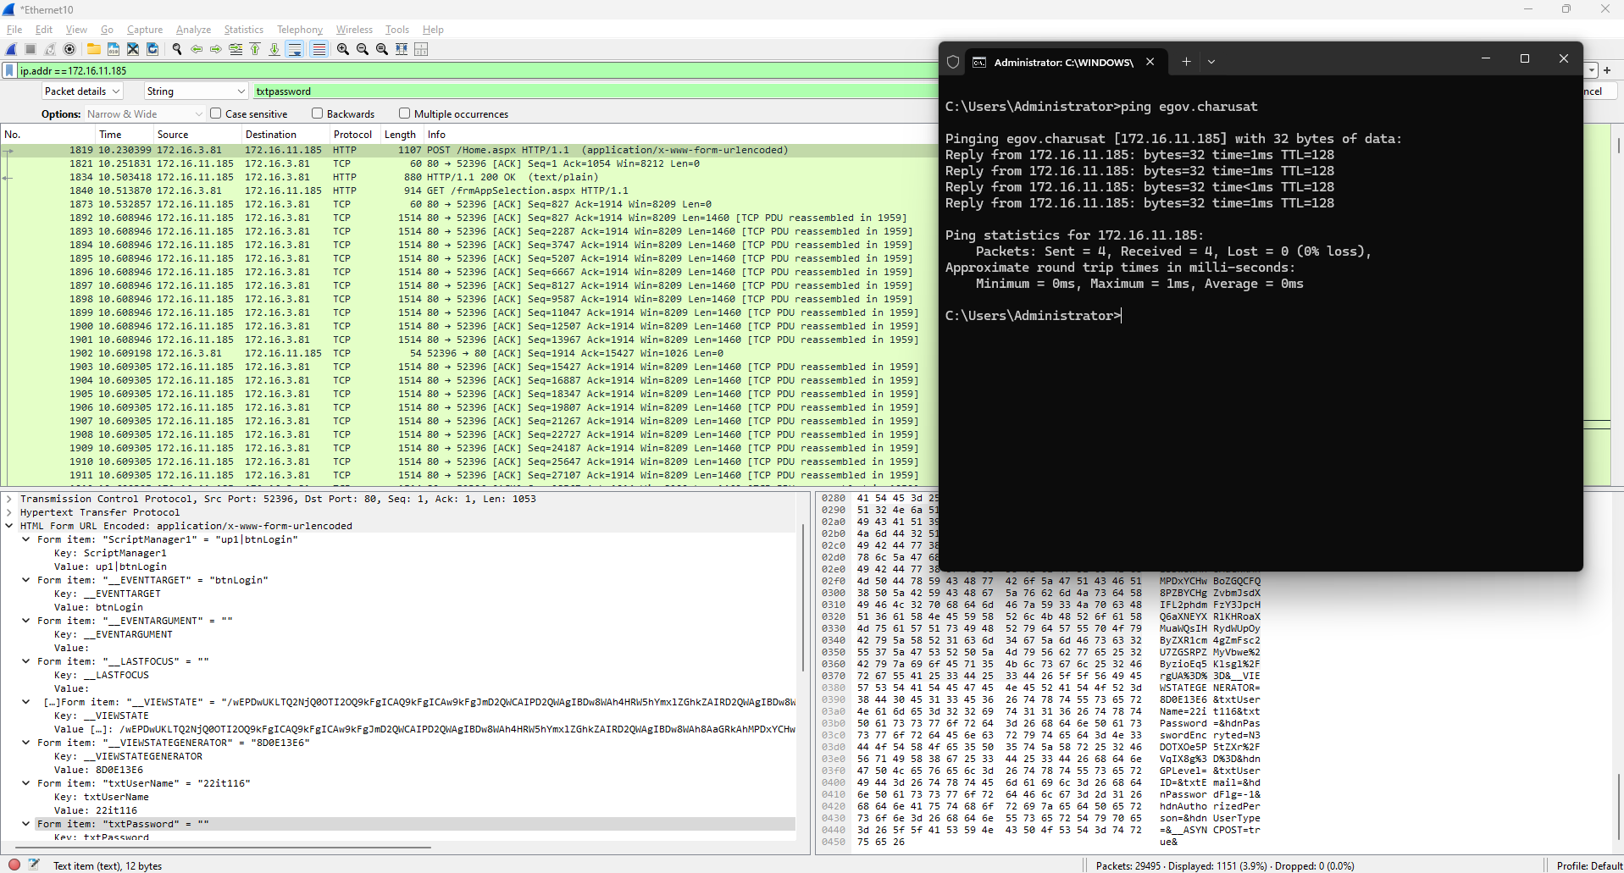

Figure 3: Flitter packet by IP address

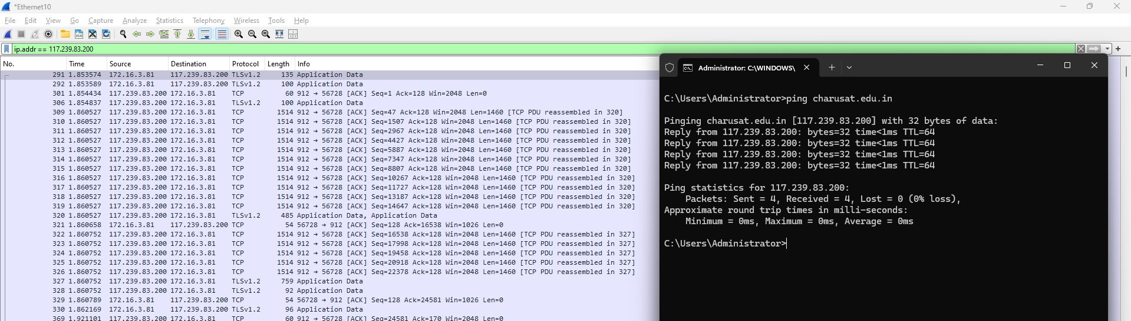

Figure 4: Check the E governance Host website IP and Apply filter for IP address

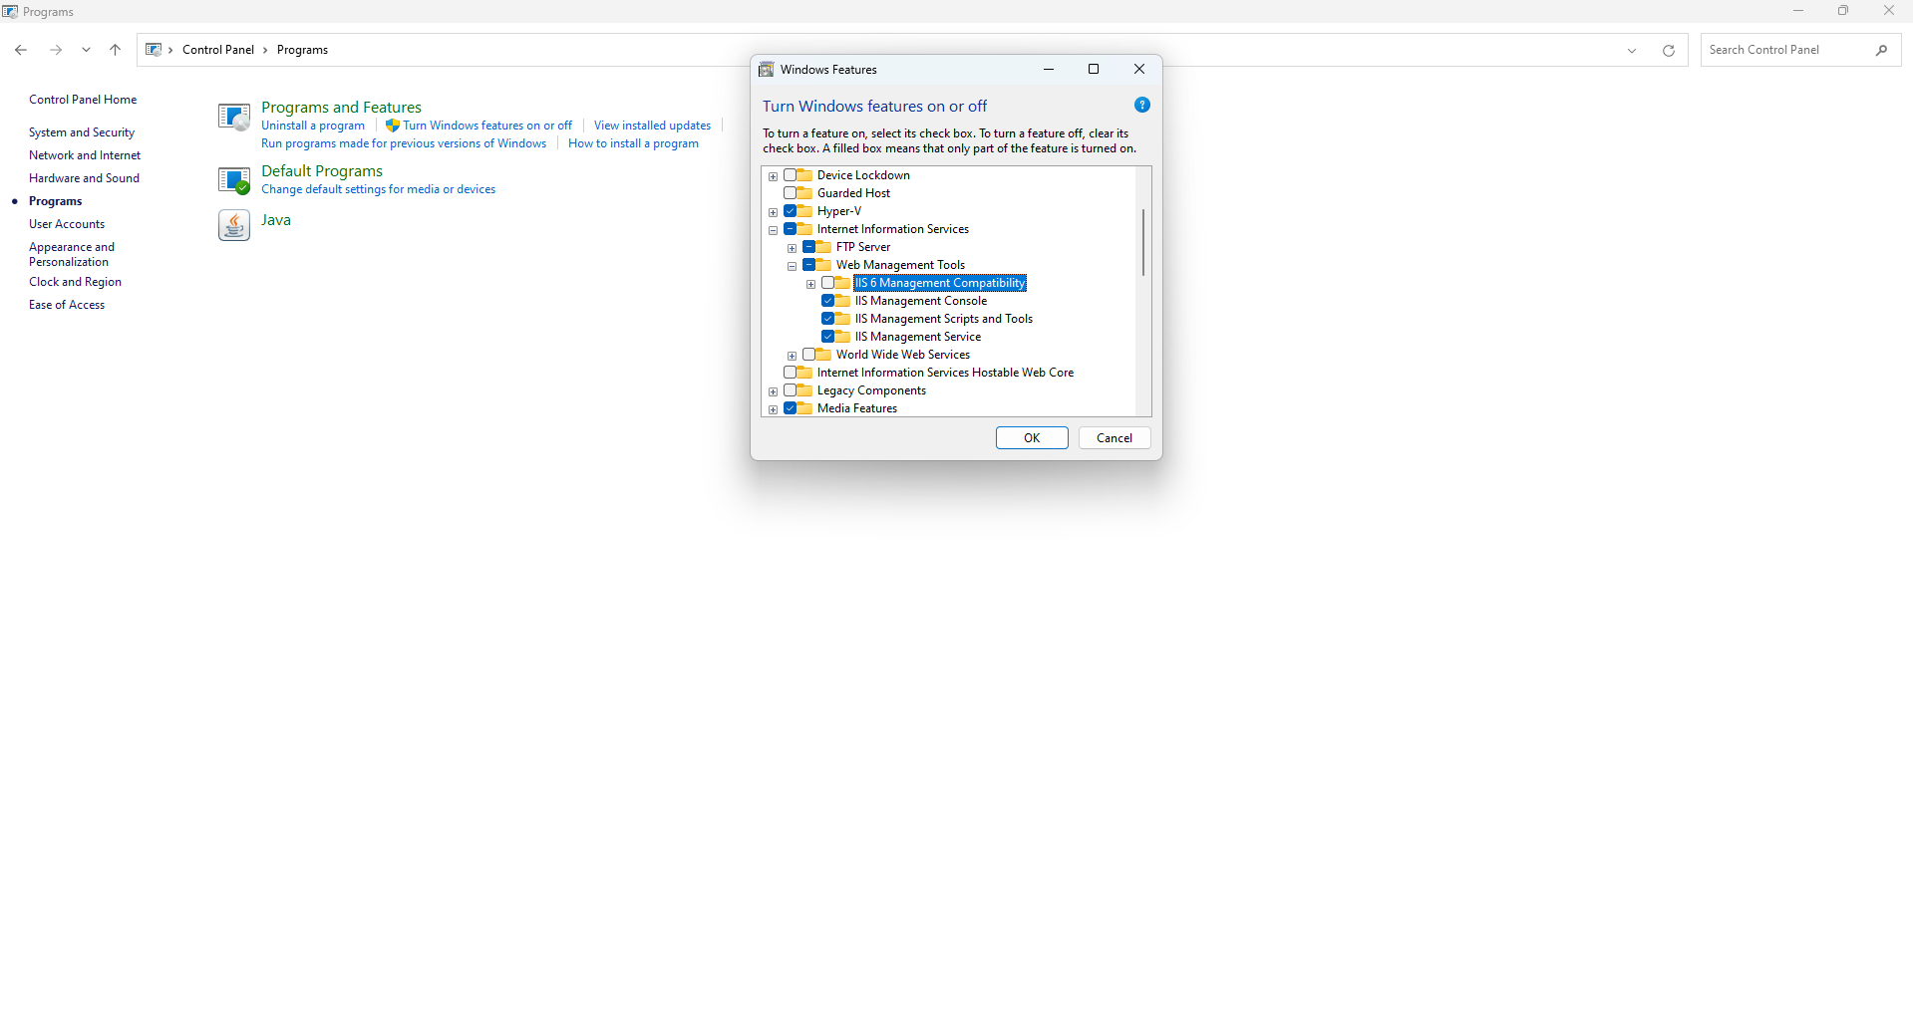

Figure 5: Open Windows Features and Check FTP service (Control Panel -> Programs -> Turn Windows features on or off -> FTP Services

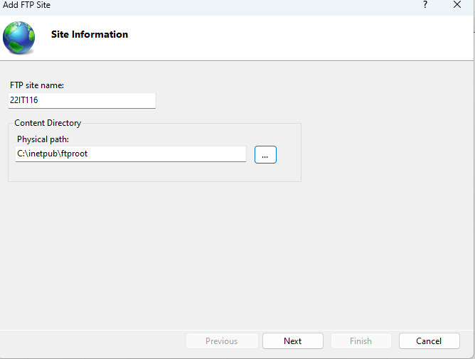

Figure 6: Enter a name for FTP site and specify the path to the folder that you want to use for FTP

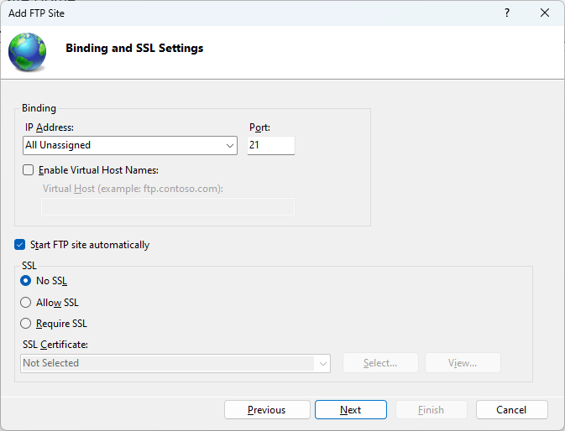

Figure 7: Configure Binding and SSL

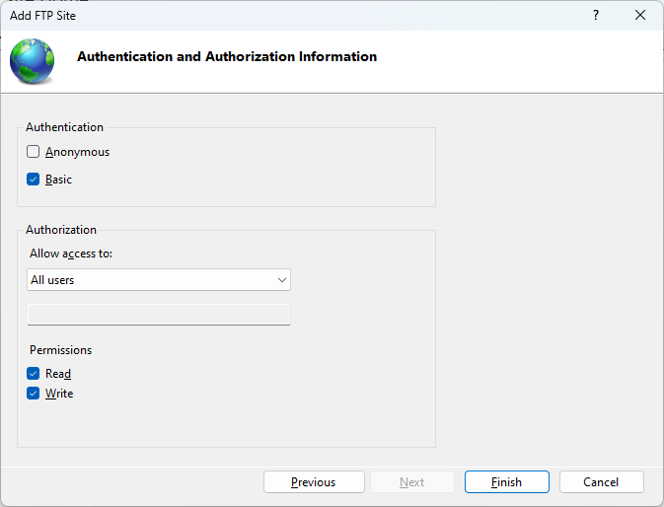

Figure 8: Click Finish to create the FTP site and start it

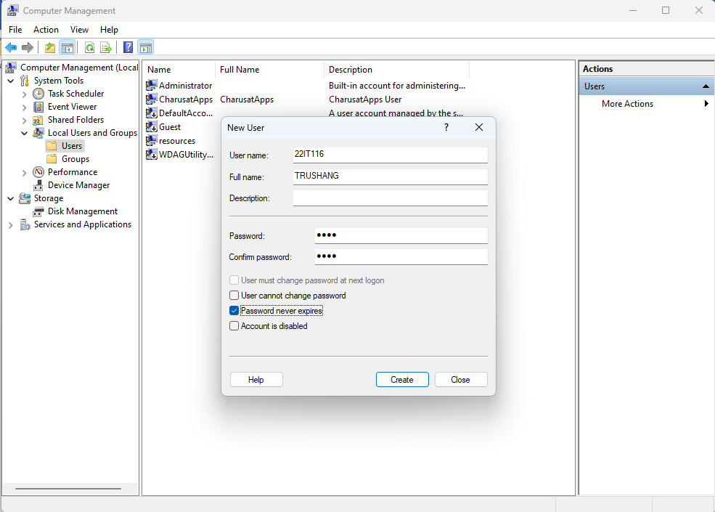

Figure 9: Create a user in computer management (Computer management ->Local Users & Groups -> User-> New User)

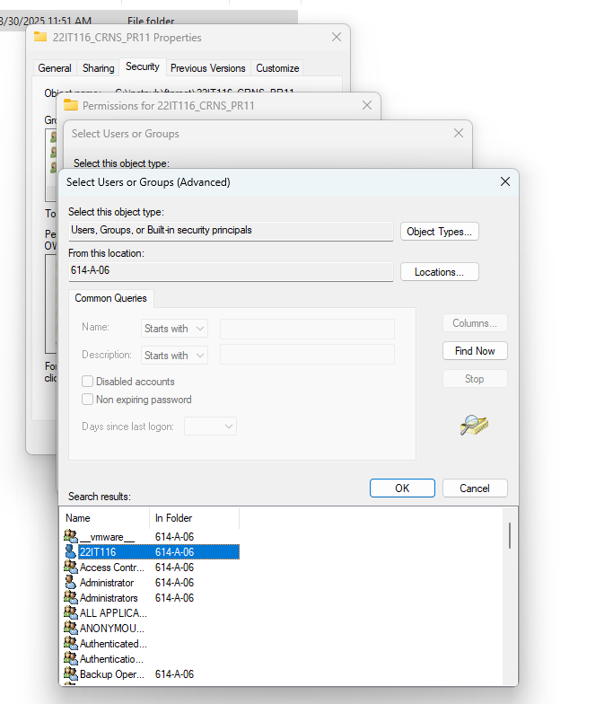

Figure 10: Create a folder and Give permission to user which created in previous step

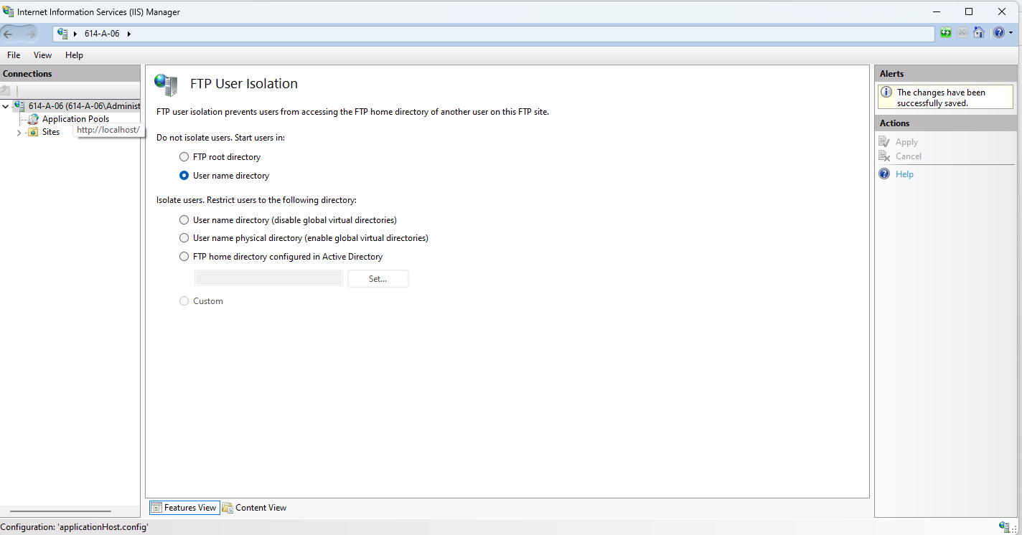

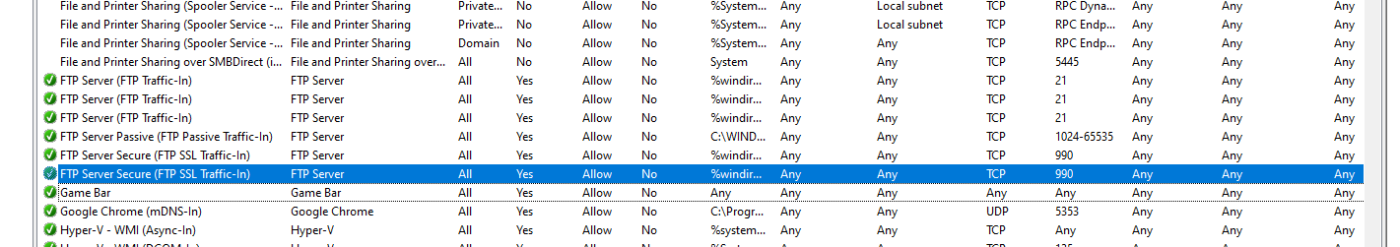

Figure 11: Enable FTP server rule

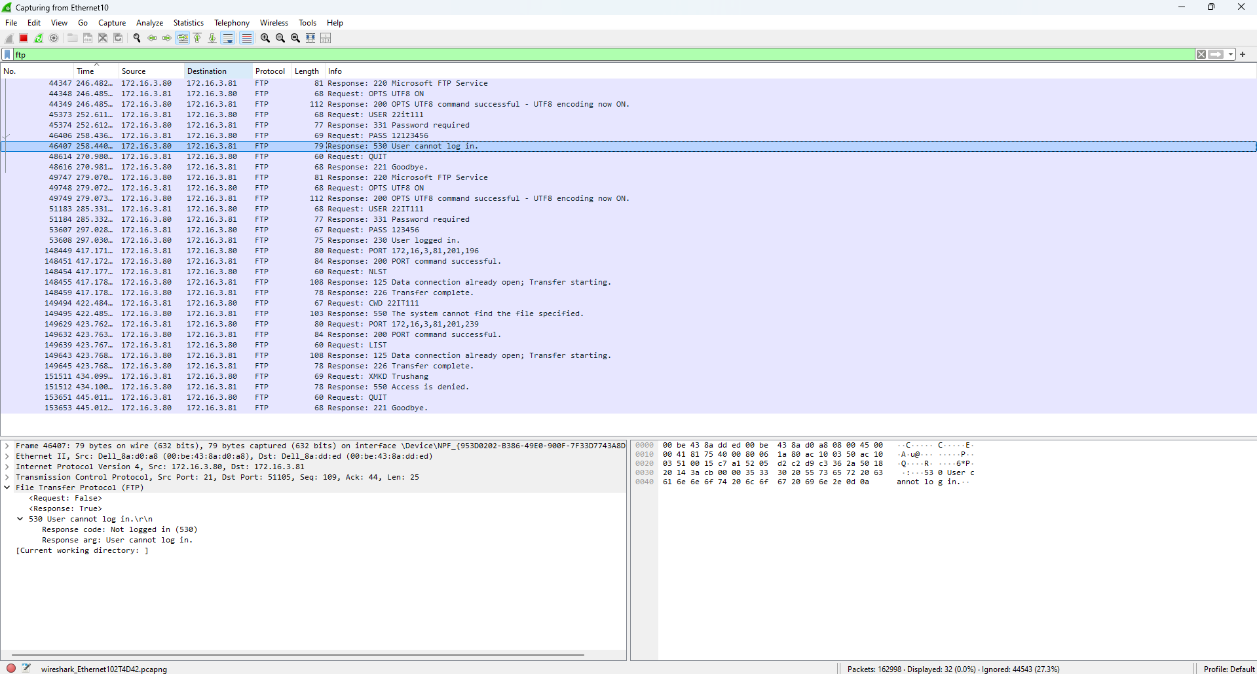

Figure 12:Get Password of FTP using Wireshark

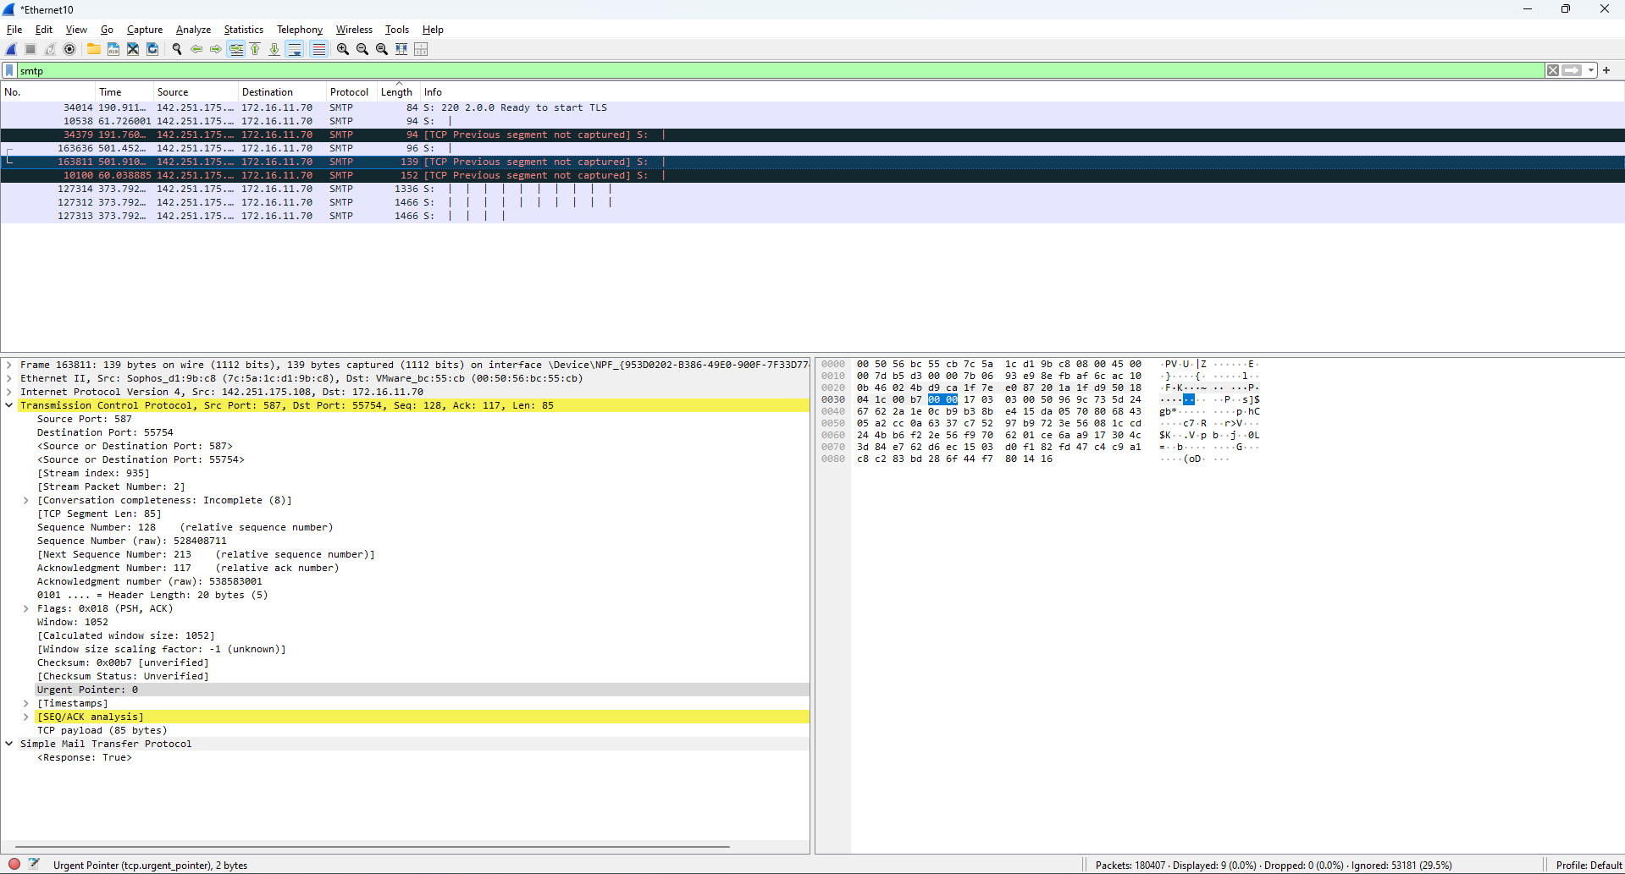

Figure 13:Check SMTP packet in Wireshark

# LATEST APPLICATIONS:

# Advanced Network Traffic Analysis:

# Intrusion Detection and Prevention:

* Malware Analysis:

# Network Forensics:

# Vulnerability Analysis

# Security Monitoring and Incident Response

# LEARNING OUTCOME:

# ​In this practical, I learned how to utilize Wireshark, a network protocol analyzer, to capture and analyze network traffic. By observing packets transmitted over the network, I gained insights into the behavior of various protocols such as HTTP, TCP, and FTP. This hands-on experience enhanced my understanding of network operations and the importance of monitoring for security purposes.

# REFERENCES:

1. YouTube : <https://www.youtube.com/watch?v=yC0e0bSSleo>
2. WireShark : <https://www.wireshark.org/docs/wsug_html_chunked/>
3. ChatGPT: <https://chatgpt.com/>