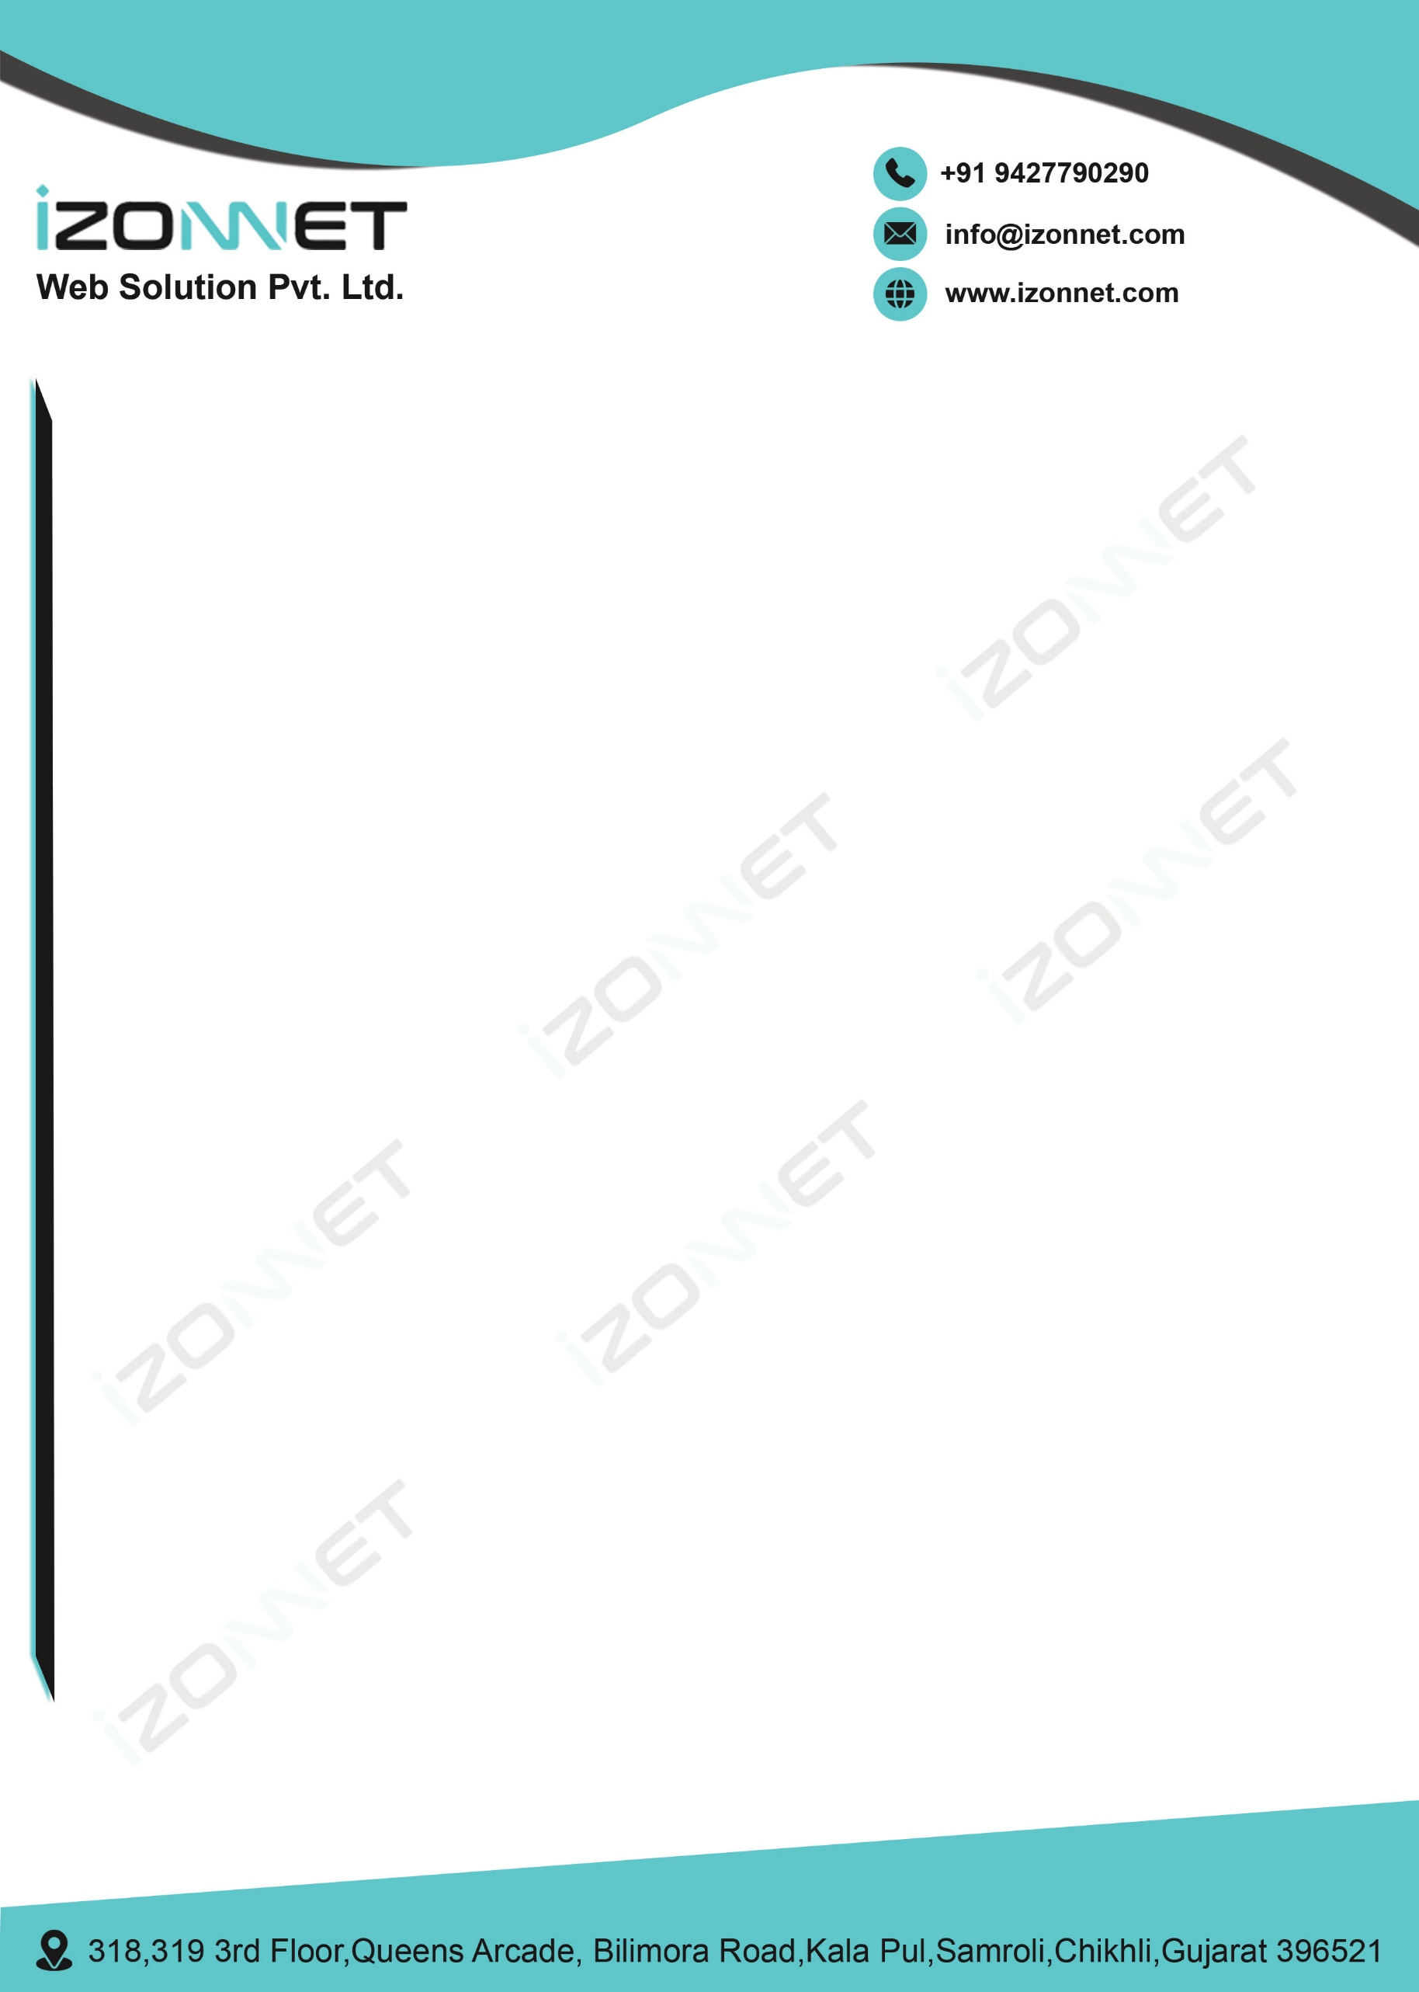

**Certificate**

This is to certify that Mr. **Trushangkumar Sumanbhai Patel**, of B.Tech (Information Technology) Roll No. **22IT116** has completed his Summer Internship (15th May 2024 to 15th June 2024) on **Mern Stack Developer** with Izonnet Web Solution Pvt. Ltd. during the academic year 2024-2025.

During the tenure mentioned above, Mr. Trushang Patel has remained involved with his duties and responsibilities assigned to him. We found him competent and active with sincerity and determination.

Sincerely,   
Nilesh Ahir

Director  
Izonnet Web Solution Pvt. Ltd. Chikhli

