**A**

**Summer Internship Report**

**On**

**"E-commerce website "**

(IT346 – Summer Internship - I)

**Prepared by**

Trushang Patel(22IT116)

**Under the Supervision of**

Prof. Pritesh Prajapati

**Submitted to**

Charotar University of Science & Technology (CHARUSAT)

for the Partial Fulfillment of the Requirements for the

Degree of Bachelor of Technology (B.Tech.)

for Semester 5

**Submitted at**



**Accredited with Grade A+ by NAAC**

**Accredited with Grade A by KCG**



**SMT. KUNDANBEN DINSHA PATEL DEPARTMENT OF INFORMATION TECHNOLOGY**

**Chandubhai S. Patel Institute of Technology (CSPIT)**

**Faculty of Technology & Engineering (FTE), CHARUSAT**

**At: Changa, Dist: Anand, Pin: 388421.**

**August, 2023**



**Accredited with Grade A by NAAC**

**Accredited with Grade A by KCG**

**CERTIFICATE**

This is to certify that the report entitled **“E-commerce website”** is a bonafied work carried out by **Trushang Patel(22IT116)** under the guidance and supervision of **Prof. Pritesh Prajapati** & **Mr. Nilesh Ahir** for the subject **Summer Internship – I (IT346)** of 5th Semester of Bachelor of Technology in **Department of Information** at Chandubhai S. Patel Institute of Technology (CSPIT), Faculty of Technology & Engineering (FTE) – CHARUSAT, Gujarat.

To the best of my knowledge and belief, this work embodies the work of candidate himself, has duly been completed, and fulfills the requirement of the ordinance relating to the B.Tech. Degree of the University and is up to the standard in respect of content, presentation and language for being referred by the examiner(s).

|  |  |
| --- | --- |
| Under the supervision of,  Dr./Prof. Pritesh Prajapati  Assistant Professor  Smt. Kundanben Dinsha Patel Department of Information Technology  CSPIT, FTE, CHARUSAT, Changa, Gujarat | Mr. Nilesh Ahir  HR  Izonnet web solution pvt. Ltd. |
| Dr. (Prof.) Parth Shah  Head of Department (IT)  CHARUSAT, Changa, Gujarat. | |

**Chandubhai S. Patel Institute of Technology (CSPIT)**

**Faculty of Technology & Engineering (FTE), CHARUSAT**

At: Changa, Ta. Petlad, Dist. Anand, Pin: 388421. Gujarat.



**Certificate**

This is to certify that Mr. **Trushangkumar Sumanbhai Patel**, of B.Tech (Information Technology) Roll No. **22IT116** has completed his Summer Internship (15th May 2024 to 15th June 2024) on **Mern Stack Developer** with Izonnet Web Solution Pvt. Ltd. during the academic year 2024-2025.

During the tenure mentioned above, Mr. Trushang Patel has remained involved with his duties and responsibilities assigned to him. We found him competent and active with sincerity and determination.

Sincerely,   
Nilesh Ahir

Director  
Izonnet Web Solution Pvt. Ltd. Chikhli



**ACKNOWLEDGEMENT**

I would like to express my deepest gratitude and appreciation to all those who have contributed to my internship experience in web development. Firstly, I am immensely thankful to Izonnet web solution pvt. Ltd. for providing me with this invaluable opportunity to enhance my skills and gain practical knowledge in the web development field. I extend my sincere thanks to my supervisor, Prof. Pritesh Prajapati, for their constant guidance, support, and mentorship throughout my internship. I am also grateful to the entire web development team at Izonnet web solution pvt. Ltd. Their welcoming and collaborative environment made it a pleasure to work alongside such talented individuals. This internship experience has been invaluable in shaping my career aspirations and has equipped me with the necessary skills and confidence to excel in the field of web development.

Sincerely,

Trushang Patel (22IT116)

Chandubhai S. Patel Institute of Technology

**ABSTRACT**

This internship report documents my one-month internship at Izonnet Web Solution Pvt. Ltd., where I undertook the development of an E-commerce website using the MERN stack.

**Purpose and Scope:** The objective of the internship was to gain practical experience in full-stack web development with a focus on the MERN stack. The scope involved designing and implementing an E-commerce website from scratch.

**Work Done:** During the internship, I developed an E-commerce website using MongoDB for database management, Express.js and Node.js for server-side scripting, and React.js for the front-end. Key tasks included designing the user interface, implementing product catalog features, user authentication, and ensuring responsive design principles were applied throughout the project.

**Conclusion:** This internship provided valuable hands-on experience in web development, particularly with the MERN stack. By successfully completing the E-commerce website project, I enhanced my skills in JavaScript frameworks, database management, and web application deployment. The experience underscored the importance of structured development practices and agile methodologies in achieving project goals.

This report summarizes the internship experience and the skills acquired during my tenure at Izonnet Web Solution Pvt. Ltd.

# Table of Contents

Chapter 1 Project Definition 1

Chapter 2 Description 2

Chapter 3 Software and Hardware Requirement 3

* 1. Software Requirement 3
  2. Hardware Requirement 3

Chapter 4 Major Functionalities 4

Chapter 5 Flow Chart 5

Chapter 6 Screenshots Project Output 6

Chapter 7 Limitations of project 10

Chapter 8 Outcomes 11

Chapter 9 Future Enhancement 12

Chapter 10 Conclusion 13

Chapter 11 References 14

**List of Figures**

Fig 1 Flow Chart 5

Fig 2 Login Page 6

Fig 3 Navbar 6

Fig 4 Shop page 7

Fig 5 Popular page 7

Fig 6 New collection 8

Fig 7 Cart 8

Fig 8 Admin panel 9

# CHAPTER 1 PROJECT DEFINITION

The shopping website project aims to create a modern, user-friendly e-commerce platform that allows customers to browse, search, and purchase a wide variety of products online. The website will feature an attractive and intuitive interface to ensure a seamless shopping experience, supporting easy navigation and efficient product discovery. Users will be able to create and manage their accounts, enabling personalized experiences such as order tracking, and purchase history. The website will be designed to be fully responsive, ensuring accessibility across desktops, tablets, and smartphones. The backend infrastructure will be developed using scalable and secure technologies, providing reliable performance and efficient order management. Integration with popular

Overall, the shopping website will deliver a secure, efficient, and enjoyable online shopping experience, driving sales growth and customer satisfaction.

# CHAPTER 2 DESCRIPTION

Our shopping website is a comprehensive online marketplace designed to offer customers a seamless and enjoyable shopping experience. Featuring a modern and intuitive interface, the platform allows users to browse and purchase a wide array of products, ranging from electronics and fashion to home goods and more.

* **User-Friendly Design**: An attractive and easy-to-navigate interface that ensures a pleasant shopping journey.
* **User Accounts**: Personalized accounts where users can manage their profiles, track orders, save wishlists, and view purchase history.
* **Efficient Order Management**: Streamlined cart and checkout processes, along with real-time order tracking.
* **Advanced Search and Filters**: Robust search functionality and filtering options to help users quickly locate desired items.

# CHAPTER 3 SOFTWARE AND HARDWARE REQUIREMENTS

## Software Requirement

* + - Text Editor or Integrated Development Environment (IDE): A reliable text editor or IDE is essential for writing and editing the React JS Code. Recommended options include Visual Studio Code, Sublime-Text, Atom.
    - Web Browser: To test and view the website locally during development, the latest version of modern web browser is necessary. Commonly used browser like Google, Chrome, Mozilla Firefox, Safari or Microsoft Edge are recommended.
    - A Version Control System like Git to manage and track changes in the project.

## Hardware requirements

* + - Personal Computer or Laptop with minimum of 2GB RAM for Smooth performance.
    - Processor: Dual-core or higher for better processing speed.
    - Display: Screen resolution of 1366*768 or higher for optimal viewing.
    - Internet connectivity to facilitate real time communication.

# CHAPTER 4 MAJOR FUNCTIONALITY

* **User Registration and Login**: Secure sign-up and sign-in processes.
* **Profile Management**: Allow users to manage their personal information, shipping addresses, and payment methods.
* **Product Listings**: Display products with images, descriptions, prices, and other relevant details.
* **Search and Filters**: Implement search functionality and filters (e.g., by category, price range, brand) to help users find products.
* **Shopping Cart**: Allow users to add, update, and remove items from their cart.
* **Shipping Options**: Provide multiple shipping methods with different delivery times and costs.
* **Multiple Payment Options**: Offer various payment methods like credit cards, digital wallets, and bank transfers.
* **Order Tracking**: Allow customers to track their orders in real-time.
* **Discount Codes and Coupons**: Implement functionalities for applying discount codes and coupons during checkout.
* **Special Offers**: Highlight sales and special offers on the website.

# CHAPTER 5 FLOW CHART

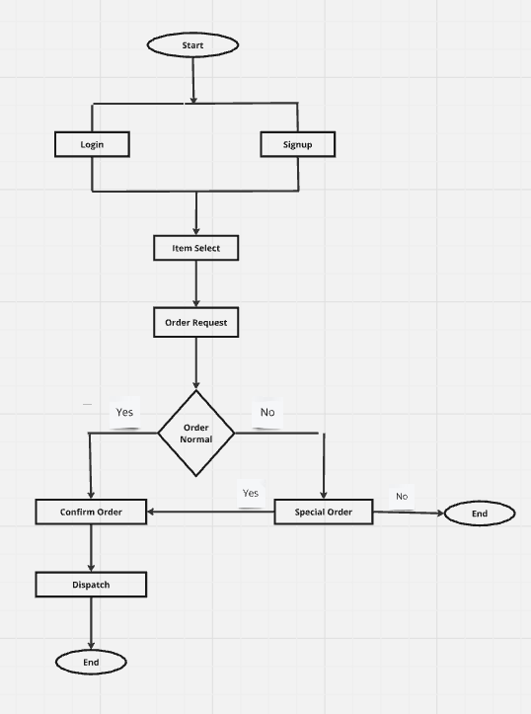

Figure 1 Flow Chart

# CHAPTER 6 SCREENSHOT OF PROJECT OUTPUT

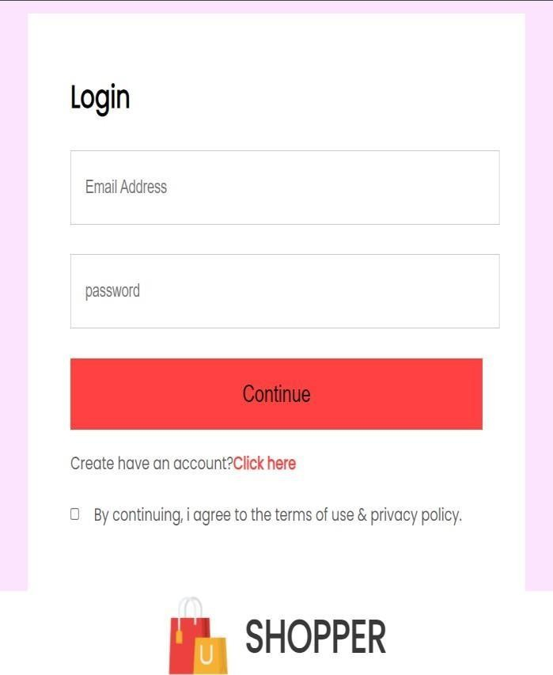

Figure 2 Login Page

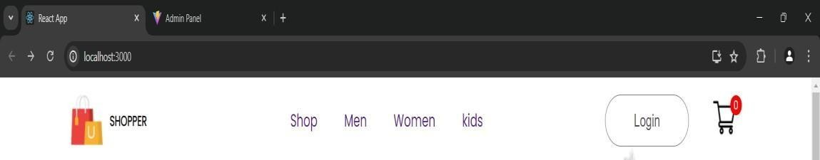

Figure 3 Navbar

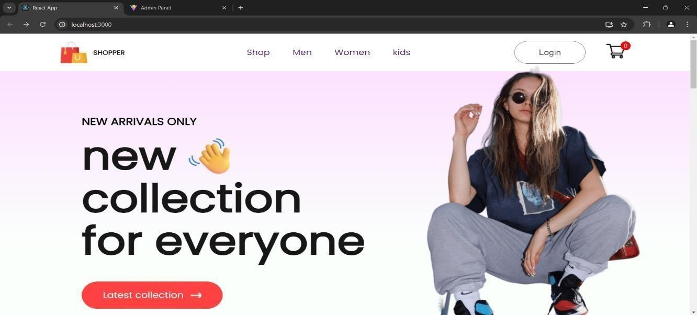

Figure 4 Shop Page

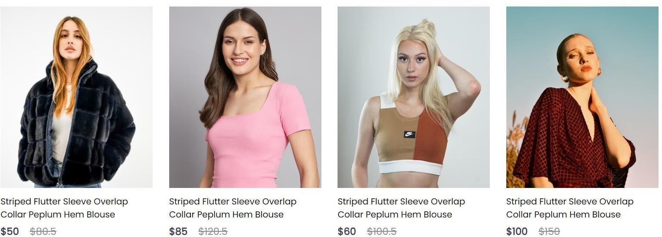

Figure 5 Popular Page

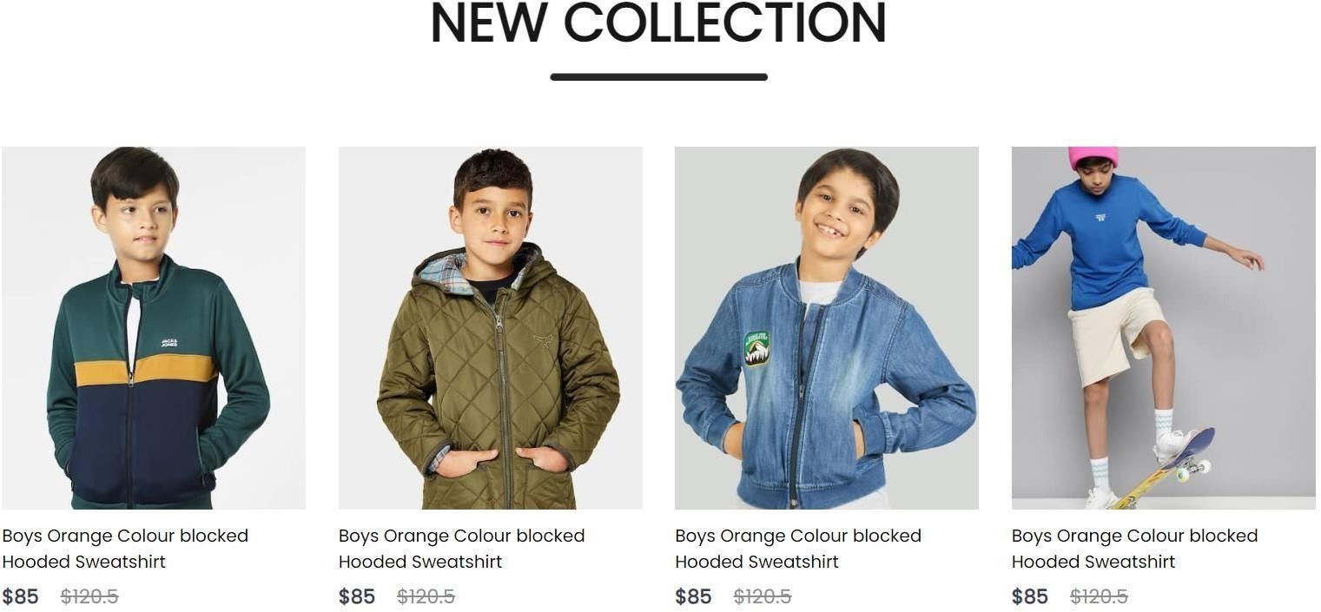

Figure 6 New Collection

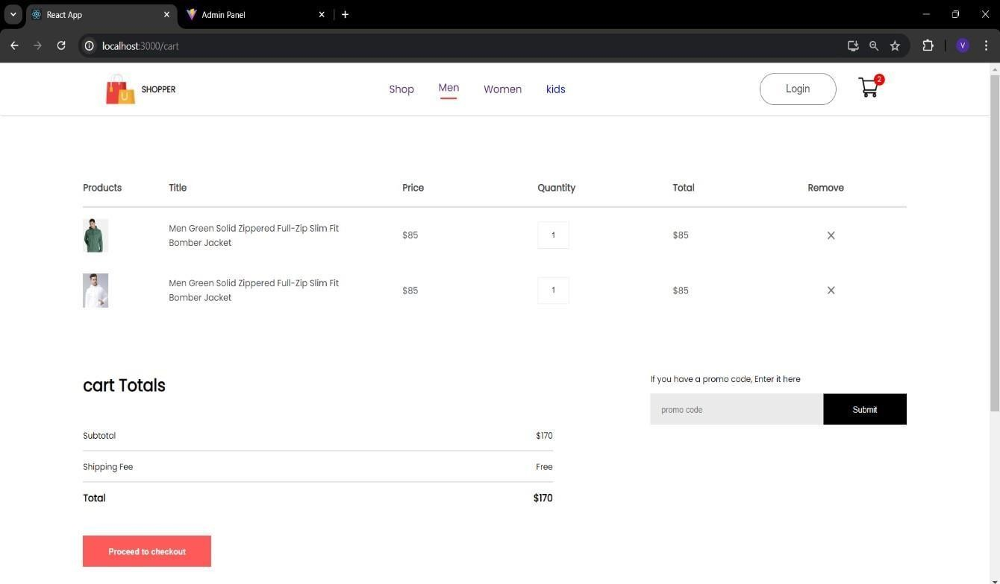

Figure 7 Cart

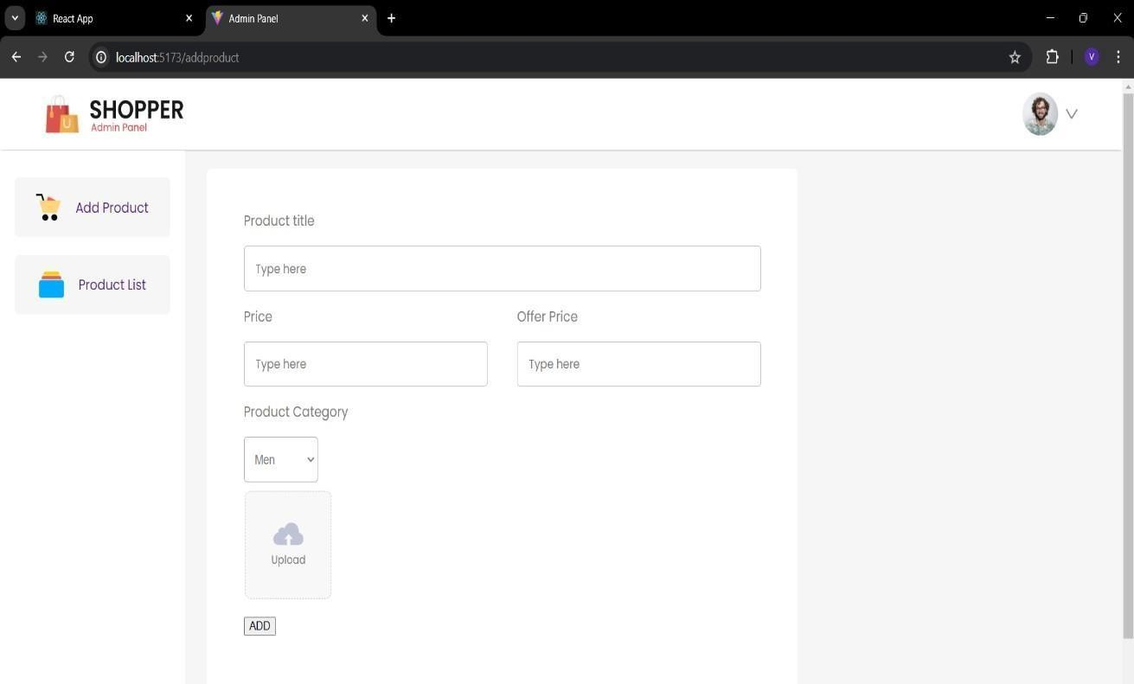

Figure 8 Admin Panel

# CHAPTER 7 LIMITATIONS OF PROJECT

* **Website Downtime**: Server issues or maintenance can cause website downtime, affecting sales and customer trust.
* **Security Risks**: E-commerce sites are prime targets for cyber-attacks such as data breaches, DDoS attacks, and hacking attempts.
* **Scalability Issues**: Handling a large number of concurrent users and transactions can be challenging without proper infrastructure.
* **Shipping Delays**: Unexpected delays in shipping can lead to customer dissatisfaction.
* **Returns and Refunds**: Managing returns and refunds can be complex and costly.
* **High Competition**: The online retail market is highly competitive, making it difficult to attract and retain customers.
* **Customer Retention**: Building brand loyalty and retaining customers can be more challenging online due to the vast number of alternatives available.
* **Continuous Updates**: The need for regular updates and maintenance to keep the website secure and functional can be resource-intensive.

# CHAPTER 8 OUTCOME

* **Average Order Value (AOV)**: Track the average amount spent per order.
* **Conversion Rate**: Percentage of visitors who make a purchase.
* **Website Traffic**: Number of visitors to the site.
* **Time on Site**: Average duration visitors spend on the site.
* **Pages per Visit**: Average number of pages viewed per visit.
* **Customer Reviews and Ratings**: Average rating from customer feedback.
* **Repeat Purchase Rate**: Percentage of customers who make more than onepurchase.
* **Return Rate**: Percentage of products returned by customers.
* **Customer Support Response Time**: Time taken to respond to customer inquiries.
* **Website Load Time**: Average time taken for the website to load.

# CHAPTER 9 FUTURE ENHANCEMENT

* **Dynamic Content**: Show personalized content, such as banners and promotions, based on user interests and browsing history.
* **Responsive Design**: Ensure the website is fully responsive and optimized for all screen sizes and devices.
* **Voice Search**: Integrate voice search capabilities to make it easier for users to find products.
* **Visual Search**: Allow users to search for products using images.
* **Buy Now, Pay Later (BNPL)**: Offer BNPL options to attract more customers and increase conversion rates.
* **Eco-Friendly Options**: Highlight eco-friendly and sustainable products.
* **Two-Factor Authentication (2FA)**: Implement 2FA to enhance account security.
* **Exclusive Memberships**: Create exclusive membership programs that offer perks such as discounts, early access to sales, and free shipping.
* **Same-Day Delivery**: Offer same-day delivery options in select locations.

22IT116

# CHAPTER 10 CONCLUSION

* + In conclusion, developing a shopping website requires a holistic approach that balances user experience, security, scalability, payment options, product management, SEO and marketing, customer support, legal compliance, analytics, and continuous improvement. By focusing on these critical elements, businesses can create a competitive, user-friendly, and secure online shopping platform that meets the needs of modern consumers.

22IT116

# CHAPTER 11 REFERENCES

1. <https://www.w3schools.com/react/>
2. <https://cloud.google.com/nodejs/docs>
3. <https://www.youtube.com/watch?v=y99YgaQjgx4>
4. <https://www.jetbrains.com/help/webstorm/react.html>
5. <https://docs.digitalocean.com/products/databases/mongodb/>

References