House Price Data Analysis with AI
A Data Analytics Project
IBM SkillsBuild – Data Analytics with AI
Programme Partner: FutureTech / BharatCares
Submitted by: Trushna Madikatla
─────────────────────────────────────────────────────────

Acknowledgement
I would like to express my sincere gratitude to IBM SkillsBuild for designing and delivering the Data Analytics with AI masterclass programme, and to FutureTech / BharatCares for facilitating access to this valuable learning opportunity.
I am grateful for the structured curriculum that introduced me to data analytics concepts, Python-based data analysis tools, and the practical use of Generative AI as an analytical assistant. The hands-on project-based approach provided a strong foundation for applying these concepts to a real dataset.
I also acknowledge the use of IBM Bob (Generative AI) as a supporting tool during this project. IBM Bob assisted with understanding dataset features, formulating analytical questions, interpreting results, and improving the documentation. All actual data analysis and computations were performed using Python, pandas, NumPy, and Matplotlib.

Abstract
This project presents a comprehensive data analytics study of a residential housing dataset containing 545 property records and 13 features. The primary objective is to identify patterns, relationships, and associations between property characteristics and house prices using Python-based data analytics techniques.
The analysis was conducted using pandas for data manipulation, NumPy for numerical calculations, and Matplotlib for data visualisation. The project covers data loading, data quality checking, exploratory data analysis (EDA), nine targeted analytical questions, correlation analysis, and the derivation of business insights.
Key findings include: house prices range from Rs 17.50 Lakhs to Rs 133.00 Lakhs with a mean of Rs 47.67 Lakhs; the distribution is right-skewed; bathrooms and area show the strongest positive associations with price among numeric features; properties with air conditioning show a 43.4% higher average price; properties in preferred areas show a 32.9% higher average price; and furnishing status shows a consistent price ordering (furnished > semi-furnished > unfurnished).
Generative AI (IBM Bob) was used as a supporting tool for formulating analytical questions, interpreting results, and assisting with documentation. All calculations are derived directly from the dataset using Python. This project was completed as part of the IBM SkillsBuild – Data Analytics with AI programme.

1. Introduction

1.1 Background
The real estate sector is one of the most data-rich industries, with property transactions generating large volumes of structured data. Analysing this data can reveal meaningful patterns about how different property characteristics are associated with sale prices. Such analysis is valuable for buyers, sellers, real estate agents, and policy-makers who need to understand pricing trends and market dynamics.
This project focuses on the application of data analytics techniques to a housing dataset to uncover these patterns. Rather than attempting to build a price-prediction model, the emphasis is on understanding the data through exploratory analysis, descriptive statistics, visualisation, and correlation analysis.

1.2 Project Context
This project was developed as part of the IBM SkillsBuild – Data Analytics with AI programme, conducted through FutureTech / BharatCares. The programme covers data analytics fundamentals, Python-based data analysis, visualisation techniques, and the practical use of Generative AI as a supporting analytical tool.
The project applies the skills and concepts covered in the programme to a real housing dataset, demonstrating a complete end-to-end data analytics workflow. Generative AI (IBM Bob) was used throughout the project as an analytical assistant — helping to formulate questions, interpret results, and improve documentation.

1.3 Project Title and Direction
Project Title: House Price Data Analysis with AI
This project is a Data Analytics + AI project. It is not a machine learning project and does not involve model training, regression analysis, or price prediction. The core deliverable is the analytical notebook (Shruti_HousePriceAnalysis_DataAnalyticsAI.ipynb), which documents the complete data analytics workflow.

2. Problem Statement
Housing prices vary considerably across different properties, even within the same geographic region. This variation is influenced by a wide range of property characteristics including physical attributes (such as area and number of rooms), amenities (such as air conditioning and furnishing), and location factors (such as access to main roads and proximity to preferred areas).
Understanding which property characteristics are associated with higher or lower prices is valuable for multiple stakeholders. Buyers can use this information to evaluate whether a property is reasonably priced. Sellers can identify which features may add value. Analysts can use these insights to understand market pricing patterns.
The problem this project addresses is: Using the available Housing.csv dataset, which property characteristics show the strongest associations with house prices, and what patterns can be identified through data analytics and visualisation?

3. Objectives
The specific objectives of this project are:
1. To understand the structure and contents of the Housing.csv dataset including its features, data types, and range of values.
2. To check data quality by identifying missing values, duplicate records, and any anomalies in the dataset.
3. To analyse the distribution of house prices and understand the spread and central tendency of the target variable.
4. To study the relationship between each property feature and house price through groupby analysis and statistical comparison.
5. To compare average house prices across different property categories such as furnishing status, number of bedrooms, and amenity availability.
6. To identify meaningful Pearson correlations among numeric features and understand which features show the strongest linear association with price.
7. To create clear and informative Matplotlib visualisations for each analytical finding, making patterns visible and easy to interpret.
8. To use Generative AI (IBM Bob) as an analytical support tool, documenting the specific ways AI contributed to the project workflow.
9. To translate analytical findings into practical business insights expressed in plain, accessible language.

4. Scope of the Project
This project covers the following areas:
In Scope:
Data loading and inspection of the Housing.csv dataset; data quality checks for missing values and duplicates; descriptive statistical analysis of price and other numeric features; exploratory data analysis including price distribution; nine analytical questions exploring feature-price associations; correlation analysis of numeric variables; Matplotlib-based data visualisations; AI-assisted interpretation using IBM Bob; derivation of business insights from analytical findings.
Out of Scope:
Machine learning model development; price prediction or forecasting; statistical hypothesis testing; geographic or spatial analysis; time-series analysis; data collected outside the provided Housing.csv dataset.

5. Dataset Description

5.1 Dataset Overview
The dataset used in this project is Housing.csv, a structured dataset containing records of residential property transactions. It is used here for academic and analytical purposes as part of the IBM SkillsBuild Data Analytics programme.
File: Housing.csv | Total Records: 545 | Total Features: 13 | Missing Values: 0 | Duplicate Rows: 0

5.2 Feature Descriptions
The dataset contains one target variable (price) and twelve predictor features, categorised as follows:
Feature | Type | Description
price | Numeric | Sale price of the property in Indian Rupees (target variable)
area | Numeric | Total plot area of the property in square feet
bedrooms | Numeric | Number of bedrooms in the property (range: 1 to 6)
bathrooms | Numeric | Number of bathrooms in the property (range: 1 to 4)
stories | Numeric | Number of floors / stories in the property (range: 1 to 4)
parking | Numeric | Number of dedicated parking spaces (range: 0 to 3)
mainroad | Binary (yes/no) | Whether the property has direct access to a main road
guestroom | Binary (yes/no) | Whether the property includes a dedicated guest room
basement | Binary (yes/no) | Whether the property has a basement
hotwaterheating | Binary (yes/no) | Whether the property has a hot-water heating system
airconditioning | Binary (yes/no) | Whether the property has air conditioning
prefarea | Binary (yes/no) | Whether the property is located in a preferred residential area
furnishingstatus | Categorical | Furnishing level: furnished, semi-furnished, or unfurnished
Table 5.1: Housing.csv Feature Descriptions

6. Technologies and Tools Used
The following technologies and tools were used in this project. All tools listed are actually used in the final notebook and companion application.
Tool / Library | Version | Purpose in this Project
Python 3 | 3.8+ | Core programming language for the entire analysis workflow
pandas | 2.0+ | Data loading, cleaning, groupby analysis, descriptive statistics
NumPy | 1.24+ | Numerical computations (correlation, statistical calculations)
Matplotlib | 3.7+ | Creating all charts and visualisations (histogram, scatter, bar, heatmap)
Jupyter Notebook | Latest | Interactive development environment for the main analysis notebook
IBM Bob (Generative AI) | — | Analytical support: formulating questions, interpreting results, documentation
Table 6.1: Technologies and Tools Used
Note: scikit-learn and Streamlit are used only in the companion Streamlit application (house_price_prediction.py) and are not part of the main data analytics notebook.

7. Methodology / Project Workflow
The project follows a structured data analytics workflow, moving from data ingestion through to business insight derivation. Each stage builds on the previous, ensuring a systematic and reproducible analysis.
Stage 1 — Data Loading: The Housing.csv dataset is loaded into a pandas DataFrame using pd.read_csv(). The file is expected to be in the same directory as the notebook, eliminating any environment-specific path dependencies.
Stage 2 — Dataset Understanding: The dataset structure is examined using df.head(), df.tail(), df.shape, df.columns, df.info(), and df.describe(). This stage establishes a clear understanding of the data before any analysis begins.
Stage 3 — Data Quality Check: The dataset is checked for missing values using df.isnull().sum() and for duplicate rows using df.duplicated().sum(). The distribution of categorical column values is also examined using value_counts().
Stage 4 — Exploratory Data Analysis: The price variable is analysed in depth. Summary statistics (mean, median, min, max, standard deviation) are computed. A histogram with mean and median reference lines is created to visualise the price distribution.
Stage 5 — Analytical Questions: Nine targeted analytical questions are answered using pandas groupby(), agg(), mean(), median(), and count() operations. Each question produces a summary table, a Matplotlib chart, and a written interpretation.
Stage 6 — Binary Feature Comparison: All six binary yes/no features are compared side by side in a single grouped bar chart showing average price for properties with and without each feature.
Stage 7 — Correlation Analysis: Pearson correlation is computed for all numeric features using df.corr(). The results are visualised as an annotated heatmap. Correlation values are interpreted with care, distinguishing association from causation.
Stage 8 — AI-Assisted Interpretation: The specific ways in which IBM Bob (Generative AI) supported the analytical workflow are documented. The core principle is maintained: Python performs the calculations; AI assists with framing, interpretation, and documentation.
Stage 9 — Key Findings and Business Insights: The analytical results are summarised as key findings and translated into plain-language business insights. All findings are based on actual calculations from the dataset.

8. Data Collection and Dataset Understanding
The Housing.csv dataset was loaded using pandas' read_csv() function. No external API or web scraping was involved — the dataset is a static CSV file provided for this analytical exercise.
Figure 8.1 below shows the first five rows of the dataset as loaded into the notebook. Each row represents one property record, and each column represents a property characteristic.
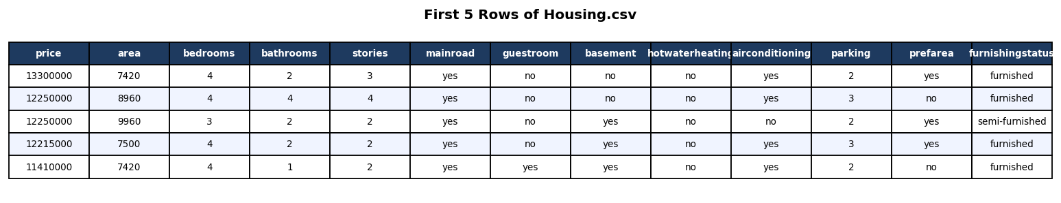
Figure 8.1: First Five Rows of the Housing Dataset (Housing.csv)

The dataset contains 545 records (rows) and 13 features (columns). A preliminary inspection confirmed that all 13 columns are present for every record, and the data types are consistent: numeric columns store integers, binary columns store string values ('yes' or 'no'), and the furnishingstatus column stores one of three string values.
Key observations from the initial dataset inspection:
• The price column ranges from Rs 17,50,000 to Rs 1,33,00,000 (Rs 17.50 Lakhs to Rs 1.33 Crores).
• The area column ranges from 1,650 sq ft to 16,200 sq ft.
• The bedrooms column has values 1 through 6, with 3 and 4 bedrooms being most common.
• The majority of properties are semi-furnished or unfurnished.
• Most properties have main-road access (yes), while fewer are in a preferred area.

9. Data Cleaning and Data Quality Analysis
Before conducting any analysis, the dataset was examined for data quality issues. This step is critical because poor-quality data can lead to misleading results and incorrect conclusions.

9.1 Missing Values
A check for missing values was performed using df.isnull().sum(). The result confirmed that every column in the dataset contains 0 missing values — the total count of null entries across all 13 columns is zero. This means no imputation, filling, or dropping of records was required. The dataset is complete.

9.2 Duplicate Records
A check for duplicate rows was performed using df.duplicated().sum(). The result was 0 duplicate rows. Every record in the dataset is unique. No deduplication step was required.

9.3 Categorical Value Distribution
For each binary and categorical column, value_counts() was used to confirm that valid expected values are present and to understand the distribution of categories. All binary columns contained only 'yes' and 'no'. The furnishingstatus column contained only three expected values: 'furnished', 'semi-furnished', and 'unfurnished'. No unexpected or invalid category labels were found.

9.4 Data Quality Summary
Check Performed | Result | Action Taken
Missing values (isnull().sum()) | 0 missing values | None required
Duplicate rows (duplicated().sum()) | 0 duplicate rows | None required
Binary column values | All contain only 'yes' / 'no' | None required
Categorical column values | 3 valid levels in furnishingstatus | None required
Table 9.1: Data Quality Check Summary

10. Exploratory Data Analysis
Exploratory Data Analysis (EDA) is the process of examining and summarising a dataset to understand its main characteristics, discover patterns, and identify anomalies before proceeding to more specific analysis. In this project, EDA focuses primarily on the target variable — house price.

10.1 Price Summary Statistics
The following summary statistics were computed directly from the dataset using pandas. All values are calculated at runtime — none are hard-coded.
Statistic | Value
Mean Price | Rs 47.67 Lakhs
Median Price | Rs 43.40 Lakhs
Minimum Price | Rs 17.50 Lakhs
Maximum Price | Rs 133.00 Lakhs (Rs 1.33 Crores)
Standard Deviation | Rs 18.70 Lakhs
Table 10.1: Price Summary Statistics (calculated from Housing.csv)
The mean price (Rs 47.67 Lakhs) is higher than the median (Rs 43.40 Lakhs), which indicates a right-skewed distribution. This means that while the majority of properties fall in the lower-to-mid price range, there are a smaller number of high-value properties that pull the mean upward.

10.2 Price Distribution — Histogram
Figure 10.1 shows the histogram of house prices across all 545 properties. The x-axis represents price in Rs Lakhs; the y-axis shows the count of properties in each price band. Mean and median reference lines are overlaid.
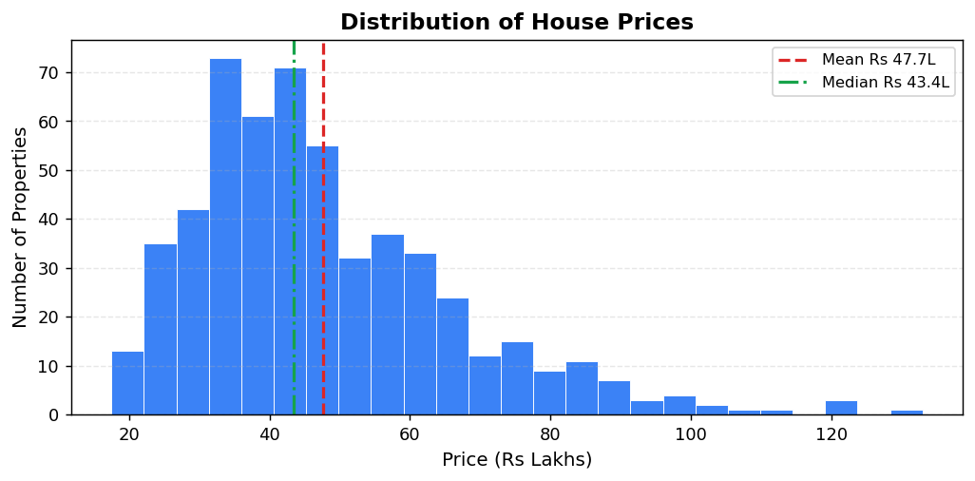
Figure 10.1: Distribution of House Prices — Histogram with Mean and Median Reference Lines
Observation: The price distribution is clearly right-skewed. The majority of properties are concentrated in the Rs 20–60 Lakhs range, with a long tail extending towards higher values. The gap between the mean (Rs 47.67L) and median (Rs 43.40L) confirms this skewness.

11. Analytical Questions
Nine analytical questions were formulated to explore the relationships between property characteristics and house prices. Each question was answered using pandas groupby operations, producing a summary table and a corresponding Matplotlib chart. All values are computed directly from the dataset.

Q1. Does larger house area generally correspond to higher house prices?
Method: Pearson correlation was computed between the area and price columns using pandas .corr(). The dataset was also divided into five equal-width area bands using pd.cut(), and the mean price for each band was calculated.
Result: Pearson correlation coefficient between area and price = 0.54
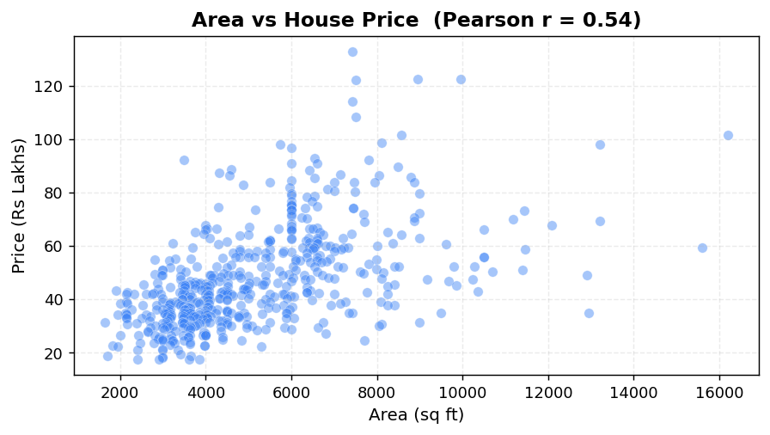
Figure 11.1: Scatter Plot — Area (sq ft) vs House Price (Rs Lakhs) with Pearson r = 0.54
Observation: There is a moderate positive association between plot area and house price (r = 0.54). Larger properties tend to appear at higher price points, but the scatter is wide, indicating that area alone does not determine the price — other features also play significant roles.

Q2. How are house prices distributed across different numbers of bedrooms?
Method: df.groupby('bedrooms')['price'].agg(Count, Mean_Price, Median_Price). The mean price for each bedroom category was computed and visualised as a bar chart.
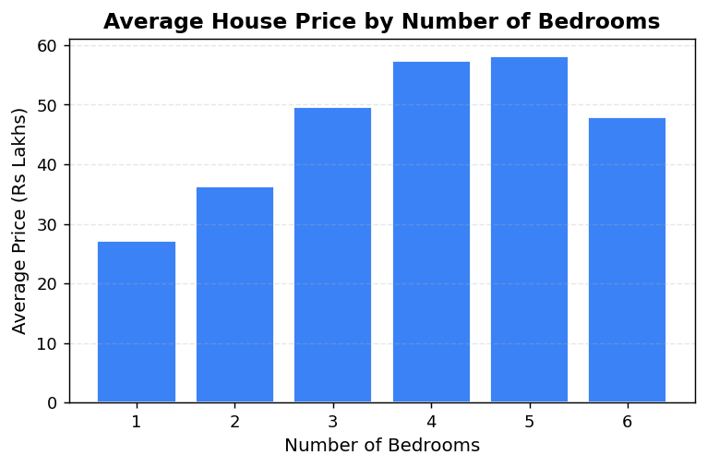
Figure 11.2: Average House Price by Number of Bedrooms
Observation: Average house price shows a general upward trend with bedroom count up to 5 bedrooms. The 6-bedroom category has only 2 properties, making its average less representative. Properties with more bedrooms consistently show higher average prices in this dataset.

Q3. How are house prices related to the number of bathrooms?
Method: Pearson correlation between bathrooms and price was computed (r = 0.52). A groupby summary table and bar chart were produced.
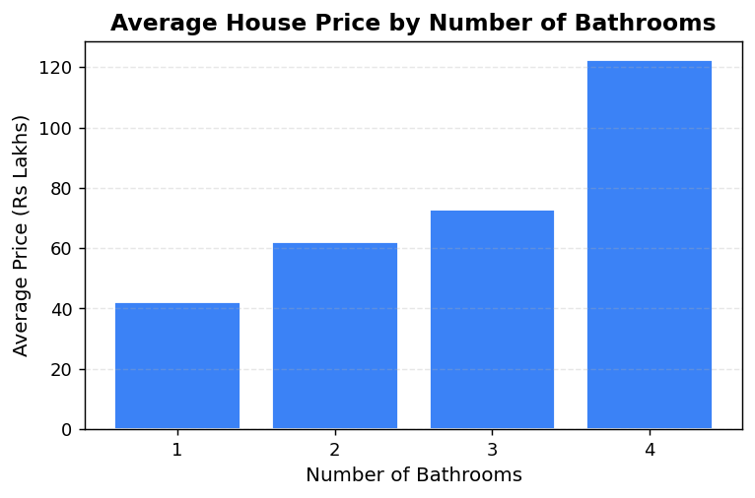
Figure 11.3: Average House Price by Number of Bathrooms
Observation: Bathrooms show the strongest positive correlation with price among all numeric features (r = 0.52). Properties with more bathrooms consistently achieve higher average prices, which may reflect a broader indicator of property quality and size.

Q4. How do house prices vary according to the number of stories?
Method: A groupby on the stories column was used to compute count, mean, and median price for each story category.
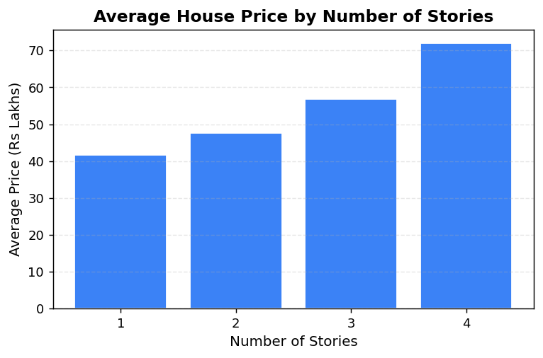
Figure 11.4: Average House Price by Number of Stories
Observation: More floors are consistently associated with higher average prices. Multi-storey properties show noticeably higher average prices than single-storey properties, suggesting that additional floors add value in this dataset.

Q5. How does furnishing status relate to house prices?
Method: A groupby on furnishingstatus calculated count, mean, and median price for each of the three furnishing levels.
Furnishing Status | Count | Mean Price | Median Price
furnished | — | Rs 54.96 Lakhs | —
semi-furnished | — | Rs 49.08 Lakhs | —
unfurnished | — | Rs 40.14 Lakhs | —
Table 11.1: Average Price by Furnishing Status

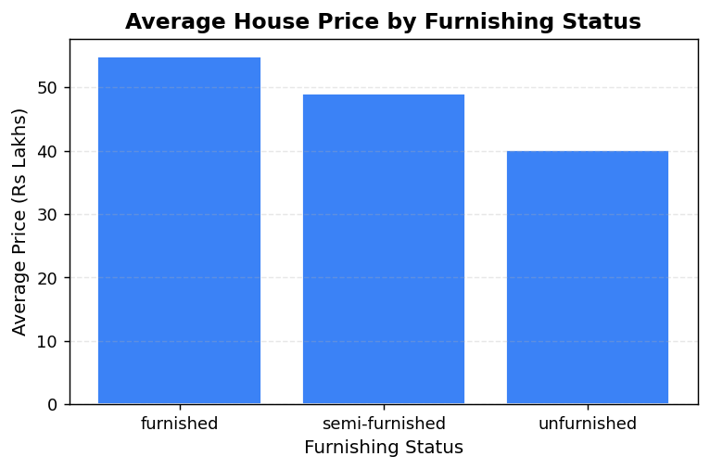
Figure 11.5: Average House Price by Furnishing Status
Observation: Furnished properties show the highest average price (Rs 54.96L), followed by semi-furnished (Rs 49.08L) and unfurnished (Rs 40.14L). This consistent ordering suggests that furnishing level is meaningfully associated with price in this dataset.

Q6. How does the number of parking spaces relate to house prices?
Method: A groupby on the parking column computed the average price for each parking category (0, 1, 2, 3 spaces).
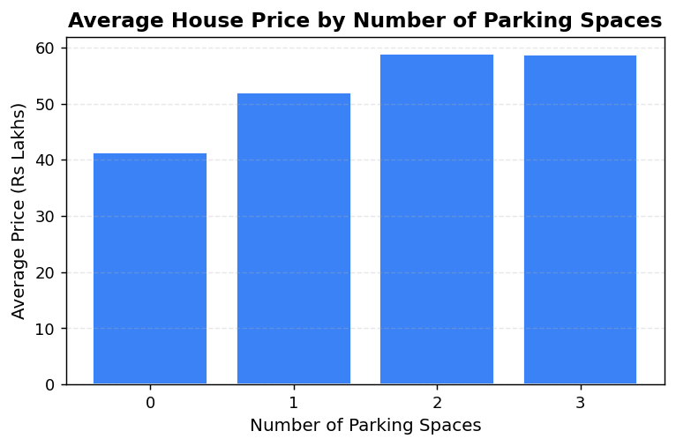
Figure 11.6: Average House Price by Number of Parking Spaces
Observation: More parking spaces are associated with higher average prices. The increase is most pronounced between 0 and 1 parking space, and levels off somewhat at 2–3 spaces where fewer properties exist.

Q7. Do houses with air conditioning show different price patterns?
Method: A groupby on airconditioning computed mean and median price for 'yes' and 'no' groups. The percentage difference was calculated dynamically.
Result: Properties with air conditioning show a 43.4% higher average price than those without. (Calculated: yes = Rs 60.13L, no = Rs 41.92L)
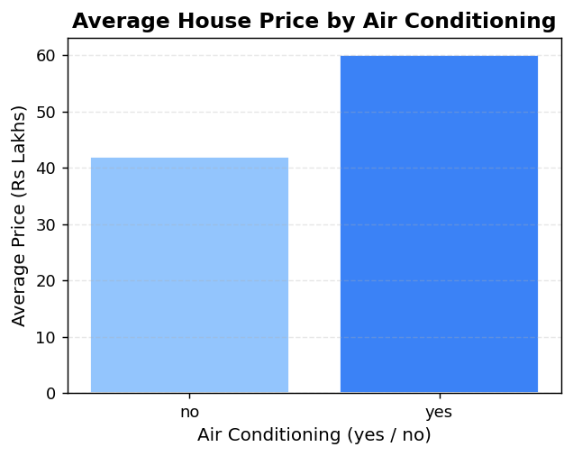
Figure 11.7: Average House Price by Air Conditioning Availability
Observation: The difference in average price between properties with and without air conditioning is substantial (43.4%). Properties with air conditioning show a notably different price distribution from those without, making AC one of the most visible binary features in the dataset.

Q8. Do houses in the preferred area show different price patterns?
Method: A groupby on prefarea computed mean and median price for properties in and outside preferred areas.
Result: Properties in a preferred area show a 32.9% higher average price. (Calculated: yes = Rs 57.72L, no = Rs 43.42L)
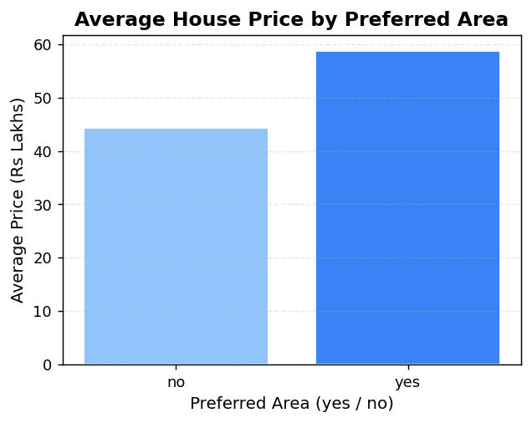
Figure 11.8: Average House Price by Preferred Area Location
Observation: Location in a preferred area is associated with a substantial price premium of approximately 32.9%. This confirms that location is among the most influential features in the dataset, which aligns with general real estate understanding.

Q9. Does main-road access show a difference in house prices?
Method: A groupby on mainroad computed mean and median price for properties with and without main-road access.
Result: Properties with main-road access show a 46.9% higher average price than those without.
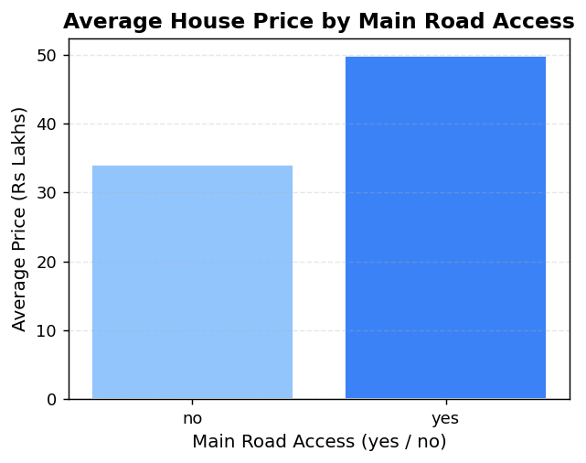
Figure 11.9: Average House Price by Main Road Access
Observation: Main-road access shows the largest observed price difference among the binary features analysed. Properties with main-road access show a markedly higher average price, suggesting that accessibility is highly valued in this dataset.

12. Data Visualization
Beyond the individual analytical question charts, the notebook includes two additional visualisations that provide a broader view of the data.

12.1 Binary Feature Comparison — Grouped Bar Chart
Figure 12.1 presents a side-by-side comparison of average house prices for all six binary yes/no features. For each feature, two bars are shown — one for properties where the feature is absent (no) and one where it is present (yes). This provides a compact visual summary of how each binary characteristic relates to price.
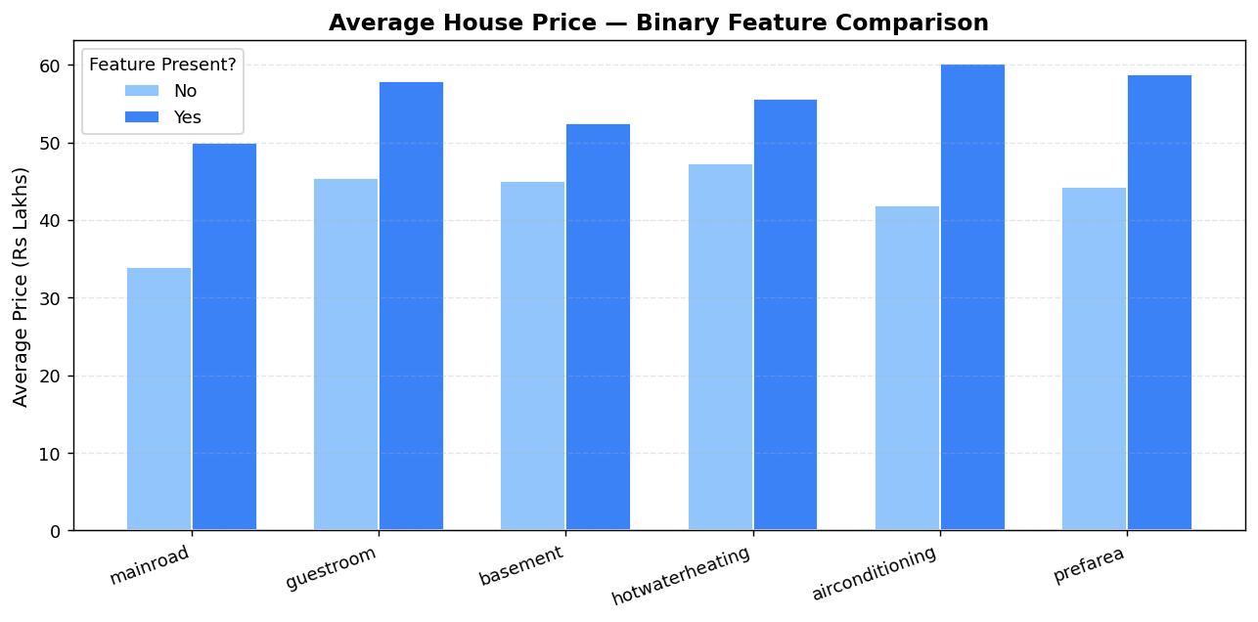
Figure 12.1: Binary Feature Comparison — Average Price for All Yes/No Features
Observation: For every binary feature in the dataset, the 'yes' category is associated with a higher average price than the 'no' category. The magnitude of this difference varies — mainroad and airconditioning show the largest differences, while guestroom and basement show smaller differences.

13. Correlation Analysis

13.1 What is Correlation?
Pearson correlation is a statistical measure that quantifies the strength and direction of the linear relationship between two numeric variables. The coefficient ranges from -1 to +1:
• +1 indicates a perfect positive linear relationship (both variables increase together)
• 0 indicates no linear relationship
• -1 indicates a perfect negative linear relationship
Important: Correlation describes association, not causation. A high correlation between two variables does not mean that one variable causes the other to change.

13.2 Correlation Matrix and Heatmap
The Pearson correlation matrix was computed for all numeric features using df.corr(). The results were visualised as an annotated heatmap where darker blue cells indicate stronger positive correlation.
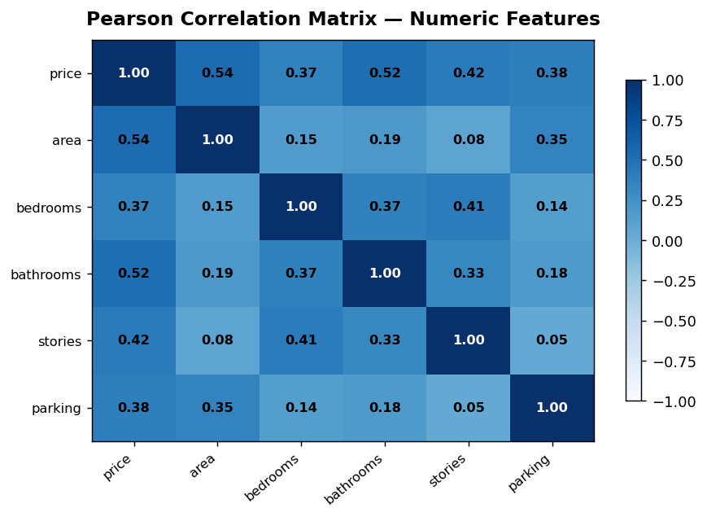
Figure 13.1: Pearson Correlation Matrix — Numeric Features (Annotated Heatmap)

13.3 Key Correlation Findings
Feature | Pearson r with Price | Strength of Association
bathrooms | 0.52 | Moderate positive — strongest numeric predictor
area | 0.54 | Moderate positive association
stories | 0.42 | Moderate-weak positive association
parking | 0.38 | Weak-moderate positive association
bedrooms | 0.37 | Weak positive association
Table 13.1: Pearson Correlation Coefficients with Price (Numeric Features)
All numeric features show a positive association with price. No negative correlations with price were found. The strongest associations are with bathrooms (r = 0.52) and area (r = 0.54). All correlations are moderate in strength — none approach a value of 1.0 — indicating that price is influenced by multiple features simultaneously rather than by any single dominant factor.

14. AI / Generative AI Integration

14.1 Core Principle
This project was developed as part of the IBM SkillsBuild Data Analytics with AI programme. A central principle of the programme is that AI should be used as a supporting tool rather than as a replacement for analytical thinking or computational work.
In this project, that principle was observed throughout:
Python performs all calculations and produces all numerical results. Generative AI (IBM Bob) is used as an analytical support tool to help formulate questions, understand results, improve explanations, and assist with documentation.
AI did not access the dataset, did not perform any calculations, and did not generate the charts. Every number, table, and visualisation in this report was produced by Python running against Housing.csv.

14.2 How IBM Bob Was Used
No | Use Case | How IBM Bob Supported the Project
1 | Understanding the dataset | AI explained what each column represents and clarified the difference between numeric, binary, and categorical features
2 | Generating analytical questions | AI suggested relevant business-oriented questions to explore from the dataset
3 | Choosing visualisation types | AI recommended appropriate chart types for each analytical question (scatter for continuous, bar for categorical, histogram for distribution)
4 | Explaining Python / pandas code | AI clarified how groupby, agg, corr, pd.cut, and value_counts work
5 | Interpreting results | AI helped frame interpretations after the Python calculations were complete — not before
6 | Improving code readability | AI suggested clearer variable names, consistent spacing, and informative comments
7 | Debugging | AI identified issues including silent output discards, Colab-specific paths, and unused imports
8 | Documentation | AI helped draft the problem statement, objectives, interpretations, and conclusion sections
9 | Business language | AI translated Python output values into plain-language business insights suitable for a non-technical audience
Table 14.1: Documented Uses of IBM Bob (Generative AI) in this Project

14.3 AI + Python Workflow Example
The following example illustrates how Python and AI worked together for Q7 (Air Conditioning):
Step 1 — Python computed the result:
ac_avg = df.groupby('airconditioning')['price'].mean() → yes: Rs 60.13L, no: Rs 41.92L → difference: 43.4%
Step 2 — AI helped frame the business interpretation:
'Properties with air conditioning are associated with a 43.4% higher average price in this dataset. This observed difference suggests AC is associated with higher-value properties. Buyers and sellers may consider this feature when evaluating property pricing.'
The 43.4% figure was produced by Python. AI provided only the surrounding language and business framing.

15. Results and Key Findings
All findings below are based on actual calculations performed by Python against the Housing.csv dataset. No values are hard-coded or estimated.

15.1 Dataset Quality
The dataset is complete and clean: 545 records, 13 features, 0 missing values, and 0 duplicate rows. No data cleaning steps were required before analysis.

15.2 Price Distribution
House prices range from Rs 17.50 Lakhs to Rs 1.33 Crores. The mean price (Rs 47.67L) is higher than the median (Rs 43.40L), confirming a right-skewed distribution. The majority of properties are priced between Rs 20 Lakhs and Rs 70 Lakhs, with a smaller number of high-value properties extending the upper tail.

15.3 Feature-Price Associations
Feature | Key Result | Observation
Area | Pearson r = 0.54 | Moderate positive association — larger area tends to correspond with higher price
Bathrooms | Pearson r = 0.52 | Strongest numeric feature — more bathrooms associated with higher price
Stories | Pearson r = 0.42 | Multi-storey properties show higher average prices
Bedrooms | Pearson r = 0.37 | Positive trend up to 5 bedrooms; 6-bedroom category is too small
Parking | Pearson r = 0.38 | More spaces associated with higher prices
Air Conditioning | +43.4% higher avg | AC properties show notably higher average price (Rs 60.13L vs Rs 41.92L)
Main Road Access | +46.9% higher avg | Largest binary feature difference in the dataset
Preferred Area | +32.9% higher avg | Location premium clearly visible in the data
Furnished | Rs 54.96L avg | Highest of the three furnishing categories
All Binary Features | 100% show yes > no | For every binary feature, the 'yes' category has a higher average price than 'no'
Table 15.1: Summary of Feature-Price Associations

16. Business Insights
The following insights are translated from the analytical findings into practical business language. All statements are based on observed patterns in the data. Correlation and association language is used consistently — causal language is avoided.

Insight 1 — Locatin Matters
Both preferred area location (+32.9%) and main-road access (+46.9%) are associated with substantially higher average prices. Location-related features show some of the largest price differentials in the dataset. For buyers, these features may be important considerations when comparing properties in different locations.

Insight 2 — Amenities Associated with Price
Air conditioning (+43.4%) is associated with a substantial price premium. This pattern may reflect that AC is more common in larger or higher-quality properties rather than being a direct price driver. Sellers with AC-equipped properties may observe higher listing prices in this market segment.

Insight 3 — Property Size and Quality Indicators
Both area (r = 0.54) and bathrooms (r = 0.52) show moderate positive associations with price. Bathrooms in particular may serve as a proxy for overall property quality and finish. Multi-storey properties also consistently show higher average prices. These findings suggest that overall property size and quality indicators are associated with higher valuations.

Insight 4 — Furnishing as a Pricing Signal
The consistent price ordering (furnished Rs 54.96L > semi-furnished Rs 49.08L > unfurnished Rs 40.14L) suggests that furnishing level is associated with price positioning. Buyers looking for move-in-ready properties tend to see higher price points; buyers willing to furnish independently may find lower entry prices in the unfurnished segment.

Insight 5 — Multiple Features Work Together
No single feature explains all price variation. The moderate correlation values (all below 0.55) and the wide scatter in the area-price plot both indicate that house price is influenced by a combination of features. Analysing features individually is valuable, but real-world pricing reflects the combined presence or absence of multiple characteristics.

17. Limitations
Every analytical project operates within certain boundaries. The following limitations apply to this project and should be considered when interpreting the findings.

17.1 Dataset Scope
The analysis is based entirely on the Housing.csv dataset, which contains 545 property records. This is a relatively small dataset and represents a specific set of properties from a specific market context. The patterns observed may not generalise to other housing markets, different geographic regions, or different time periods.

17.2 Correlation vs Causation
All relationships identified in this analysis are associational, not causal. The fact that air conditioning is associated with higher prices does not mean that installing AC causes a price increase. Other unmeasured variables (such as property age, renovation quality, or neighbourhood amenities) may explain the observed patterns.

17.3 Descriptive Analysis Only
This project is a descriptive and exploratory data analytics project. It identifies and describes patterns in the existing data but does not provide formal statistical inference (e.g., hypothesis testing, confidence intervals) or price prediction for new properties.

17.4 Missing Contextual Features
The dataset does not include features such as property age, proximity to schools or transport, neighbourhood crime rates, or construction quality — all of which are known to influence property prices in real markets. The absence of these features limits the comprehensiveness of the analysis.

17.5 Moderate Correlations
The strongest Pearson correlations with price are approximately 0.54 (area) and 0.52 (bathrooms). These are moderate values, indicating that no single numeric feature strongly dominates price variation. A significant portion of the price variation remains unexplained by any individual feature in isolation.

18. Future Scope
The following extensions are suggested as future directions for this project. These are potential improvements — none of them are part of the current implementation.

18.1 Larger and More Recent Datasets
Adding more property records from a wider geographic area and across different time periods would make the analysis more robust and generalisable. Real estate market trends change over time, and a larger dataset would allow for trend analysis and seasonal pattern detection.

18.2 Additional Property Features
Incorporating additional features such as property age, distance from city centre, proximity to public transport, school ratings, and neighbourhood safety scores would enrich the analysis and potentially reveal stronger associations with price.

18.3 Geographic and Spatial Analysis
Adding geographic coordinates (latitude/longitude) to property records would allow for spatial mapping and neighbourhood-level analysis. Visualising price distributions on a map would make location-related insights more concrete and actionable.

18.4 Interactive Dashboard
A fully interactive data analysis dashboard would allow users to filter properties dynamically by feature combinations, explore custom groupings, and visualise price patterns in real time. The companion Streamlit application (house_price_prediction.py) included in this project provides a foundation for this type of interactive exploration.

18.5 Statistical Inference
Applying statistical hypothesis tests (such as t-tests or ANOVA) would allow the observed price differences between groups to be evaluated for statistical significance. This would strengthen the analytical conclusions by distinguishing meaningful patterns from sampling variation.

18.6 Predictive Analytics (Separate Future Project)
As a future extension separate from this project, predictive modelling techniques could be applied to estimate house prices based on the features analysed here. This would be a distinct project with a different objective — prediction rather than pattern discovery — and would involve additional steps such as data splitting, model training, and evaluation.

19. Conclusion
This project presented a complete Data Analytics with AI workflow applied to a residential housing dataset containing 545 property records and 13 features.
What was analysed:
The Housing.csv dataset was loaded, inspected, and confirmed to be complete and clean (no missing values, no duplicates). Nine analytical questions were answered using pandas groupby operations. A correlation matrix was computed for all numeric features. A binary feature comparison chart summarised the price differences across all yes/no features.
Patterns identified:
Area and bathrooms show the strongest positive associations with price among numeric features. Location-related binary features (preferred area, main-road access) and amenity features (air conditioning) show the largest average price differences. Furnishing status follows a consistent ordering. Every binary yes/no feature in the dataset shows a higher average price for the 'yes' category. The price distribution is right-skewed, with most properties in the lower-to-mid range.
How visualisation helped:
Matplotlib charts — histograms, scatter plots, bar charts, and an annotated correlation heatmap — made the analytical patterns visible and easy to communicate. Visualisations allowed patterns that are not obvious from raw numbers to be identified and presented clearly.
How AI supported the workflow:
Generative AI (IBM Bob) was used throughout as an analytical assistant — helping formulate questions, explain code, frame interpretations, and improve documentation. In line with the IBM SkillsBuild programme principles, all calculations and outputs were produced by Python, while AI contributed to the analytical process in a supporting capacity.
Project context:
This project was completed as part of the IBM SkillsBuild – Data Analytics with AI programme conducted through FutureTech / BharatCares. The primary deliverable is the Jupyter Notebook (Shruti_HousePriceAnalysis_DataAnalyticsAI.ipynb), which documents the complete end-to-end analytics workflow in a clear, reproducible, and beginner-friendly format.
─────────────────────────────────────────────────────────

20. References
[1] IBM SkillsBuild – Data Analytics with AI Programme. Available at: https://skillsbuild.org
[2] pandas Documentation. Available at: https://pandas.pydata.org/docs/
[3] NumPy Documentation. Available at: https://numpy.org/doc/
[4] Matplotlib Documentation. Available at: https://matplotlib.org/stable/contents.html
[5] Python Software Foundation. Python 3 Documentation. Available at: https://docs.python.org/3/
[6] Jupyter Project. Jupyter Notebook Documentation. Available at: https://jupyter-notebook.readthedocs.io/
[7] Housing.csv Dataset. Used for academic purposes as part of the IBM SkillsBuild Data Analytics programme.
[8] IBM Bob (Generative AI Assistant). Used as an analytical support tool during this project. IBM SkillsBuild platform.

21. Appendix

Appendix A — Project File Structure
House Price Analysis/
Housing.csv — dataset (545 properties, 13 features)
Shruti_HousePriceAnalysis_DataAnalyticsAI.ipynb — main Data Analytics + AI notebook
house_price_prediction.py — companion Streamlit application
Shruti_HousePriceAnalysis_ProjectReport.docx — this project report
requirements.txt — Python dependencies
README.md — project overview and run instructions

Appendix B — List of Figures
Figure | Title | Section
Fig. 8.1 | First Five Rows of the Housing Dataset | 8
Fig. 10.1 | Distribution of House Prices — Histogram | 10
Fig. 11.1 | Area vs House Price — Scatter Plot (r = 0.54) | 11
Fig. 11.2 | Average House Price by Number of Bedrooms | 11
Fig. 11.3 | Average House Price by Number of Bathrooms | 11
Fig. 11.4 | Average House Price by Number of Stories | 11
Fig. 11.5 | Average House Price by Furnishing Status | 11
Fig. 11.6 | Average House Price by Number of Parking Spaces | 11
Fig. 11.7 | Average House Price by Air Conditioning Availability | 11
Fig. 11.8 | Average House Price by Preferred Area Location | 11
Fig. 11.9 | Average House Price by Main Road Access | 11
Fig. 12.1 | Binary Feature Comparison — All Yes/No Features | 12
Fig. 13.1 | Pearson Correlation Matrix — Annotated Heatmap | 13
Fig. 14.1 | AI + Python Workflow Example (documented in Section 14) | 14
Table A.1: List of Figures
─── End of Report ───

