Danutella Output

# **Table of Contents**

|  |  |
| --- | --- |
| I. | Push Based Output |
| II. | Pull Based Output |

# Push Based Output

**get p9-1k.txt**

$ java -jar Peer.jar push

Please enter a command: get {filename}, files, edit {filename}, refresh, ? for help

danutella-2000> get p9-1k.txt

danutella-2000> Received hitQuery from localhost:2009 meant for localhost:2000.

Successfully downloaded p9-1k.txt from localhost:2009.

File size: 1020 bytes.

<==|== Start of File Contents ==||==>

This is peer 9's file of size 1K. This is peer 9's file of size 1K. This is peer 9's file of size 1K. This is peer 9's file of size 1K. This is peer 9's file of size 1K. This is peer 9's file of size 1K. This is peer 9's file of size 1K. This is peer 9's file of size 1K. This is peer 9's file of size 1K. This is peer 9's file of size 1K. This is peer 9's file of size 1K. This is peer 9's file of size 1K. This is peer 9's file of size 1K. This is peer 9's file of size 1K. This is peer 9's file of size 1K. This is peer 9's file of size 1K. This is peer 9's file of size 1K. This is peer 9's file of size 1K. This is peer 9's file of size 1K. This is peer 9's file of size 1K. This is peer 9's file of size 1K. This is peer 9's file of size 1K. This is peer 9's file of size 1K. This is peer 9's file of size 1K. This is peer 9's file of size 1K. This is peer 9's file of size 1K. This is peer 9's file of size 1K. This is peer 9's file of size 1K. This is peer 9's file of size 1K. This is peer 9's file of size 1K.

<==|== End of File Contents ==||==>

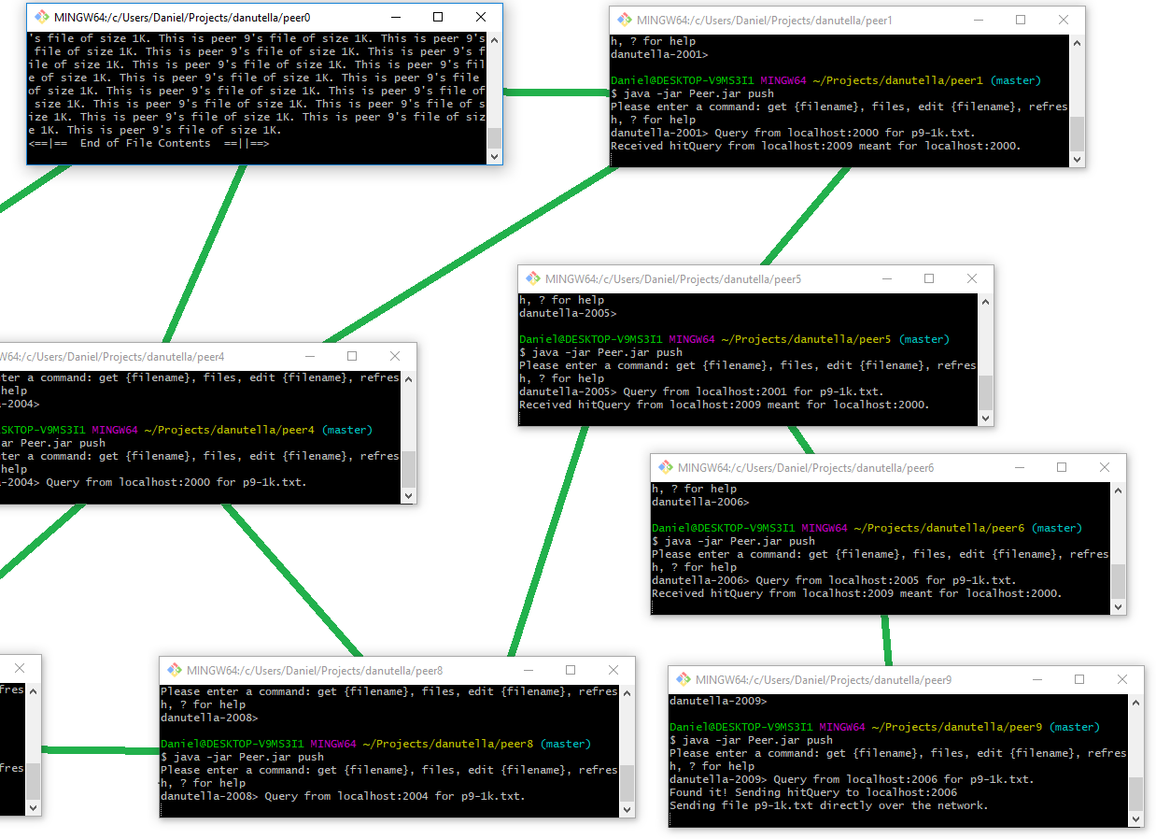

Figure : Shows the flow of queries and the resulting flow of hitQueries that goes backwards.

**files (displaying list of files)**

danutella-2000> files

List of Files:

+++ p0-10k.txt : {

version: 0;

state: VALID;

lastModified: 21:51:10;

lastPolled: NOW

}

+++ p0-1k.txt : {

version: 0;

state: VALID;

lastModified: 21:51:10;

lastPolled: NOW

}

+++ p0-2k.txt : {

version: 0;

state: VALID;

lastModified: 21:51:10;

lastPolled: NOW

}

+++ p0-3k.txt : {

version: 0;

state: VALID;

lastModified: 21:51:10;

lastPolled: NOW

}

+++ p0-4k.txt : {

version: 0;

state: VALID;

lastModified: 21:51:10;

lastPolled: NOW

}

+++ p0-5k.txt : {

version: 0;

state: VALID;

lastModified: 21:51:10;

lastPolled: NOW

}

+++ p0-6k.txt : {

version: 0;

state: VALID;

lastModified: 21:51:10;

lastPolled: NOW

}

+++ p0-7k.txt : {

version: 0;

state: VALID;

lastModified: 21:51:10;

lastPolled: NOW

}

+++ p0-8k.txt : {

version: 0;

state: VALID;

lastModified: 21:51:10;

lastPolled: NOW

}

+++ p0-9k.txt : {

version: 0;

state: VALID;

lastModified: 21:51:10;

lastPolled: NOW

}

- p9-1k.txt : {

version: 0;

state: VALID;

lastModified: 21:51:07;

lastPolled: 21:51:33

}

danutella-2000>

**edit p9-1k.txt**

peer9:

danutella-2009>edit p9-1k.txt

Invalidating p9-1k.txt; new version: 1

danutella-2009>

peer0:

danutella-2000> Invalidation received! p9-1k.txt version is now 1

Invalidation successful.

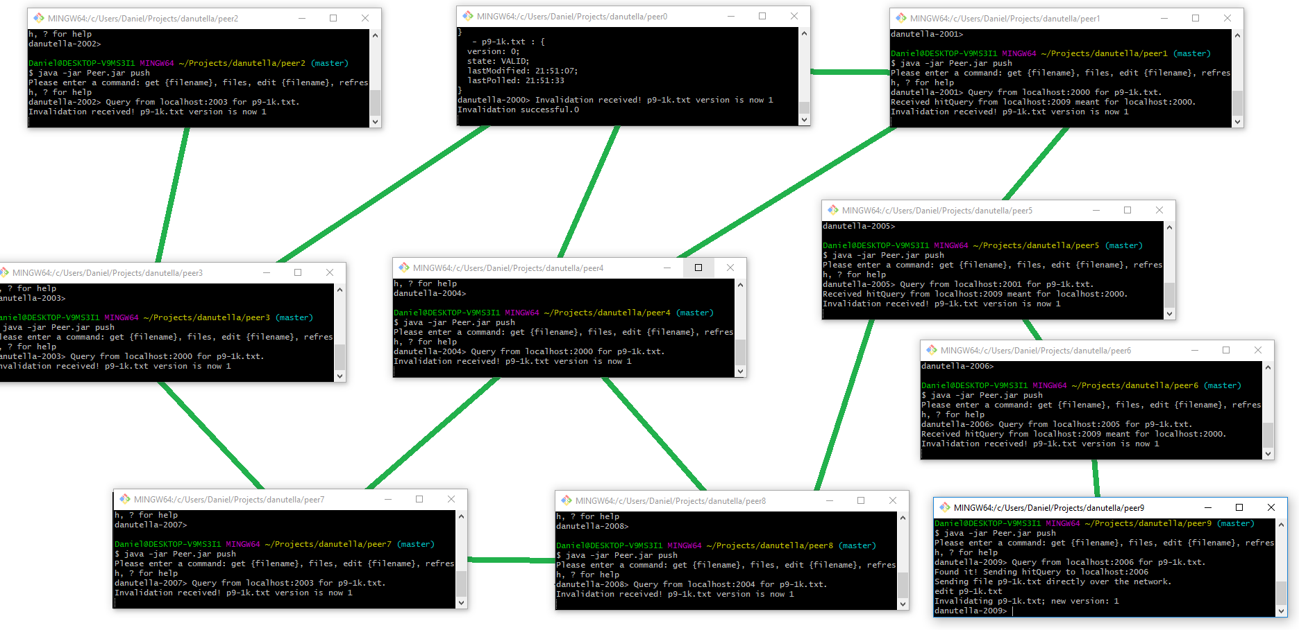

Figure : Shows invalidation message propagation.

**Files**

danutella-2000>files

List of Files:

+++ p0-10k.txt : {

version: 0;

state: VALID;

lastModified: 21:51:10;

lastPolled: NOW

}

+++ p0-1k.txt : {

version: 0;

state: VALID;

lastModified: 21:51:10;

lastPolled: NOW

}

+++ p0-2k.txt : {

version: 0;

state: VALID;

lastModified: 21:51:10;

lastPolled: NOW

}

+++ p0-3k.txt : {

version: 0;

state: VALID;

lastModified: 21:51:10;

lastPolled: NOW

}

+++ p0-4k.txt : {

version: 0;

state: VALID;

lastModified: 21:51:10;

lastPolled: NOW

}

+++ p0-5k.txt : {

version: 0;

state: VALID;

lastModified: 21:51:10;

lastPolled: NOW

}

+++ p0-6k.txt : {

version: 0;

state: VALID;

lastModified: 21:51:10;

lastPolled: NOW

}

+++ p0-7k.txt : {

version: 0;

state: VALID;

lastModified: 21:51:10;

lastPolled: NOW

}

+++ p0-8k.txt : {

version: 0;

state: VALID;

lastModified: 21:51:10;

lastPolled: NOW

}

+++ p0-9k.txt : {

version: 0;

state: VALID;

lastModified: 21:51:10;

lastPolled: NOW

}

- p9-1k.txt : {

version: 0;

state: INVALID;

lastModified: 21:51:07;

lastPolled: 21:51:33

}

**refresh**

danutella-2000> refresh

Successfully refreshed p9-1k.txt

File size: 1020 bytes.

<==|== Start of File Contents ==||==>

This is peer 9's file of size 1K. This is peer 9's file of size 1K. This is peer 9's file of size 1K. This is peer 9's file of size 1K. This is peer 9's file of size 1K. This is peer 9's file of size 1K. This is peer 9's file of size 1K. This is peer 9's file of size 1K. This is peer 9's file of size 1K. This is peer 9's file of size 1K. This is peer 9's file of size 1K. This is peer 9's file of size 1K. This is peer 9's file of size 1K. This is peer 9's file of size 1K. This is peer 9's file of size 1K. This is peer 9's file of size 1K. This is peer 9's file of size 1K. This is peer 9's file of size 1K. This is peer 9's file of size 1K. This is peer 9's file of size 1K. This is peer 9's file of size 1K. This is peer 9's file of size 1K. This is peer 9's file of size 1K. This is peer 9's file of size 1K. This is peer 9's file of size 1K. This is peer 9's file of size 1K. This is peer 9's file of size 1K. This is peer 9's file of size 1K. This is peer 9's file of size 1K. This is peer 9's file of size 1K.

<==|== End of File Contents ==||==>

danutella-2000>

# Pull Based Output

02-22-2018-20-00-41: Registering localhost:2018 with file p1-1k.txt.

02-22-2018-20-13-04: Searching for p2-3k.txt: 1 peers found.

**(Same as Push based with these small changes):**

**Polls every so often (configurable in code)**

danutella-2000> Automatically polling...

Automatically polling...

get p9-1k.txt

danutella-2000> Automatically polling...

Received hitQuery from localhost:2009 meant for localhost:2000.

Successfully downloaded p9-1k.txt from localhost:2009.

File size: 1020 bytes.

<==|== Start of File Contents ==||==>

This is peer 9's file of size 1K. This is peer 9's file of size 1K. This is peer 9's file of size 1K. This is peer 9's file of size 1K. This is peer 9's file of size 1K. This is peer 9's file of size 1K. This is peer 9's file of size 1K. This is peer 9's file of size 1K. This is peer 9's file of size 1K. This is peer 9's file of size 1K. This is peer 9's file of size 1K. This is peer 9's file of size 1K. This is peer 9's file of size 1K. This is peer 9's file of size 1K. This is peer 9's file of size 1K. This is peer 9's file of size 1K. This is peer 9's file of size 1K. This is peer 9's file of size 1K. This is peer 9's file of size 1K. This is peer 9's file of size 1K. This is peer 9's file of size 1K. This is peer 9's file of size 1K. This is peer 9's file of size 1K. This is peer 9's file of size 1K. This is peer 9's file of size 1K. This is peer 9's file of size 1K. This is peer 9's file of size 1K. This is peer 9's file of size 1K. This is peer 9's file of size 1K. This is peer 9's file of size 1K.

<==|== End of File Contents ==||==>

Automatically polling...

**File TTR expires after some pre-set amount of time:**

danutella-2000> files

List of Files:

+++ p0-10k.txt : {

version: 0;

state: VALID;

lastModified: 22:01:23;

lastPolled: NOW

}

+++ p0-1k.txt : {

version: 0;

state: VALID;

lastModified: 22:01:23;

lastPolled: NOW

}

+++ p0-2k.txt : {

version: 0;

state: VALID;

lastModified: 22:01:23;

lastPolled: NOW

}

+++ p0-3k.txt : {

version: 0;

state: VALID;

lastModified: 22:01:23;

lastPolled: NOW

}

+++ p0-4k.txt : {

version: 0;

state: VALID;

lastModified: 22:01:23;

lastPolled: NOW

}

+++ p0-5k.txt : {

version: 0;

state: VALID;

lastModified: 22:01:23;

lastPolled: NOW

}

+++ p0-6k.txt : {

version: 0;

state: VALID;

lastModified: 22:01:23;

lastPolled: NOW

}

+++ p0-7k.txt : {

version: 0;

state: VALID;

lastModified: 22:01:23;

lastPolled: NOW

}

+++ p0-8k.txt : {

version: 0;

state: VALID;

lastModified: 22:01:23;

lastPolled: NOW

}

+++ p0-9k.txt : {

version: 0;

state: VALID;

lastModified: 22:01:23;

lastPolled: NOW

}

- p9-1k.txt : {

version: 0;

state: TTR_EXPIRED;

lastModified: 22:01:25;

lastPolled: 22:02:19

}

danutella-2000> Automatically polling...

**After simulating edit on p9-1k.txt:**

Automatically polling...

Invalidating p9-1k.txt. The poll gave back a newer version.

**File after this auto-poll:**

- p9-1k.txt : {

version: 0;

state: INVALID;

lastModified: 22:01:25;

lastPolled: 22:04:23

}