PROJECT PRESENTATION
Campus SkillX
A Campus Skill Exchange Platform
Project Explanation and Presentation Guide
Why it was built, what it does, how it works — and how to present it to your school.
Presenter | Trust Mwendabai
Programme | [Add your programme]
Institution | [Add your school / university]
Supervisor | [Add your lecturer's name]
Presentation date | [Add the date]

Items in [square brackets] are for you to fill in.

Contents and how to use this document
This guide has two parts. Part A explains the project itself — the reasons for it (Why), the finished system (What) and how it was built (How). Part B prepares you to present it: a slide plan, a live-demo script, a Q&A bank and checklists.

Section | Title | Use it to…
1 | Project at a glance | Get the whole project on one page
PART A | THE PROJECT
2 | WHY — the problem and the purpose | Justify the project
3 | WHAT — the system and its features | Describe the finished product
4 | HOW — design, build, security and testing | Explain the technical work
PART B | PRESENTING TO YOUR SCHOOL
5 | Presentation strategy | Decide what to emphasise
6 | Slide-by-slide plan | Build your slides
7 | Live demo script | Rehearse the demonstration
8 | Opening and closing script | Start and finish confidently
9 | Questions you may be asked | Prepare answers
10 | Limitations and future work | Be honest about scope
11 | Checklists and delivery tips | Prepare on the day
A–C | Appendices: screenshots, demo accounts, glossary | Reference

Suggested way to prepare
1. Read Part A once so the project's story is clear in your head.
2. Build slides from Section 6, keeping words on slides short.
3. Rehearse the demo in Section 7 at least three times, with a timer.
4. Practise answering the questions in Section 9 out loud.

1. Project at a glance
Campus SkillX is a web platform that lets students teach the skills they have and learn the skills they want — by exchanging with each other. A student who is good at Python and wants to learn graphic design is matched with a student who is good at graphic design and wants to learn Python. Both learn; nobody pays.

Project name | Campus SkillX (Campus Skill Exchange Platform)
Purpose | Connect students who can teach a skill with students who want to learn it, and manage the whole exchange.
Users | Students, Administrators and a Super Administrator
Core cycle | Discover → Match → Request → Communicate → Schedule → Exchange → Review
Technology | HTML5, CSS3, JavaScript (no framework), PHP 8 with PDO, MySQL / MariaDB, Chart.js. Runs on XAMPP.
Size of the system | 16 database tables · 17 public and student pages · 14 administrator pages · 5 JSON API endpoints
Main innovation | Two-way skill matching with a 0–100 compatibility score and a plain-language explanation of every match
Security highlights | Hashed passwords, prepared statements, CSRF protection, login lockout, privacy settings, admin audit log
Status | Complete and working. Tested end to end with demo data (see Section 4.7).

The project in three sentences
Skill-sharing on campus happens by chance today. Campus SkillX makes it organised: students list what they can teach and want to learn, the system finds and explains good partners, and it supports the whole exchange from first request to final review.
Administrators keep the community safe with moderation tools, reports and analytics.
PART A
The Project
Why it was built · What it does · How it works

2. WHY — the problem and the purpose

2.1 The problem
A campus is full of practical knowledge. Students can code, design, speak several languages, play instruments, edit video, run statistics, cook, budget and more. But that knowledge is hidden. Today, students who want to learn something usually depend on luck: a friend who happens to know it, or a message in a crowded group chat.
Four specific problems follow from this:
Problem | What it looks like on campus
Discovery | There is no way to search for “who here can teach Photoshop?”. Skills are only known inside friend groups.
Trust | Students hesitate to approach strangers. There is no rating, history or profile to judge whether someone is a good teacher.
Coordination | Even when two people find each other, arranging times, places and follow-ups is scattered across chats and memory.
No record | Nothing is tracked. Good teachers get no recognition and the institution cannot see how much peer learning is happening.

Existing options do not fully solve this. Paid tutoring is expensive and covers few skills. Lectures cover the syllabus, not the wider skills students want. Social media groups are unstructured: no search, no matching, no trust signals.

2.2 Why a skill exchange?
Campus SkillX uses an exchange model rather than a tutoring marketplace. That choice is deliberate:
- Both sides benefit. Each student is a teacher and a learner, so there is a reason for everyone to take part.
- It is free. Skills are the currency, so cost is never a barrier.
- Teaching deepens learning. Explaining a skill to someone else strengthens your own understanding.
- It builds community. Students meet across programmes and years they would not normally mix with.

2.3 Objectives
- Let every student publish the skills they can teach and the skills they want to learn.
- Automatically find compatible partners and explain why they are a good fit.
- Provide a clear request-and-accept process so exchanges begin by mutual agreement.
- Let matched students communicate and schedule sessions without leaving the platform.
- Build trust through ratings and reviews after each exchange.
- Give administrators the tools to manage users, skills, reports and announcements — and to see how the platform is used.
- Protect students’ accounts and privacy by design.
- Provide a modern interface that works on desktop, tablet and phone.

2.4 Who benefits
Group | Benefit
Students as learners | Access to many skills they could not otherwise afford or find, from people on the same campus.
Students as teachers | Recognition, practice in explaining, and a review history they can be proud of.
The institution | A visible, measurable culture of peer learning and student engagement.
Administrators | Oversight tools: moderation, reporting, announcements and analytics.

2.5 Why these technologies
Choice | Reason
PHP 8 + MySQL | Widely supported, easy to deploy on XAMPP or any shared hosting, and well suited to session-based web applications with relational data.
HTML5 / CSS3 / vanilla JavaScript | No build tools or frameworks to install. The site is light, fast, and shows mastery of the fundamentals.
PDO with prepared statements | The standard secure way to talk to a database from PHP; it removes SQL injection at the source.
Chart.js | A small, well-known library for the administrator analytics charts.
A relational database | The data is naturally linked (students ↔ skills ↔ requests ↔ matches ↔ reviews), so foreign keys and constraints protect its integrity.

3. WHAT — the system and its features

3.1 Roles
Role | What they can do
Student | Create a profile, manage skills, discover and get matched with partners, send and answer requests, message, schedule sessions, leave reviews, report problems, manage settings.
Administrator | Manage students, skills and categories; monitor requests, matches and sessions; moderate reviews; handle reports; publish announcements; view analytics.
Super Administrator | Everything an administrator can do, plus creating and managing administrator accounts and changing major system settings.

3.2 The student journey
The whole system is organised around one cycle. Every feature exists to move a student from one step to the next.
Discover | Match | Request | Communicate | Schedule | Exchange | Review

Step | What happens
Discover | Search by skill, category, level, programme, year, availability, format and rating — or open the recommended list.
Match | The matching engine scores each candidate and explains why they fit.
Request | The student sends an exchange request: the skill they want, the skill they offer in return, a message, and a preferred format, date and time.
Communicate | When the partner accepts, a match is created and messaging opens.
Schedule | Either partner schedules a session with a title, date, times, place or meeting link.
Exchange | The sessions take place. Partners mark them completed and then mark the whole exchange completed.
Review | Each partner rates the other (1–5 stars) with a comment. One review per person per exchange.

3.3 Student features
Feature | What it does
Registration and login | Register with name, student ID, email, phone, programme, faculty and year. Log in with email or student ID. Change password. Log out.
Dashboard | Greeting, search, four statistic cards, recommended partners, pending requests (accept or decline in one click), upcoming sessions, recent messages, recent activity and a profile-completeness prompt.
Find Skills | Search plus filters (category, level, programme, year, day available, format, minimum rating) and sorting. Every result card shows a match percentage.
Recommended partners | Students ranked by two-way compatibility, each with a “Why this match” explanation.
My Skills | Add, edit and remove skills the student can teach or wants to learn, with level, description, experience and availability. New skills can be created on the spot.
Requests | Received and sent tabs with status filters. Accept, decline or cancel.
My Matches | Active, completed and cancelled matches with the compatibility score, skills exchanged and quick actions.
Messages | Chat with matched partners. Unread badges and automatic refresh every few seconds.
Learning Sessions | Schedule sessions, mark them completed or cancelled. Old scheduled sessions become “missed” automatically.
Reviews | Rate and review partners; see reviews received and given.
Notifications | Bell with unread count, dropdown and full page: new matches, requests, replies, messages, sessions, reviews and announcements.
Profile | A portfolio-style page: about, skills offered and wanted, availability, learning preferences, reviews and exchange statistics.
Settings | Privacy, learning preferences, weekly availability, notification preferences, password change and “log out from other sessions”.
Reports | Report a student for fake profile, spam, harassment, misleading information and other reasons.

3.4 Administrator features
Feature | What it does
Dashboard | Key numbers, alerts for accounts awaiting verification and open reports, newest students and recent admin activity.
Students | Search and filter; view and edit profiles; activate, suspend or delete accounts.
Skills and Categories | Add, rename, deactivate or delete. Deactivating hides a skill from search but keeps its history.
Requests, Matches, Sessions | Read-only monitoring with status filters.
Messages | Message metadata only. The text is shown only where a user in that conversation has an open report, to protect privacy.
Reviews | Hide, restore or delete abusive or misleading reviews.
Reports | Review each report, change its status, record notes and optionally suspend the reported student.
Announcements | Publish a message that reaches every active student as a notification.
Analytics | Charts: registrations per month, completed exchanges, most popular skills, most requested skills, skill categories and platform activity.
Admin Accounts (super admin) | Create, suspend, demote and delete administrators.
Settings | Registration on/off, account verification on/off and a site-wide notice (super admin).
Audit log | Every administrator action is recorded with who, what and when.

3.5 What makes it different: four innovations
Innovation | Explanation
Two-way skill matching | The engine looks for students whose offered and wanted skills complement each other — not just a keyword search.
Compatibility scoring | Each candidate gets a 0–100 score built from skills, levels, availability, categories, format and track record.
Explainable recommendations | Every match comes with a plain-language reason, so students understand and trust the suggestion.
Skill exchange history | Completed exchanges and peer reviews create a record that builds trust across campus.

4. HOW — design, build, security and testing

4.1 Architecture
Campus SkillX follows a classic three-layer web architecture:
Presentation layer | HTML5 pages styled with CSS3, enhanced by JavaScript (`app.js`): mobile menu, notification bell, live chat polling, skill suggestions, confirmation dialogs. Charts use Chart.js.
Application layer | PHP pages that handle each request, sharing code from the `includes/` folder: authentication, helper functions, the matching engine and the exchange business rules. Five JSON endpoints in `api/` serve the JavaScript.
Data layer | MySQL / MariaDB, accessed only through PDO prepared statements. 16 tables with foreign keys and constraints.

Request flow: the browser requests a page → PHP checks the session and the user’s role → business rules run in `includes/` → PDO reads or writes MySQL → PHP returns HTML (or JSON for the API). Because the rules live in one place, the pages and the API can never disagree about what is allowed.

4.2 Project structure
Location | Contents
Root (`*.php`) | Public pages (index, login, register, logout) and student pages (dashboard, find-skills, skills, matches, requests, messages, sessions, reviews, notifications, profile, edit-profile, settings, reports).
`admin/` | The separate administrator interface — 14 pages.
`api/` | JSON endpoints: notifications, messages, search-skills, matching, requests.
`includes/` | bootstrap, config, db, auth, functions, matching, exchange (business logic), layout files (header, sidebar, admin sidebar, footer).
`assets/` | `css/` (style.css for the landing page and design tokens, app.css for the application) and `js/`.
`database/` | The SQL schema, a create-admin script and an optional demo-data script.

4.3 Database design
The database has 16 tables:
Table | Purpose
users | Accounts: identity, programme, role, status, privacy and notification settings.
categories, skills | The skill catalogue. Every skill belongs to a category.
user_skills | Which student offers or wants which skill, with level, description and experience.
availability | Weekly time slots per student.
requests | Exchange requests: sender, receiver, skill wanted, skill offered, preferred format/date/time, status.
matches | Created when a request is accepted; stores both skills and the compatibility score.
sessions | Scheduled learning sessions for a match.
messages | Chat messages between matched students.
ratings | Reviews with a 1–5 score; can be hidden by an administrator.
notifications | Per-student notifications of nine kinds.
reports | Student reports and how administrators handled them.
announcements | Campus-wide messages from administrators.
admin_actions | Audit log of administrator actions.
settings | System settings such as registration and verification.
login_attempts | Failed logins, used to block brute-force attacks.

Key relationships and integrity rules
- A user has many user_skills; each links to one skill, which belongs to one category.
- A request links a sender and a receiver to the skill(s) involved. Accepting it creates exactly one match (a one-to-one link).
- A match has many sessions and up to two ratings (one from each partner).
- A unique constraint allows only one review per person per exchange; another prevents listing the same skill twice.
- Foreign keys with cascading deletes keep the data consistent when an account or skill is removed.

4.4 The matching engine
The matching engine is the heart of the project. For a given student it finds candidates and gives each a score from 0 to 100 built from seven signals:
# | Signal | Weight | Meaning
1 | They teach what you want | 35 | Share of the skills you want to learn that this student offers.
2 | You teach what they want | 25 | Share of the skills they want that you offer.
3 | Availability overlap | 15 | How much of your weekly free time overlaps with theirs.
4 | Category affinity | 10 | Related fields count even without an exact skill match (e.g. both in Design).
5 | Skill level fit | 5 | The teacher’s level is at least the learner’s level.
6 | Learning format | 5 | Compatible preferences (online, in person, group, one-to-one).
7 | Track record | 5 | Average rating and number of completed exchanges.

Worked example (from the demo data)
Trust wants Graphic design, UI/UX design and Video editing, and offers Python, Ethical hacking and Networking. Mary offers Graphic design, Adobe Photoshop and Video editing, and wants Python and Excel. Both are free Monday, Wednesday and Friday 16:00–18:00.
Signal | Raw value | Weight | Points
They teach what you want | 2 of 3 skills = 0.67 | 35 | 23.3
You teach what they want | 1 of 2 skills = 0.50 | 25 | 12.5
Availability overlap | Full overlap = 1.00 | 15 | 15.0
Category affinity | 0.75 | 10 | 7.5
Skill level fit | 1.00 | 5 | 5.0
Learning format | Compatible = 1 | 5 | 5.0
Track record | No ratings yet = 0.35 | 5 | 1.8
Total |  | 100 | 70 (70%)

Explanation shown to the student: “You want to learn Graphic design and Video editing, which Mary offers, while they want to learn Python, which you offer.” A two-way match like this is ranked above one-way matches.
Why rules and not machine learning?
The scoring is a transparent weighted rule set, not machine learning. That is deliberate: a new campus platform has no training data, and students need to understand why someone is recommended. Every weight can be explained and adjusted. Machine learning is listed as future work once real usage data exists.

4.5 Key workflows

Sending and accepting a request
- The sender chooses a skill the receiver actually offers; the server checks this, rejects duplicates and validates dates.
- The receiver is notified.
- On accept, the server runs a database transaction with a row lock, so a request can never be accepted twice: it marks the request accepted, calculates the compatibility score and creates the match.
- Both students receive notifications and messaging is unlocked.

Messaging
- Students can message once matched, or if the recipient’s privacy setting allows anyone to write.
- The chat page fetches new messages every four seconds with JavaScript (AJAX polling) — simple and reliable without a WebSocket server.

Sessions and reviews
- Sessions can be completed only on or after their date. Scheduled sessions that pass unattended become “missed”.
- Reviews are allowed only after an exchange is completed, and only once per person, enforced by the database.

4.6 Security and privacy
Threat | Protection in Campus SkillX
Stolen passwords | Passwords are stored as bcrypt hashes (`password_hash`), never in plain text, and upgraded automatically when the algorithm improves.
SQL injection | Every query uses PDO prepared statements with bound parameters.
Cross-site scripting (XSS) | All output is HTML-escaped; JavaScript inserts user text as plain text, not HTML.
Cross-site request forgery | Every state-changing request needs a secret token, including the JSON API. Logout is a POST request.
Session fixation / hijacking | Session ID regenerated at login; cookies are HttpOnly and SameSite.
Brute-force guessing | After 5 failed logins for an account (or 20 from one address) in 15 minutes, login is blocked for that window.
Account enumeration | The same message is shown for a wrong password or unknown account, and password checking takes similar time either way.
Unauthorised actions | The server checks ownership and role on every action: you cannot accept someone else’s request, review a match you are not in, or open the admin area as a student.
Lost or shared devices | Changing your password, or using “Log out from other sessions”, invalidates every other session.
Privacy | Students can limit profile and skill visibility and who may message them. Administrators cannot read private messages unless a user in the conversation has an open report.
Accountability | Every administrator action is written to an audit log.

4.7 Testing and results
Testing was done by running the real application against a separate test database filled with demo data, and driving it the way a browser would — by sending real web requests for each role (student, administrator, super administrator).
What was checked | Result
Every page for each role | All pages load; the server log was checked for PHP warnings and errors across a full sweep.
Registration | Validation errors, duplicate email and student ID, automatic email lowercasing, login by student ID.
Verification mode | New accounts stay pending and cannot log in until activated; closing registration works.
Login protection | After five wrong passwords the next attempt is blocked; even the correct password is refused while locked.
Authorisation | Another student could not accept a request that was not theirs; a student received “forbidden” on admin pages; admins were kept out of super-admin pages.
CSRF | Requests without a valid token were rejected.
Request lifecycle | Send → accept created a match; messaging worked between matched students and was refused otherwise.
Sessions and reviews | Past dates, bad times and non-web links were rejected; reviews blocked before completion and blocked when duplicated.
Reports and moderation | A report led to the admin suspending a student, who was then unable to log in; announcements reached all active students.
Password change | Other devices were signed out; the current device stayed signed in.
Appearance | Checked visually in a browser at desktop and phone widths: the sidebar becomes a drawer, cards stack and the chat switches to one pane.

A real bug found and fixed
Checking the server log (not just the page output) revealed a warning on the admin dashboard: the admin sidebar reused a variable name and overwrote the dashboard’s list of open reports. It was renamed and a full re-test of all pages showed zero warnings. This is a good story to tell if asked about testing.

Honest limit: testing was scripted end-to-end checks and visual inspection. There is not yet an automated unit-test suite (see Section 10).

4.8 Installing and running
- Copy the project folder into `C:\xampp\htdocs\`.
- Start Apache and MySQL in the XAMPP Control Panel.
- Import `database/campus_skill_exchange.sql` (phpMyAdmin → Import, or the mysql command line).
- Create an administrator: `php database\create-admin.php "Your Name" you@campus.edu super`.
- Optional: load demo data with `php database\seed-demo.php --yes`.
- Open `http://localhost/Campus%20Skill%20Exchange%20Platform/`.

4.9 Requirements coverage
How the finished system maps to the original project specification:
Requirement | Status | Notes
Registration, login (email or ID), logout, change password | Done | No “forgot password”, as specified.
Account verification | Done* | *Administrator approval, switchable in settings (no email service on XAMPP).
Landing page with live statistics | Done | Numbers come from the database.
Student dashboard | Done | All sections in the specification.
Sidebar navigation, mobile drawer | Done | Highlights the current page; slides out on phones.
Find Skills with filters and match % | Done | Category, level, programme, year, availability, format, rating.
My Skills (add, edit, remove) | Done | Level, description, experience and availability.
Intelligent matching with explanation | Done | Seven weighted signals, plain-language reason.
Requests, matches, messaging, sessions, reviews | Done | Full lifecycle with status tracking.
Notifications and announcements | Done | Bell, dropdown, page, nine notification types.
Profile, availability, settings, reports | Done | Including privacy and “log out other sessions”.
Administrator interface (14 areas) | Done | Separate sidebar and layout.
Analytics with charts | Done | Six charts plus summary numbers.
Super administrator | Done | Manages admin accounts and system settings.
Profile photos | Not done | Avatars show initials; listed as future work.
PART B
Presenting to Your School
Strategy · Slides · Demo · Questions · Checklists

5. Presentation strategy

5.1 What the panel is looking for
A school panel is usually judging four things. Build your presentation to answer each one:
They want to see… | So make sure you…
A real problem worth solving | Open with the problem, not the technology. Use a relatable campus example.
A system that actually works | Do a live demo of the full cycle. Working software is your strongest evidence.
That you understand it | Explain the matching logic and the design choices in your own words.
Quality and honesty | Mention security, testing, and the limitations. Owning the gaps builds credibility.

5.2 Three key messages
- The problem is real. Campus knowledge is hidden, and nobody organises it.
- The solution is complete. One system covers the whole cycle: discover, match, request, communicate, schedule, exchange, review — for students and administrators.
- It is carefully engineered. Explainable two-way matching, strong security and privacy, and tested end to end.
Come back to these three messages in your opening, in the middle, and in your closing.

5.3 Timing
The plan in Section 6 takes about 12–13 minutes plus questions. Adjust to your slot:
If you have… | Do this
5 minutes | Slides 1–3 (60 s each), a 2-minute “short demo” (Section 7.3), and a 30-second close. Skip architecture and security detail.
10 minutes | Follow Section 6 but shorten the demo to about 3 minutes and compress slides 9–10 into one.
15 minutes | Follow Section 6 in full and add the matching worked example (Section 4.4) as an extra slide.

6. Slide-by-slide plan
Keep each slide to a headline and three to five short points, or a picture. Your voice carries the detail — use the “Say” column as your notes.
# | Slide | Put on the slide | Say (key points) | Time
1 | Title | Campus SkillX — A Campus Skill Exchange Platform. Your name, programme, supervisor, date. | Introduce yourself and the project in one sentence: “a platform where students trade skills.” | 0:20
2 | The problem | Hidden skills · No way to search · No trust · No record. (Optional: a chat-group screenshot.) | Campus is full of skills but learning happens by chance. Tutoring is costly; groups are unstructured. | 1:00
3 | Purpose and objectives | “Learn what you want. Teach what you know.” Four or five objectives as short bullets. | Explain the exchange model and why it is free and two-sided. State what the system sets out to do. | 1:00
4 | The system overview | Three roles (Student, Admin, Super Admin) and the tech stack icons or names. | Who uses it and what it is built with, and why (Section 2.5). | 1:00
5 | The student journey | The 7-step flow: Discover → Match → Request → Communicate → Schedule → Exchange → Review. | Walk along the flow once. This is the backbone of the whole system and sets up the demo. | 1:00
6 | LIVE DEMO | Just a title slide: “Live demo”. Then switch to the browser. | Follow the script in Section 7. Narrate what you click and why it matters. | 3:00
7 | Matching engine | The 7 signals with weights (table), and one example: 70% with the “Why” sentence. | Explain two-way matching and that it is explainable rule-based scoring, not a black box. | 1:30
8 | Administration | Screenshot of the admin dashboard and analytics charts. | Show that the platform can be governed: moderation, reports, announcements, audit log, analytics. | 1:00
9 | Architecture and database | Three-layer diagram. ER summary: users → user_skills → skills; requests → matches → sessions/ratings. | PHP + MySQL + JS, shared business rules, 16 tables with constraints. | 1:00
10 | Security and testing | Six shield points (hashing, prepared statements, CSRF, lockout, privacy, audit) and a “tested end to end” badge. | Mention one concrete example: the bug found by checking the server log. | 1:00
11 | Limitations and future work | Left: Limitations. Right: Next steps. | Be honest: no photos, no email, polling chat. Then the roadmap (Section 10). | 0:40
12 | Conclusion | The three key messages in one line each. “Thank you — questions?” | Restate the problem, the solution and the engineering. Invite questions. | 0:30

Total: about 12 minutes 20 seconds.
Slide design tips
Use the project’s colours (navy and blue) so the slides match the product. Large text, few words.
Use real screenshots from Appendix A instead of stock pictures.
One idea per slide. If a slide needs a paragraph, it belongs in your notes, not on the slide.

7. Live demo script

7.1 Prepare the demo
Use the demo data so the system already has students, skills, a match and a pending request. Reset it before each rehearsal so the story always starts from the same point (commands in Appendix B).
Demo state after seeding | Details
Your student account | Trust Mwendabai — offers Python, Ethical hacking, Networking; wants Graphic design, UI/UX design, Video editing.
Existing active match | Trust ⇄ Mary Phiri, with a session scheduled three days ahead and two chat messages.
A pending request | Amara Okafor has asked to learn Ethical hacking from Trust (offering SQL). You will accept this live.
A completed exchange | Brian Tembo ⇄ John Banda with reviews, so ratings appear on profiles.
Administrator | Demo Admin and Demo Super Admin.

Before you present
Open two browser windows: one normal (student) and one private/incognito (admin), each already logged in and on its first page.
Set the browser zoom to about 110% so the audience can read. Close other tabs and turn on “Do not disturb”.
Keep a copy of the screenshots (Appendix A) open as a backup.
Optional: as a student, file one report (Reports page) before the demo so the admin Reports page has something to show.

7.2 Full demo (about 3 minutes on the day; 6–7 minutes with narration if you have longer)
# | Action | Say | Point out
1 | Landing page: scroll to the statistics strip and “How it works”. | “This is the public face. The statistics come live from the database.” | Six-step how-it-works, live counts.
2 | Log in as Trust (student window). | “I log in with my email or student ID. Passwords are hashed, and repeated wrong attempts lock the account.” | Login by email or ID.
3 | Dashboard: read the greeting, cards, Recommended partners. | “The dashboard is my workspace. Recommended partners are ranked by two-way compatibility.” | Match ring (72%) and the “Why this match” sentence.
4 | Find Skills: search “Python”, then set Level = Advanced. | “I can search and filter by category, level, programme, year, availability, format and rating. Every card shows a match percentage.” | Filters, match % on cards.
5 | Open a profile (Mary Phiri) and show Compatibility. | “The compatibility panel breaks the score into parts, so nothing is a black box.” | Breakdown bars, reviews, availability.
6 | Requests → Received. Click Accept on Amara’s request. | “Requests are agreed by both sides. Accepting creates a match inside a database transaction.” | Flash message “You are now matched”.
7 | Messages: open Amara, send “Hi Amara, when are you free?”. | “Messaging opens only after a match. It refreshes automatically.” | Message appears instantly.
8 | Sessions: Schedule a session with Amara (title, tomorrow, 16:00–17:00, a location). | “We can schedule a session with a place or a meeting link.” | Validation: try an end time before the start time to show the error.
9 | My Matches: click Mark completed, then Reviews and leave 5 stars. | “After the exchange each person reviews the other. The database allows only one review per person.” | Star rating, one-review rule.
10 | Switch to the admin window: Dashboard, then Students. | “Administrators have a separate interface with moderation tools.” | Key numbers, student list with activate / suspend, the different sidebar.
11 | Admin: Announcements → publish a short message. Switch back to the student window and open the bell. | “An announcement reaches every active student as a notification.” | Notification appears with the count.
12 | Admin: Analytics. | “Analytics show how the platform is used: registrations, popular skills, activity.” | Charts.

7.3 Short demo (2 minutes)
If time is tight, do only steps 3, 5, 6, 7 and 12. That shows matching with explanation, the request → match → message cycle, and administrator analytics.

7.4 If something goes wrong
- Stay calm and say so. “Let me show you that from my backup screenshots.” Panels forgive small glitches; they remember panic.
- Backup 1: the screenshots in Appendix A, pasted at the end of your slides.
- Backup 2: a short screen recording of the full demo, recorded the day before.
- Common fixes: Apache or MySQL not started in XAMPP; wrong URL; you were logged out (log in again); demo data not reset (re-run the seed).

8. Opening and closing script

8.1 Opening (about 40 seconds)
“Good morning, everyone. My name is Trust Mwendabai, and today I am presenting Campus SkillX, a skill exchange platform for students.
Think about your own campus. Someone in your class can build websites. Someone else plays the guitar beautifully. Another speaks three languages. But if you want to learn one of those skills, how do you find that person? Usually you can’t — it happens by luck.
Campus SkillX fixes that. Students list the skills they can teach and the skills they want to learn, and the system connects people whose skills complement each other. In the next twelve minutes I will show you why I built it, what it does, and how it works.”

8.2 Transition into the demo (about 15 seconds)
“That is the design. Now let me show you the real system, following one student through the whole cycle.”

8.3 Closing (about 40 seconds)
“To summarise: the problem is real — skills on campus are hidden. Campus SkillX solves it with a complete cycle: discover, match, request, communicate, schedule, exchange and review. And it is carefully engineered: explainable two-way matching, strong security and privacy, and end-to-end testing.
There is more to build — profile photos, email notifications and automated tests — but the core system is complete and working.
Thank you for listening. I would be glad to answer your questions.”

9. Questions you may be asked
Panels usually ask a mix of “why”, “how”, “what if” and “what next”. Below are about 40 likely questions, grouped by theme, each with a suggested answer you can put in your own words. Practise them out loud and keep each answer to 20–40 seconds.
The 3-step answer formula
1. Answer directly in one sentence. 2. Give the reason or evidence (a fact from the project). 3. Link to the bigger picture or say what you would improve.
If you do not know something, say so and explain how you would find out. That is a good answer too.

9.1 About the project and its purpose
Question | Suggested answer
Why did you choose this project? | I noticed a real gap: students have skills others want, but no organised way to find each other. It also let me cover the full stack — database design, business logic, security and interface — in one system.
What problem does it solve? | Four problems: students cannot discover who can teach a skill, cannot judge whether a stranger is a good teacher, struggle to coordinate, and leave no record of peer learning. Campus SkillX addresses each: search and matching, ratings, built-in messaging and scheduling, and an exchange history.
Who is it for? | Any student who has a skill to share or something to learn. Administrators and the institution also benefit through moderation tools and analytics on peer-learning activity.
How is this different from a WhatsApp group or paid tutoring? | Groups have no search, matching, trust signals or records. Tutoring costs money and covers few skills. Campus SkillX is free, searchable, matches in both directions, tracks each exchange and builds a review history.
Why an exchange model rather than a tutoring marketplace? | Because both sides benefit, so everyone has a reason to take part; it is free; teaching deepens your own learning; and it connects students across programmes.
What is the main innovation? | Two-way skill matching with an explainable compatibility score. The system does not just list people — it finds those whose skills complement yours and tells you why.
Who would run this in a real school? | A student-affairs office or a department could own it. The Super Administrator sets system policy, and administrators handle day-to-day moderation.

9.2 Design and technology
Question | Suggested answer
Why PHP and MySQL and not a framework like Laravel? | They are widely supported and run on any basic host or XAMPP. Building without a framework let me show I understand sessions, security and SQL directly. For a larger team I would move to a framework.
Why did you use vanilla JavaScript? | The interactive parts are small: menus, notifications, chat polling and suggestions. A framework would add tooling and weight without much benefit, and plain JavaScript shows the fundamentals.
Explain your database design. | Users own skills through user_skills, and each skill belongs to a category. A request between two users creates exactly one match when accepted. A match has sessions and up to two reviews. Foreign keys keep data consistent and unique constraints stop duplicates.
Why a relational database? | The data is naturally linked — students, skills, requests, matches, reviews. Relational tables with foreign keys and constraints protect integrity and make queries like “who offers what I want” straightforward.
How is the code organised? | Pages handle requests; shared rules live in the includes folder — authentication, helpers, matching and exchange logic. Both the pages and the JSON API call the same functions, so rules cannot drift apart.
How does the live chat work? | JavaScript asks the server for new messages every four seconds (AJAX polling) and appends them. It is simple and reliable on XAMPP. WebSockets would give instant delivery and are on the roadmap.
How does the responsive design work? | The layout uses CSS grid and flexbox with breakpoints. On phones the sidebar becomes a slide-out drawer opened by a menu button, cards stack, and the chat shows one pane at a time.
Why separate admin and student interfaces? | They have different tasks and permissions. A separate layout and sidebar makes administration clearer, and the server refuses students access to admin pages.

9.3 The matching engine
Question | Suggested answer
How does the matching work? Is it AI? | It is a transparent weighted scoring system, not machine learning. Seven signals — skill coverage in both directions, availability, category affinity, level, format and track record — give a 0–100 score with a plain-language explanation. A new platform has no training data, and students need to understand why someone is recommended.
Why those weights? (35 / 25 / 15 / 10 / 5 / 5 / 5) | Skills are what an exchange is about, so the two skill signals carry 60%. Availability matters because a match that cannot meet is useless, so it is next at 15%. The remainder refine the ranking. The weights are configurable and could be tuned from real usage.
What is a “two-way” match? | Both students gain: they teach something you want and you teach something they want. These are ranked above one-way matches because both people have a reason to commit.
What if I offer nothing anyone wants? | You still get one-way recommendations, and you can request a partner who can teach you. You can add more skills at any time, and category affinity still finds related partners.
Can you show a calculation? | Yes. In the demo data, Trust and Mary score 70: skills Trust wants that Mary offers gave 23.3 of 35, skills Mary wants that Trust offers gave 12.5 of 25, availability 15 of 15, category 7.5 of 10, level 5, format 5, and track record 1.8 — 70 in total. (Table in Section 4.4.)
What about cold start — few users at the start? | Recommendations are empty at first, so the dashboard guides new users to add skills. Search and filters work regardless, and an announcement or a launch event can seed the first skills.
Could the matching be unfair or biased? | It uses only skills, availability, format, level and ratings — no name, gender or background. Rule-based scoring makes any bias inspectable. Ratings could favour established users, which is why track record is only 5%.

9.4 Security and privacy
Question | Suggested answer
How do you protect passwords? | They are hashed with bcrypt (`password_hash`), never stored in plain text, and upgraded automatically when the algorithm improves.
How do you prevent SQL injection? | Every query uses PDO prepared statements: data is sent separately from the SQL command, so input can never change the query.
How do you prevent XSS? | All output is HTML-escaped, and the JavaScript inserts user text as plain text instead of HTML. I tested this by sending a message containing HTML tags; it displayed literally.
What is CSRF and what did you do about it? | It is an attack that makes a logged-in user’s browser send an unwanted request. Every state-changing request needs a secret token, including the API, and logout is a POST request.
What stops someone guessing passwords? | After five failed logins for an account, or twenty from one address, in fifteen minutes, login is blocked for that window — even the correct password is refused. I tested this.
What stops one student acting on another’s data? | The server checks ownership on every action: only the receiver can accept a request, and only match participants can review. I tried accepting another student’s request and it was refused.
What about privacy of messages? | Messages are only between matched students, or anyone the recipient allows. Administrators cannot read message text unless someone in that conversation has an open report.
What if a phone or laptop is lost? | The student can change their password or use “Log out from other sessions”; both invalidate every other session immediately.
Do administrators have too much power? | Administrator actions are limited to their role and every action is written to an audit log. Only the Super Administrator can manage administrator accounts or system settings.
How do you prevent fake accounts? | Registration needs a unique student ID and email, and an administrator can require account verification. Students can report fake profiles, and administrators can suspend accounts.

9.5 Testing and quality
Question | Suggested answer
How did you test it? | I ran the application against a separate test database with demo data and drove it with real web requests for each role, checking pages, validation, permissions, CSRF, lockout and the full request-to-review workflow. I also checked the server log, not just the pages.
Did you find any bugs? | Yes. The server log showed a warning on the admin dashboard: the admin sidebar reused a variable name and overwrote the list of open reports. I renamed it and re-tested all pages with zero warnings.
Is there an automated test suite? | Not yet. Testing was scripted end-to-end checks plus visual review. An automated unit and integration suite is my first priority for the next version.
How do you know it works on phones? | I checked the layout in a browser at phone width; stat cards form two columns, match cards stack, and the sidebar becomes a drawer. I would also test on real devices before launch.
What happens if the database is down? | The landing page still loads without the live statistics, and other pages show a friendly error page rather than technical details.

9.6 Limitations, scale and future work
Question | Suggested answer
What are the limitations? | No profile photos, no email notifications, chat uses polling, and testing is scripted rather than automated. I would address these next.
How does it scale? | The database is indexed and lists are paginated. Matching scores up to 300 candidates per request in PHP, which suits one campus. For much larger use I would pre-compute or cache scores and move chat to WebSockets.
What would you add next? | Photo upload, email and SMS notifications, an automated test suite, WebSocket chat, group sessions, and smarter matching using real usage data.
Why is there no “forgot password”? | It was excluded by the project specification. Without an email service on the local server, an administrator-assisted reset would be the safest future option.
Could this be used at a real school? | With hosting, HTTPS and email, yes. The core system is complete. Before launch I would add a privacy policy, email verification and load testing.
What if students misuse it — for example to date or harass? | Students can report users in seven categories, administrators investigate and can suspend accounts, ratings expose bad behaviour, and privacy settings let students limit who can message them.

9.7 Personal and “curveball” questions
Question | Suggested answer
What was the hardest part? | Designing the matching so it is fair and explainable, and making accept-request safe: it uses a database transaction with a row lock so a request can never create two matches.
What did you learn? | That security and validation must be designed in from the start, that testing the server log finds bugs pages do not show, and that a good explanation makes a recommendation more trustworthy.
What would you do differently? | Write automated tests from day one, and design the notification system earlier so every feature reports events consistently.
If you had one more month? | Automated tests, profile photos, email notifications, then a pilot with real students to tune the matching weights.
What are you most proud of? | That it is a complete working cycle — from registration to review — with a matching engine that explains itself, and that it is secure and tested.

Tip for the Q&A
Have your laptop ready to show things: if asked about security, open a page or the database; if asked about the matching, open a profile’s Compatibility panel. Showing is more convincing than describing.

10. Limitations and future work
Mentioning these yourself shows maturity and pre-empts awkward questions.
Limitation today | Planned improvement
No profile photos (avatars use initials) | Image upload with size limits, type checks and safe storage.
No email or SMS — verification is administrator approval | Email verification links and notification emails when hosted with a mail service.
Chat refreshes by polling every few seconds | WebSockets for instant delivery and typing indicators.
Testing is scripted end-to-end checks and visual review | An automated test suite (unit and integration tests) run on every change.
Matching uses fixed weights | Tune weights from real data; later, learn from accepted and completed matches.
Matching scores up to 300 candidates per request | Pre-compute and cache scores for larger campuses.
One-to-one exchanges only | Group sessions and skill workshops.
No “forgot password” (by specification) | Administrator-assisted recovery or verified-email reset.

11. Checklists and delivery tips

11.1 One week before
- Fill in the cover details and fix your presentation date and time.
- Build the slides from Section 6 and add screenshots.
- Rehearse the full talk with a timer. Trim until you finish 30 seconds under time.
- Practise the Q&A in Section 9 with a friend who interrupts — start with the questions in 9.1 and 9.3.

11.2 The day before
- Reset the demo data (Appendix B) and run the whole demo once.
- Record a backup screen video of the demo.
- Copy the project, the database export, the slides and the video to a USB drive and to the cloud.
- Charge your laptop and pack the charger and any display adapter.

11.3 Ten minutes before
 | Check
☐ | XAMPP is open with Apache and MySQL both running (green).
☐ | Student window logged in as Trust; admin window logged in as Demo Admin (private window).
☐ | Browser zoom about 110%; unnecessary tabs closed; notifications silenced.
☐ | Slides open in presentation mode with the demo slide ready; backup screenshots at the end.
☐ | Water, and a printed copy of the slide plan.

11.4 Delivery tips
- Speak to the panel, not the screen. Glance at the screen, then look up.
- Slow down when you click. Say what you are about to do, do it, then say what happened.
- Use plain language first, technical terms second: “the system blocks repeated wrong passwords (a brute-force lockout)”.
- Tell the story of one student, not a tour of pages.
- Show pride and honesty: what works, what you learned, and what you would do next.
- Pause after questions; a two-second pause looks thoughtful, not unsure.

Appendix A — Screenshots
Screenshots from the running system using demo data (dark theme shown; the application also has a light theme). Add these to your slides or keep them as a backup.
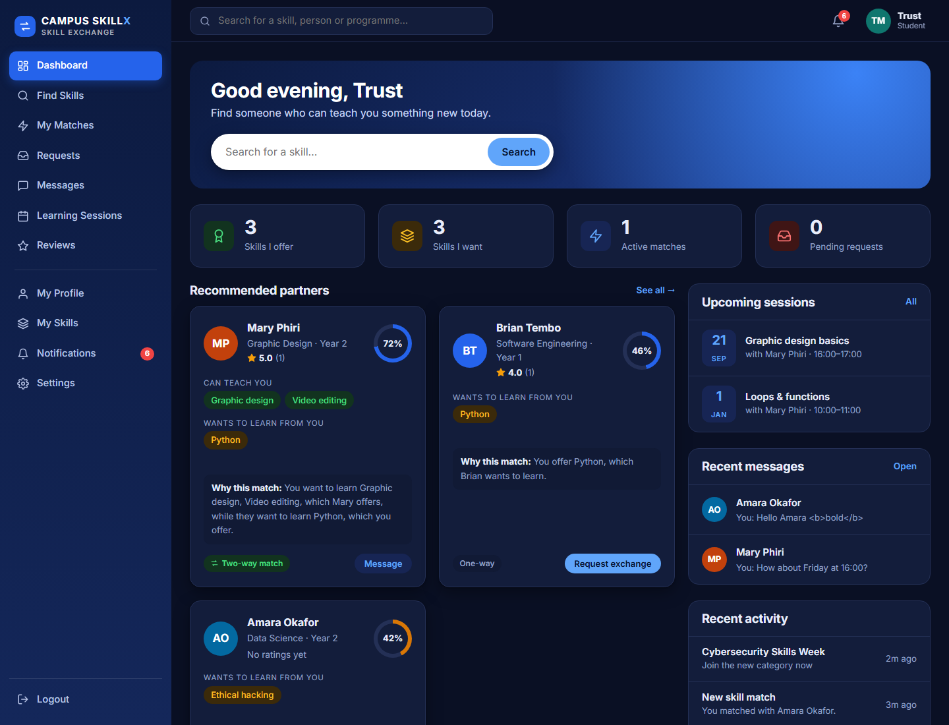
Figure 1 — Student dashboard: statistics, recommended partners with “Why this match”, sessions, messages and activity.
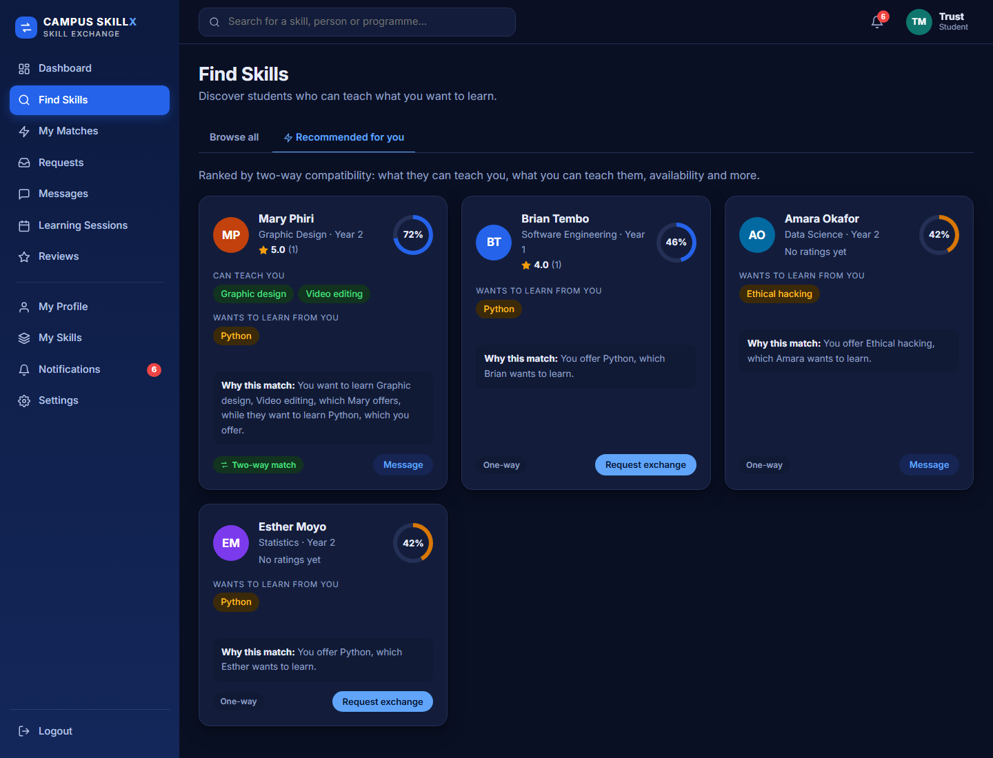
Figure 2 — Find Skills, Recommended tab: compatibility ring and explanation on every card.
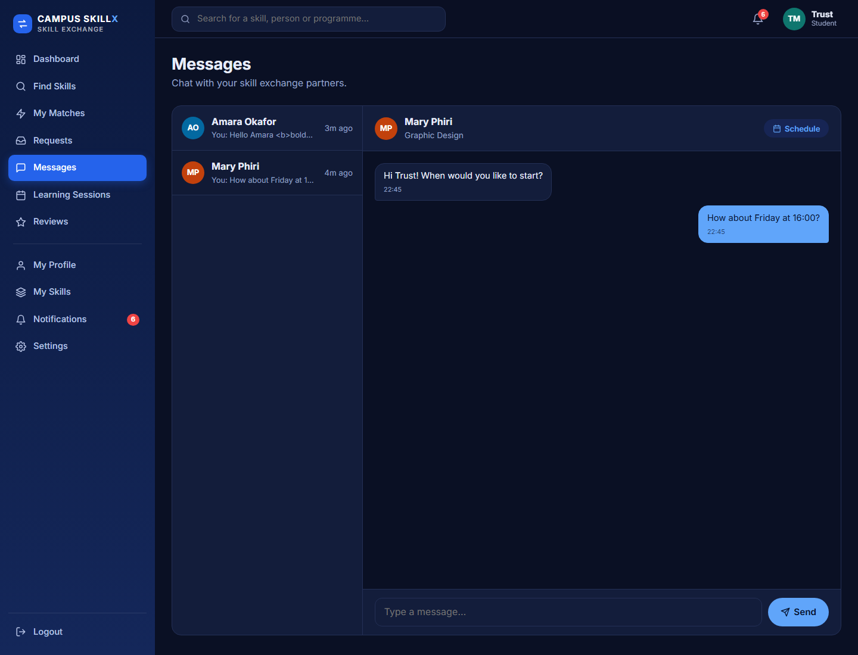
Figure 3 — Messages: conversation list and chat with a matched partner.
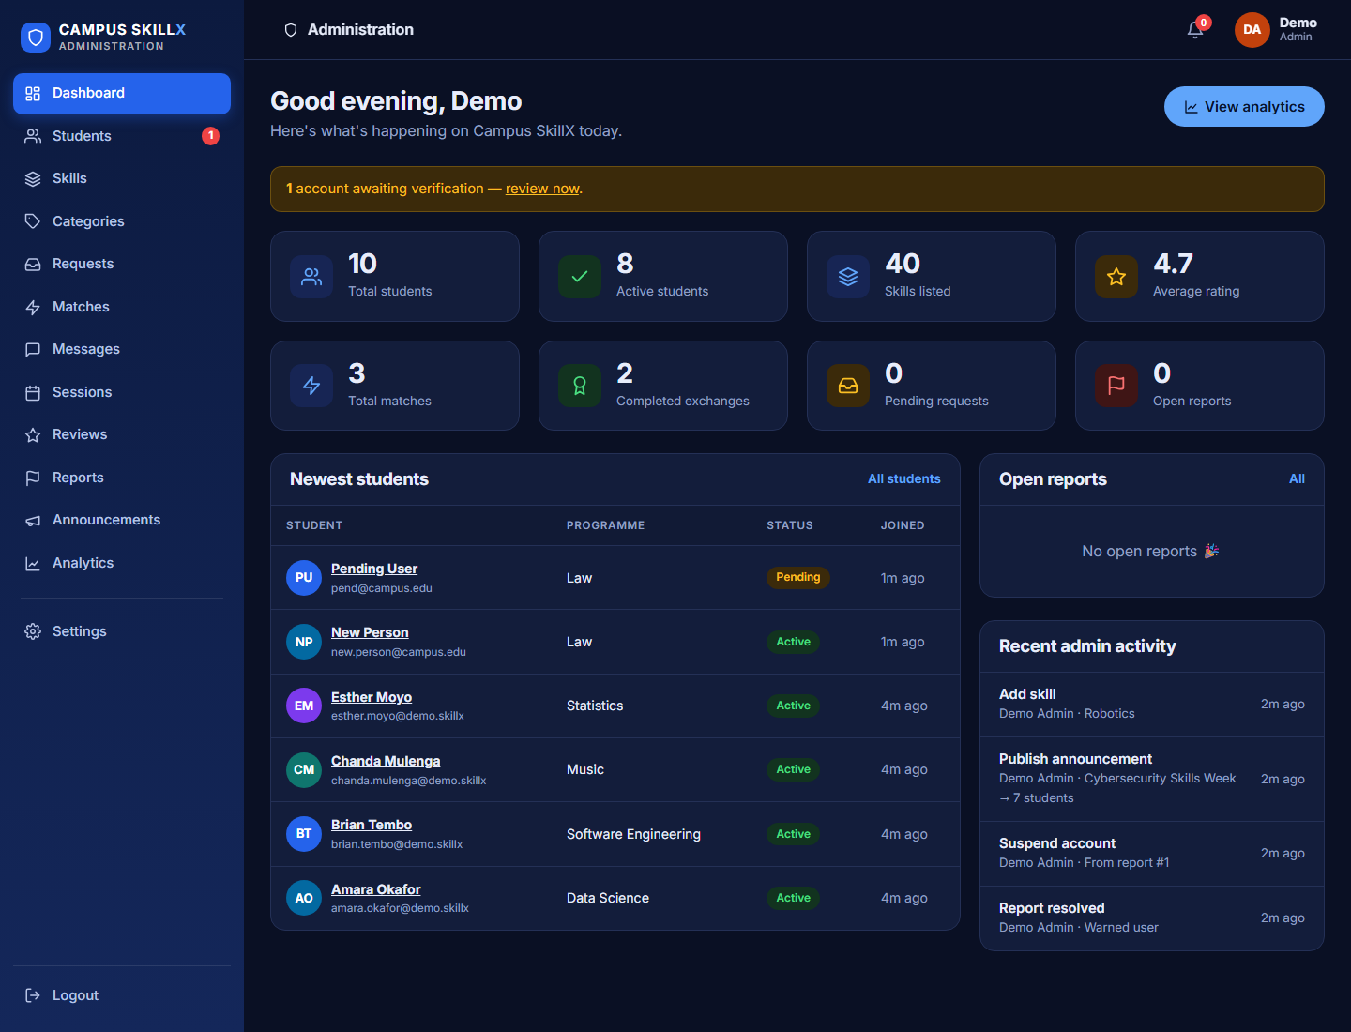
Figure 4 — Administrator dashboard: key numbers, alerts, newest students and audit activity.
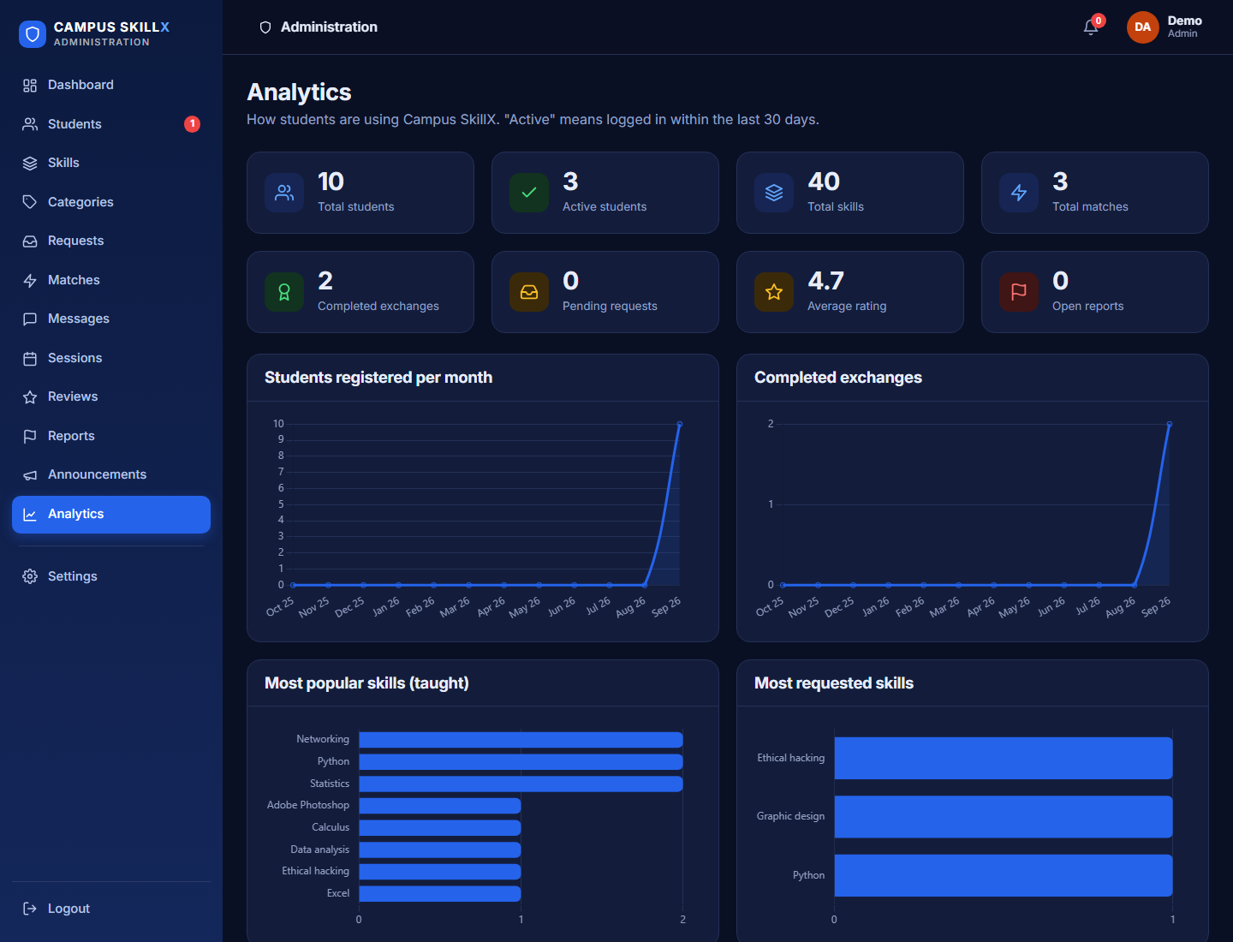
Figure 5 — Analytics: registrations, completed exchanges, popular and requested skills.

Appendix B — Demo accounts and reset commands
Development data only
These accounts exist only if you run the demo seed script. Never use it on a real deployment, and delete the demo accounts afterwards.

Account | Email / login | Password
Student (you) | trust.mwendabai@demo.skillx | Demo1234
Student | mary.phiri@demo.skillx | Demo1234
Student (has pending request) | amara.okafor@demo.skillx | Demo1234
Student | chanda.mulenga@demo.skillx | Demo1234
Administrator | admin@demo.skillx | Admin1234
Super administrator | super@demo.skillx | Admin1234

Reset the demo (before each rehearsal)
Run these three commands in a terminal. They rebuild the database and reload the demo data:
`C:\xampp\mysql\bin\mysql.exe -u root -e "DROP DATABASE IF EXISTS campus_skill_exchange"`
`C:\xampp\mysql\bin\mysql.exe -u root < database\campus_skill_exchange.sql`
`C:\xampp\php\php.exe database\seed-demo.php --yes`
Run them from the project folder. To keep real data separate, set the environment variable DB_NAME to a different database name before running the seed.

Optional two-way request demo: log in as Amara and request Guitar from Chanda (offering SQL), then log in as Chanda and accept — a natural two-way match, because Chanda wants SQL and Amara wants Guitar.

Appendix C — Glossary
Term | Meaning
PHP | The server-side programming language that runs the application logic.
MySQL / MariaDB | The relational database that stores users, skills, requests and so on.
PDO | PHP Data Objects — a secure, consistent way for PHP to talk to a database.
Prepared statement | A database query where data is sent separately from the SQL command, which prevents SQL injection.
SQL injection | An attack where malicious text is inserted into a query to read or change data.
XSS (cross-site scripting) | An attack that makes a page run malicious script; prevented by escaping output.
CSRF | An attack that tricks a logged-in user’s browser into sending an unwanted request; prevented with secret tokens.
bcrypt / hashing | A one-way transformation of a password so the original cannot be recovered from the database.
Session | Server-side memory of who is logged in, linked to a cookie in the browser.
Transaction | A group of database steps that all succeed or all fail together.
Foreign key | A database rule that links a row to a row in another table and keeps them consistent.
API / JSON endpoint | A URL that returns data (not a full page) for JavaScript to use.
AJAX / polling | JavaScript asking the server for updates in the background, here every few seconds for chat.
Compatibility score | The 0–100 rating of how well two students’ skills and availability complement each other.

