|  |  |  |  |  |  |
| --- | --- | --- | --- | --- | --- |
| IP ADDRESSING TABLE ---ROUTERS---- | | | | | |
| Router | Interface | IP Address | Subnet Mask | Default Gateway | VLAN |
| ISP_RT | G0/1 | 192.168.1.1 | 255.255.255.252 | N/A | N/A |
| S0/1/0 | 100.100.100.2 | 255.255.255.252 | N/A | N/A |
| S0/1/1 | 100.100.100.5 | 255.255.255.252 | N/A | N/A |
| BRANCH | G0/0 |  |  | N/A | N/A |
| G0/0.10 | 192.168.5.1 | 255.255.255.224 | N/A | N/A |
| G0/0.15 | 192.168.5.129 | 255.255.255.248 | N/A | N/A |
| G0/0.20 | 192.168.5.33 | 255.255.255.224 | N/A | N/A |
| G0/0.30 | 192.168.5.65 | 255.255.255.224 | N/A | N/A |
| S0/1/1 | 100.100.100.6 | 255.255.255.252 | N/A | N/A |
| HQ | G0/0 |  |  | N/A | N/A |
| G0/0.10 | 192.168.10.1 | 255.255.255.224 | N/A | N/A |
| G0/0.15 | 192.168.10.129 | 255.255.255.248 | N/A | N/A |
| G0/0.20 | 192.168.10.33 | 255.255.255.224 | N/A | N/A |
| G0/0.30 | 192.168.10.65 | 255.255.255.224 | N/A | N/A |
| G0/0.40 | 192.168.10.97 | 255.255.255.224 | N/A | N/A |
| S0/1/0 | 100.100.100.1 | 255.255.255.252 | N/A | N/A |
| S0/1/1 | 100.100.100.9 | 255.255.255.252 | N/A | N/A |
| DEFAULT | G0/1 | 100.100.100.17 | 255.255.255.252 | N/A | N/A |
| S0/1/0 | 100.100.100.13 | 255.255.255.252 | N/A | N/A |
| S0/1/1 | 100.100.100.10 | 255.255.255.252 | N/A | N/A |
| REMOTE | G0/1 | 192.168.10.137 | 255.255.255.248 | N/A | N/A |
| S0/1/0 | 100.100.100.14 | 255.255.255.252 | N/A | N/A |

IP ADDRESSING TABLE

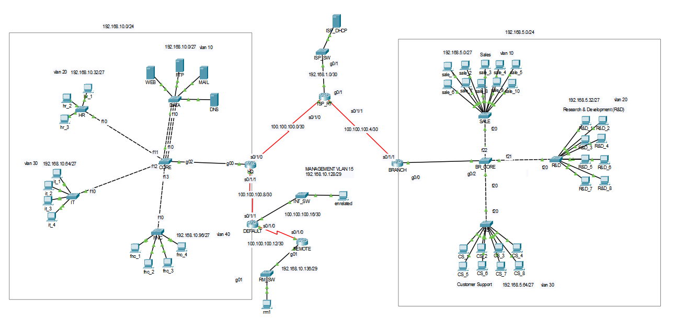

|  |  |  |  |  |  |
| --- | --- | --- | --- | --- | --- |
| IP ADDRESSING TABLE ---PC-SERVER---- | | | | | |
| VLANS | PC | IP Address | Subnet Mask | Default Gateway | DNS |
| -- | ISP_DHCP | 192.168.1.2(M) | 255.255.255.252 | 192.168.1.1 | N/A |
| BRANCH  VLAN 10  SALE | sale_1 | 192.168.5.2(M) | 255.255.255.224 | 192.168.5.1 | 192.168.1.2 |
| sale_2 | 192.168.5.3(M) | 255.255.255.224 | 192.168.5.1 | 192.168.10.8 |
| sale_3 | DHCP | 255.255.255.224 | 192.168.5.1 | 192.168.1.2 |
| sale_4 | DHCP | 255.255.255.224 | 192.168.5.1 | 192.168.1.2 |
| sale_5 | DHCP | 255.255.255.224 | 192.168.5.1 | 192.168.1.2 |
| sale_6 | DHCP | 255.255.255.224 | 192.168.5.1 | 192.168.1.2 |
| sale_7 | DHCP | 255.255.255.224 | 192.168.5.1 | 192.168.1.2 |
| sale_8 | DHCP | 255.255.255.224 | 192.168.5.1 | 192.168.1.2 |
| sale_9 | DHCP | 255.255.255.224 | 192.168.5.1 | 192.168.1.2 |
| sale_10 | DHCP | 255.255.255.224 | 192.168.5.1 | 192.168.1.2 |
| BRANCH  VLAN 20  Resarcher&  Development | R%D_1 | 192.168.5.34(M) | 255.255.255.224 | 192.168.5.33 | 192.168.1.2 |
| R%D_2 | DHCP | 255.255.255.224 | 192.168.5.33 | 192.168.1.2 |
| R%D_3 | DHCP | 255.255.255.248 | 192.168.5.33 | 192.168.1.2 |
| R%D_4 | DHCP | 255.255.255.224 | 192.168.5.33 | 192.168.1.2 |
| R%D_5 | DHCP | 255.255.255.224 | 192.168.5.33 | 192.168.1.2 |
| R%D_6 | DHCP | 255.255.255.224 | 192.168.5.33 | 192.168.1.2 |
| R%D_7 | DHCP | 255.255.255.224 | 192.168.5.33 | 192.168.1.2 |
| R%D_8 | DHCP | 255.255.255.224 | 192.168.5.33 | 192.168.1.2 |
| BRANCH  VLAN 30  Costumer  Support | CS_1 | 192.168.5.66(M) | 255.255.255.224 | 192.168.5.65 | 192.168.10.8 |
| CS_1 | DHCP | 255.255.255.224 | 192.168.5.65 | 192.168.1.2 |
| CS_1 | DHCP | 255.255.255.224 | 192.168.5.65 | 192.168.1.2 |
| CS_1 | DHCP | 255.255.255.224 | 192.168.5.65 | 192.168.1.2 |
| CS_1 | DHCP | 255.255.255.224 | 192.168.5.65 | 192.168.1.2 |
| CS_1 | DHCP | 255.255.255.224 | 192.168.5.65 | 192.168.1.2 |
| CS_1 | DHCP | 255.255.255.224 | 192.168.5.65 | 192.168.1.2 |
| CS_1 | DHCP | 255.255.255.224 | 192.168.5.65 | 192.168.1.2 |
| Core  VLAN 15  MANAGEMENT | DATA | 192.168.10.131 | 255.255.255.248 | 192.168.10.129 | N/A |
| HR | 192.168.10.132 | 255.255.255.248 | 192.168.10.129 | N/A |
| IT | 192.168.10.133 | 255.255.255.248 | 192.168.10.129 | N/A |
| CORE | 192.168.10.130 | 255.255.255.248 | 192.168.10.129 | N/A |
| FNC | 192.168.10.134 | 255.255.255.248 | 192.168.10.129 | N/A |
| -- | rm1 | 192.168.10.138 | 255.255.255.248 | 192.168.10.137 | 192.168.10.8 |
| -- | unrelated | 100.100.100.18 | 255.255.255.252 | 100.100.100.17 | 192.168.10.8 |
| CORE  VLAN 10  DATA | WEB | 192.168.10.5(M) | 255.255.255.224 | 192.168.10.1 | 192.168.10.8 |
| FTP | 192.168.10.6(M) | 255.255.255.224 | 192.168.10.1 | 192.168.10.8 |
| MAIL | 192.168.10.7(M) | 255.255.255.224 | 192.168.10.1 | 192.168.10.8 |
| DNS | 192.168.10.8(M) | 255.255.255.224 | 192.168.10.1 | 192.168.10.8 |
| CORE  VLAN 20  HR | hr_1 | 192.168.10.34(M) | 255.255.255.224 | 192.168.10.33 | 192.168.10.8 |
| hr_2 | DHCP | 255.255.255.224 | 192.168.10.33 | 192.168.10.8 |
| hr_3 | DHCP | 255.255.255.224 | 192.168.10.33 | 192.168.10.8 |
| CORE  VLAN 30  IT | İt_1 | 192.168.10.66(M) | 255.255.255.224 | 192.168.10.65 | 192.168.10.8 |
| İt_2 | DHCP | 255.255.255.224 | 192.168.10.65 | 192.168.10.8 |
| İt_3 | DHCP | 255.255.255.224 | 192.168.10.65 | 192.168.10.8 |
| İt_4 | DHCP | 255.255.255.224 | 192.168.10.65 | 192.168.10.8 |
| CORE  VLAN 40  FNC | fnc_1 | 192.168.10.98(M) | 255.255.255.224 | 192.168.10.97 | 192.168.10.8 |
| fnc_2 | DHCP | 255.255.255.224 | 192.168.10.97 | 192.168.10.8 |
| fnc_3 | DHCP | 255.255.255.224 | 192.168.10.97 | 192.168.10.8 |
| fnc_4 | DHCP | 255.255.255.224 | 192.168.10.97 | 192.168.10.8 |
| Branch  VLAN 15  MANAGEMENT | SALE | 192.168.5.131 | 255.255.255.248 | 192.168.5.129 | N/A |
| R&D | 192.168.5.132 | 255.255.255.248 | 192.168.5.129 | N/A |
| CS | 192.168.5.133 | 255.255.255.248 | 192.168.5.129 | N/A |
| BR_CORE | 192.168.5.130 | 255.255.255.248 | 192.168.5.129 | N/A |

(M) = is used to determine the device which is configured manually.

To Addition the vlans:  
There is also native vlans in topology:

There is an unsecure default vlan which is Vlan 1 so not to be exploided by someone I configured new native vlans which are:  
  
Core:  
Vlan 99

Branch:

Vlan 99

* 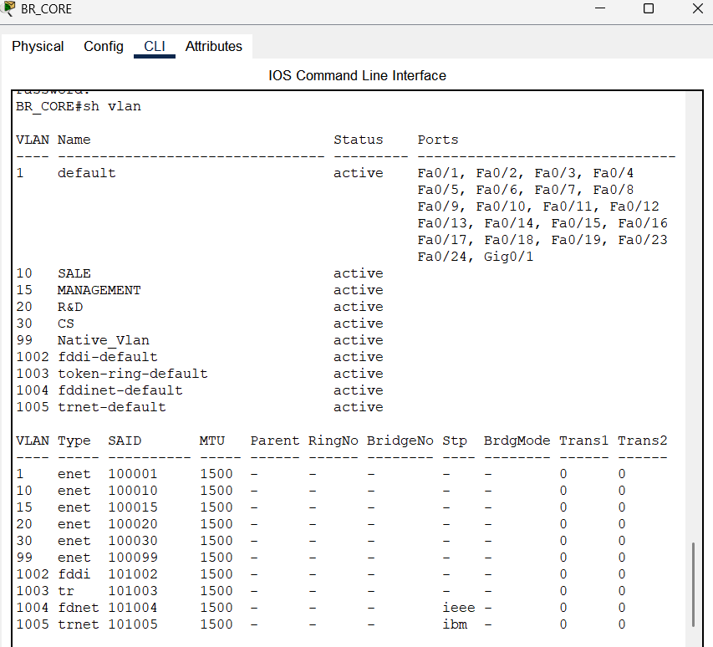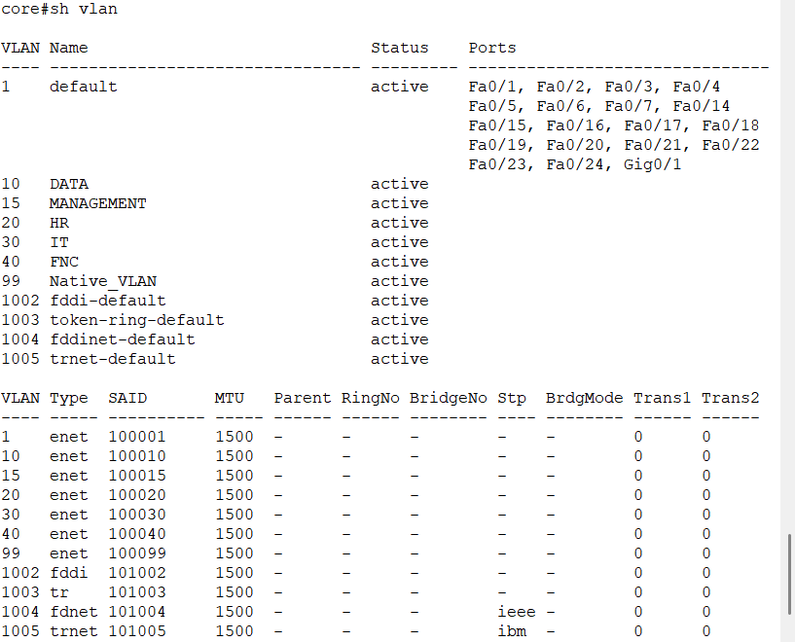Native vlan was configured in core and branch_sw to carry untagged traffic to the trunk port.  
    
    
  **Native VLAN images**  
  core br_core