**ROUTING TABLE**

AUTONOMOUS SYSYTEM (AS) **AS 10**

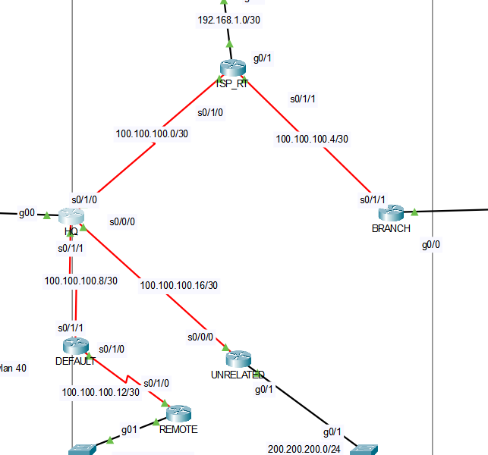

ALL of them in some AS, so when I configurate eigrp put them in a same AS and just indicate the networks around of routers. When I configure a router and if I assumed that router is part of internet then I route networks I could write “0.0.0.0 0.0.0.0 “and it means everywhere to everywhere.

|  |  |  |  |
| --- | --- | --- | --- |
| NETWORK ADDRESS | NETMASK | GATEWAY ADDRESS | INTERFACE |
| 192.168.10.0 | 255.255.255.224 | 192.168.10.1 | G0/0.10 |
| 192.168.10.32 | 255.255.255.224 | 192.168.10.33 | G0/0.20 |
| 192.168.10.64 | 255.255.255.224 | 192.168.10.65 | G0/0.30 |
| 192.168.10.96 | 255.255.255.224 | 192.168.10.97 | G0/0.40 |
| 192.168.5.0 | 255.255.255.224 | 192.168.5.1 | G0/0.10 |
| 192.168.5.32 | 255.255.255.224 | 192.168.5.33 | G0/0.20 |
| 192.168.5.64 | 255.255.255.224 | 192.168.5.65 | G0/0.30 |
| 192.168.10.128 | 255.255.255.224 | 192.168.10.129 | G0/1 |
| 200.200.200.0 | 255.255.255.0 | 200.200.200.1 | G0/1 |
| 100.100.100.0 | 255.255.255.252 | 100.100.100.1 | S0/1/0 |
| 100.100.100.4 | 255.255.255.252 | 100.100.100.1 | S0/1/1 |
| 100.100.100.8 | 255.255.255.252 | 100.100.100.1 | S0/1/1 |
| 100.100.100.12 | 255.255.255.252 | 100.100.100.1 | S0/1/0 |
| 100.100.100.16 | 255.255.255.252 | 100.100.100.1 | S0/0/0 |
| 192.168.1.0 | 255.255.255.252 | 192.168.1.1 | G0/1 |

There is id (1.1.1.1) AS, settling eigrp it looks like this.   
  
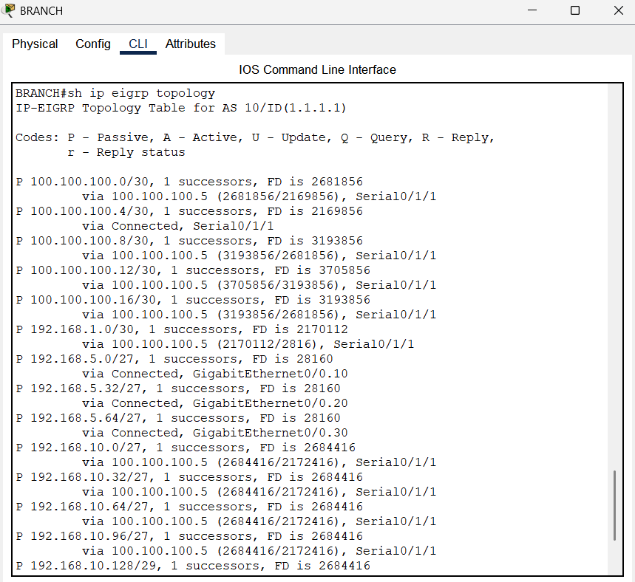

For example the first one says:  
I can connect 100.100.100.0/30 Network via 100.100.100.5 serial0/1/1

HQ -ip route-

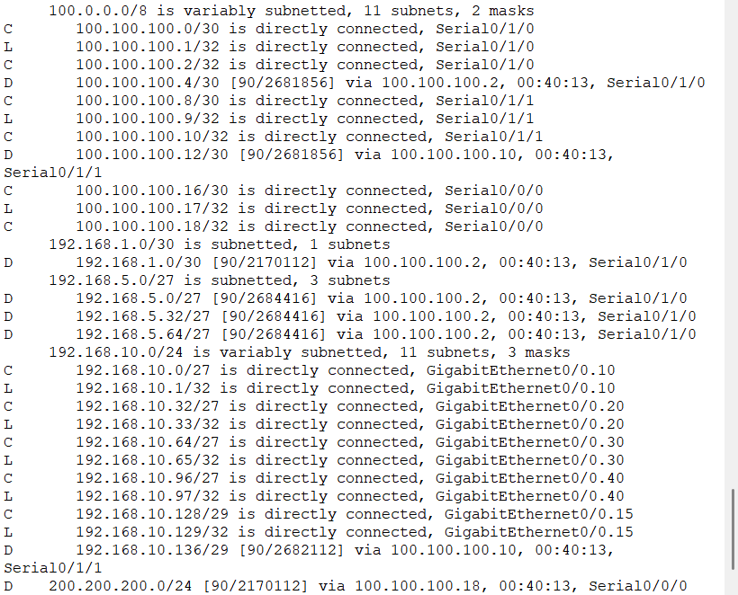

* The commends and explanation of them are given in Report.