pandas projects

Project1: Airbnb Data analysis

Airbnb is an online marketplace that connects people who want to rent out their homes with people looking for accommodations in that locale. NYC is the most populous city in the United States, and one of the most popular tourism and business places globally.
Since 2008, guests and hosts have used Airbnb to expand on traveling possibilities and present a more unique, personalized way of experiencing the world. Nowadays, Airbnb became one of a kind service that is used by the whole world. Data analysts become a crucial factor for the company that provided millions of listings through Airbnb. These listings generate a lot of data that can be analyzed and used for security, business decisions, understanding of customers’ and providers’ behavior on the platform, implementing innovative additional services, guiding marketing initiatives, and much more.

Load data set in pandas notebook

The dataset we use is “New York Airbnb Open Data” from Kaggle. Using Pandas Library, we’ll load the CSV file. Named it with nyc_df for the dataset.

2. Data Profiling and Cleansing

3: cheak all relationship within data

4:Exploration Data and Visualizing
Now time to explore our data and visualize it to recognize the relationship between the dataset. You can use matplotlib and seaborn and get pie plot as well as

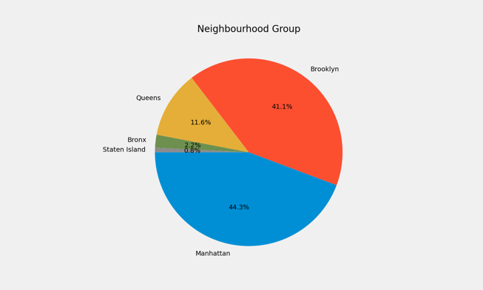

………
below question not required to do

5:Put linear regression using pyspark

X = nyc_df[['host_id','neighbourhood_group','neighbourhood','latitude','longitude','room_type','minimum_nights','number_of_reviews','reviews_per_month','calculated_host_listings_count','availability_365']]

Y feature will be
y = nyc_df['price']

All above will be using pyspark

