AI-Based Menu Recommendation System
Case study: Camelia Restaurant
Build-to-book handover document | Version 0.1 | 11 November 2026
Status: planning stage. Nothing described here has been built yet. Each section will be replaced with the real details as the system is built.

1. How to use this document
The project has two parts: the system, and the project paper (the book) that describes it. This document carries information from the first to the second. It follows the department’s Undergraduate Project Paper Guidelines, so that each chapter of the paper has the facts, diagrams and tables it needs from the system.
It gives facts, not finished chapters. The student writes each chapter in her own words and in the past tense, as the guidelines require. References such as “section 5.11” point to the numbered sections of the guidelines.

2. Who provides what
The table follows the order of the paper. Page limits are those set in the guidelines.
Part of the paper | Pages | The student writes | The developer provides
Preliminary pages | not set | Title page, declaration, dedication, acknowledgements, abstract, table of contents, lists of tables and figures | Meanings of the technical abbreviations used (API, JWT, TF-IDF and others)
Chapter 1: Introduction | 2–3 | Introduction, background of the restaurant, problem statement, objectives, justification | What the system covers and leaves out; technical risks and how each is handled; hardware, software and hosting used, with costs; build tasks and their durations for the schedule
Chapter 2: Literature review | 3–5 | The whole chapter | Names of the methods the system uses (section 4 below), so that the review covers the right topics
Chapter 3: Methodology | 4–5 | How facts were collected (interviews, questionnaire, observation, document review) and how the data was analysed | The development model followed; tools used to build and test the system; time schedule and project cost
Chapter 4: System analysis and requirement modelling | 8–10 | How the restaurant works today, with a flowchart; findings from the data collected | Functional and non-functional requirements; use case diagram; data flow diagrams of the new system
Chapter 5: System design | 7–10 | Explanation of each design | Architecture diagram; database design at three levels (conceptual ER diagram, logical tables, physical data dictionary); flowchart of the recommendation process; screen designs
Chapter 6: System implementation | 3–4 | Proposed change-over technique | Tools used for coding and testing, with version numbers; system test plan; test cases with the test data and results; screenshots of the working system
Chapter 7: Limitations, conclusions and recommendations | 1–2 | The whole chapter | Technical limitations met during the build; improvements for the future
References | 1–2 | Reference list in the Harvard system | Official documentation of each tool, to cite
Appendix | 10–20 | Organisational structure of the restaurant; questionnaire and interview guide; Gantt chart and network diagram showing the critical path | Four pages of the most important code; technical guide; user manual

Three points follow from the guidelines:
- Chapters 4, 5 and 6 rest on the system. Together they take 18 to 24 of the 28 to 39 chapter pages.
- Page budget. The chapter minimums add up to 28 pages and the maximums to 39, while the main document must have 35 to 50 pages (section 4.0). Every chapter therefore needs to be near its upper limit.
- Code in the appendix. Section 4.0 asks for at least four pages of code and section 5.16 allows at most four, so the appendix carries exactly four.

3. What the system does
The system is a web application. Customers open it on their own phones by scanning a QR code or following a link; nothing is installed. The manager uses it from a laptop or tablet.
The customer can:
- Browse the menu by category, with photos, prices and descriptions, and search or filter it
- Answer a short set of questions on diet, allergies, favourite kinds of food, spice level and budget
- See a “Recommended for you” list, where each dish shows the reason it was suggested
- See “Goes well with” suggestions beside each dish
- Rate dishes from one to five stars and save favourites
- Send a simple order with a table number (no payment)
The restaurant manager can:
- Sign in to a protected management area
- Add, change and remove dishes, with category, price, photo, ingredients and dietary labels, and mark a dish as unavailable
- See incoming orders and customer ratings
- View a dashboard of the most ordered dishes, the best rated dishes and how often suggestions are accepted
- Retrain the recommendation model and see its accuracy measures
Optional additions, only if time allows:
- A chat assistant: the customer describes what they feel like eating and receives suggestions from the menu
- Kinyarwanda and French versions of the screens
- A screen for waiters or the kitchen
Not covered: online or Mobile Money payment, delivery, stock control, a native Android or iOS app, and management of more than one branch. These belong in the scope and limitation section of Chapter 1.
This list is a proposal. It must agree with the objectives in the approved project proposal; where the two differ, the proposal is followed.

4. How the recommendation works
The system uses a hybrid recommender: several methods working together, so that each covers a weakness of the others. A request for suggestions passes through five steps.
- Rules first. Dishes that are unavailable, that break the customer’s diet or allergy limits, or that cost more than the budget are removed. These are fixed rules, not learned ones, because a mistake about an allergy is not acceptable.
- Content-based filtering. Every dish is described by its category, ingredients, taste and price band. The system compares these descriptions with the customer’s taste profile, built from the questions answered and the dishes rated highly, and scores how well each dish matches. Techniques: TF-IDF vectors and cosine similarity.
- Collaborative filtering. The system looks at the ratings and orders of all customers and finds dishes that tend to be liked by the same people. Technique: item-based collaborative filtering.
- Popularity and time of day. The system counts what is ordered most at breakfast, lunch and dinner. This serves new customers who have no history yet, a difficulty the literature calls the cold-start problem.
- Combined score. The three scores are added with weights. A new customer is served mostly by steps 2 and 4; as ratings build up, step 3 gains weight. The highest-scoring dishes are shown, each with a short reason such as “because you liked …”.
“Goes well with” suggestions come from a separate method, association rules, which finds dishes that are often ordered together.
Measuring quality. Two checks are planned. In the first, part of the collected ratings is hidden from the model, and the model is tested on whether its top suggestions include dishes those customers really rated highly (measures: Precision@K and Recall@K). In the second, real customers and staff try the system and answer a short acceptance questionnaire. Both sets of results go into Chapter 6.
Data the model learns from. The restaurant’s menu; ratings from the customer questionnaire; orders and ratings recorded once the system is in use. If there is too little real data, simulated data will be added for testing, and the paper will state clearly which results come from real data and which from simulated data.
Topics for Chapter 2. Recommender systems in general; content-based filtering; collaborative filtering; hybrid recommenders; the cold-start problem; association rule mining; how recommenders are evaluated; recommendation of food and restaurant menus; similar existing systems.

5. Architecture and hosting
Figure 1 shows the planned structure. It has three layers, a common arrangement for web systems.
- The presentation layer is the part people see. It runs in the web browser of the customer’s phone or the manager’s laptop.
- The application layer is the server. It receives each request, checks who is asking and what they may do, reads and writes the records, and runs the recommendation engine.
- The data layer keeps the records in the database and the dish photos in an image store.
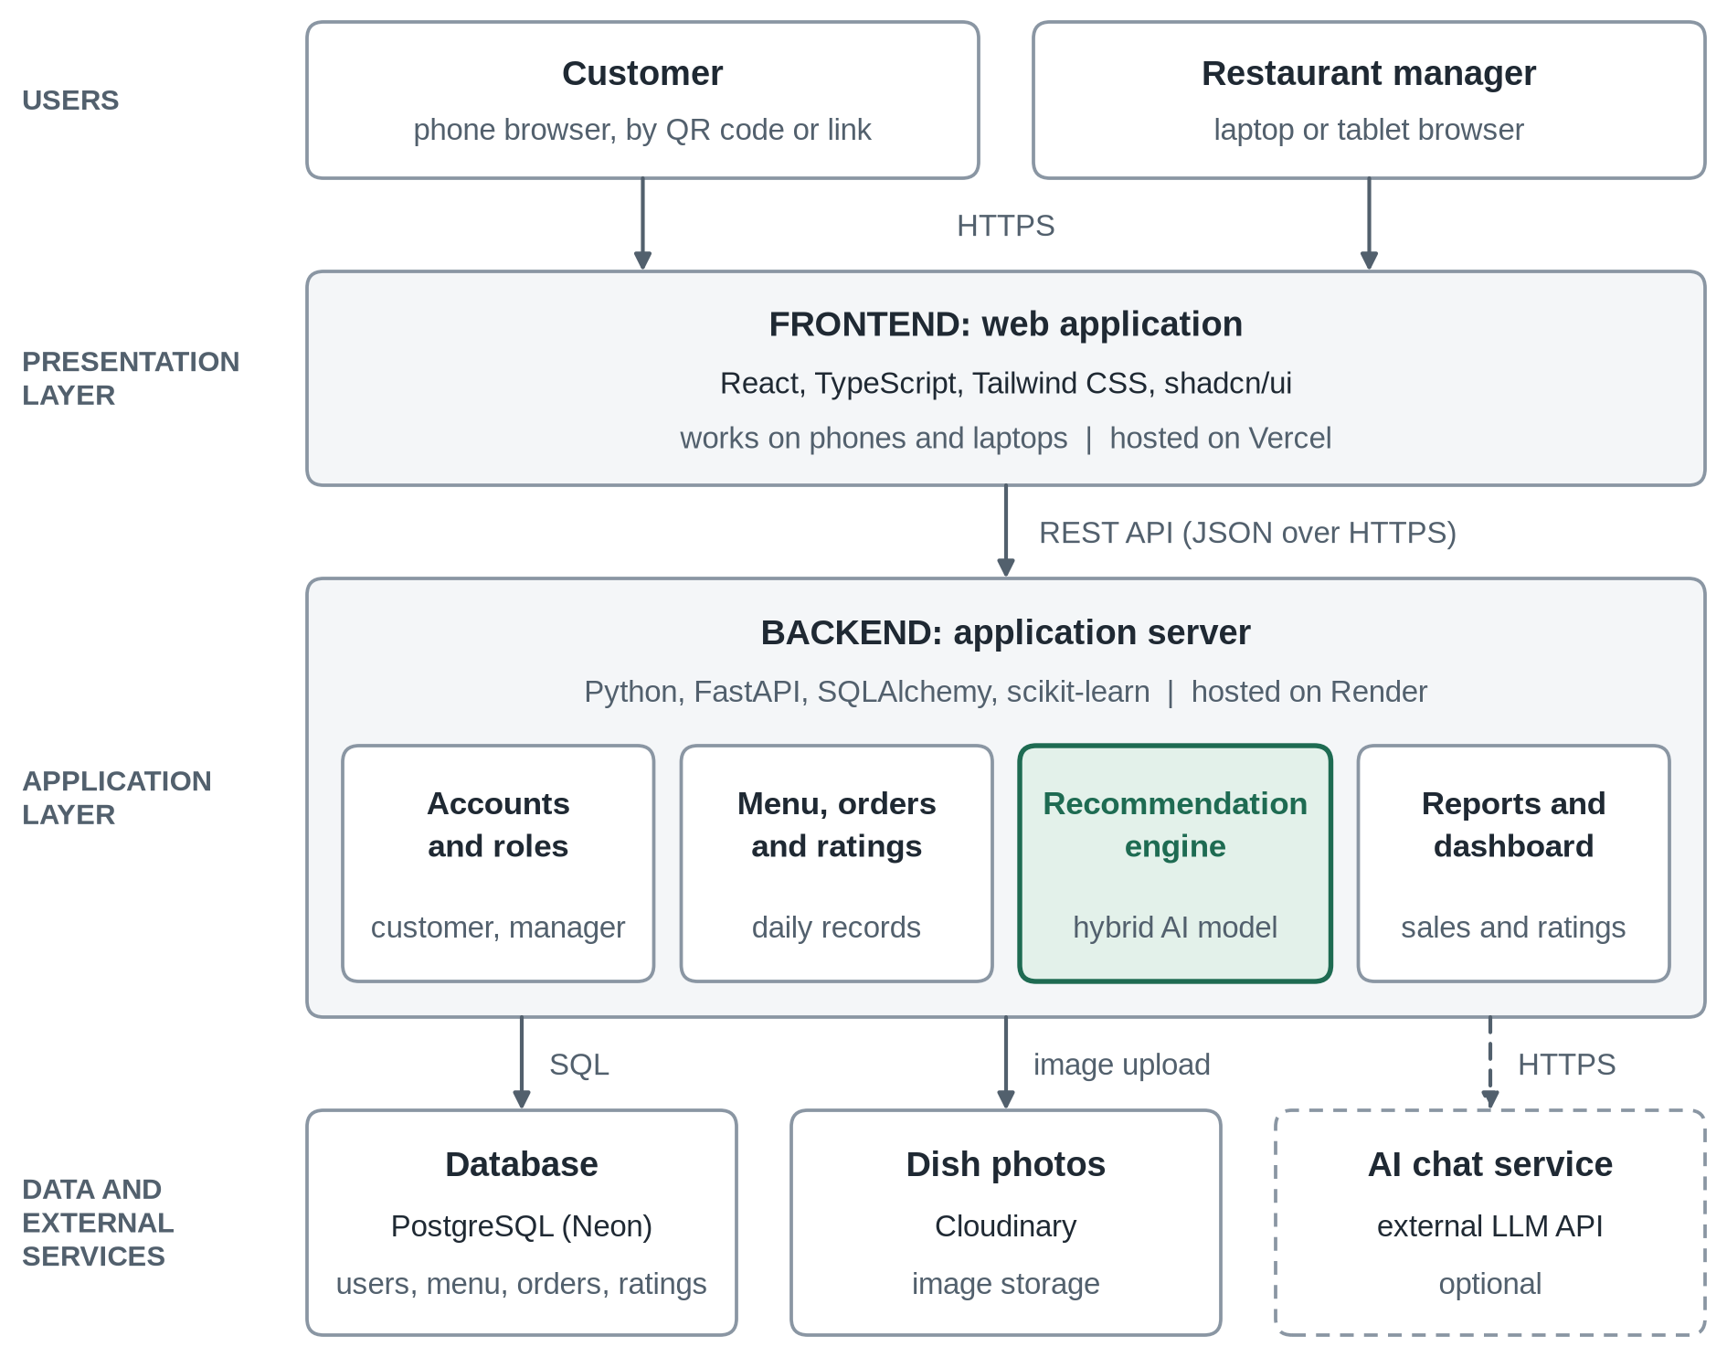
Figure 1: Planned system architecture
Hosting. The screens will be hosted on Vercel, the server on Render, the database on Neon and the photos on Cloudinary. Each offered a free plan when this document was written. A complete copy will also run on a laptop without the internet, as a safeguard for the system demonstration; the same copy serves as the softcopy of the system that must be submitted (section 8.0).

6. Technology stack
These are the planned tools. Exact version numbers will be added once each tool is installed, for use in Chapters 3 and 6.
Layer | Tool | Reason for the choice
Screens (frontend) | React with TypeScript, built with Vite | Widely used and well documented; gives a fast single-page web application
Appearance and charts | Tailwind CSS with shadcn/ui components; Recharts for charts | Consistent, professional screens on phones and laptops; dashboard charts
Server (backend) | Python with FastAPI | The same language as the machine-learning libraries, so one server handles both; produces its own API documentation
Recommendation engine | pandas and scikit-learn | Free, standard machine-learning libraries; every method used can be explained and tested
Database | PostgreSQL, with the SQLAlchemy and Alembic libraries | A relational database, which suits the ER diagram and table designs required in Chapter 5
Sign-in and access | Hashed passwords, JSON Web Tokens (JWT) and user roles | Customers and the manager see only what their role allows
Testing | pytest for the server; Vitest for the screens | Provide the test cases and results for Chapter 6
Source code | Git and GitHub | Keeps the history of the work and supplies the softcopy of the system
Diagrams | draw.io (diagrams.net) | Flowcharts, data flow, use case and ER diagrams
Hosting | Vercel, Render, Neon and Cloudinary | Free plans at the time of writing; described in section 5

7. What the build needs from the student
The work also flows the other way. The system cannot be built without information from the restaurant, and the same information is the raw material for Chapters 1, 3 and 4. Items 1 to 4 are needed before building starts.
No. | What is needed | What it is used for
1 | The approved project proposal, with its objectives and scope, and the submission deadline | Keeping the system and the paper in agreement; dates for section 8
2 | A contact person at the restaurant, and permission to collect information | Access to the menu, staff and customers
3 | The full menu: name of each dish, category, price, description, main ingredients and dietary information | Loaded into the system; the basis of content-based filtering
4 | A description of how customers choose and order today, and who advises them | Flowchart of the current system (Chapter 4); problem statement (Chapter 1)
5 | Photos of the dishes, or permission to take them | Menu screens
6 | Interviews with the manager and waiters | Requirements and findings (Chapter 4)
7 | A customer questionnaire: food preferences, and ratings of dishes already tried | Findings (Chapter 4); first data for training the model
8 | Sales records, if the restaurant agrees, with no customer names | Popularity scores and “Goes well with” suggestions
9 | The organisational structure of the restaurant | Appendix (section 5.16)

8. Order of work
The build is planned in six stages. The last column shows which parts of the paper can be written once a stage is finished, so that writing does not wait until the end. Dates will be added when the submission deadline is known.
Stage | What is done | What can then be written
1. Fieldwork and setup | Information collected from the restaurant; requirements agreed; project set up | Chapters 1 to 3; the current-system part of Chapter 4
2. Menu and management | Database, sign-in and the manager’s menu screens | Requirements and diagrams in Chapter 4; database design in Chapter 5
3. Customer screens | Menu browsing, preference questions, ratings and orders | Screen designs in Chapter 5
4. Recommendation engine | The hybrid model, “Goes well with” suggestions and the quality checks | Recommendation design in Chapter 5
5. Testing and hosting | Tests with real users; system placed online | Chapter 6
6. Handover | Final diagrams, screenshots, code extracts, user manual and technical guide | Chapter 7 and the appendix; practice for the demonstration

9. Points to confirm with the supervisor
- Outside help. How much technical help from another person is allowed, and how it should be acknowledged. The declaration (Appendix B of the guidelines) states that the project is the student’s original work, and she presents and demonstrates the system herself, for 40 of the 100 marks (section 9.0). She therefore needs to take part in the build closely enough to explain every screen and every step of section 4.
- Version of the guidelines. The copy used here is dated August 2012. Ask whether a newer version applies, since papers that depart from the required format are rejected (section 9.0).
- Length. Section 1.0 asks for 15,000 words, while the chapter page limits total 39 pages at most. Ask which measure the coordinator checks.
- Name of the restaurant. The spelling on the title page must match the approved proposal and the name the restaurant itself uses.
- Development model. Whether a particular model is preferred for Chapter 3. The stages in section 8 fit an iterative (Agile) model.
- Simulated data. Whether simulated data may be used beside real data, provided the paper declares it.

