Exercise 1 Step 2

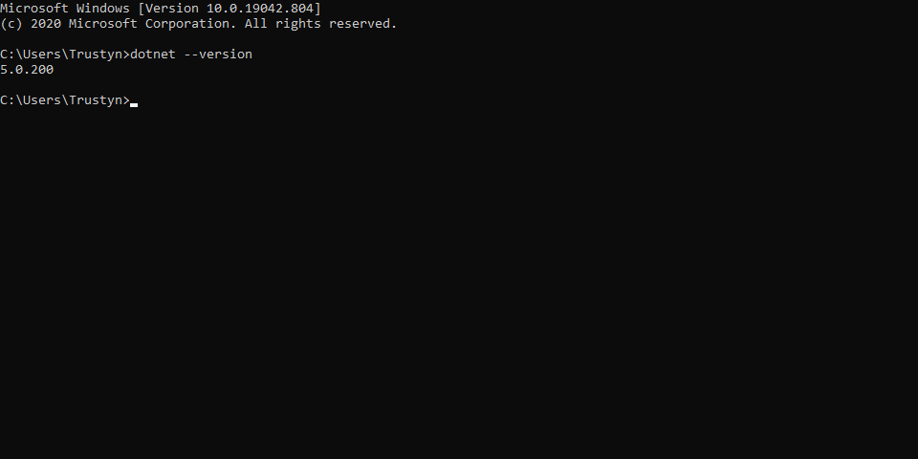

Exercise 1 Step 3

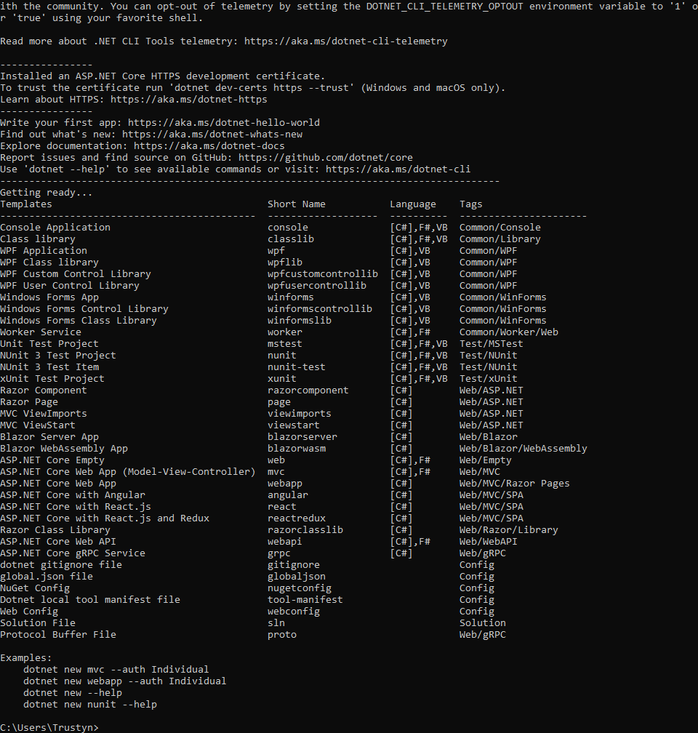

Exercise 3 Step 7

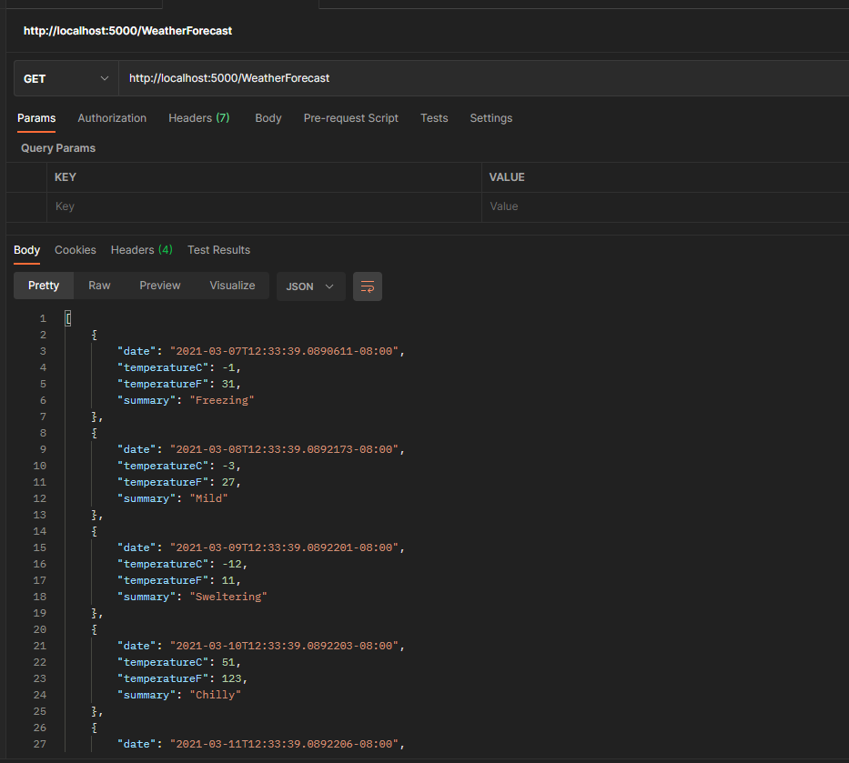

Exercise 3 Step 8

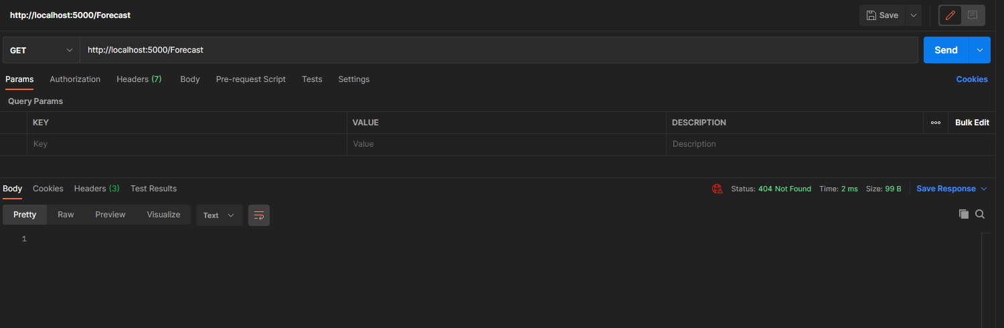

Exercise 4 Step 5 STUDENT

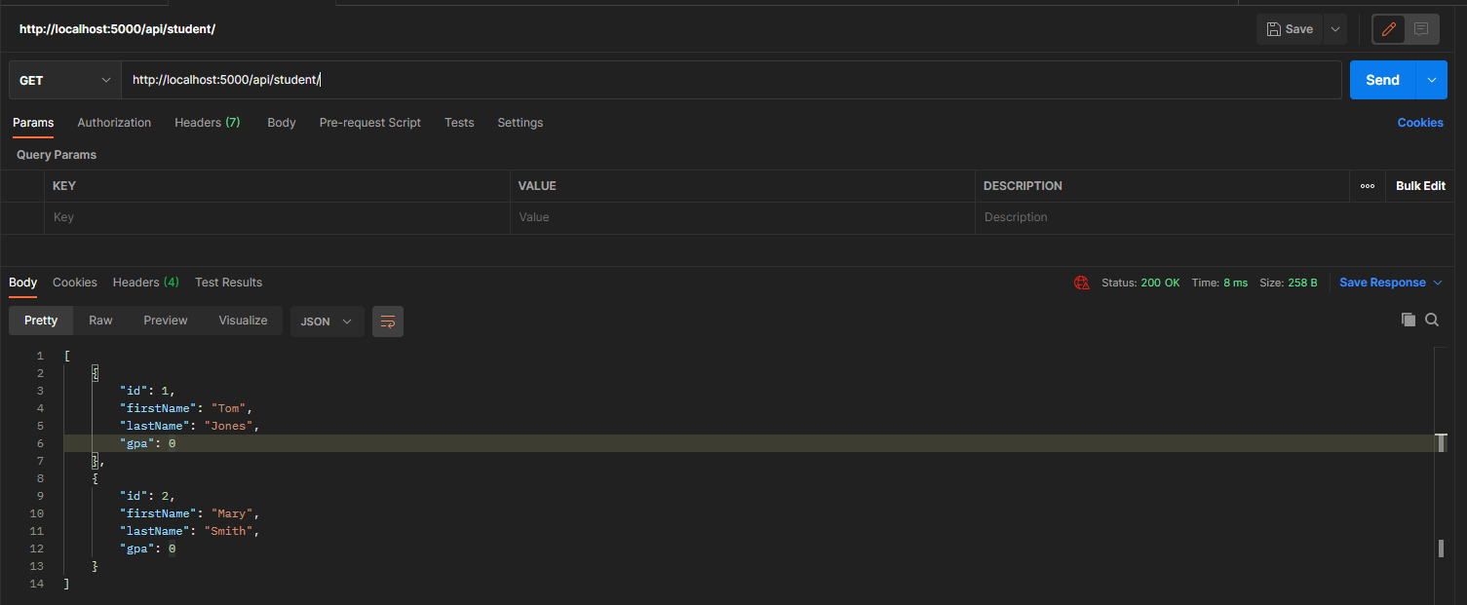

Exercise 4 Step 5 INSTRUCTOR

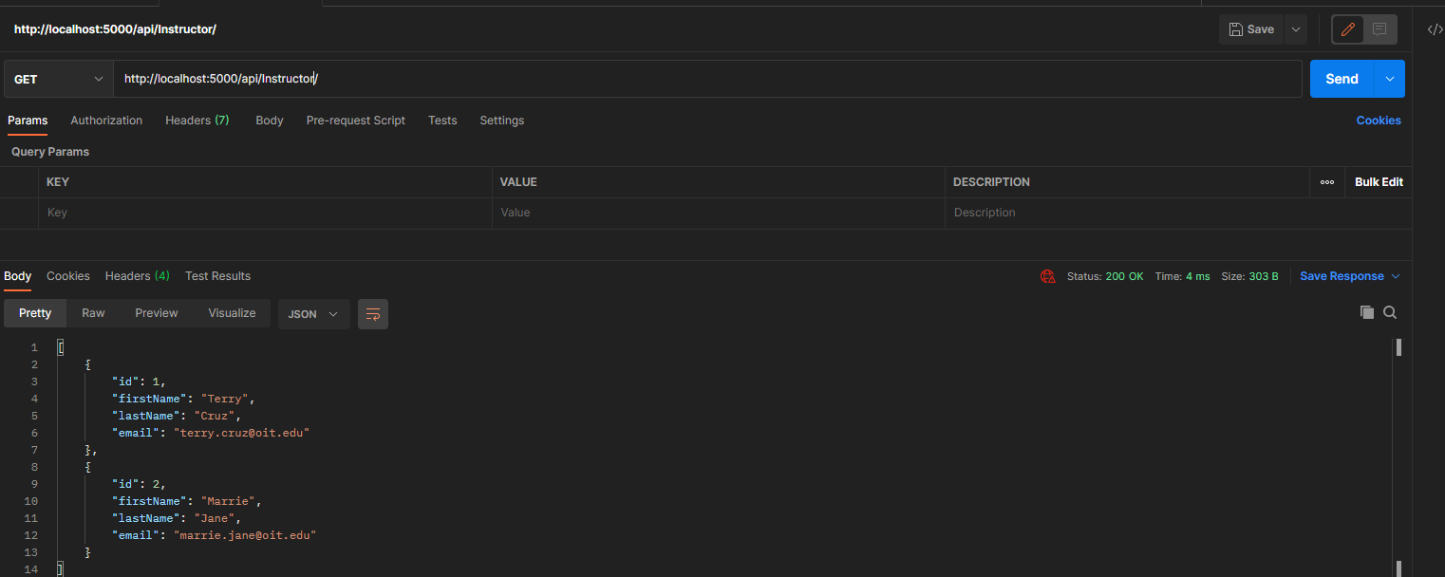

Exercise 5 Step 4

