Exercise 1 Step 7

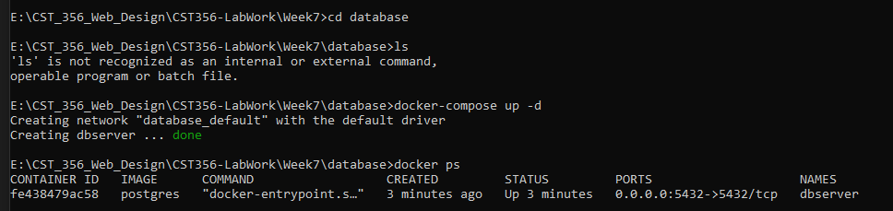

Exercise 1 Step 8

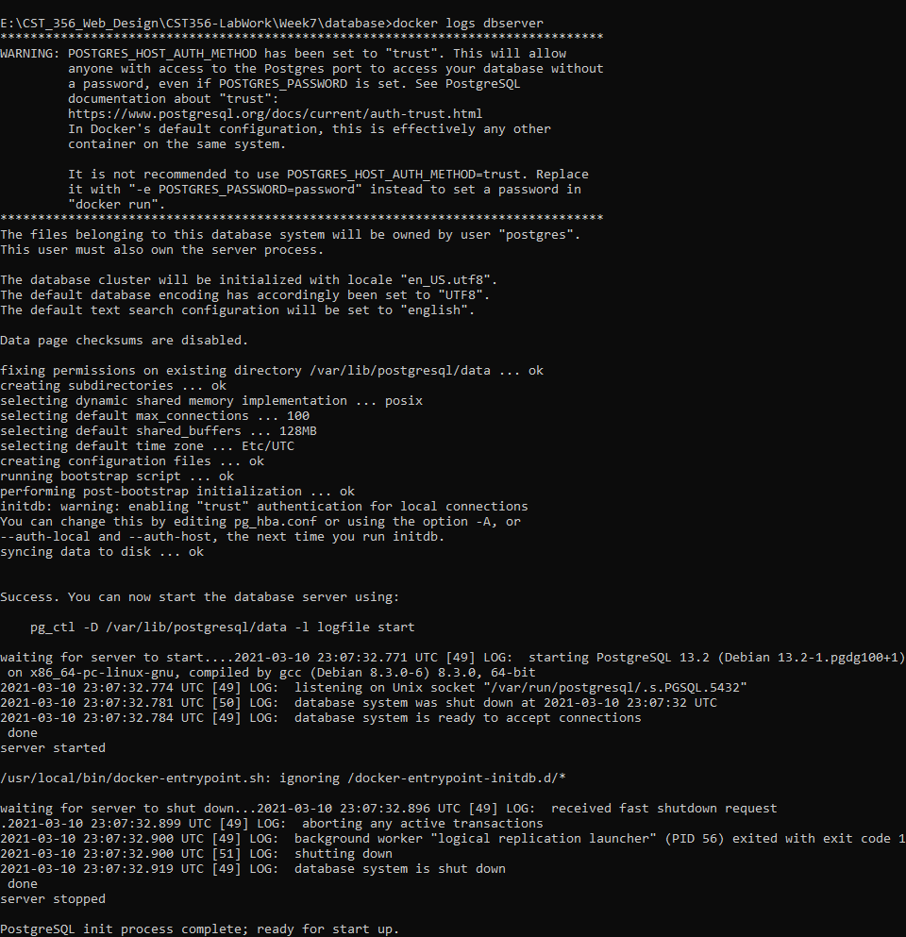

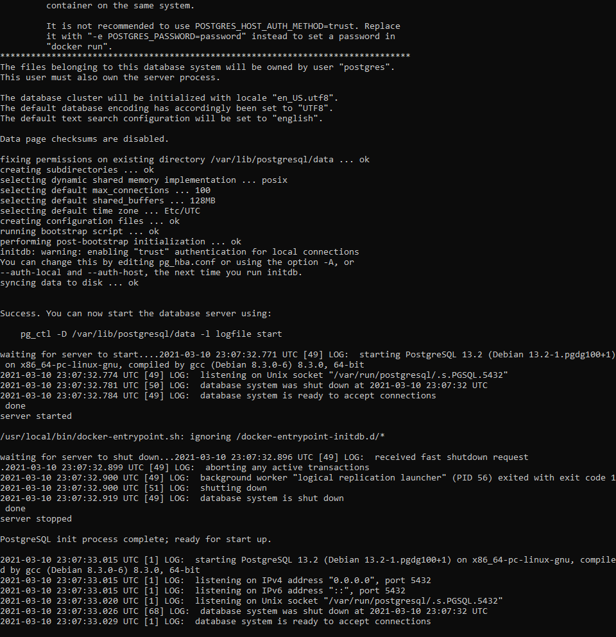

Exercise 1 Step 10

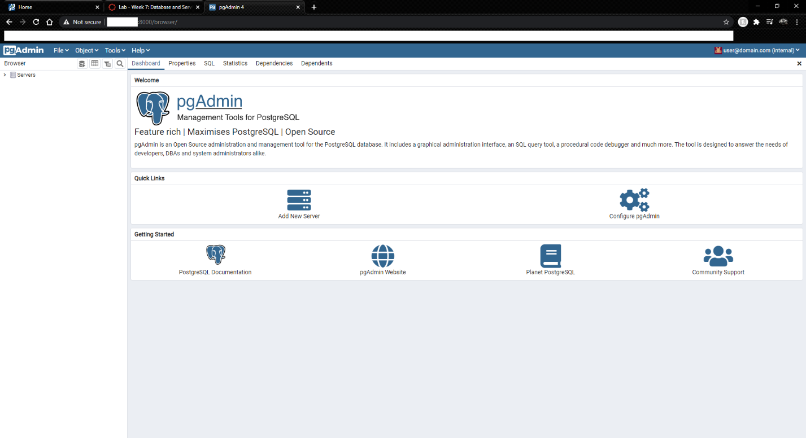

Exercise 4 Step 7

