电子书

<https://weston-embedded.com/micrium-books>

移植版本下载：

<https://weston-embedded.com/micrium-examples>

选择Microsoft🡪Visual Studio2017

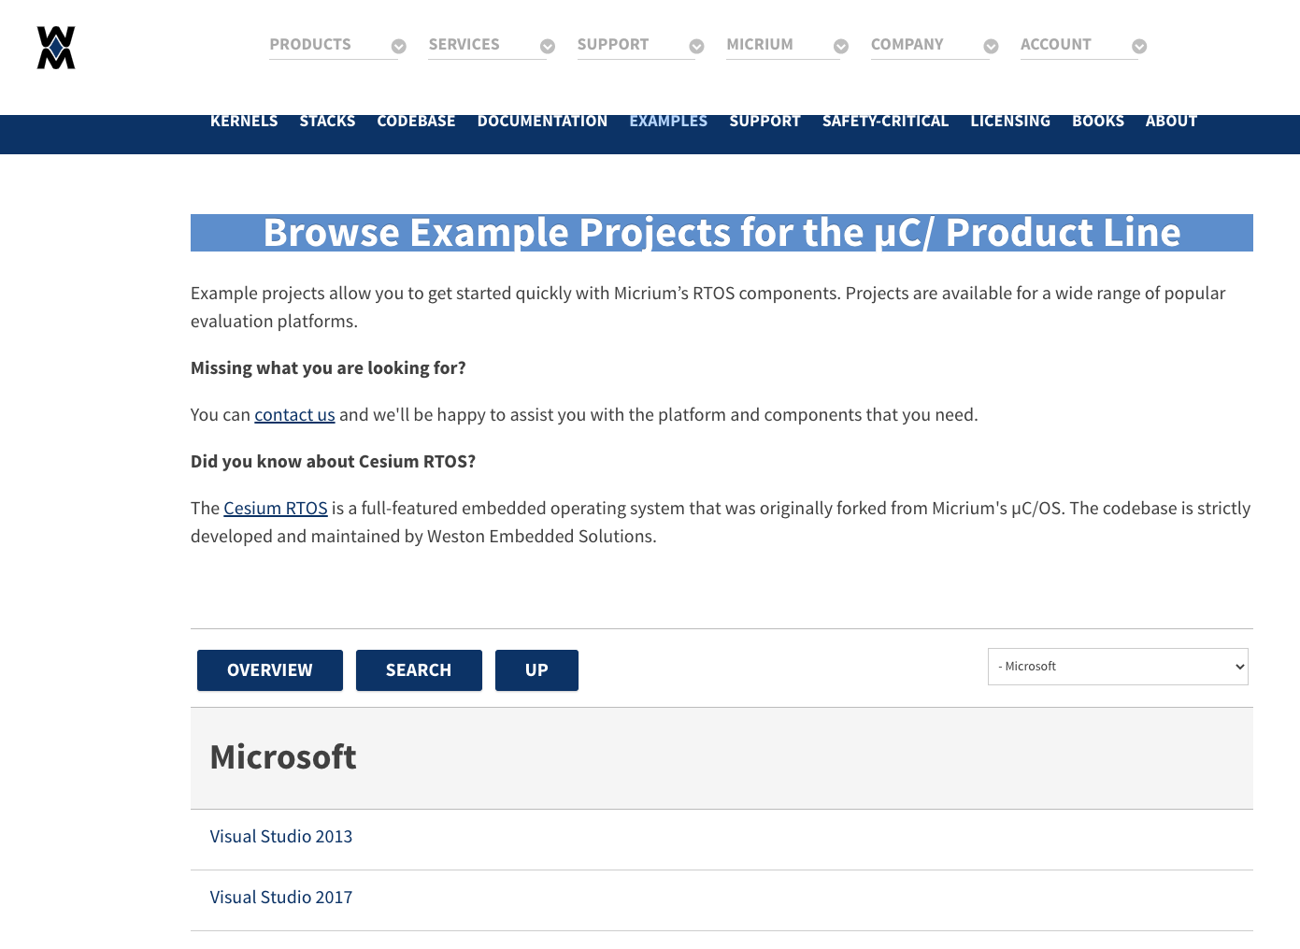

https://weston-embedded.com/micrium-examples/category/91-visual-studio-2017

解压后看readme，工程文件位于

- Microsoft/Windows/Kernel/OS2/VS/OS2.sln