Protocols

## HTTP

HyperText Transfer Protocol is used by the web that is used to send requests to web servers for web elements, HTTP is used by most websites which connects the user with the clients. Once the request has been made by the user they get disconnected from the client. HTTP isn’t as secure as HTTPS.

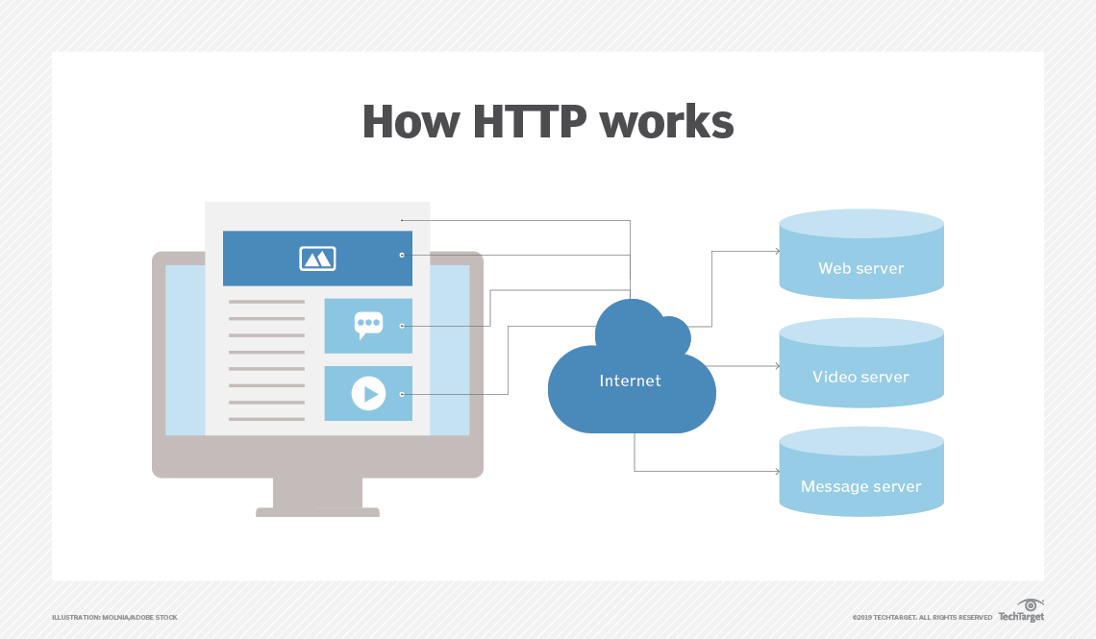

### 

### 

## VOIP

## Is short for Voice over Internet Protocol. VOIP is a method using software and hardware that enables the user to send voice data in packets using the internet as a transmission medium. Skype, whatsapp and facebook are examples of internet media that use VOIP.

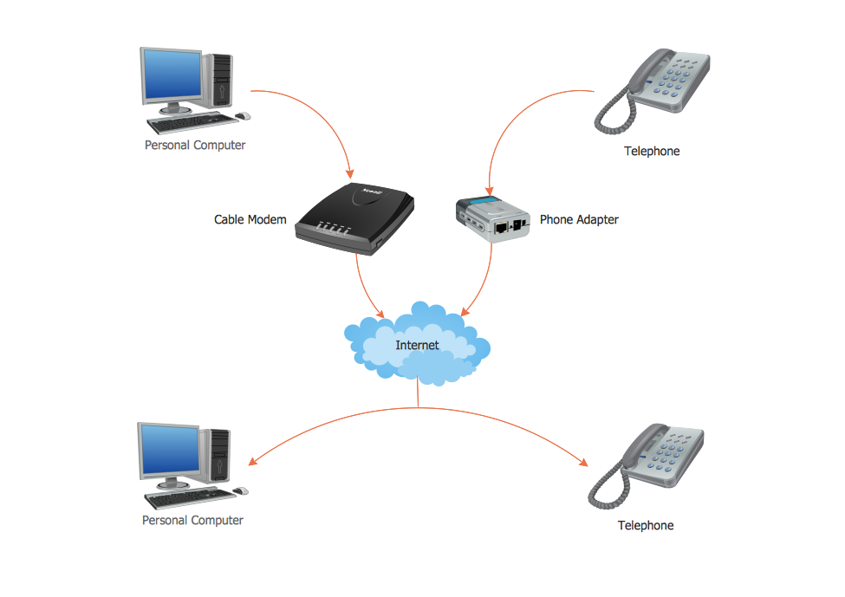

## 

## 

## TCP (IP)

Transmission Control Protocol is one of the main protocols of the internet protocol suite. TCP is the main form of communicating bytes with applications through an IP Network. TCP is used with major internet sites and applications such as the World Wide Web, Emails and Transferring files. TCP is connection orientated which requires a reliable connection/data stream between 2 users. TCP also has vulnerabilities which leave it subject to attacks such as DOS and Connection Hijacking. TCP can also be logged and interfered with using software such as a packet sniffer.

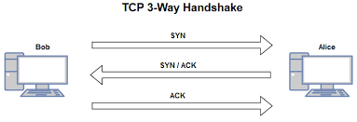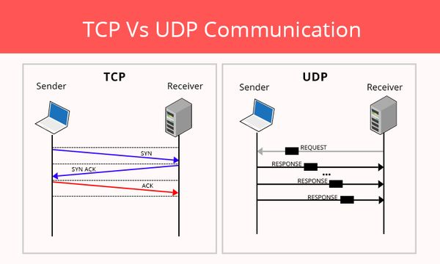

## 

## 

## UDP

User Datagram Protocol is an alternative to TCP but not quite the same, unlike TCP, UDP does not need a response/permission from the other user it is sending data too, it has no handshaking dialogues and exposes the users program to unreliability since there is no guarantee of delivery. UDP is sufficient when error-checking and correction are not necessary.

