Revision

**a) Briefly describe each of the following terms:**

**i. Stack** – an abstract data type

**ii. LIFO** – handles data structures, processed first = last, last = first

**iii. Queue** – ordered collection of items

**iv. FIFO** – processes stuff based on when they arrive

**v. push()** – adds more entries to a stack

**vi. removeFirst()** – removes first substring

**vii. Head** – clustering algorithm

**viii. Tail –** for data with heavy distribution

**ix. stackTop() –** used to reference the top or newest element of the stack

**x. Doubly Linked List** - a linked data structure that consists of a set of back-to-back nodes

**b) The merge sort algorithm unlike some other sorting algorithms is not an in-place sort. Describe what an in-place sort is with regard to implications on system resources.**

**ANS**: a sort algorithm in which the sorted items stay in the same storage as the original ones, most constant no. of items are kept in the auxiliary memory.

**c) Explain with a simple diagram how you would remove an element from a linked list**

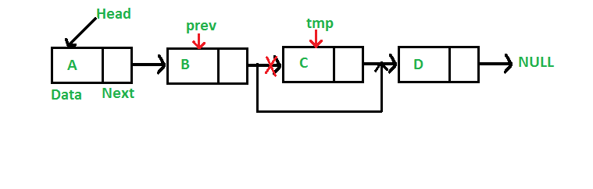

**d) Compare and contrast the Bubble Sort algorithm and the Selection Sort. Which is more efficient?**

Bubble sort takes an order of n time whereas selection sort consumes an order of n2 time

Selection sort is fast and efficient compared to bubble sort.

**e) With a standard bubble sort, how many comparisons are required**

**i. For an array with 5 elements -** 8

**ii. For an array with 10 elements –** 14

**b) With regard to Hash Tables, what is meant by the term collision?**

A collision occurs when two keys are hashed to the same index in a hash table

**d) What is the difference between a Linked List and an Array List?**

Array lists uses a dynamic array to store it’s elements, linked lists use doubly linked lists, array lists are slower than LinkedList

**c) What is the basic difference between a set and a map?**

The difference is a set is used to store only keys while a map stores key value pairs

**e) In the worst case scenario, what does a binary tree resemble?**

**O(logN)**

**d) Describe Recursion outlining the two conditions it must satisfy and provide some insight into how Recursion could be implemented correctly.**

A recursive algorithm must have a base case, it must call itself

**b) Briefly describe Tail recursion.**

A function that ends by returning the value of the recursive call.