Comp 2322 Computer Networking
Project Report: Multi-thread Web Server

LIU Sunyi
24133856d

1. Introduction

This project aims to implement a multi-threaded Web server by using Python socket programming. The server follows the HTTP protocol and is capable of handling requests from web browsers or other client programs. This implementation is completely developed from scratch based on the underlying socket API and does not rely on any built-in HTTP server libraries (such as HTTPServer) or web frameworks.

The server runs on the local IP address 127.0.0.1:8080 and supports basic HTTP functions, including request parsing, file retrieval, response generation, connection management, and concurrent request handling. The main objective of this project is to demonstrate practical understanding of HTTP communication, socket-based server design, and multi-threaded request processing in a computer network environment.

2. Design and Implementation Summary
2.1 Overall Architecture

This project adopts a modular design, dividing different functions into multiple independent files to enhance the maintainability and readability of the code. Among them, server.py serves as the core module, responsible for the overall operation logic of the server, including the creation, binding, listening of sockets, as well as the reception of client connections, and implementing multi-threading processing mechanism and response sending. The utils.py module encapsulates functions such as HTTP request parsing, response construction, file reading, path resolution, and cache judgment, making the main program logic clearer. The logger_util.py module is specifically used to record access logs, writing the information of each request into the log file. The server only allows access to files under the www/ directory and restricts the access scope through the path resolution mechanism, thereby effectively preventing directory traversal attacks.

2.2 Multi-threading Design

In order to support processing concurrently, two-layer multi-threaded structure is adopted. The main thread is responsible for listening for incoming client connection requests. When a new client is connecting, the server will create an independent connecting processing thread to manage this connection. In each connection, after a complete HTTP request is received, the server creates a request-processing thread to handle that request, which includes request parsing, file reading, and response construction. When the clients uses "Connection: keep-alive", the connection-handling thread does not close the socket immediately. Instead, it continues listening for following requests on the same connection and creates a new request-processing thread for each request. The server can handle multiple client requests at the same time, and can also process multiple requests in the same connection by using this design, which can improve concurrency and meet the project requirement for multi-threading.

2.3 Request Processing Flow

The server processes HTTP requests following the standard request-response process. After the client establishes a TCP connection, the server first reads the request data from the socket and checks if the complete HTTP request header has been received. Subsequently, the server parses the request line and request headers, and verifies whether the request method and format are legal. If the request is valid, the server maps the request path to the actual file path in the local www/ directory and performs security checks to prevent illegal access. If the requested resource does not exist, a 404 status code is returned; if the request path is illegal, a 403 status code is returned. After confirming that the file exists and is accessible, the server decides to return the complete content or only the status information based on the request situation, such as whether it contains cache-related headers. Finally, the server builds the complete HTTP response message and sends it to the client, and records the request in the log file.

2.4 Supported Status Codes
This server strictly complies with the project requirements and only implements five HTTP status codes. For normal requests, the server returns 200 OK along with the requested resource content. When the request format is incorrect or an unsupported method is used, the server returns 400 Bad Request. When the client attempts to access restricted paths (such as accessing server files through path traversal) or access directories, the server returns 403 Forbidden. When the requested file does not exist, it returns 404 File Not Found. Additionally, when the client provides valid cache information and the file has not been modified, the server returns 304 Not Modified and does not include the response body. All these status codes have been verified through actual testing.

2.5 Last-Modified and If-Modified-Since
To enhance transmission efficiency, this project implements a basic HTTP caching mechanism. When the server returns a file, it adds the Last-Modified field to the response header to indicate the last modification time of the file. When the client includes the If-Modified-Since header in subsequent requests, the server parses this time and compares it with the actual modification time of the file. If the file has not changed since that time, the server returns a 304 Not Modified status code and does not return the file content, thereby avoiding redundant data transmission. This mechanism performed normally in the tests and can correctly determine whether the file has been modified.

2.6 Connection Header Handling
The server supports the connection control mechanism in HTTP/1.1, including two modes: Connection: close and Connection: keep-alive. When the client specifies Connection: close, the server will close the TCP connection after sending the response; while when the client uses Connection: keep-alive, the server will maintain the connection state and continue to receive subsequent requests on this connection. In actual tests, by customizing the client program to send multiple requests continuously on the same socket, the server was able to correctly return multiple responses and terminate the communication when the connection was specified to be closed, indicating that this function has been implemented correctly.

2.7 Logging design
To record the operation status of the server, this project has implemented an access log function. The server records all request information in the file logs/server.log, with each request corresponding to one log entry. The log content includes the client's IP address, access time, request method, request path, HTTP version, and response status code. The logs are output in a unified format for easy subsequent analysis and debugging. Even in a multi-threaded environment, the log system can ensure that each request is correctly recorded, thus meeting the project's requirements for the log function.

3. Demonstration and Screenshots
3.1 Server Execution

The server was first executed locally using the Python command line. After running the program, the server successfully started and began listening on the address 127.0.0.1:8080. The terminal output confirms that the server is ready to accept incoming HTTP connections.
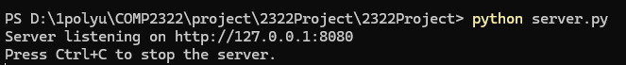
Figure 1: Server startup output showing listening address
This screenshot shows that the server starts successfully and listens on 127.0.0.1:8080.

3.2 Browser Access

To verify basic functionality, the server was accessed through a web browser by visiting the root path /. The server correctly returned the default index.html file, demonstrating that the request parsing and file serving mechanisms are working as expected.
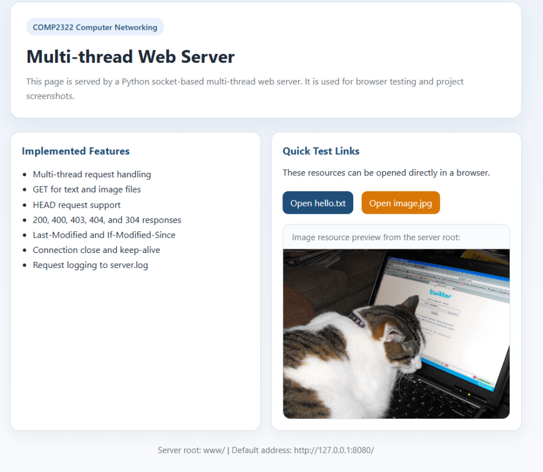
Figure 2: Browser access to root path returning index.html

3.3 GET Request Demonstration

A GET request was tested using curl to retrieve a text file from the server. The response returned a 200 OK status along with the file content, indicating successful request handling.
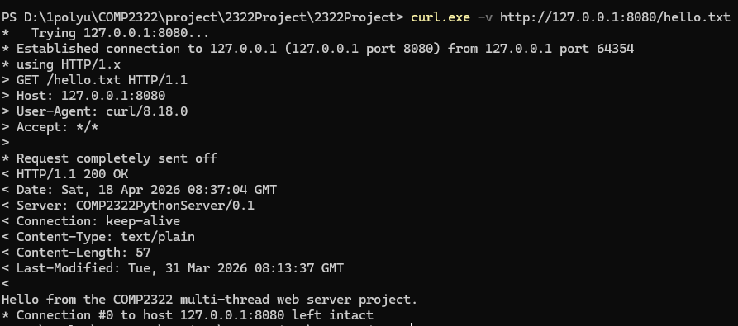
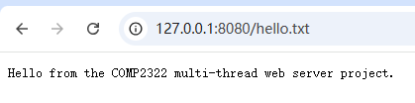
Figure 3: GET /hello.txt returning 200 OK, confirming correct file retrieval and response generation

In addition, a GET request for an image file was also tested. The server successfully returned the image data, confirming support for binary file transmission.

Figure 4: GET /image.jpg returning image content

3.4 HEAD Request Demonstration

The HEAD method was tested to verify that the server correctly returns only the response headers without the message body. The result shows that the server responds with 200 OK and includes appropriate headers, while no body content is returned.
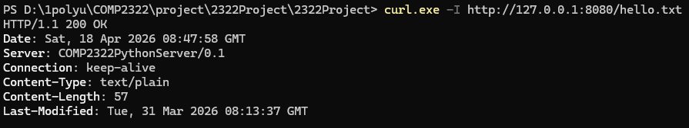
Figure 5: HEAD request showing headers only

3.5 Error Handling Demonstration

Several error cases were tested to ensure correct status code handling. When requesting a non-existing file, the server returned 404 File Not Found. When attempting a path traversal request using ../, the server correctly blocked the access and returned 403 Forbidden. Additionally, unsupported HTTP methods such as POST resulted in a 400 Bad Request response.
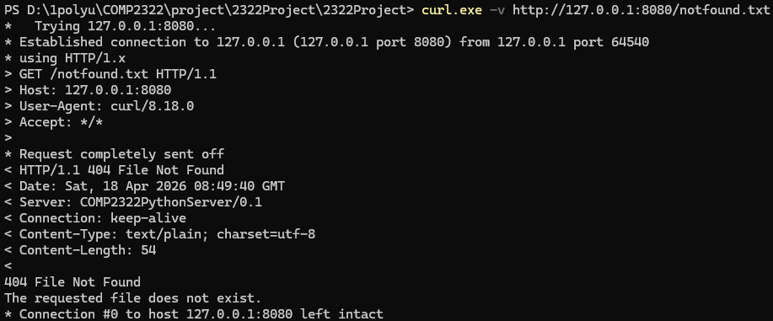
Figure 6: 404 Not Found response
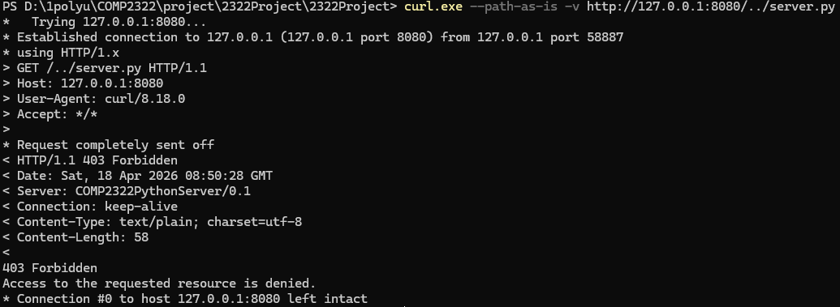
Figure 7: 403 Forbidden response
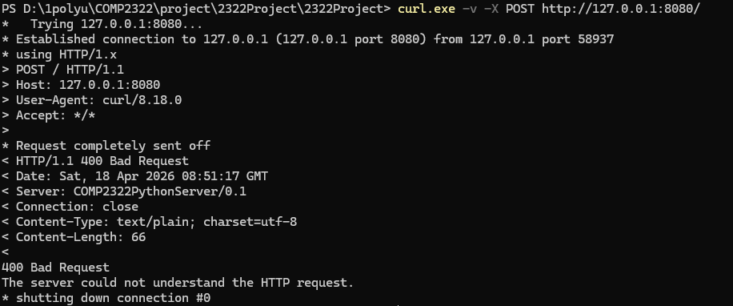
Figure 8: 400 Bad Request response
3.6 Cache Validation Demonstration (304 Not Modified)

To test cache validation, a request with the If-Modified-Since header was sent. When the file had not been modified since the specified time, the server returned a 304 Not Modified response without a message body. This confirms that the caching mechanism is functioning correctly.
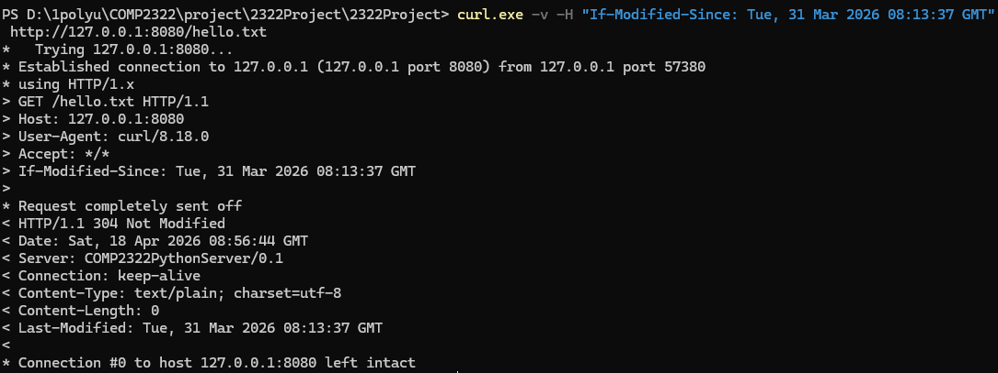
Figure 9: 304 Not Modified response

3.7 Connection Header Demonstration
The connection control mechanism of the server was tested using both Connection: close and Connection: keep-alive headers.

When a request was sent with the header Connection: close, the server returned a response containing the same header and terminated the TCP connection immediately after sending the response. As shown in Figure 10, the Connection: close field is included in the response header, and the connection is closed after the data is transmitted.

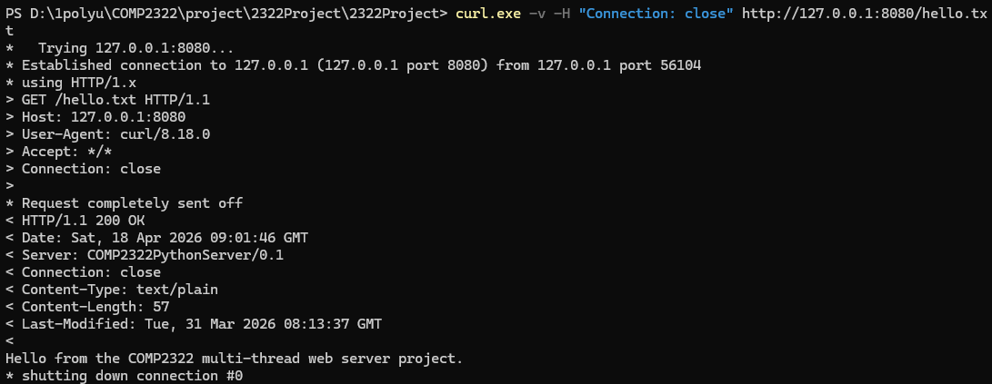
Figure 10: Connection: close
In contrast, when a request was sent with the header Connection: keep-alive, the server preserved the TCP connection after sending the response. As shown in Figure 11, the response includes Connection: keep-alive, and the client indicates that the connection is kept open (“Connection #0 to host 127.0.0.1 left intact”). This allows multiple requests to be sent over the same connection.
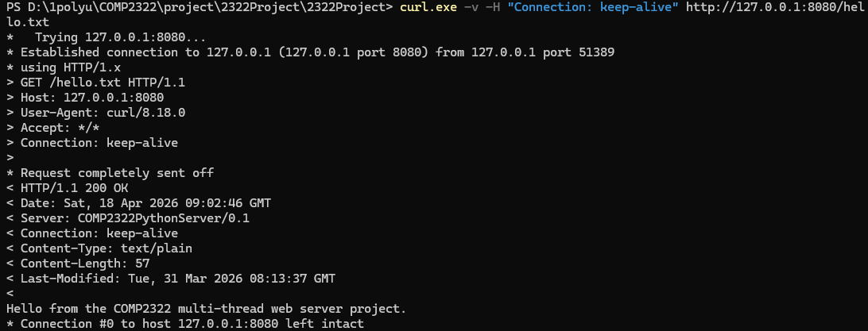
Figure 11: Connection: keep-alive
These results confirm that the server correctly handles both persistent and non-persistent HTTP connections according to the Connection header.

3.8 Persistent Connection Demonstration (Keep-Alive)

A custom client program (keep_alive_client.py) was used to test persistent connections. Two HTTP requests were sent over the same TCP connection. The server successfully processed two requests on the same TCP connection and returned two corresponding responses. The connection remained open after the first request and was closed only after the second response when Connection: close was specified.
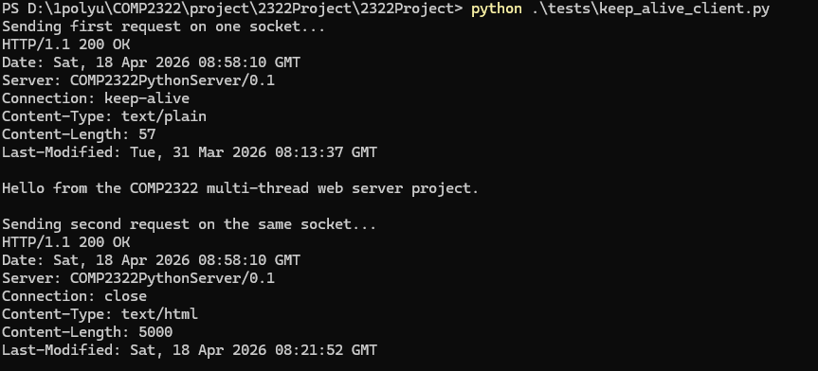
Figure 12: Two requests handled over one connection (keep-alive)
3.9 Multi-threading Observation

The server terminal output shows that multiple threads are created to handle client connections and HTTP requests. Each client connection is managed by a dedicated connection-handling thread, and each HTTP request is processed by a separate request-processing thread. The presence of multiple thread identifiers in the output confirms that the server handles requests concurrently using multi-threading.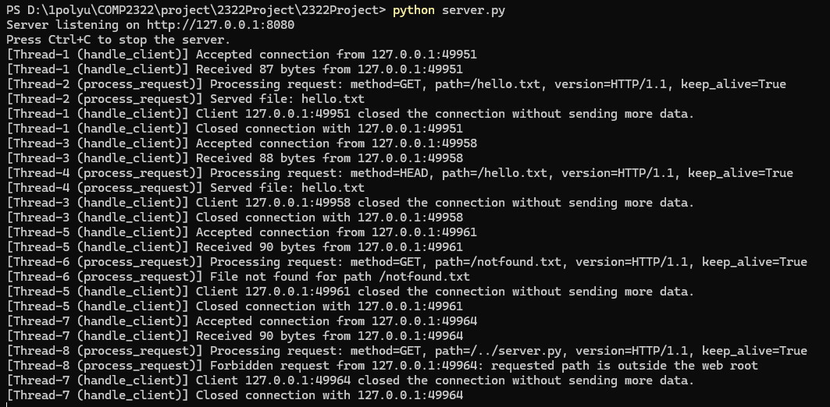
Figure 13: Server terminal showing multiple threads

3.10 Log File Verification

Finally, the log file was examined to verify that each request was recorded correctly. The log entries include client IP address, access time, request line, and status code, demonstrating that the logging system is functioning as intended. This confirms that each HTTP request generates exactly one log entry, which satisfies the project requirement for logging under multi-threaded conditions.
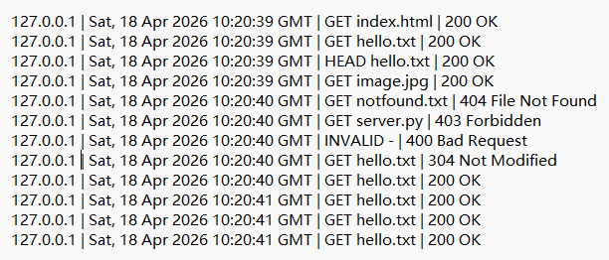
Figure 14: Log file entries in server.log
4. Conclusion
This project successfully implements a multi-threaded web server using Python socket programming. The server is capable of receiving and parsing HTTP requests, serving text and image files, generating correct HTTP responses, managing persistent and non-persistent connections, and supporting basic cache validation. All required functions, including multi-threading, status code handling, GETandHEADsupport,Last-Modified/If-Modified-Since, and request logging, were implemented and verified through testing. The overall results demonstrate a clear understanding of the HTTP protocol and the design of a concurrent web server.

5. Github Link
https://github.com/Try1ng1ng/2322Project.git

