# Angular Forms Lab

## 1. Setup Project

### 1.1 Install Dependencies

1. Change directory to calab:

* cd calab

1. Install dependencies by running the following command:

* npm install

1. You should see a message in your Terminal confirming the npm packages were installed successfully: 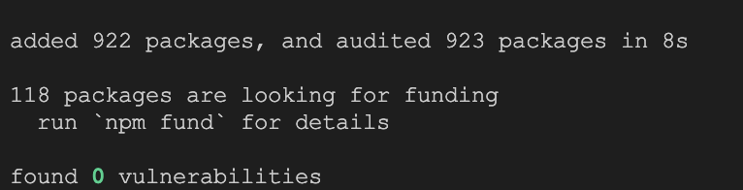

### 1.1 Start The Application

1. Start Angular Development Server if not yet started:

* npx -p @angular/cli ng serve
* *Otherwise refresh the browser tab to see updated view.*

1. You should see the following getting rendered in your browser:

* 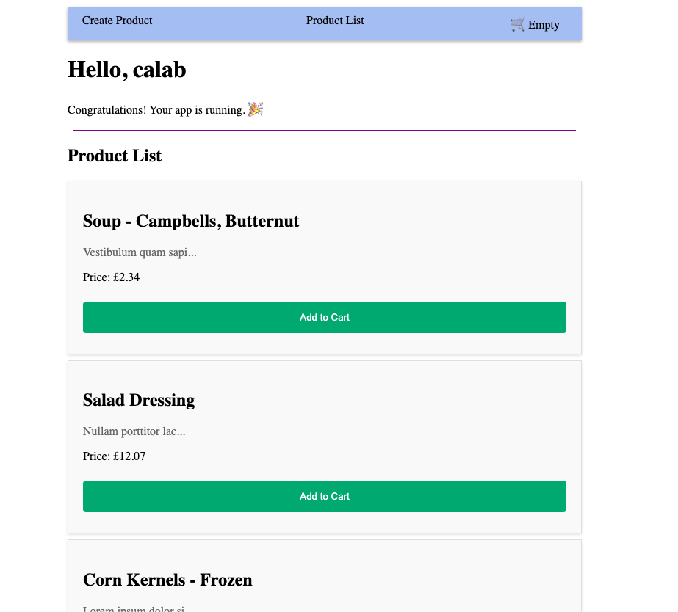
* *You should see similar view to where you left off in previous lab.*

## Create a Template Driven Form

### Setup Template Driven Form

* Open src/app/components/create-product/create-product.component.ts and do the following:
  + Import FormsModule:
  + import { FormsModule } from '@angular/forms';​
  + Update imports to include FormsModule
  + imports: [FormsModule],​
* Open src/app/components/create-product/create-product.component.html file and add the following form:
* <form>  
   <label for="name">Product Name:</label>  
   <input type="text" id="name" name="name" required>  
    
   <label for="description">Product Desctiption:</label>   
   <input type="text" id="description" name="description" required>  
    
   <label for="price">Product Price:</label>  
   <input type="number" id="price" name="price">  
    
   <button type="submit">Submit</button>   
  </form>
* Open src/app/components/create-product/create-product.component.css file and add some style:
* /* Style inputs */  
  input, select {  
   width: 100%;  
   padding: 12px 20px;  
   margin: 8px 0;  
   display: inline-block;  
   border: 1px solid #ccc;  
   border-radius: 4px;  
   box-sizing: border-box;  
  }  
    
  /* Style the submit button */  
  button[type=submit] {  
   width: 100%;  
   background-color: #04AA6D;  
   color: white;  
   padding: 14px 20px;  
   margin: 8px 0;  
   border: none;  
   border-radius: 4px;  
   cursor: pointer;  
  }  
  /* Style the disabled button */  
  button:disabled{  
  opacity: 0.3;  
  }  
    
  /* Add a background color to the submit button on mouse-over */  
  button[type=submit]:hover {  
   background-color: #45a049;  
  }  
    
  .ng-valid[required], .ng-valid.required {  
   border-left: 5px solid #42A948; /* green */  
  }  
  .ng-invalid:not(form) {  
   border-left: 5px solid #a94442; /* red */  
  }

### Data Bind With ngModel

* Open src/app/models/product.ts and make id optional:
* export class Product {  
   constructor(  
   public name: string,  
   public description: string,  
   public price: number,  
   public id?: number,  
   ) {}  
  }
* Open src/app/components/create-product/create-product.component.ts and do the following:
  + Import Product model:
  + import { Product } from '../../models/product';
  + Declare a product model to bind to the template:
  + product: Product;
  + Declare constructor and inside initialize Product instance
  + constructor(){  
     this.product = new Product('', '', 1);​  
    }
* Open src/app/components/create-product/create-product.component.html file and add the following form:
  + Update a form template with ngModel directive to enable two-way data binding.
  + <form>  
     <label for="name">Product Name:</label>  
     <input type="text" id="name" name="name" required [(ngModel)]="product.name">  
      
     <label for="description">Product Desctiption:</label>   
     <input type="text" id="description" name="description" required [(ngModel)]="product.description">  
      
     <label for="price">Product Price:</label>  
     <input type="number" id="price" name="price" [(ngModel)]="product.price">  
      
     <button type="submit">Submit</button>   
    </form>

### Submitting the Form

* Open src/app/components/create-product/create-product.component.ts and do the following:
  + Import ProductService:
  + import { ProductService } from '../../services/product.service';
  + Injecct ProductService into constrctor.
  + constructor(private productService: ProductService){...}
  + Implement onSubmit method that calls ProductService and it’s createProduct function.
  + onSubmit(){  
     console.log(this.product);  
     this.productService.createProduct(this.product);  
    }
  + *createProduct() function will be created in the next step.*
* Open src/app/components/create-product/create-product.component.html and Add an ngSubmit event listener to the form tag with the onSubmit() callback method:
* <form (ngSubmit)="onSubmit()">  
  ...

### Update ProductService

* Open src/app/services/product.service.ts and do the folowing:
  + Import Product model:
  + import { Product } from '../models/product';
  + Declare a list if Products and initialize it with an empty list []:
  + products: Product[] = [];
  + Inside constructor assign products array a default list of values.
  + this.products = DATA;
  + Update getProducts() method to return products list.
  + getProducts(){  
     this.logger.log('Fetching Products');  
     return this.products;  
    }
  + Create new method to append new product to the existing list:
  + createProduct(product: Product){  
     product.id = this.products.length;  
     this.products.push(product);  
    }

### Reroute To Product List When New Product Is Successfully Created

* Open src/app/components/create-product/create-product.component.ts and do the following:
  + Import Router:
  + import { Router } from '@angular/router';
  + Just above constructor create a new instance of a Router.
  + router = new Router();
  + Update onSubmit() method to call router:
  + this.router.navigate(['/product-list']);

### Enamble Form Validation

* Open src/app/components/create-product/create-product.component.html and do the following:
  + Update the <form> tag with a template reference variable, #productForm
  + <form (ngSubmit)="onSubmit()" #productForm="ngForm">
  + Add disabled property to submit button:
  + <button type="submit" [disabled]="productForm.invalid" >Submit</button>

### 3.3 Review Changes

1. Start Angular Development Server if not yet started:

* npx -p @angular/cli ng serve
* *Otherwise refresh the browser tab to see updated view.*

1. You should see the following getting rendered in your browser: 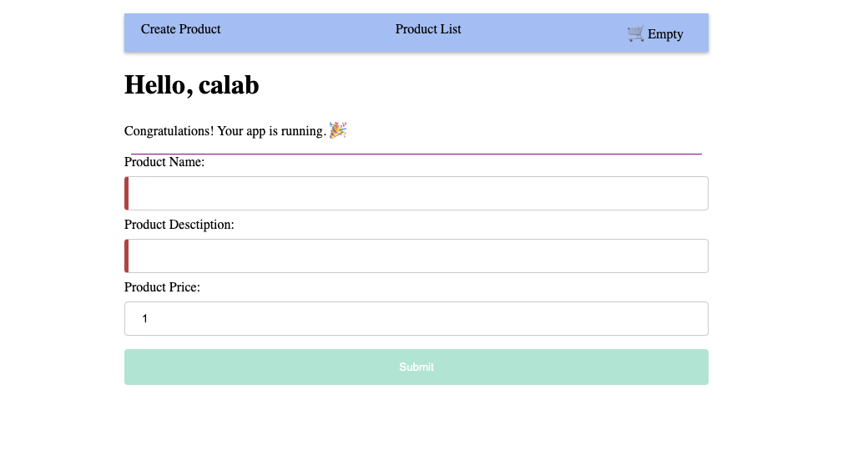
2. Once you enter data into the form you should see button getting enabled: 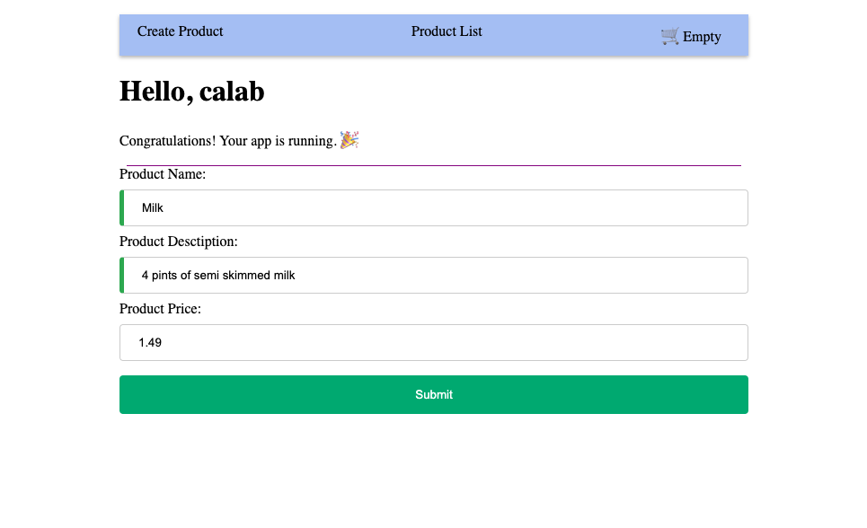
3. Once submitted you should be redirected to new Product List screen and see newly added Product at the bottom of the list 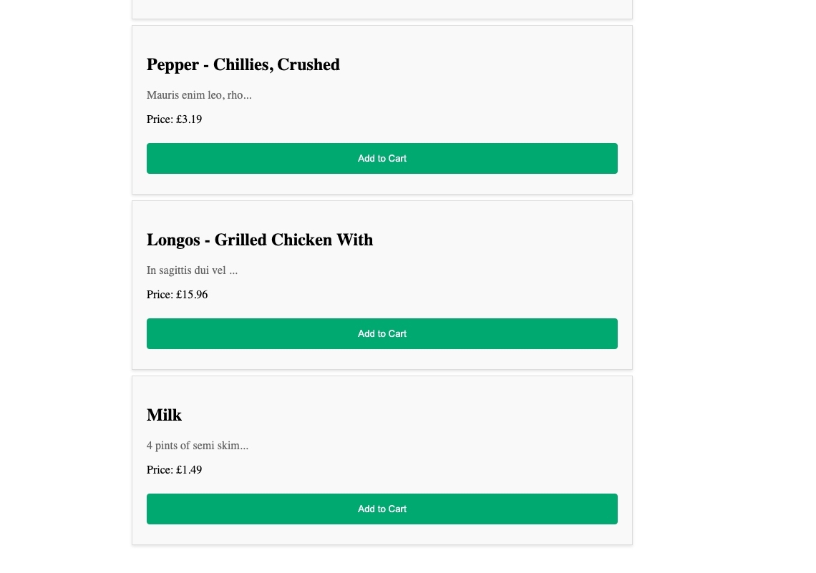

## Replace Template Driven Form With Reactive Form

### Create Reactive Form

* Open src/app/components/create-product/create-product.component.ts and do the following:
  + Import FormBuilder, FormGroup and ReactiveFormsModule:
  + import { FormBuilder, FormGroup, ReactiveFormsModule } from '@angular/forms';​
  + Update imports to include ReactiveFormsModule
  + imports: [ReactiveFormsModule],​
  + Just above constructor, replace product with productForm:
  + productForm: FormGroup;
  + Inject FormBuilder into constructor: .js constructor(private productService: ProductService, private formBuilder: FormBuilder){...}
  + Inside constructor replace product with productForm instance
  + this.productForm = this.formBuilder.group({  
     name: [''],  
     description: [''],  
     price:[0]  
    });
  + Update onSubmit() function to use productForm value:
  + this.router.navigate(['/product-list']);  
    console.log(this.productForm.value);  
    this.productService.createProduct(this.productForm.value);
* Open src/app/components/create-product/create-product.component.html and do the following:
  + Register productForm formGroup in the template:
  + <form (ngSubmit)="onSubmit()" [formGroup]="productForm">
  + Associate FormGroup model with individual template elements using formControlName directive.
  + <label for="name">Product Name:</label>  
    <input type="text" id="name" name="name" formControlName="name">  
      
    <label for="description">Product Desctiption:</label>   
    <input type="text" id="description" name="description" formControlName="description">  
      
    <label for="price">Product Price:</label>  
    <input type="number" id="price" name="price" formControlName="price">

### Enable Reactive Form Validation

* Open src/app/components/create-product/create-product.component.ts and do the following:
  + Import Validators:
  + import { FormBuilder, FormGroup, ReactiveFormsModule, Validators } from '@angular/forms';​
  + Add required validators to name and description form controls. Update productForm with the following:
* this.productForm = this.formBuilder.group({  
   name: ['', [Validators.required]],  
   description: ['', [Validators.required]],  
   price:[0]  
  });

### 3.3 Review Changes

1. Start Angular Development Server if not yet started:

* npx -p @angular/cli ng serve
* *Otherwise refresh the browser tab to see updated view.*

1. You should see the same behaviour as when using Template Driven form: 
2. Once you enter data into the form you should see button getting enabled: 
3. Once submitted you should be redirected to new Product List screen and see newly added Product at the bottom of the list 