# Angular HTTP Client Lab

## 1. Setup Project

### 1.1 Install JSON Server Dependencies

1. Change directory to json-server:

* cd json-server

1. Install dependencies by running the following command:

* npm install

1. You should see a message in your Terminal confirming the npm packages were installed successfully: 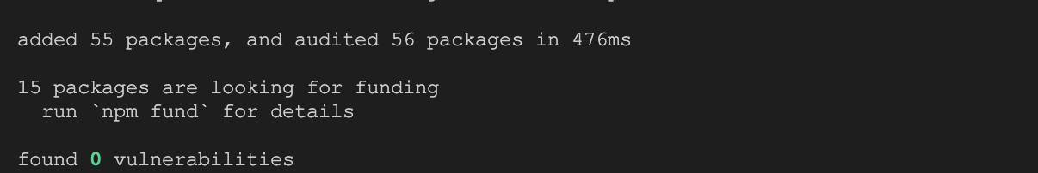

### 1.2 Start JSON Server

1. Start JSON server:

* npx json-server MOCK_DATA.json -p 3001

1. You should see the following getting rendered in your browser:

* 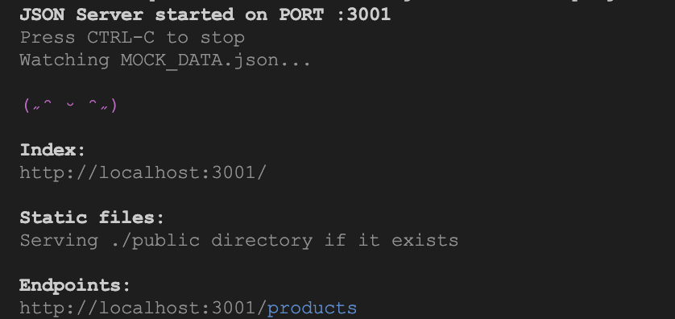
* *You should see similar view to where you left off in previous lab.*

### 1.3 Install Angular Dependencies

1. Open new terminal window.
2. Change directory to calab:

* cd calab

1. Install dependencies by running the following command:

* npm install

1. You should see a message in your Terminal confirming the npm packages were installed successfully: 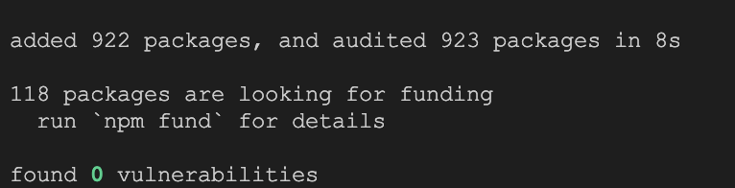

### 1.1 Start The Application

1. Start Angular Development Server if not yet started:

* npx -p @angular/cli ng serve
* *Otherwise refresh the browser tab to see updated view.*

1. You should see the following getting rendered in your browser:

* 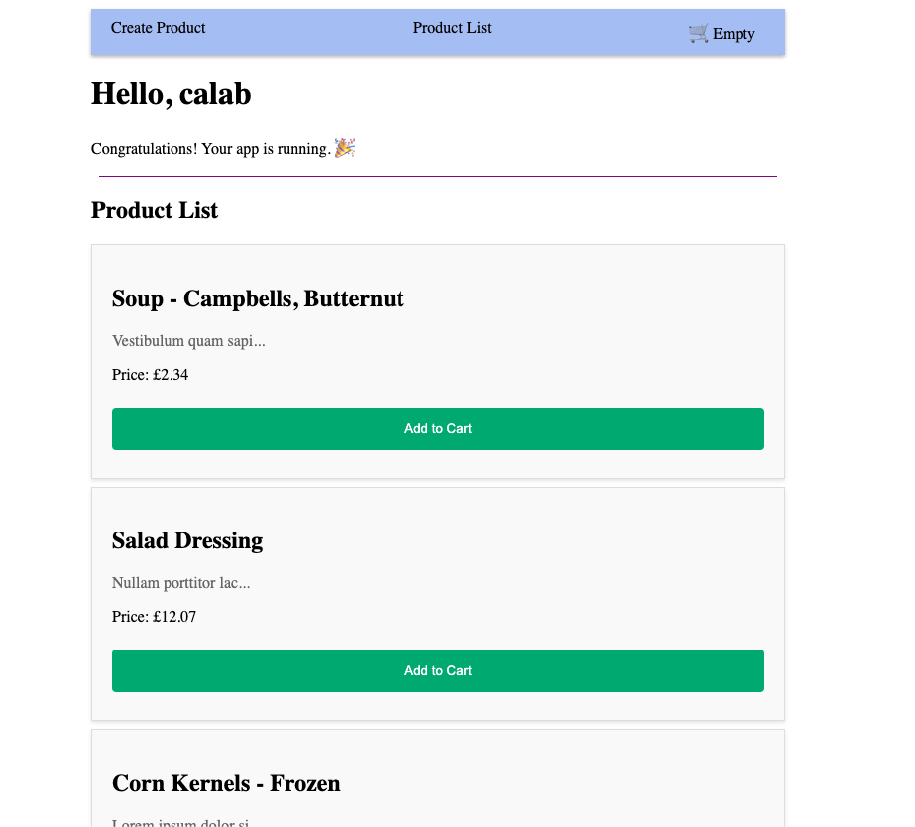
* *You should see similar view to where you left off in previous lab.*

## 2. Setup HttpClient

### 2.1 Update App Configuration

1. Open src/app/app.config.ts file and do the following:
   * Import provideHttpClient: .js import { provideHttpClient } from '@angular/common/http';
   * Provide provideHttpClient helper function:
   * export const appConfig: ApplicationConfig = {  
      providers: [provideRouter(routes), provideClientHydration(), {provide: LoggerService, useClass: TimedLoggerService}, provideHttpClient() ]  
     };

## 3. Configure a Service

### 3.2 Inject The HttpClient Service

1. Open src/app/services/product.service.ts file and do the following:
   * Import HttpClient.
   * import { HttpClient } from '@angular/common/http';
   * Inject HttpClient as a dependency into ProductService constructor.
   * export class ProductService {  
      constructor(private logger: LoggerService, private httpClient: HttpClient) { ... }  
     }

## 4. Update Product Service

### 5.1 Create a GET http request

1. Open src/app/services/product.service.ts file and do the following:
   * Delete list if Products variable which is declared just above constructor.
   * Also delete it’s reference from constructor.
   * Update function called getProducts to call http get() method.
   * getProducts(): Observable<Product[]>{  
      this.logger.log('Fetching Products');  
      return this.httpClient.get<Product[]>('http://localhost:3001/products');  
     }
   * Update function called createProduct to call http post() method.
   * createProduct(product: Product){  
      this.httpClient.post<Product>('http://localhost:3001/products', product).subscribe(res => {​  
      console.log('Product was created successfully:', res);​  
      });  
     }

## 4. Update Product List Component

* Open src/app/components/product-list/product-list.component.ts file and do the following:
  + Import Observable and AsyncPipe.
  + import { Observable } from 'rxjs';  
    import { AsyncPipe } from '@angular/common';​
  + Update imports to include AsyncPipe
  + imports: [ProductComponent, AsyncPipe],​
  + Update product List variable to an Observable.
  + products$!: Observable<Product[]>;
  + Make a ProductService call to get all products whjen Components is initialized:
  + ngOnInit(): void {  
     this.products$ = this.productService.getProducts();  
    }
* Open src/app/components/product-list/product-list.component.html file and do the following:
  + Combine @If with the async pipe to render the UI for the data only after it’s finished loading: .html @if (products$ | async; as products) { @for (product of products; track product) { <app-product [product]="product"(addToCartEvent)="addToCart($event)"></app-product> } }

### 3.3 Review Changes

1. Start Angular Development Server if not yet started:

* npx -p @angular/cli ng serve
* *Otherwise refresh the browser tab to see updated view.*

1. You should see the same behaviour as before, but this time values persist until JSON server is restarted: 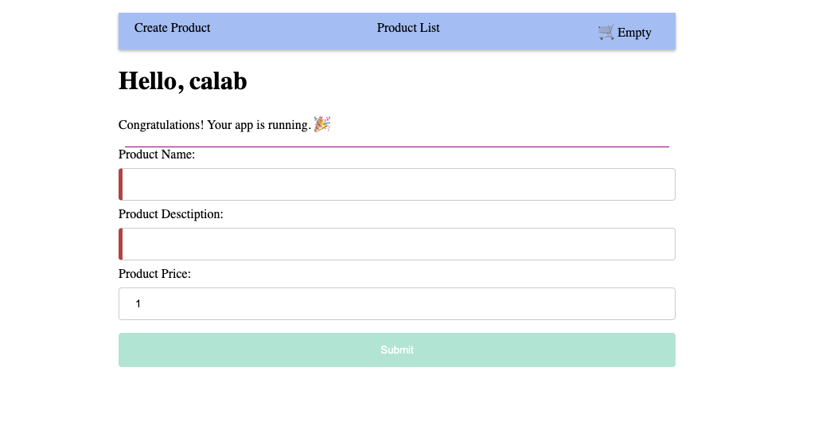
2. Once you enter data into the form you should see button getting enabled: 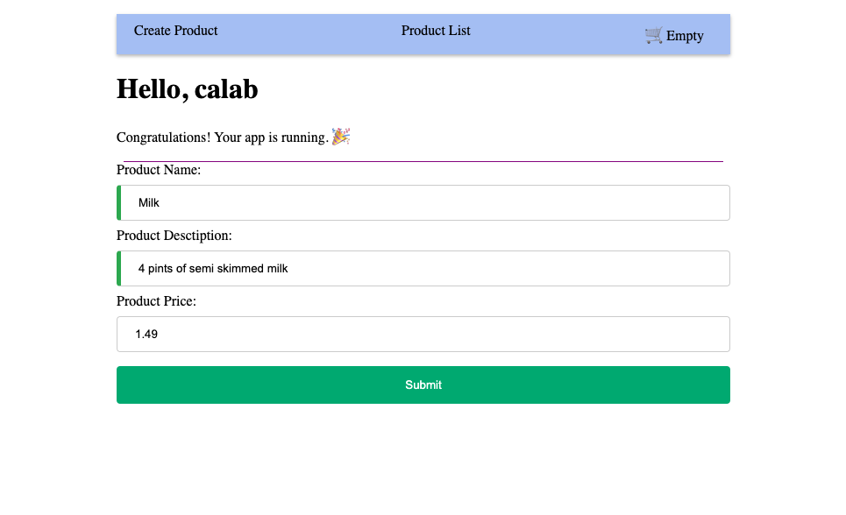
3. Once submitted you should be redirected to new Product List screen and see newly added Product at the bottom of the list 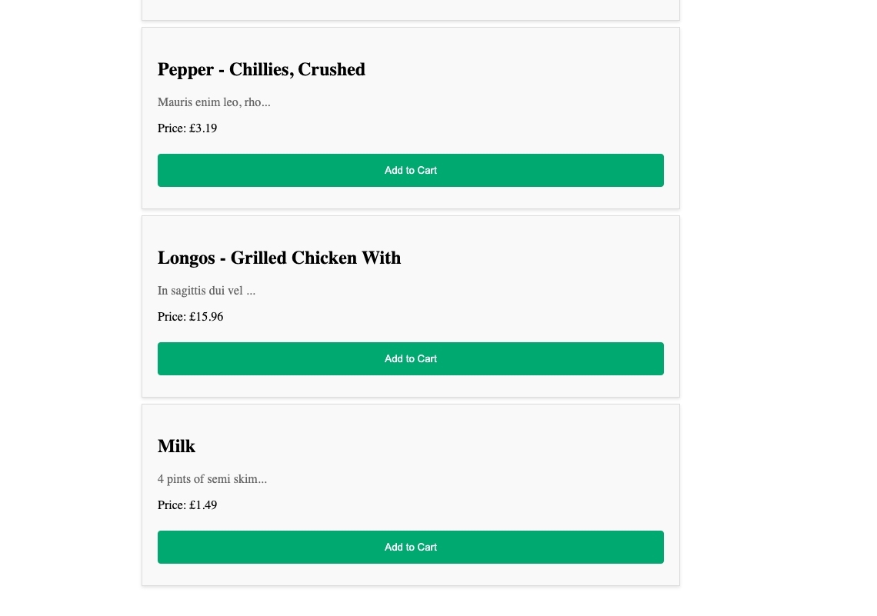

## 6. Interceptors

### 6.1 Define an Interceptor

1. Open src/app/app.config.ts file and do the following:
   * Import HttpEvent, HttpHandlerFn, HttpRequest, withInterceptors and Observable.
   * import { HttpEvent, HttpHandlerFn, HttpRequest, provideHttpClient, withInterceptors } from '@angular/common/http';  
     import { Observable } from 'rxjs';
   * Define a loggingInterceptor helper function:
   * export function loggingInterceptor(req: HttpRequest<unknown>, next: HttpHandlerFn): Observable<HttpEvent<unknown>> {  
      console.log(`Request URL is: ${req.url}`);  
      return next(req);  
     }
   * Declare an interceptor inside provideHttpClient helper function:
   * ```.js export const appConfig: ApplicationConfig = { providers: [provideRouter(routes), provideClientHydration(), provideHttpClient(withInterceptors([loggingInterceptor])), {provide: LoggerService, useClass: TimedLoggerService}] };

### 3.3 Review Changes

1. Start Angular Development Server if not yet started:

* npx -p @angular/cli ng serve
* *Otherwise refresh the browser tab to see updated view.*

1. You should see the same behaviour as before but in addition URL is getting logged result6