Design Phase

Description:

Our app is a mobile weather app. You can locate your position or choose a position. After you set that you can get the Temperature through a weather API.

Use Cases:

1. The User can set his location manually.
2. The User can set his location automatically.
3. The User can look up the temperature of his chosen location.
4. The User can look up the weather of his chosen location.

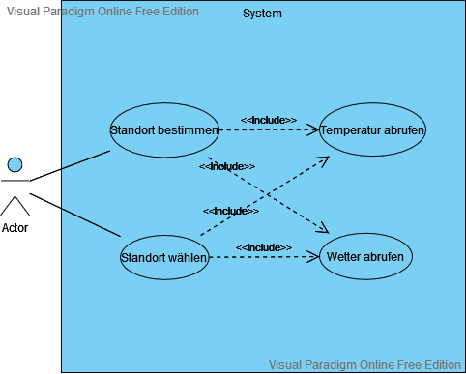

CRC Cards:

Ein Bild, das Text enthält.

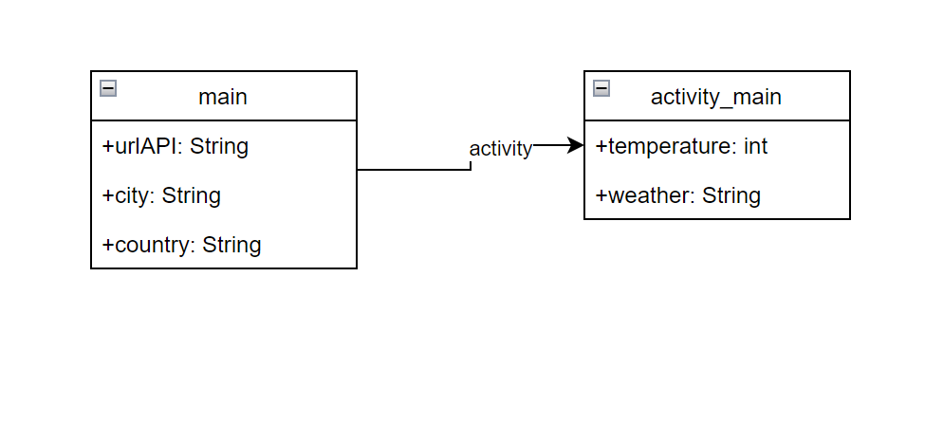Domain Model:

Class Diagramm:

Ein Bild, das Text enthält.
