**Information about the snow depth sample dataset**

**Background:**

This project explores the use of topography and weather data to model snow depth over a Swedish mountain region (Västerbotten, Sweden). You will access snow depth data measurements done over these mountains from winter 2017 to 2021 (5 years). Different methods can be used to model the snow depth (interpolation, geostatistics or machine learning). You are welcome to use R software or ArcGIS Pro, and/or ENVI if you intend to use satellite imagery.

**Context:**

The snow depth dataset from Vindelfjällen is part of a bigger project that aims at monitoring wildlife by surveying snowtracks in winter. This project has been on-going since 2004, led by the Swedish Arctic Fox Project, based at Stockholm University (Zoology department) in collaboration with Västerbotten county. Vindelfjällen nature reserve is in fact the biggest nature reserve of Sweden and is one the last Swedish mountain ranges that hosts a population of Arctic fox (*Vulpes lagopus*). If you wish to know more about the studies done regarding the ecology of the Arctic fox thanks to these snowtrack surveys, don’t hesitate to ask Marianne ([marianne.stoessel@natgeo.su.se](mailto:marianne.stoessel@natgeo.su.se)) who collaborates on this project. More literature on this can also be found [here](https://onlinelibrary.wiley.com/doi/pdf/10.1111/ecog.03984).

The snowtrack transects are in triangular shapes (Fig. 1). Since the quality of snow and snow depth can greatly affect the quality of the snowtrack surveys, it was decided to sample snow depth at every corner of the triangular transects over several years. Ultimately, the aim of these snow depth measurements is to model how snow depth changes over the landscape, but also over the years. Are there areas of the nature reserve that are less trustworthy for snowtracking surveys because of its exposure to wind? Does the snow depth and quality vary very much between years due to the weather? Or do the topographic settings of the area matter more in predicting snow depth?

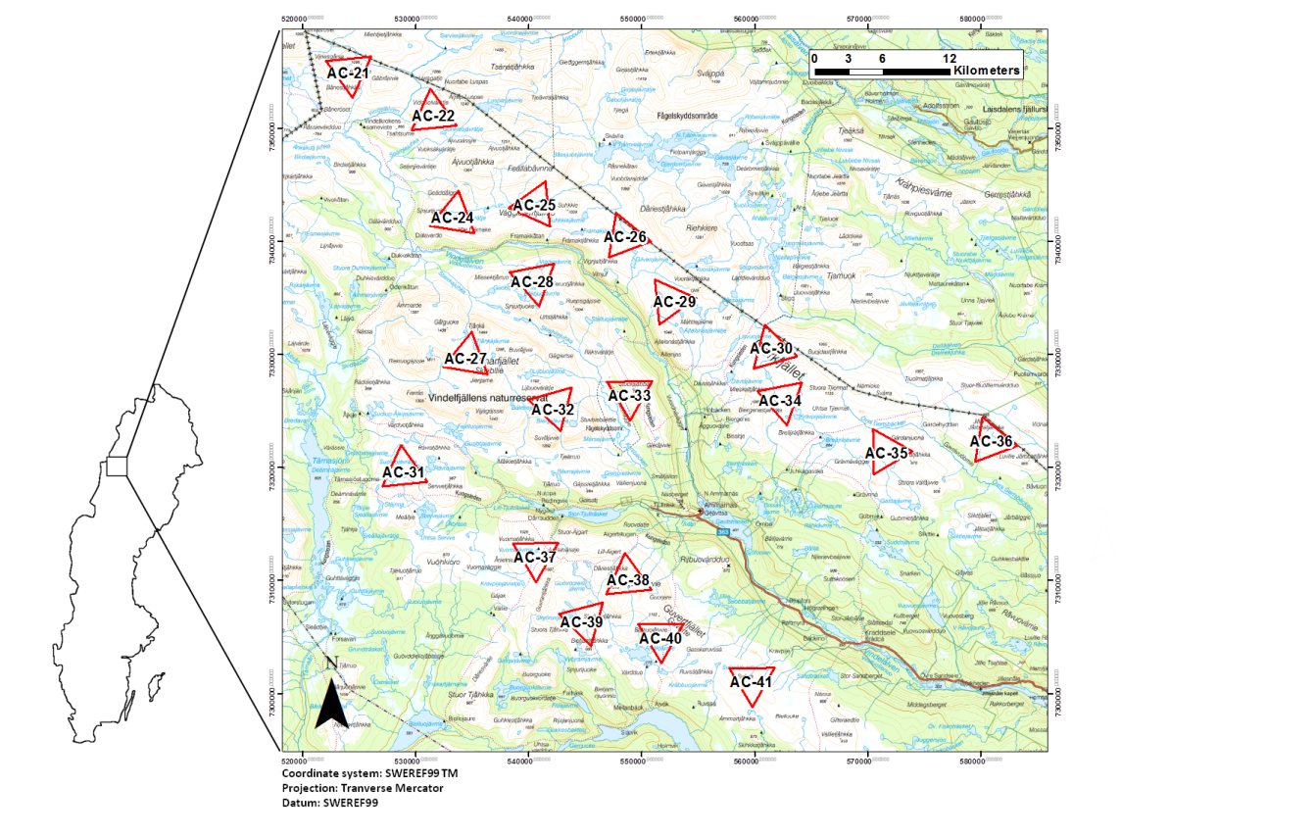**Figure 1:** map of the study area in Vindelfjällen, northern Sweden

**Information about the Excel datafile:**

This dataset is made of two Excel sheets, the first is called “Census_data”, the second “Triangle_infos”.

Under “Census_data”, you will find the snow depth measurements for every corner of a triangle, as well as the date and time of the census, some information about the weather (cloudiness, temperature, quality of snow), the number of snowtracks found for this triangle (independent from the species – it could be red fox *Vulpes vulpes* ; Norwegian lemming *Lemmus lemmus* ; ptarmigan *Lagopus sp* ; Arctic fox etc.), also if the triangle has been surveyed once or twice that year (NbTimesSurveyed_perYear). Some comments are also given in Swedish at the end, from the surveyor Mikael Vinka.

Under “Triangle_infos”, you will find the locations (latitude & longitude) of all the corners of the triangles. Two different reference systems are given (it is up to you to choose which one you wish to use), Sweref99TM (EPSG 3006) or RT90 2.5 gon V (EPSG 3021).

Some data management and data handling will be needed to get the snow depth sampling points imported in GIS. This can be done with Excel or R.

For additional data, you should be able to find the Digital Elevation Model from Lantmäteriet’s website (<https://zeus.slu.se/get/>) and some weather data from SMHI (<https://www.smhi.se/data>). Satellite imagery can also be relevant depending on how you want to proceed for this project.