Michał Nowaczyk 263971

Michał Bernacki-Janson 264021

**Inżynieria oprogramowania – etapy 5-7 Program wystawiający rachunki**

Spis treści

Diagram klas 2

Struktura klas 3

Application 3

BarcodeScanner 3

VATBracket 3

PrintingPosition 3

Product 3

InternalPosition 4

Database 4

Invoice 4

Bill 5

Diagramy sekwencji 6

Diagram PU adding/removing a product 6

Subdiagram getProduct() 7

Subdiagram addPosition() 8

Subdiagram removePosition() 9

Subdiagram printPosition() 10

Diagram PU Finalzaing the bill 11

Subdiagram taxes() 13

Uzyskany kod 14

BarcodeScanner 14

VATBracket 14

Invoice 14

PrintingPosition 14

Database 15

Bill 15

InternalPosition 18

Application 18

Product 19

# Diagram klas

## Struktura klas

### Application

public class Application {  
 static Bill;  
 private static int *cashierID*;

Application(){}

private int informQuantity(){return 0;}

private void setCashierId(int id){}

private boolean informpayed(){return false;}  
 private boolean informInvoice(){return false;}  
 private boolean informSending(){return false;}  
 private String informEmail(){return null;}

private void login(){}  
 public static void main(String[] args){}  
}

### BarcodeScanner

public interface BarcodeScanner {  
 public int scan();  
}

### VATBracket

public enum VATBracket {  
 *A*(23),  
 *B*(8),  
 *C*(5),  
 *D*(0);  
  
 public final int value;  
 private VATBracket(int label) {this.value = label;}  
}

### PrintingPosition

public class PrintingPosition {  
  
 protected Product Product;  
 protected int Quantity;  
  
 public PrintingPosition(Product product, int quantity) {  
 Product=product;  
 Quantity=quantity;  
 }  
}

### Product

public class Product {  
 private String Name;  
 private float Price;  
 private VATBracket VAT;  
 private int ProductID;  
  
 Product(String Name, float Price, VATBracket VAT, int ProductID){  
 }  
  
 public Product(Product Product) {  
 }  
  
 public String getName() {  
 return Name;  
 }

public float getPrice() {  
 return Price;  
 }  
  
 public VATBracket getVAT() {  
 return VAT;  
 }  
  
 public int getProductID() {  
 return ProductID;  
 }  
  
 public void setProductID(int ProductID) {}  
  
}

### InternalPosition

public class InternalPosition extends PrintingPosition {  
  
 public InternalPosition(Product product, int quantity) {  
 super(product, quantity);  
 }  
  
 public void increment(int quantity) {}  
 public void decrement(int quantity) {}  
}

### Database

public class Database {  
 private static ArrayList<InternalPosition> *Products*;  
 private ArrayList<Bill> bills;  
 private ArrayList<Invoice> invoices;  
 public static Product getProduct(int id){null;}  
 public static int getQuantity(int id){return 0;}  
  
 public void saveBill(Bill bill){}  
 public void saveInvoice(Invoice invoice){}

public boolean login(String login, String password){ return false;}  
  
}

### Invoice

public class Invoice{  
 Bill Bill;  
 int NIP;  
 String CompanyName;  
  
 public Invoice(Bill Bill,int NIP,String CompanyName){  
 this.Bill=Bill;  
 this.NIP = NIP;  
 this.CompanyName = CompanyName;  
  
 }  
  
 public void printInvoice(int cashierID){}  
 public void sendInvoice(String email){}  
  
}

### Bill

import java.text.SimpleDateFormat;  
import java.util.ArrayList;  
import java.util.Date;  
public class Bill {  
  
 private ArrayList<InternalPosition> products;  
 private int billId;  
 private Date Date;  
  
 Bill(){}  
  
 public void printHeader(int cashierID){}  
 public void addPosition(Product product, int quantity) {}  
  
 public void printPosition(PrintingPosition product) {}  
  
 public void show() {}  
  
 public void removePosition(Product product, int quantity) {}  
  
 public void calculatingFinalSums(){}  
  
 private float sum(){return 0.0f}  
 private ArrayList<Float> taxes() {return null;}  
 private void printSum(float sum){}  
 private void printTaxes(ArrayList<Float> taxesSums){}  
 public void printBill(){}  
  
}

# Diagramy sekwencji

## Diagram PU adding/removing a product

### Subdiagram getProduct()

public static Product getProduct(int id){  
 Product product;  
 for (InternalPosition x:*Products*) {  
 if(x.Product.getProductID()==id){  
 product=x.Product;  
 return product;  
 }  
 }  
 return null;  
}

### Subdiagram addPosition()

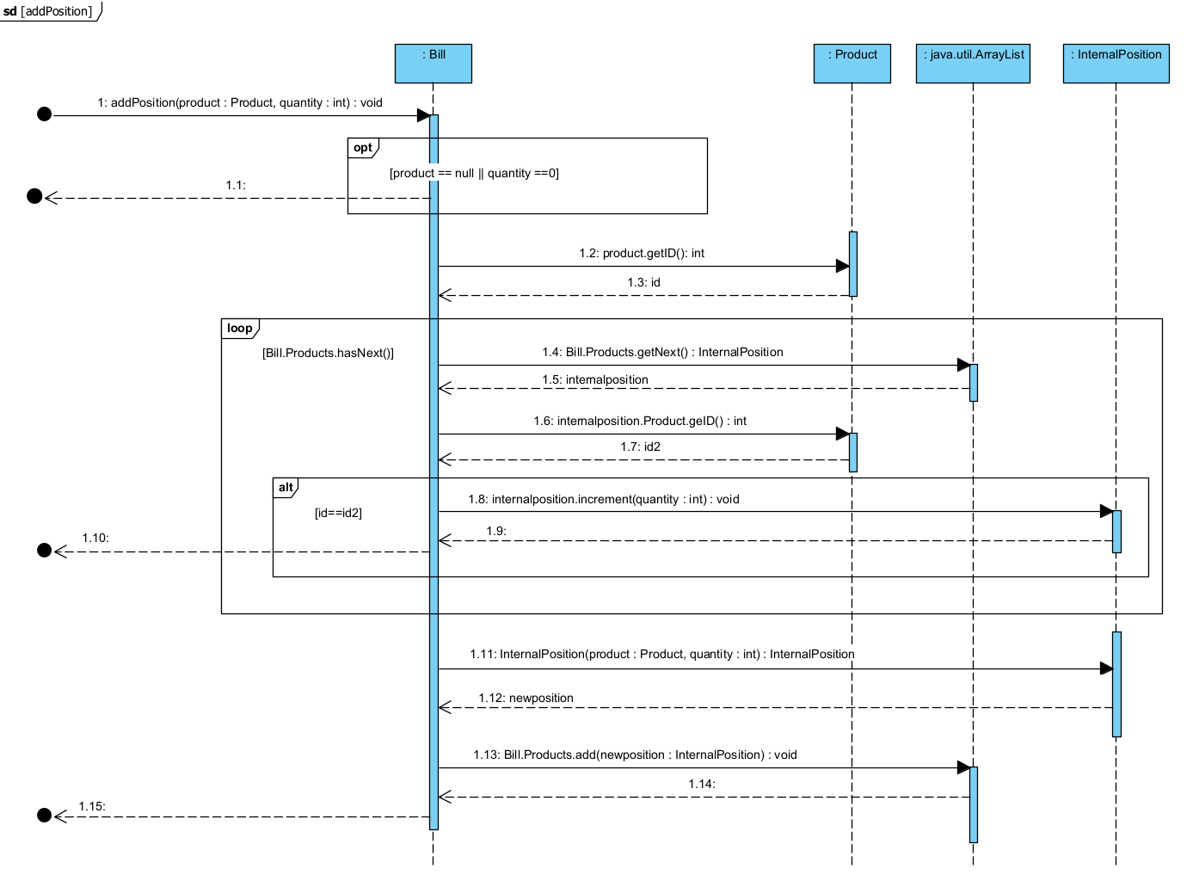

public void addPosition(Product product, int quantity) {  
  
 for (var produt : products) {  
  
 if(produt.Product.getProductID()==product.getProductID()){  
 produt.increment(quantity);  
 return;  
 }  
 }  
 products.add(new InternalPosition(product,quantity));  
}

public void increment(int quantity) {  
 this.Quantity+=quantity;  
}

### Subdiagram removePosition()

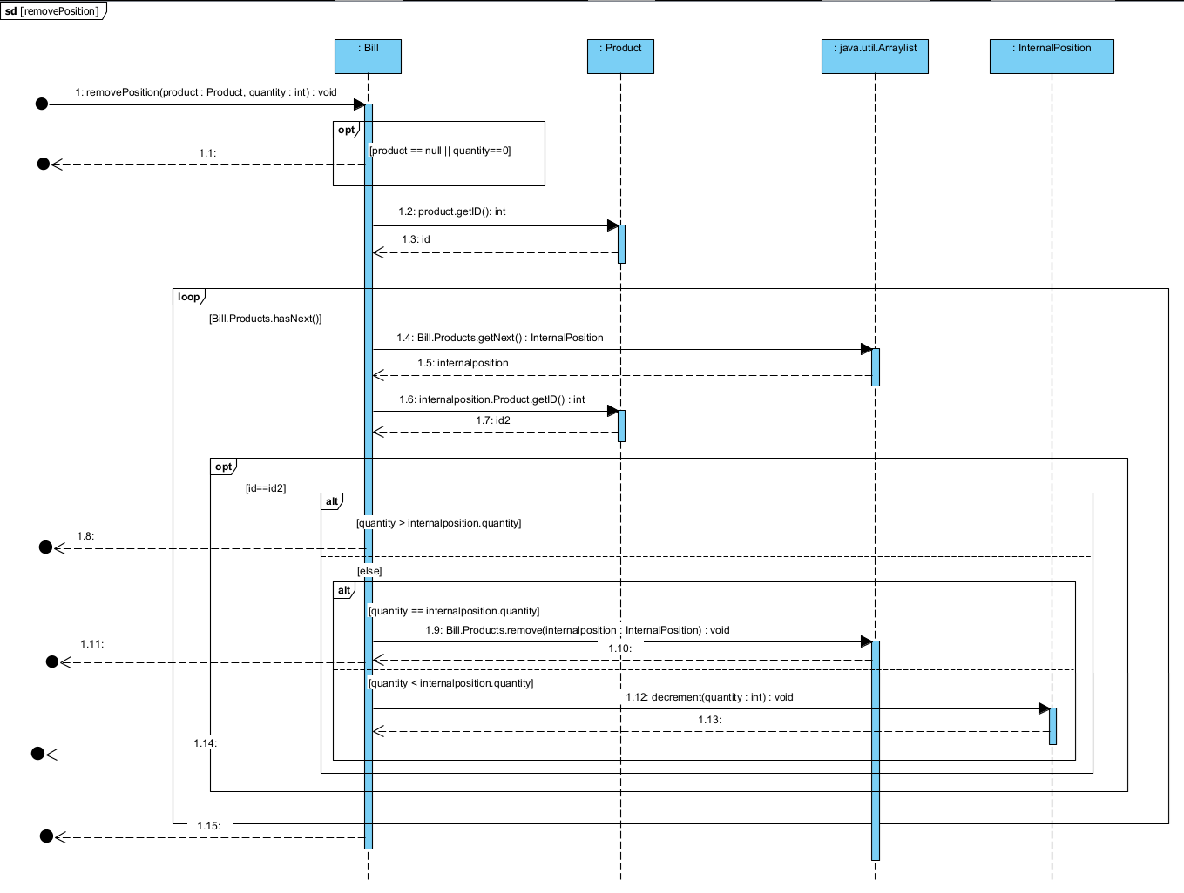

public void removePosition(Product product, int quantity) {  
 for (var produt : products) {  
 if (produt.Product.getProductID() == product.getProductID()) {  
 if(quantity> produt.Quantity) return;  
 else {  
 if (produt.Quantity > quantity)  
 produt.decrement(quantity);  
 else {  
 products.remove(produt);  
 }  
 }  
 return;  
 }  
 }  
}

### Subdiagram printPosition()

public void printPosition(PrintingPosition product) {  
System.*out*.println(product.Product.getName()+" "+product.Quantity+" "+product.Product.getPrice()+" "+product.Product.getVAT());  
}

## Diagram PU Finalzaing the bill

public void calculatingFinalSums(){  
 printSum(sum());;  
 printTaxes(taxes());  
  
}

private float sum(){  
 float sum = 0;  
 for (var product : products){  
 sum += product.Product.getPrice() * product.Quantity;  
 }  
 return sum;  
}  
  
  
private void printSum(float sum){  
 System.*out*.println("Suma: "+sum);  
}  
private void printTaxes(ArrayList<Float> taxesSums){  
  
 for(int i=0;i<4;i++)  
 System.*out*.println(VATBracket.*getBracketForValue*(i)+" "+taxesSums.get(i));  
  
  
}

public void printBill(){  
 System.*out*.println("Dziekujemy za zakupy");  
}

public void saveBill(Bill bill){  
 bills.add(bill);  
}  
public void saveInvoice(Invoice invoice){  
 invoices.add(invoice);  
}

public void printInvoice(int cashierID){  
 System.*out*.print("Data : ");  
 Bill.printHeader(cashierID);  
 System.*out*.println("NAZWA FIRMY : " + CompanyName);  
 System.*out*.println("NIP : " + NIP);  
 Bill.show();  
 Bill.calculatingFinalSums();  
}  
public void sendInvoice(String email){  
 System.*out*.println("Wysylanie faktury na adres email: " + email);  
}

### Subdiagram taxes()

private ArrayList<Float> taxes() {  
 ArrayList<Float> taxesSums = new ArrayList<Float>();  
 taxesSums.add(0.0f);  
 taxesSums.add(0.0f);  
 taxesSums.add(0.0f);  
 taxesSums.add(0.0f);  
  
 for (var product : products) {  
 int index = switch (product.Product.getVAT()) {  
 case *A* -> 0;  
 case *B* -> 1;  
 case *C* -> 2;  
 case *D* -> 3;  
 };  
  
 taxesSums.set(index, taxesSums.get(index) + product.Product.getPrice() * product.Quantity * VATBracket.*valueOf*(product.Product.getVAT().name()).value / 100);  
 }  
  
 return taxesSums;  
}

# Uzyskany kod

## BarcodeScanner

public interface BarcodeScanner {  
 public int scan();  
}

## VATBracket

public enum VATBracket {  
 *A*(23),  
 *B*(8),  
 *C*(5),  
 *D*(0);  
 public final int value;  
 private VATBracket(int label) {this.value = label;}  
}

## Invoice

import java.util.ArrayList;

public class Invoice extends sklep.Bill {  
 Bill Bill;  
 int NIP;  
 String CompanyName;  
  
 public Invoice(Bill Bill,int NIP,String CompanyName){  
 this.Bill=Bill;  
 this.NIP = NIP;  
 this.CompanyName = CompanyName;  
  
 }  
public void printInvoice(int cashierID){  
 Bill.printHeader(cashierID);  
 System.*out*.println("NAZWA FIRMY : " + CompanyName);  
 System.*out*.println("NIP : " + NIP);  
 Bill.show();  
 Bill.calculatingFinalSums();  
}

public void sendInvoice(String email){  
 System.*out*.println("Wysylanie faktury na adres email: " + email);  
 }  
}

## PrintingPosition

public class PrintingPosition {  
  
 protected Product Product;  
 protected int Quantity;  
  
 public PrintingPosition(Product product, int quantity) {  
  
 Product=product;  
 Quantity=quantity;  
 }  
}

## Database

import java.util.ArrayList;  
public class Database {  
 private static ArrayList<InternalPosition> *Products*;  
 static{  
 *Products*=new ArrayList<InternalPosition>();  
 *Products*.add(new InternalPosition(new Product("Chleb pszenny",3.49f, VATBracket.*B*,1),36));  
 *Products*.add(new InternalPosition(new Product("Mleko muuu",3.99f, VATBracket.*B*,2),314));  
 *Products*.add(new InternalPosition(new Product("Telewizor 32''",1299.99f, VATBracket.*A*,3),4));  
 *Products*.add(new InternalPosition(new Product("Radioodbiornik Rydzunio",333.33f, VATBracket.*A*,4),12));  
 }  
 private ArrayList<Bill> bills = new ArrayList<Bill>();  
 private ArrayList<Invoice> invoices= new ArrayList<Invoice>();  
 public static Product getProduct(int id){  
 Product product;  
 for (InternalPosition x:*Products*) {  
 if(x.Product.getProductID()==id){  
 product=x.Product;  
 return product;  
 }  
 }  
 return null;  
 }  
 public static int getQuantity(int id){  
  
 int quantity = -1;  
 for (InternalPosition x:*Products*) {  
 if(x.Product.getProductID()==id){  
 quantity=x.Quantity;  
 }  
 }  
 return quantity;  
 }  
  
public void saveBill(Bill bill){  
 bills.add(bill);  
}  
public void saveInvoice(Invoice invoice){  
 invoices.add(invoice);  
}  
  
public boolean login(String login, String password){  
 if(login.compareTo(Login) == 0 && password.compareTo(Passowrd)==0)  
 return true;  
 return false;  
}

}

## Bill

import java.text.SimpleDateFormat;  
import java.util.ArrayList;  
import java.util.Date;  
public class Bill {  
  
 private ArrayList<InternalPosition> products;  
 private int billId;  
 private Date Date;  
  
 Bill(){  
 products=new ArrayList<InternalPosition>();  
 billId = (int) new Date().getTime();  
 Date = new Date();  
 }  
  
 public void printHeader(int cashierID){  
 SimpleDateFormat f = new SimpleDateFormat("yyyy-MM-dd hh:mm");  
 System.*out*.println("Sklep Fajny");  
 System.*out*.println("NIP 328957834275");  
 System.*out*.println("Kasjer : "+cashierID);  
 System.*out*.println(f.format(Date));  
  
 }  
 public void addPosition(Product product, int quantity) {  
  
 for (var produt : products) {  
  
 if(produt.Product.getProductID()==product.getProductID() && produt.Quantity<quantity){  
 produt.increment(quantity);  
 return;  
 }  
 }  
 products.add(new InternalPosition(product,quantity));  
 }  
  
 public void printPosition(PrintingPosition product) {  
 System.*out*.println(product.Product.getName()+" "+product.Quantity+" "+product.Product.getPrice()+" "+product.Product.getVAT());  
 }  
  
 public void show() {  
 for (InternalPosition product:products) {  
 System.*out*.println(product.Product.getName()+" "+product.Quantity+" "+product.Product.getPrice()+" "+product.Product.getVAT());  
 }  
 }  
  
 public void removePosition(Product product, int quantity) {  
 for (var produt : products) {  
 if (produt.Product.getProductID() == product.getProductID()) {  
 if(quantity> produt.Quantity) return;  
 else {  
 if (produt.Quantity > quantity)  
 produt.decrement(quantity);  
 else {  
 products.remove(produt);  
 }  
 }  
 return;  
 }  
 }  
 }  
  
 public void calculatingFinalSums(){  
 printSum(sum());;  
 printTaxes(taxes());  
  
 }  
  
 private float sum(){  
 float sum = 0;  
 for (var product : products){  
 sum += product.Product.getPrice() * product.Quantity;  
 }  
 return sum;  
 }  
 private ArrayList<Float> taxes() {  
 ArrayList<Float> taxesSums = new ArrayList<Float>();  
 taxesSums.add(0.0f);  
 taxesSums.add(0.0f);  
 taxesSums.add(0.0f);  
 taxesSums.add(0.0f);  
  
 for (var product : products) {  
 int index = switch (product.Product.getVAT()) {  
 case *A* -> 0;  
 case *B* -> 1;  
 case *C* -> 2;  
 case *D* -> 3;  
 };  
  
 taxesSums.set(index, taxesSums.get(index) + product.Product.getPrice() * product.Quantity * VATBracket.*valueOf*(product.Product.getVAT().name()).value / 100);  
 }  
  
 return taxesSums;  
 }  
  
 private void printSum(float sum){  
 System.*out*.println("Suma: "+sum);  
 }  
 private void printTaxes(ArrayList<Float> taxesSums){  
 char v = 'A';  
 for(int i=0;i<4;i++){  
 System.*out*.println(v+" "+taxesSums.get(i));  
 v++;  
 }  
  
 }  
  
 public void printBill(){  
 System.*out*.println("Dziekujemy za zakupy");  
 }  
  
}

## InternalPosition

public class InternalPosition extends PrintingPosition {  
  
 public InternalPosition(Product product, int quantity) {  
 super(product, quantity);  
 }  
  
 public void increment(int quantity) {  
 this.Quantity+=quantity;  
 }  
 public void decrement(int quantity) {  
 this.Quantity-=quantity;  
 }  
}

## Application

public class Application {  
 private static Bill *bill*;  
 private static int *cashierID*;  
 Application(){ //ustawione dane do przetestowania  
 *bill* = new Bill();  
 setCashierId(32);  
 *bill*.addPosition(Database.*getProduct*(2),2);  
 *bill*.addPosition(Database.*getProduct*(2),2);  
 *bill*.show();  
 *bill*.calculatingFinalSums();  
 System.*out*.println("\n\n\n");  
 *bill*.addPosition(Database.*getProduct*(1),2);  
 *bill*.removePosition(Database.*getProduct*(2),2);  
 *bill*.show();  
 *bill*.calculatingFinalSums();  
 System.*out*.println("\n\n\n");  
 Invoice x = new Invoice(*bill*,277277277,"Firma kox");  
 x.printInvoice(*cashierID*);  
 }  
 private void setCashierId(int id){  
 *cashierID* = id;  
 }  
 private int informQuantity(){return 0;}  
 private boolean informPayed(){return false;}  
 private boolean informInvoice(){return false;}  
 private boolean informSending(){return false;}  
 private String informEmail(){return null;}

private void login(){}  
 public static void main(String[] args){  
 new Application();  
 }  
  
}

## Product

public class Product {  
 private String Name;  
 private float Price;  
 private VATBracket VAT;  
 private int ProductID;  
  
 Product(String Name, float Price, VATBracket VAT, int ProductID) {  
 this.Name = Name;  
 this.Price = Price;  
 this.VAT = VAT;  
 this.ProductID = ProductID;  
 }  
  
 public String getName() {  
 return this.Name;  
 }  
  
 public float getPrice() {  
 return this.Price;  
 }  
  
 public VATBracket getVAT() {  
 return this.VAT;  
 }  
  
 public int getProductID() {  
 return this.ProductID;  
 }  
}